Use Case 3 Learner Guide
ETL for ML preparation, curated publishing, and governed model versioning

1-hour structure: Use the deck for 10 to 15 minutes, then spend the remaining time in S3 and the notebook running the ETL and training flow.

What learners should understand
- Raw churn data is first treated as an ETL input, not as direct model input.
- Validation, standardization, and curated publish points are visible before training begins.
- SageMaker training and Model Registry are the downstream consumers of a well-engineered dataset.
- The same notebook logic can later become an AWS Glue job for production reuse.
AWS services in scope
Service | Why it appears | Where learners see it | ETL role
Amazon S3 | Stores raw and curated churn files plus validation artifacts | S3 bucket and notebook paths | Landing, curated publish, artifact storage
Jupyter / SageMaker Notebook | Walkthrough environment for profiling and transformation | Notebook cells | Extract, profile, transform, validate
AWS Glue (optional bridge) | Shows how notebook ETL becomes repeatable PySpark | Code asset discussion | Production ETL job
Amazon SageMaker | Trains the baseline model and registers the version | Training explanation and registry step | Consumes curated data and publishes model artifact
Hands-on sequence
- Step 1 - Open S3 and show the raw file in churn/raw/. Explain why a raw zone is important for lineage and replay.
- Step 2 - Run the notebook profiling section. Discuss schema, blanks, duplicates, TotalCharges cleanup, and churn label quality.
- Step 3 - Transform the dataset. Standardize TotalCharges, create label, engineer is_new_customer, monthly_charge_band, and spend-gap features.
- Step 4 - Validate before publish. Call out the validation_summary as an artifact, not a throwaway debug step.
- Step 5 - Publish train.csv and test.csv into churn/ml_ready/. Show how curated paths make the training stage reusable.
- Step 6 - Train the baseline model in SageMaker or locally for demo speed. Keep the emphasis on curated inputs and governed outputs.
- Step 7 - Explain Model Registry as the publish point for the trained model version. This is the model equivalent of a curated data product.
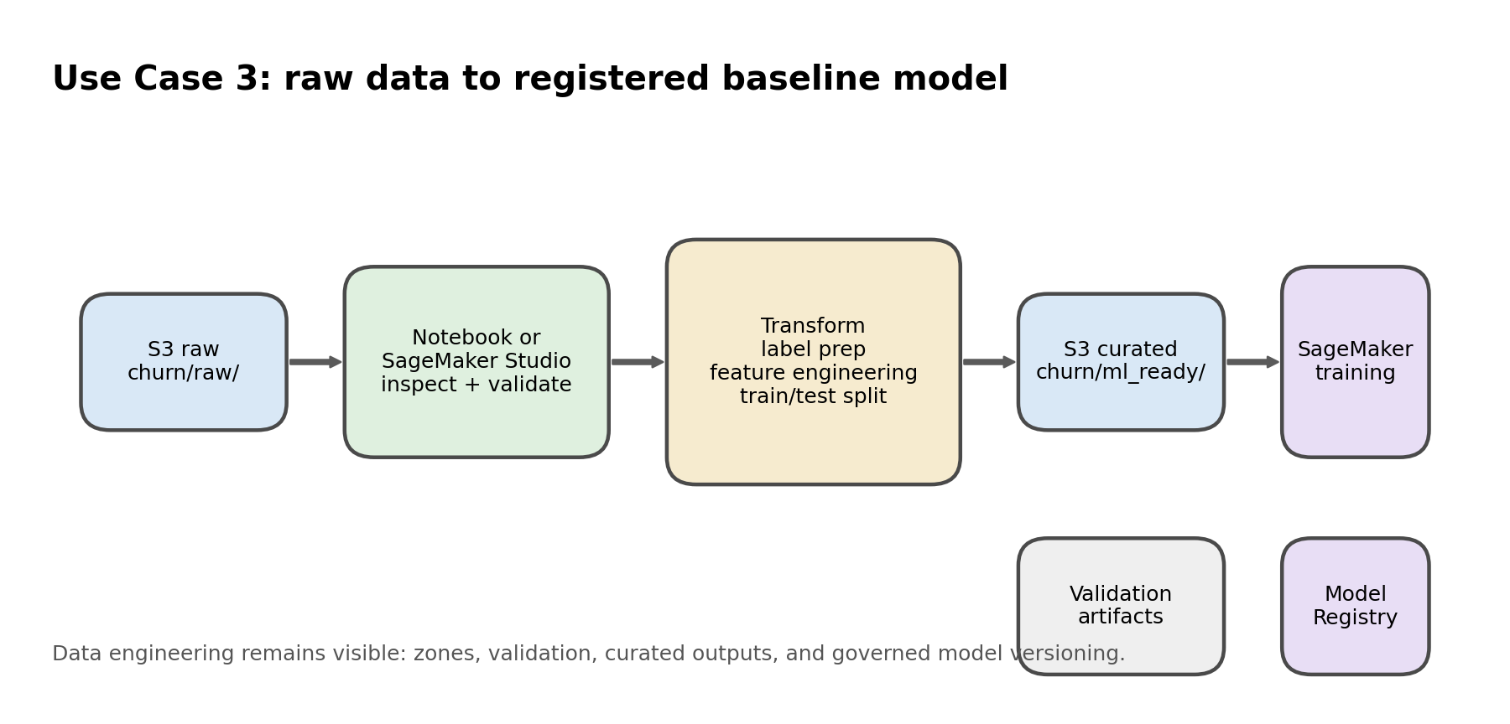
Use Case 3 reframed as an ETL-led workflow.
Expected outputs
Output | Where it lands | Why it matters
train.csv / test.csv | S3 curated or local 04_Datasets/ml_ready/ | Reusable ML-ready datasets
validation_summary.csv | Artifacts folder | Demonstrates ETL validation discipline
evaluation_summary.json | Artifacts folder | Summarizes test metrics for review
model_registry_manifest.json | Artifacts folder | Explains approval and traceability narrative
Presenter workaround: If a managed training job would take too long, train locally in the notebook but still explain the SageMaker training and Model Registry path using the provided manifest.

Productionization discussion
- Move notebook transforms into AWS Glue PySpark for repeatable ETL.
- Use EventBridge or Step Functions later if the client wants orchestration.
- Use CloudWatch to monitor Glue and SageMaker jobs in a production architecture.

