Use Case 4 Learner Guide
ETL for monitoring, bias review, and controlled lifecycle decisions

1-hour structure: Use the deck for 10 to 15 minutes, then spend the remaining time in S3 and the notebook showing baseline creation, incoming batch comparison, and lifecycle decisions.

What learners should understand
- Monitoring is another ETL workflow: a new batch arrives, gets profiled, gets compared, and produces review outputs.
- Bias or explainability checks are part of responsible data and model operations.
- Monitoring artifacts belong in managed storage, just like curated data artifacts.
- The lifecycle decision ladder depends on evidence gathered from baseline and incoming data.
AWS services in scope
Service | Why it appears | Where learners see it | ETL role
Amazon S3 | Stores baseline and future scoring datasets plus monitoring outputs | Baseline and monitoring prefixes | Landing, profile outputs, audit trail
Jupyter / SageMaker Notebook | Compares incoming data to baseline and explains findings | Notebook cells | Extract, profile, compare, persist findings
AWS Glue (optional bridge) | Shows how profile creation could become a repeatable batch ETL job | Code asset discussion | Production monitoring ETL
Amazon SageMaker | Supports explainability, bias review, and monitoring narrative | Service explanation and lifecycle discussion | Model review and monitoring services
Hands-on sequence
- Step 1 - Reuse the curated training baseline from Use Case 3. Explain that monitoring always starts from a known-good reference.
- Step 2 - Build or load the baseline profile. Emphasize that the profile is a stored artifact, not just notebook output.
- Step 3 - Show a new incoming scoring batch in S3. Position it as another batch landing zone in the data pipeline.
- Step 4 - Compare incoming data against the baseline. Talk through mean shift, category shift, and null-rate shift.
- Step 5 - Review grouped churn behaviour by segment and connect that conversation to SageMaker Clarify style checks.
- Step 6 - Use the decision ladder to explain retain, review, retrain, or rollback actions.
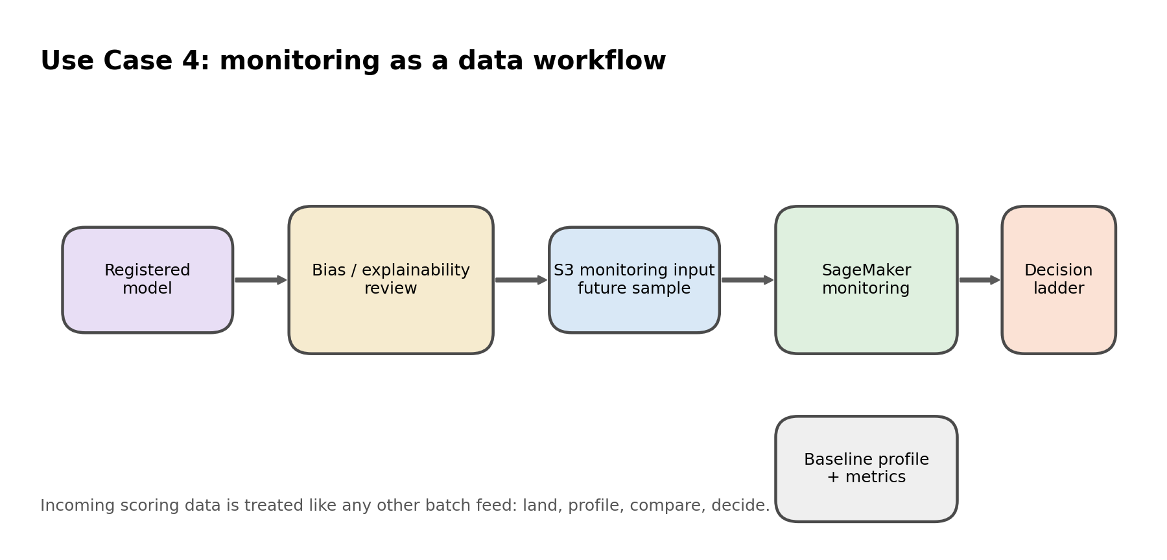
Use Case 4 reframed as a monitoring data workflow.
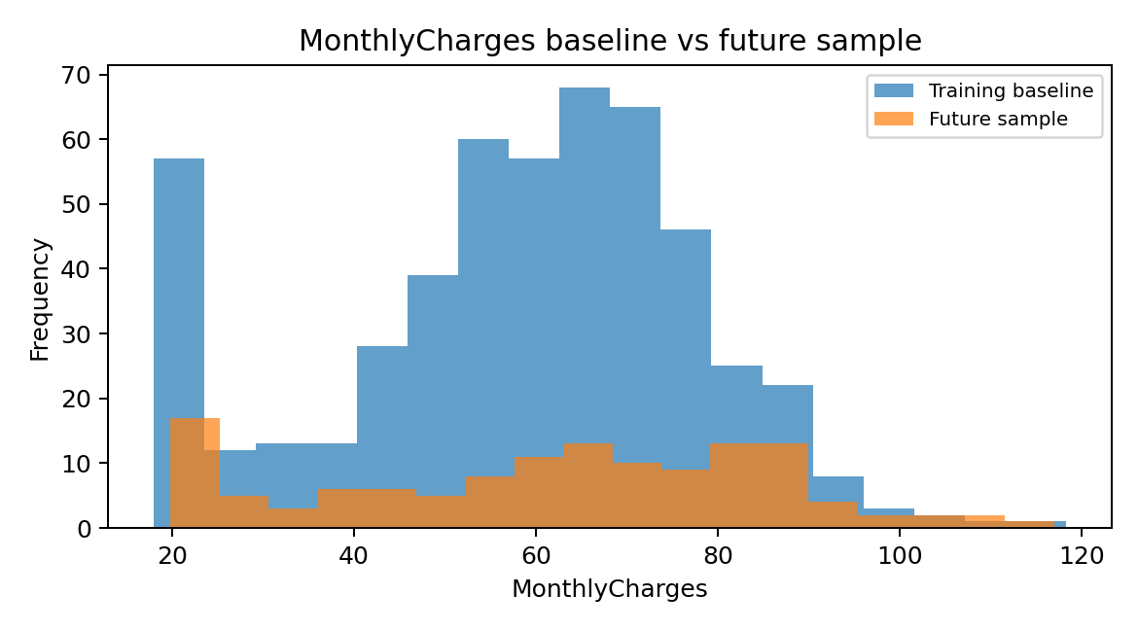
Example visual used to explain baseline vs incoming shift.
Expected outputs
Output | Where it lands | Why it matters
baseline_profile.csv | Monitoring dataset folder | Reference profile for future comparisons
drift_findings.csv | Artifacts folder | Evidence for monitoring review
segment_churn_summary.csv | Artifacts folder | Simple fairness / explainability talking point
monitoring_decision_manifest.json | Artifacts folder | Explains lifecycle action from findings
Presenter workaround: If managed SageMaker monitoring is too heavy for the live slot, run the notebook comparison locally and describe how SageMaker Model Monitor and Clarify operationalize the same logic.

Productionization discussion
- Store incoming scoring batches in a dedicated S3 monitoring prefix.
- Create recurring profile jobs with AWS Glue or SageMaker processing.
- Use Step Functions or EventBridge later if the client wants scheduled monitoring workflows.
- Use CloudWatch alarms for unexpected data drift or job failures in a production design.

