Data_0: long data

Data_0: 长的数据

Data_1: short data

Data_1: 短的数据

Trigger of module EditDistance: rst

使用rst信号触发EditDistance模块进行计算

Result_addr is place which Data_1 started in Data_0

Result_addr显示了Data_0的开头在Data_1的哪一位

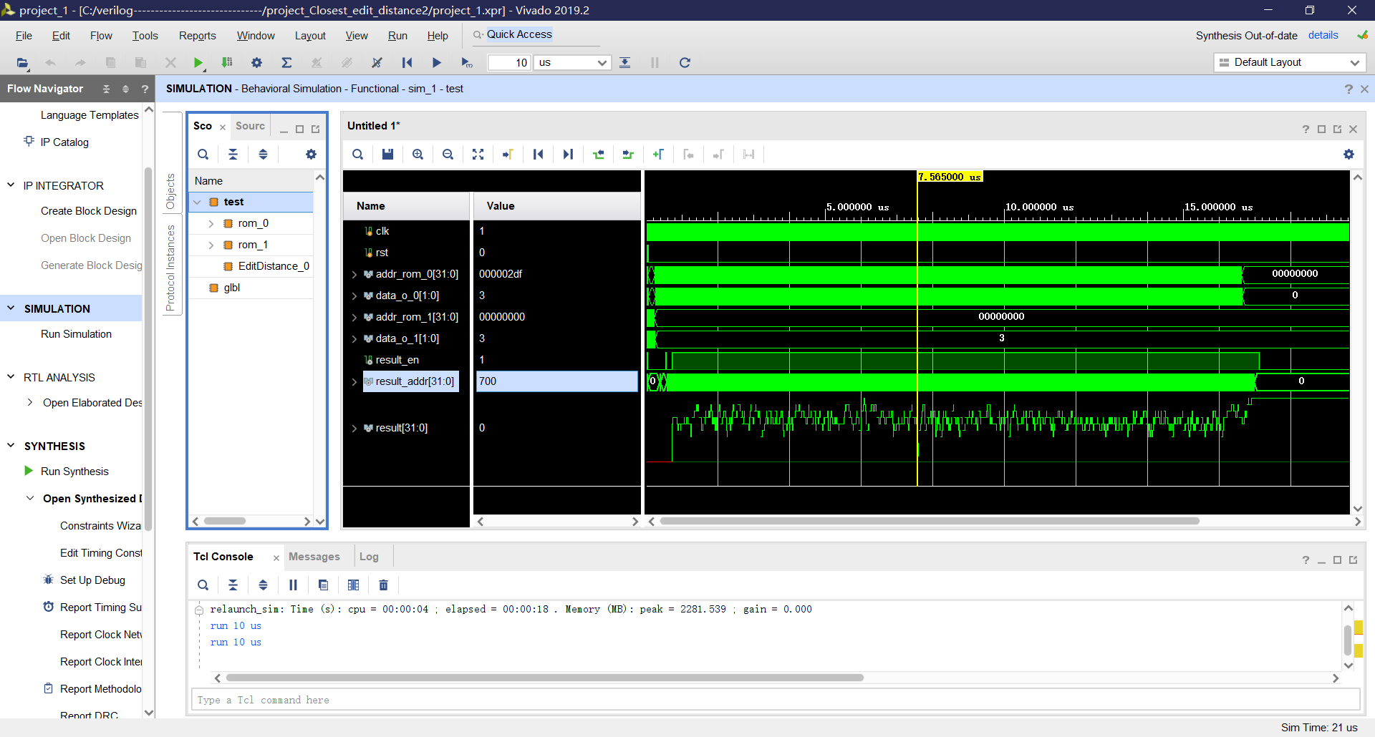

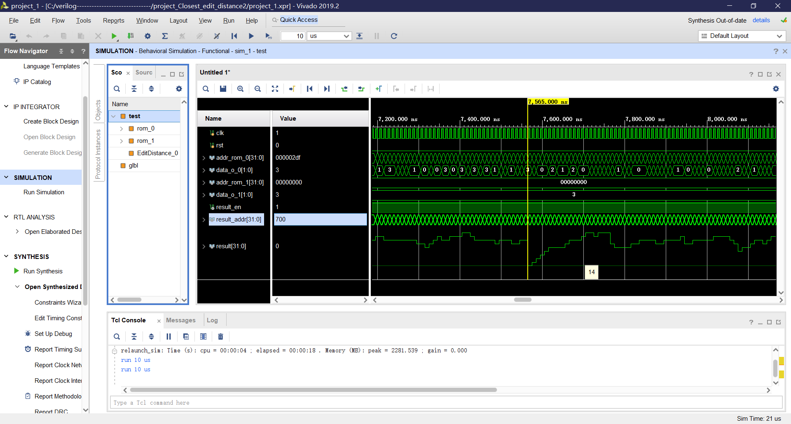

You can customize the address, data width, detection length

你可以自定义地址、数据宽度、检测长度

Resources:

资源消耗:

