Software Design Specification
for
VAKVIC
Value Analytics & Knowledge-driven Value Intelligence Core
Version 1.0
Mahindra University • Software Engineering
April 8, 2026
Prepared by
Name | Student ID | Role | Email
Amogh | SE23UCSE022 | Database | se23ucse022@mahindrauniversity.edu.in
Venkat | SE23UCSE001 | ML / DL | se23ucse001@mahindrauniversity.edu.in
Vivardhan | SE23UCSE006 | ML / DL | se23ucse006@mahindrauniversity.edu.in
Vishwanath | SE23UCSE208 | UI / UX | se23ucse208@mahindrauniversity.edu.in
Charan | SE23UCSE005 | UI / UX | se23ucse005@mahindrauniversity.edu.in
Koushik | SE23UCSE096 | Backend | se23ucse096@mahindrauniversity.edu.in

Document Information
Title | Software Design Specification — VAKVIC v1.0
Version | 1.0
Date | April 8, 2026
Prepared By | VAKVIC Team (all six members)

Version History
Ver. | Date | Revised By | Description
1.0 | 08/04/2026 | All Team Members | Initial SDS based on SRS v1.0

1 Introduction

1.1 Purpose
This Software Design Specification describes the internal design of VAKVIC v1.0. Where the SRS answered what the system should do, this document answers how it is built. It is the working reference for the six developers and the document the course evaluator will use to check the design against the requirements.

1.2 Scope
Covers the design of all four VAKVIC subsystems — PostgreSQL database, ML/DL models, Express backend, React frontend — plus the yfinance ingestion job. Does not cover business case, schedule, or test cases (the Test Plan is a separate deliverable due April 20).

1.3 Definitions, Acronyms, and Abbreviations
Most terms are defined in SRS Section 1.4. Additions specific to the design layer:
Term | Definition
DAL | Data Access Layer — helper functions that wrap all SQL
DTO | Data Transfer Object — JSON shape crossing the API boundary
MVO | Markowitz Mean-Variance Optimization
JWT | JSON Web Token — used for stateless authentication

1.4 References
- VAKVIC Software Requirements Specification v1.0, 9 March 2026
- IEEE Std 1016-2009 — Recommended Practice for Software Design Descriptions
- PostgreSQL 16, Express.js, TensorFlow/Keras, scikit-learn, node-pg-migrate, yfinance — official documentation

2 Use Case View
The SRS defines three use cases. Two of them — Compare Assets and Generate Portfolio Recommendation — drive most of the design because they touch every subsystem. Manage Watchlist is a simpler flow reused from the same building blocks.

2.1 Use Cases
Full descriptions are in SRS Section 3.3. Summaries:
- UC1 Compare Assets — User picks 2+ assets; backend pulls metrics from asset_metrics, normalizes them to 0–100, persists the comparison, returns JSON; frontend renders a radar chart and metric table.
- UC2 Generate Portfolio — User submits capital, risk tolerance, time horizon; backend validates, calls the Markowitz optimizer, persists results, returns the allocation; frontend renders a pie chart and INR breakdown.
- UC3 Manage Watchlist — User adds or removes an asset; backend checks JWT, calls the DAL helper, returns the updated list. Duplicates are caught by a unique constraint.
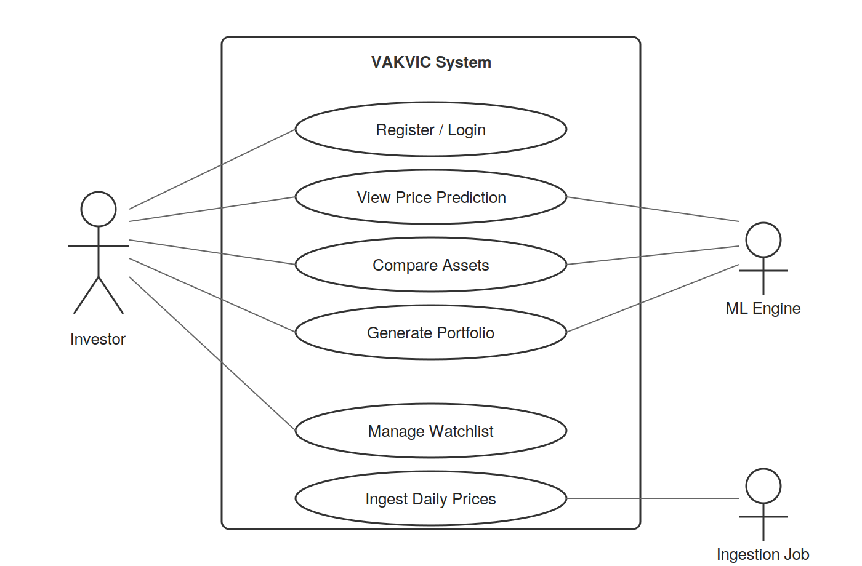
Figure 1 — Use Case Diagram. Investor drives the user-facing flows; the ML Engine and Ingestion Job are supporting actors.

3 Design Overview
VAKVIC is a four-tier web application. The browser talks to a React SPA, which talks to an Express REST API, which talks to PostgreSQL through a thin data access layer and to a Python ML service through a small HTTP shim. A separate scheduled Python job uses yfinance to keep the database fresh.
Four design choices shape almost everything that follows. No caller writes raw SQL — every read and write goes through the DAL. Schema changes go through node-pg-migrate with up and down scripts. ML models are trained offline and loaded at startup, not retrained per request. All monetary values use DECIMAL(15,4) to avoid floating-point drift.

3.1 Design Goals and Constraints
- Database: PostgreSQL 16 only, schema versioned via node-pg-migrate.
- Backend: Node.js + Express, all routes under /api/v1/, JSON in and out.
- ML stack: TensorFlow/Keras for LSTM, scikit-learn for scoring and Markowitz.
- Frontend: React.js SPA, dark terminal-finance theme, already prototyped in VAKVIC.jsx.
- Currency and universe: INR throughout, NIFTY 50 plus a small set of NSE-listed ETFs (~60 instruments).
- Team: Six members, 9-week sprint. Integration risk is the biggest constraint, hence the strict helper-function rule.

3.2 Design Assumptions
- Yahoo Finance stays available throughout the project window.
- LSTM models are trained offline; runtime never trains.
- Concurrent users stay below 50 in the evaluation environment.
- Database, backend, and ML service all run on the same Linux host during development.

3.3 Significant Design Packages
Five top-level packages, each with one or two owners and a clear responsibility.
Package | Owner | Responsibility
vakvic.frontend | Vishwanath, Charan | React SPA: Dashboard, Compare, Portfolio, Watchlist, Auth.
vakvic.backend.api | Koushik | Express REST controllers, JWT auth, validation.
vakvic.backend.dal | Amogh + Koushik | Helper functions wrapping every database operation.
vakvic.ml | Venkat, Vivardhan | LSTM inference, suitability scoring, Markowitz optimizer.
vakvic.ingestion | Amogh | Daily yfinance fetch with retry/backoff.
Dependencies flow strictly downward: frontend → backend.api → (dal, ml). The DAL and ML service do not call each other.

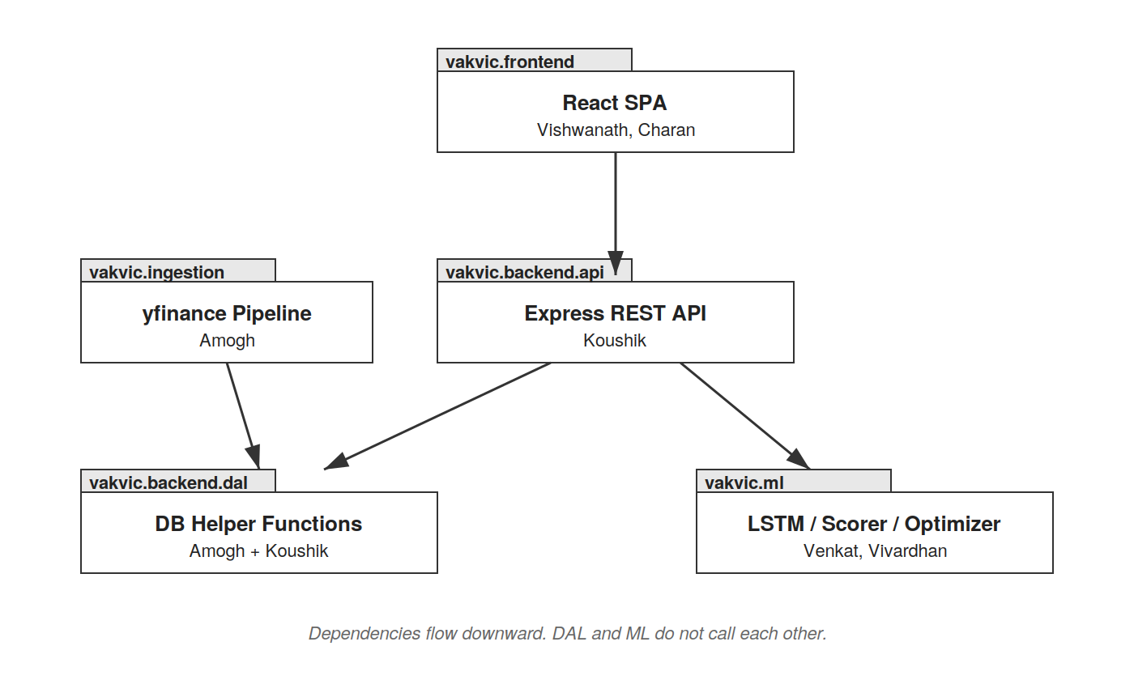
Figure 2 — Package Diagram. Dependencies flow strictly downward; the DAL and ML service do not call each other.

3.4 Dependent External Interfaces
External Interface | Module Using It | Functionality
yfinance (Python) | vakvic.ingestion | Fetches daily OHLCV history for each ticker.
TensorFlow/Keras | vakvic.ml.predictor | Loads pre-trained LSTM models and runs inference.
scikit-learn / cvxpy | vakvic.ml | Statistical primitives and Markowitz solver.
pg driver / psycopg2 | dal / ml / ingestion | All database I/O, accessed through helper functions only.
bcrypt + jsonwebtoken | backend.api.auth | Password hashing and JWT issuance/verification.

3.5 Implemented Application External Interfaces
In v1.0 the only external consumer is the React frontend; there are no third-party API clients.
Interface | Module | Description
REST API /api/v1/* | vakvic.backend.api | JSON over HTTPS, JWT-protected for user-specific routes.
Health check /health | vakvic.backend.api | Returns 200 with build version and DB connectivity.

4 Logical View

4.1 Design Model
Each package decomposes into a small set of modules. The frontend has the App router plus an AuthContext and one component per page (Dashboard, Compare, Portfolio, Watchlist), backed by reusable widgets (RadarChart, ScoreRing, TickerBar) defined inline in the prototype today.
The backend.api package has one route file per resource (assets, predictions, compare, portfolio, watchlist, auth), an auth middleware that verifies JWTs, and a validate middleware that rejects bad input at the edge. The DAL exposes one helper function per database operation, named after what it does rather than what table it touches — getAllAssets, getLatestPrediction, savePortfolio, addToWatchlist, and so on. A parallel Python module (vakvic.ml.db_helpers) exposes the same operations to the ML service and ingestion job.
The ML package has three working modules — predictor.py loads pre-trained Keras models and runs inference, scorer.py computes suitability metrics, optimizer.py runs Markowitz with cvxpy — plus a small Flask shim (service.py) that exposes them to the backend over localhost HTTP. The ingestion job is two files: fetch.py (yfinance wrapper) and pipeline.py (orchestration with retry/backoff), scheduled via cron after market close.
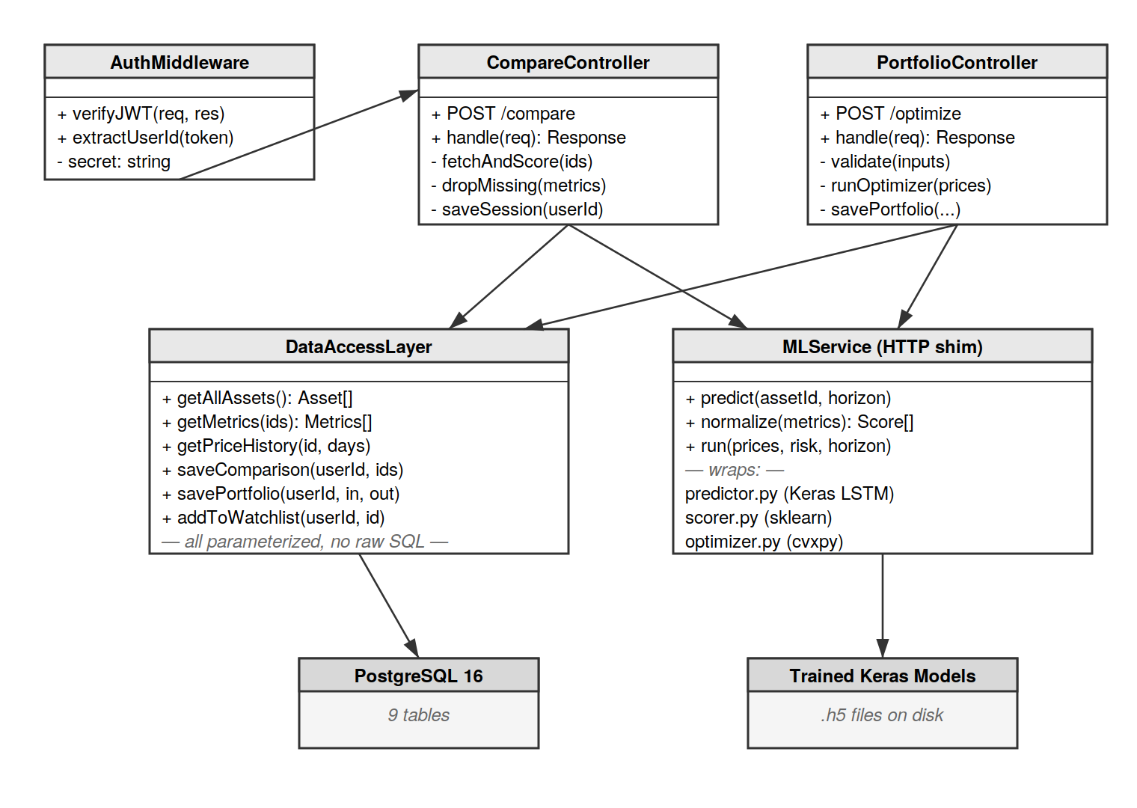
Figure 3 — Class Diagram. Backend controllers call into the DAL and the MLService; the DAL is the only path to PostgreSQL.

4.2 Use Case Realization
UC1 Compare Assets:
ComparePage POSTs to /api/v1/compare with the asset IDs and the JWT. The auth middleware verifies the token, the controller calls dal.getMetrics() for the requested assets, drops any with missing data into a warnings list, asks scorer.normalize() to convert raw metrics to 0–100 scores, persists the session via dal.saveComparison(), and responds with the assets, scores, and warnings. The frontend then renders the radar chart and metric table.
UC2 Generate Portfolio Recommendation:
PortfolioOptimizer POSTs to /api/v1/portfolio/optimize after validating capital > 0 client-side. The controller calls dal.getAllAssets() and dal.getPriceHistory(), passes everything to optimizer.run() on the ML service, which builds the covariance matrix, picks the objective based on risk tolerance (Low → minimum variance, Medium → maximum Sharpe, High → maximum return), solves with cvxpy, and returns weights plus expected return and volatility. The controller wraps the persistence in a transaction so portfolios and portfolio_assets stay consistent, then responds with the full payload.
UC3 Manage Watchlist:
POST /api/v1/watchlist with an asset_id. Auth middleware extracts user_id, the controller calls dal.addToWatchlist(), the DAL runs INSERT ... ON CONFLICT DO NOTHING and reports back whether anything was inserted. Duplicates return 200 with { added: false } so the UI can show a toast; new entries return 201 with the updated list.
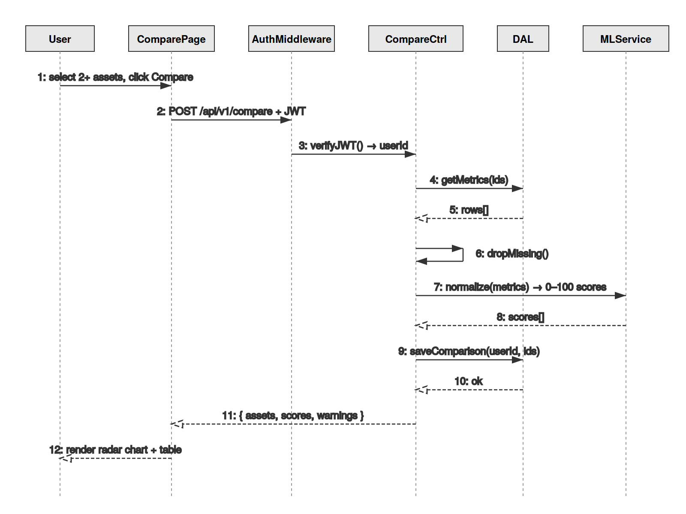
Figure 4 — Sequence Diagram for UC1 Compare Assets.

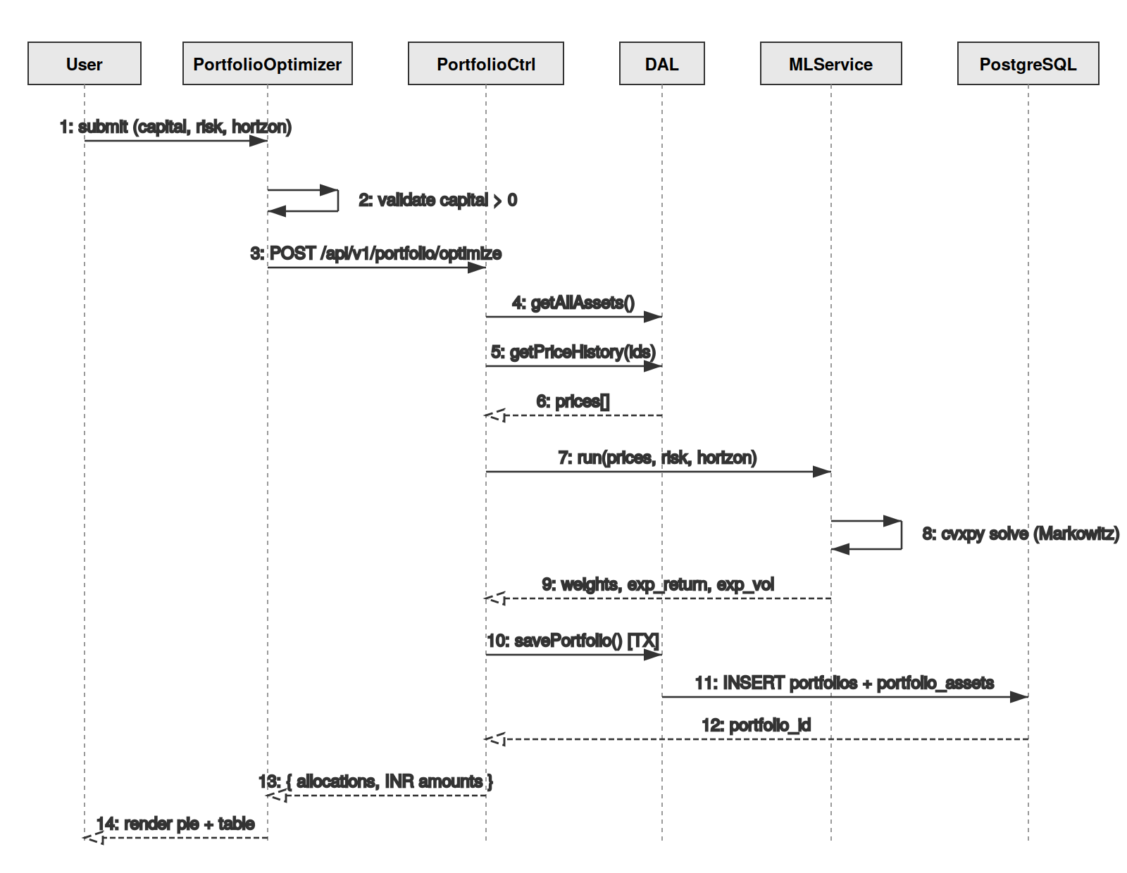
Figure 5 — Sequence Diagram for UC2 Generate Portfolio Recommendation.

5 Data View

5.1 Domain Model
Six core entities. An Asset has many AssetPrices, many Predictions, and one current AssetMetrics row. A User has many WatchlistEntries, Portfolios, and AssetComparisons. A Portfolio has many PortfolioAssets, each linking back to an Asset with a percentage and an INR amount.

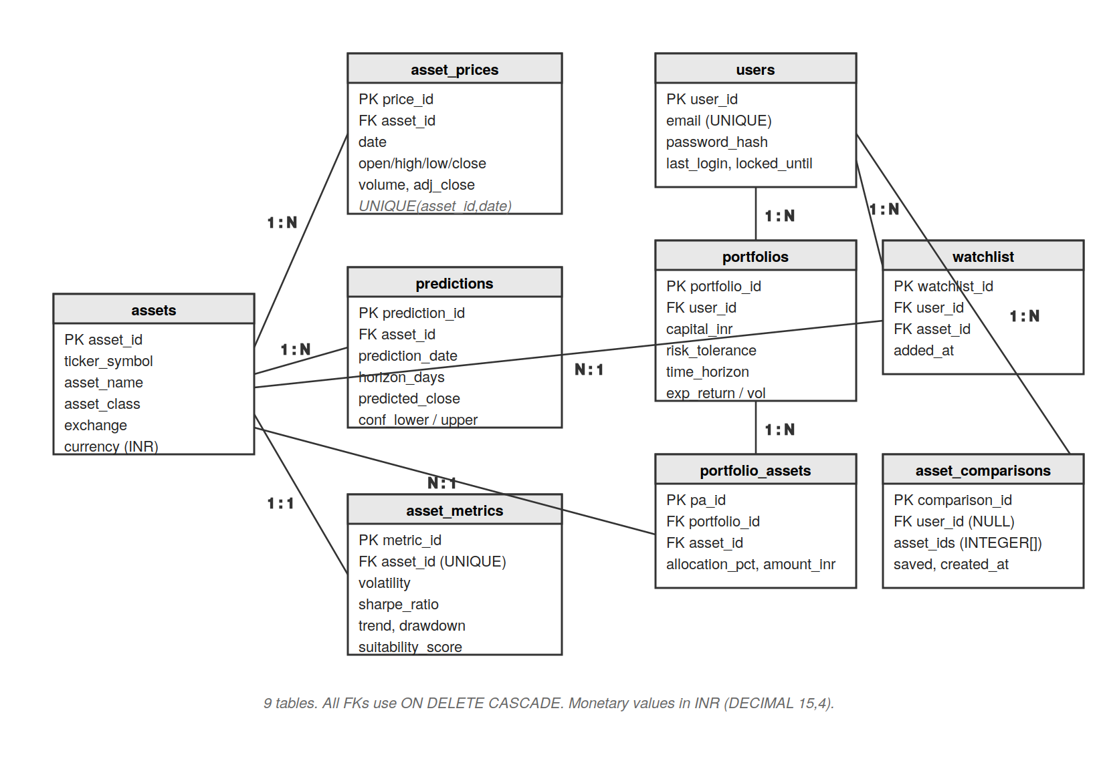
Figure 6 — Entity-Relationship Diagram. All foreign keys use ON DELETE CASCADE; monetary values are stored in INR as DECIMAL(15,4).

5.2 Data Model
Nine PostgreSQL 16 tables. Full DDL lives in /db/migrations/. Monetary values are DECIMAL(15,4), timestamps are TIMESTAMP WITH TIME ZONE in UTC, and primary keys are SERIAL throughout. Full column-by-column documentation is in SRS Appendix A; the table below summarizes each table's purpose and the integrity constraints worth knowing about for the design.
Table | Purpose and key constraints
assets | Master registry. UNIQUE(ticker_symbol). asset_class enumerated.
asset_prices | Daily OHLCV. UNIQUE(asset_id, date). Index on (asset_id, date DESC) for fast latest-N reads.
predictions | LSTM outputs with confidence interval, horizon, and model_version.
asset_metrics | Current metrics per asset. UNIQUE(asset_id) — one row per asset, latest values only.
asset_comparisons | Saved comparison sessions. user_id nullable for anonymous sessions.
portfolios | Optimizer runs. Stores capital, risk, horizon, and computed return/volatility.
portfolio_assets | Per-asset allocations. ON DELETE CASCADE from portfolios.
users | Email + bcrypt password_hash + lockout fields.
watchlist | UNIQUE(user_id, asset_id) — relied on by addToWatchlist.

6 Exception Handling
Errors fall into four buckets, each with its own handling pattern.
- Validation errors (400) — Caught by validate middleware before the controller. Returned as { error, field, message }. Logged at info level.
- Auth errors (401/403) — Missing or expired JWT → 401. Accessing another user's resource → 403. Logged at warn level with user_id and route.
- Database errors (500) — DAL helpers wrap queries in try/catch and rethrow as DalError. Controllers translate to 500 with { error: 'internal' } — never raw SQL. UNIQUE violations on watchlist are special-cased to the duplicate path.
- ML service errors (503/500) — Service unreachable → 503 and a friendly retry message. Bad input or missing weights → 500 and the Python traceback is logged.
The yfinance ingestion job runs offline and never surfaces errors to users. Each per-asset fetch retries up to 3 times with 30s / 2min / 5min backoff; after the third failure the asset is logged with { asset_id, ticker, error_type, timestamp } and the pipeline moves on.

7 Configurable Parameters
All configuration is read from environment variables at startup. None are dynamic — changes require a restart.
Parameter | Definition and Usage | Dynamic?
DB_HOST / DB_PORT / DB_NAME / DB_USER / DB_PASSWORD | PostgreSQL connection settings. | No
JWT_SECRET, JWT_EXPIRY | Token signing key and lifetime (default 24h). | No
BCRYPT_ROUNDS | Password hashing work factor (default 12). | No
ML_SERVICE_URL | Localhost URL of the Python ML service. | No
PREDICTION_STALENESS_HOURS | How old a cached prediction can be before recalculation (default 24). | No
RISK_FREE_RATE | Used by Sharpe ratio (default 0.065 for INR). | No
LOG_LEVEL, NODE_ENV | Logging verbosity and runtime environment. | No

8 Quality of Service

8.1 Availability
VAKVIC v1.0 is evaluated in a development environment, so there is no formal uptime SLA. The design still avoids obvious downtime traps: the ingestion job runs out-of-process so it cannot block the API, and the ML service runs as a separate process so a model crash does not take down the backend. The /health endpoint exists for ops checks.

8.2 Security and Authorization
Three layers, all per the SRS:
- Passwords are bcrypt-hashed with work factor ≥ 12. Plaintext is never logged or persisted.
- All user-specific routes require a valid JWT, expiring after 24 hours. The auth middleware is the single chokepoint.
- Every DAL helper uses parameterized queries. SQL injection is impossible by construction, not by vigilance.
There is no role-based access control in v1.0 — every authenticated user has the same permissions and can only see their own rows.

8.3 Load and Performance Implications
The SRS budget is 2s for cached responses, 5s for LSTM inference, 3s for the dashboard, up to 50 concurrent users. Predictions and metrics are precomputed and cached, so the hot path for /compare and /predictions is a single indexed read. The pg connection pool is sized to 10. LSTM models are loaded once at ML service startup, so per-request inference is just a forward pass on a 60-day window. Database growth is trivial: ~60 assets × 252 trading days × 5 years ≈ 75k rows in asset_prices.

8.4 Monitoring and Control
Three observable signals:
- /health endpoint with build version, database ping, and ML service ping.
- Structured JSON logs for every request: timestamp, request_id, route, status, duration_ms, user_id.
- Per-run ingestion summary: assets attempted, succeeded, failed, with error types for each failure.

