Transit Equity in Salt Lake County
  - A GIS-Based 2-Step Floating Catchment Area Accessibility Analysis of UTA-TRAX
Faria Afrin Zinia
Pukar Bhandari
Justice Prosper Tuffour
Andy Hong
May 4, 2022
Abstract
Public transit systems are foundational infrastructure for urban mobility, yet their spatial distribution often reflects — and sometimes reinforces — existing socioeconomic disparities. This study employs a Cross-Sectional research design to evaluate the construct of geospatial accessibility and social equity in the UTA-TRAX light rail system within Salt Lake County, Utah. Using ACS 5-year (2015–2019) data stratified at the Census Block Group (CBG) level, we define eight social equity indicators — household income, race, ethnicity, age, employment, education, vehicle ownership, and housing tenure — and calculate a 2-Step Floating Catchment Area (2SFCA) accessibility score based on 20-minute isochrone walking catchments from OpenRouteService. Spatial autocorrelation (Moran’s I) reveals significant clustering of accessibility around downtown Salt Lake City and Draper. Spatial Lag and Spatial Error autoregressive models demonstrate that the percentage of car-free households is the only equity variable with a statistically significant positive relationship with TRAX accessibility, suggesting that the system partially — but incompletely — serves transit-dependent populations.
Table of contents

library(tidyverse)
library(tidycensus)
library(sf)
library(tigris)
library(openrouteservice) # ORS isochrones (GitHub: GIScience/openrouteservice-r)
library(mapgl) # Interactive MapLibre GL maps (HTML output)
library(classInt) # Jenks breaks for map classification
library(ggpubr)
library(scales)
library(ggspatial) # annotation_scale / annotation_north_arrow
library(spdep)
library(spatialreg)
library(gtsummary)
library(gt)
library(broom)
library(knitr)
library(glue)
options(tigris_use_cache = TRUE)

1. Introduction
Public transit systems are often described as the foundational blood veins of a city — the infrastructure upon which education, healthcare, housing, and employment opportunities depend. The overarching goal of a transit network is to increase accessibility: the ability of people to reach the destinations that matter to their daily lives. Yet transit investment does not always accrue equally to all segments of the population.
The UTA-TRAX is an electric-powered light rail system serving the Salt Lake Valley of Utah. Operating on four major lines — the Blue, Red, Green, and S-Line — the network spans approximately 44.8 miles (72.1 km) with an annual ridership of about 19.7 million boardings. Despite this extensive reach, the critical question remains: does UTA-TRAX adequately serve the county’s most socially vulnerable residents?
This study directly addresses that question. Our central research question is:
“Does UTA-TRAX moderate social equity in Salt Lake County?”
We establish the following hypotheses:
- H₀ (Null): Transit accessibility does not address equity by impacting social minorities.
- H₁ (Alternative): Transit accessibility addresses equity by impacting social minorities.
The study is contextualized within Salt Lake County and employs a 2-Step Floating Catchment Area (2SFCA) accessibility method to spatially quantify the relationship between TRAX station accessibility and eight social equity indicators derived from the American Community Survey (ACS). This report is the companion analytic document to the paper published in the Transportation Research Record (DOI: 10.1177/03611981231170005).

1.1 Research Rationale
Cities across the United States are pursuing Mass Rapid Transit (MRT) and Transit-Oriented Development (TOD) strategies to combat traffic congestion, housing unaffordability, air pollution, and urban sprawl. Salt Lake County and the Wasatch Front Regional Council are similarly pursuing a polycentric development pattern anchored by the TRAX network.
Despite these transit-focused agendas, the Civil Rights Act of 1964, Title VI, prohibits federally funded transit providers from administering programs in ways that discriminate based on race, color, or national origin. There are legitimate public interest concerns about whether transit expansion genuinely serves minority and low-income communities, or whether it displaces them through gentrification. Empirically identifying and quantifying accessibility gaps for vulnerable groups is therefore essential for evidence-based, equitable planning.

2. Setup

2.1 API Configuration
This analysis requires two API keys:
- U.S. Census Bureau API — for tidycensus data retrieval. Register at api.census.gov.
- OpenRouteService (ORS) API — for isochrone generation. Register at openrouteservice.org.
# Register Census API Key (run once; stores in ~/.Renviron)
census_api_key("YOUR_CENSUS_API_KEY", install = TRUE, overwrite = TRUE)
readRenviron("~/.Renviron")
# Register ORS API Key
ors_api_key("YOUR_ORS_API_KEY")

2.2 Project Data Paths
All spatial intermediate files (isochrones, shapefiles) are read from and written to a local data/ folder. Adjust the path below to your local environment.
# Relative path — place all raw shapefiles in data/raw/
path_raw <- here::here("data", "raw")
path_proc <- here::here("data", "processed")
# Ensure processed directory exists
if (!dir.exists(path_proc)) dir.create(path_proc, recursive = TRUE)

3. Data Acquisition

3.1 Social Equity Variables from the American Community Survey
We use the ACS 5-year estimates (2015–2019) at the Census Block Group (CBG) level to capture demographic and socioeconomic characteristics within Salt Lake County. Block groups provide finer spatial resolution than tracts — critical for proximity-based accessibility analyses — while still providing reliable multi-year estimates.
The full variable list spans race, ethnicity, age, income, employment, education, vehicle ownership, and housing tenure. ?@tbl-variables summarizes each equity indicator and its source variable(s).
Table 1: Social equity indicators, operational definitions, and ACS variable codes.
Table 1: Social Equity Indicators and ACS Sources
# | Indicator | Operational Definition | ACS Variable(s)
1 | Household Income | % households with income < 80% of Area Median ($74,865) | B19001_002–011
2 | Race | % non-White population | B02001_003–008
3 | Ethnicity | % Hispanic or Latino population | B03003_003
4 | Age | % population aged <18 or >65 (dependent age groups) | B01001_003–006, 020–025, 027–030, 044–049
5 | Employment | % unemployed civilian labor force | B23025_004–005
6 | Education | % population ≥25 years with less than a high school diploma | B15003_002–016
7 | Vehicle Ownership | % households with no vehicle | B25044_003, 010
8 | House Ownership | % renter-occupied households | B25003_003
# ACS variable vector — all raw variables needed for indicator construction
acs_vars <- c(
# Population denominators
total_pop = "B02001_001",
total_hh = "B25003_001",
total_age = "B01001_001",
total_income = "B19001_001",
# Age: <18 (male)
age1 = "B01001_003", age2 = "B01001_004",
age3 = "B01001_005", age4 = "B01001_006",
# Age: >65 (male)
age5 = "B01001_020", age6 = "B01001_021",
age7 = "B01001_022", age8 = "B01001_023",
age9 = "B01001_024", age10 = "B01001_025",
# Age: <18 (female)
age11 = "B01001_027", age12 = "B01001_028",
age13 = "B01001_029", age14 = "B01001_030",
# Age: >65 (female)
age15 = "B01001_044", age16 = "B01001_045",
age17 = "B01001_046", age18 = "B01001_047",
age19 = "B01001_048", age20 = "B01001_049",
# Income: below $59,999 (proxy for <80% AMI @ $74,865)
Inc1 = "B19001_002", Inc2 = "B19001_003",
Inc3 = "B19001_004", Inc4 = "B19001_005",
Inc5 = "B19001_006", Inc6 = "B19001_007",
Inc7 = "B19001_008", Inc8 = "B19001_009",
Inc9 = "B19001_010", Inc10 = "B19001_011",
# Race
pop_white = "B02001_002", pop_black = "B02001_003",
pop_ameind = "B02001_004", pop_asian = "B02001_005",
pop_native = "B02001_006", pop_others = "B02001_007",
pop_2races = "B02001_008",
# Ethnicity
pop_nonhisp = "B03003_002",
pop_hispanic = "B03003_003",
# Vehicle ownership
own_novehicle = "B25044_003", # Owner-occupied, no vehicle
rent_novehicle = "B25044_010", # Renter-occupied, no vehicle
# Education (no diploma, 25+ yrs)
pop_educ1 = "B15003_002", pop_educ2 = "B15003_003",
pop_educ3 = "B15003_004", pop_educ4 = "B15003_005",
pop_educ5 = "B15003_006", pop_educ6 = "B15003_007",
pop_educ7 = "B15003_008", pop_educ8 = "B15003_009",
pop_educ9 = "B15003_010", pop_educ10 = "B15003_011",
pop_educ11 = "B15003_012", pop_educ12 = "B15003_013",
pop_educ13 = "B15003_014", pop_educ14 = "B15003_015",
pop_educ15 = "B15003_016",
# Employment
pop_employ = "B23025_004", # Employed civilian labor force
pop_unemp = "B23025_005", # Unemployed civilian labor force
# Housing tenure
hh_owner = "B25003_002",
hh_renter = "B25003_003"
)
slco_blockgrp <- get_acs(
year = 2019,
survey = "acs5",
geography = "block group",
state = "UT",
county = "Salt Lake",
variables = acs_vars,
output = "wide",
geometry = TRUE
) |>
st_transform(3566) # Utah Central State Plane (NAD83 / ft)

3.2 TRAX Station and Line Shapefiles
TRAX station point data and line shapefiles are sourced from the Utah Geospatial Resource Center (UGRC) and projected to the same coordinate reference system (EPSG 3566).
trax_stn <- st_read(file.path(path_raw, "LightRailStations_UTA_3566.shp"), quiet = TRUE)
trax_line <- st_read(file.path(path_raw, "LightRail_UTA_3566.shp"), quiet = TRUE)
glue("TRAX Stations loaded: {nrow(trax_stn)} | CRS: {st_crs(trax_stn)$epsg}")
#> TRAX Stations loaded: 57 | CRS: 3566

4. Equity Indicator Construction
Each social equity indicator is expressed as a percentage of the relevant population or household denominator within each block group. This normalization allows meaningful comparisons across block groups of varying size.
Note on Indicator 5 (Employment): The original script contained an operator-precedence error in the unemployment rate formula. The corrected formula uses explicit parentheses: pop_unemp / (pop_employ + pop_unemp).
slco_blockgrp <- slco_blockgrp |>
mutate(
# 1. Age: % of population in dependent age groups (<18 or >65)
p_Age = (
(age1E + age2E + age3E + age4E + # Male <18
age5E + age6E + age7E + age8E + # Male 65–79
age9E + age10E + # Male 80+
age11E + age12E + age13E + age14E + # Female <18
age15E + age16E + age17E + age18E + # Female 65–79
age19E + age20E) / total_ageE # Female 80+
) * 100,
# 2. Income: % of households earning below 80% of SLCo AMI ($74,865)
# Brackets $0–$59,999 used as proxy (ACS top-codes income groups)
p_Income = (
(Inc1E + Inc2E + Inc3E + Inc4E + Inc5E +
Inc6E + Inc7E + Inc8E + Inc9E + Inc10E) / total_incomeE
) * 100,
# 3. Race: % non-White population
p_Race = (
(pop_blackE + pop_ameindE + pop_asianE +
pop_nativeE + pop_othersE + pop_2racesE) / total_popE
) * 100,
# 4. Ethnicity: % Hispanic or Latino population
p_Ethnicity = (pop_hispanicE / total_popE) * 100,
# 5. Employment: % unemployed of total civilian labor force (CORRECTED)
p_Employment = (
pop_unempE / (pop_employE + pop_unempE)
) * 100,
# 6. Education: % aged 25+ without a high school diploma
p_Education = (
(pop_educ1E + pop_educ2E + pop_educ3E + pop_educ4E + pop_educ5E +
pop_educ6E + pop_educ7E + pop_educ8E + pop_educ9E + pop_educ10E +
pop_educ11E + pop_educ12E + pop_educ13E + pop_educ14E + pop_educ15E) /
total_popE
) * 100,
# 7. Vehicle Ownership: % households with no vehicle (owners + renters)
p_VOwnership = (
(own_novehicleE + rent_novehicleE) / total_hhE
) * 100,
# 8. House Ownership: % renter-occupied households
p_HMOwnership = (hh_renterE / total_hhE) * 100
)

4.1 Summary of Equity Indicators
slco_blockgrp |>
st_drop_geometry() |>
select(
`Age (Dependent)` = p_Age,
`Income (<80% AMI)` = p_Income,
`Race (Non-White)` = p_Race,
`Ethnicity (Hispanic)` = p_Ethnicity,
`Employment (Unemployed)`= p_Employment,
`Education (No HS Dipl)` = p_Education,
`Vehicle-Free HH` = p_VOwnership,
`Renter-Occupied HH` = p_HMOwnership
) |>
tbl_summary(
statistic = list(all_continuous() ~ "{mean} ({sd}) [{min}–{max}]"),
digits = all_continuous() ~ 1,
label = list(
`Age (Dependent)` ~ "Age: Dependent (<18 or >65) (%)",
`Income (<80% AMI)` ~ "Household Income: <80% AMI (%)",
`Race (Non-White)` ~ "Race: Non-White (%)",
`Ethnicity (Hispanic)` ~ "Ethnicity: Hispanic/Latino (%)",
`Employment (Unemployed)` ~ "Employment: Unemployed (%)",
`Education (No HS Dipl)` ~ "Education: No HS Diploma (%)",
`Vehicle-Free HH` ~ "Vehicle Ownership: No Vehicle (%)",
`Renter-Occupied HH` ~ "Housing: Renter-Occupied (%)"
),
missing = "no"
) |>
bold_labels() |>
modify_caption("**Descriptive Statistics — Social Equity Indicators**") |>
as_gt()
Table 2: Descriptive statistics for the eight social equity indicators across Salt Lake County block groups.
Characteristic | N = 612¹
Age: Dependent (<18 or >65) (%) | 37.1 (8.9) [4.0–61.3]
Household Income: <80% AMI (%) | 39.4 (19.1) [0.0–89.0]
Race: Non-White (%) | 20.1 (16.6) [0.0–86.6]
Ethnicity: Hispanic/Latino (%) | 17.8 (16.8) [0.0–81.7]
Employment: Unemployed (%) | 3.7 (3.4) [0.0–21.2]
Education: No HS Diploma (%) | 6.0 (5.9) [0.0–38.2]
Vehicle Ownership: No Vehicle (%) | 4.9 (6.9) [0.0–50.2]
Housing: Renter-Occupied (%) | 31.2 (25.4) [0.0–100.0]
¹Mean (SD) [Min–Max]

5. Supply and Demand: TRAX Catchment Isochrones

5.1 Methodology: Two-Step Floating Catchment Area (2SFCA)
The 2SFCA method quantifies spatial accessibility by combining supply (transit service capacity) and demand (population) within a shared catchment zone. The method proceeds in two steps:
Step 1 — Supply Ratio: For each TRAX station j, define a supply catchment as the 20-minute pedestrian isochrone. Sum the population of all block group centroids falling within that isochrone. Compute the supply ratio as:
Rj=Sjk∈{dkj≤d0}​Pk
where $S_{j}$ is the service capacity of station $j$ (average riders × seating capacity) and $P_{k}$ is the population of block group $k$.
Step 2 — Demand (Accessibility) Score: For each block group centroid i, define a demand catchment as the 20-minute pedestrian isochrone. Sum the supply ratios of all TRAX stations falling within that catchment:
Ai=j∈{dij≤d0}​Rj
Higher values of $A_{i}$ indicate greater transit accessibility.

5.2 Step 1: TRAX Station Isochrones (Supply Catchments)
TRAX station isochrones (20-minute foot-walking, 57 stations) are stored in data/processed/trax_iso.shp and loaded directly from disk. The ORS fallback only runs if the file is missing.
trax_iso_path <- file.path(path_proc, "trax_iso.shp")
if (file.exists(trax_iso_path)) {
trax_iso <- st_read(trax_iso_path, quiet = TRUE)
message(glue("trax_iso loaded from disk ({nrow(trax_iso)} features)."))
} else {
message("trax_iso.shp not found — running ORS API fallback.")
trax_coords <- trax_stn |>
st_transform(4326) |>
st_coordinates()
output_trax <- tibble()
for (i in seq_len(nrow(trax_coords))) {
cat(glue(" → Isochrone {i}/{nrow(trax_coords)}: {trax_stn$STATIONNAM[i]}\n"))
res <- ors_isochrones(
locations = trax_coords[i, ],
range = 20 * 60,
profile = "foot-walking",
output = "sf"
)
Sys.sleep(2)
output_trax <- bind_rows(output_trax, res)
}
trax_iso <- output_trax |> select(-any_of("center"))
st_write(trax_iso, trax_iso_path, quiet = TRUE)
message("trax_iso computed and saved.")
}
# Attach TRAX station attributes to isochrones and reproject
trax_catchment <- trax_iso |>
mutate(
OBJECTID = trax_stn$OBJECTID,
STATIONNAM = trax_stn$STATIONNAM,
Boarding = trax_stn$Boarding,
Alighting = trax_stn$Alighting,
AvgRider = trax_stn$AvgRider,
ServCapaCT = trax_stn$ServCapaCT
) |>
st_transform(3566)
# Block group centroids — always recomputed from slco_blockgrp in memory.
# Saving centroids to .shp would truncate long ACS column names (10-char limit),
# breaking downstream summarise() calls that reference e.g. total_popE.
blockgrp_centroid <- slco_blockgrp |> st_centroid()
# Spatial join: TRAX catchment polygons ∩ block group centroids → supply ratio
supply_ratio <- st_join(trax_catchment, blockgrp_centroid, left = FALSE) |>
group_by(OBJECTID) |>
summarise(
sum_pop = sum(total_popE, na.rm = TRUE),
supply_ratio1 = first(ServCapaCT) / sum_pop, # Capacity-based
supply_ratio2 = first(AvgRider) / sum_pop # Ridership-based
) |>
st_drop_geometry()
# Attach supply ratios back to TRAX station points
trax_to_pop <- left_join(trax_stn, supply_ratio, by = "OBJECTID") |>
select(OBJECTID, STATIONNAM, supply_ratio1, supply_ratio2)

5.3 Step 2: Block Group Isochrones (Demand Catchments)
The block group isochrones were pre-computed via the OpenRouteService API (~670 walking-time polygons, 20-minute threshold) and are stored in data/processed/blockgrp_iso.shp. They are loaded directly from disk. If the file is ever missing, the fallback loop below will regenerate it — but under normal circumstances that branch never executes.
blockgrp_iso_path <- file.path(path_proc, "blockgrp_iso.shp")
if (file.exists(blockgrp_iso_path)) {
# Normal path: file already committed to data/processed/
blockgrp_iso_combined <- st_read(blockgrp_iso_path, quiet = TRUE)
message(glue("blockgrp_iso loaded from disk ({nrow(blockgrp_iso_combined)} features)."))
} else {
# Fallback: recompute via ORS API (requires a valid ORS API key).
# Runs in two batches to respect the API's per-minute rate limit.
message("blockgrp_iso.shp not found — running ORS API fallback (this takes ~30 min).")
blockgrp_coords <- blockgrp_centroid |>
st_transform(4326) |>
st_coordinates()
run_batch <- function(idx) {
out <- tibble()
for (i in idx) {
cat(glue(" → Block group isochrone {i}/{max(idx)}\n"))
res <- ors_isochrones(
locations = blockgrp_coords[i, ],
range = 20 * 60,
profile = "foot-walking",
output = "sf"
)
Sys.sleep(2)
out <- bind_rows(out, res)
}
out
}
output1 <- run_batch(seq_len(min(350, nrow(blockgrp_coords))))
output2 <- run_batch(seq(351, nrow(blockgrp_coords)))
blockgrp_iso_combined <- bind_rows(output1, output2)
st_write(blockgrp_iso_combined |> select(-any_of("center")),
blockgrp_iso_path, quiet = TRUE)
message("blockgrp_iso computed and saved.")
}

5.4 Computing the 2SFCA Accessibility Index
# Use .rds (not .shp) to preserve all long ACS column names needed for
# regression (shapefile truncates field names to 10 characters).
tsfca_path <- file.path(path_proc, "TSFCA_Network.rds")
if (!file.exists(tsfca_path)) {
# Attach block group attributes to demand catchment isochrones
pop_catchment <- blockgrp_iso_combined |>
mutate(
GEOID = blockgrp_centroid$GEOID,
total_pop = blockgrp_centroid$total_popE
) |>
st_transform(3566)
# Spatial join: demand catchment ∩ supply ratios → accessibility score
supply_demand_ratio <- st_join(pop_catchment, trax_to_pop) |>
group_by(GEOID) |>
summarise(
access1 = sum(supply_ratio1, na.rm = TRUE), # Capacity-based 2SFCA
access2 = sum(supply_ratio2, na.rm = TRUE) # Ridership-based 2SFCA
) |>
st_drop_geometry()
# Merge accessibility scores back into block group polygon layer
TSFCA_network <- left_join(slco_blockgrp, supply_demand_ratio, by = "GEOID")
saveRDS(TSFCA_network, tsfca_path)
message("2SFCA accessibility computed and saved.")
} else {
TSFCA_network <- readRDS(tsfca_path)
message("TSFCA_Network loaded from disk.")
}

6. Accessibility Mapping (2SFCA)
The 2SFCA accessibility surface reveals pronounced spatial heterogeneity across Salt Lake County. Block groups surrounding downtown Salt Lake City, Sugarhouse, and portions of West Valley City exhibit the highest accessibility scores, largely because multiple TRAX stations are clustered in proximity — increasing supply ratios and expanding the overlap of pedestrian catchments.
Conversely, the southern reaches of the county (Draper, portions of Sandy and South Jordan) show lower accessibility despite being served by the Red Line, owing to lower station density and larger block groups requiring longer walks to reach stations.
# Shared objects used by both the interactive and static maps.
# Defined once here so they are available throughout this section and
# in the LISA mapping section below.
slco_county <- tigris::counties(state = "UT", year = 2019, cb = TRUE) |>
filter(NAME == "Salt Lake") |>
st_transform(3566)
TSFCA_wgs84 <- TSFCA_network |> st_transform(4326)
trax_stn_wgs84 <- trax_stn |> st_transform(4326)
ggplot() +
geom_sf(data = TSFCA_network, aes(fill = access1), color = NA) +
geom_sf(data = slco_county, fill = NA, color = "black", linewidth = 0.6) +
geom_sf(data = trax_stn, color = "#0057b8", size = 1.2) +
scale_fill_distiller(
palette = "Reds",
direction = 1,
na.value = "grey85",
name = "2SFCA\nAccessibility",
labels = scales::label_number(accuracy = 0.01)
) +
annotation_scale(location = "bl") +
annotation_north_arrow(location = "tr", style = north_arrow_minimal()) +
labs(
title = "UTA TRAX Accessibility in Salt Lake County",
subtitle = "2-Step Floating Catchment Area (2SFCA) Index — Capacity-Based",
caption = "Data: ACS 2015–2019, UGRC, OpenRouteService"
) +
theme_minimal(base_size = 11) +
theme(
plot.title = element_text(face = "bold"),
legend.position = "right"
)
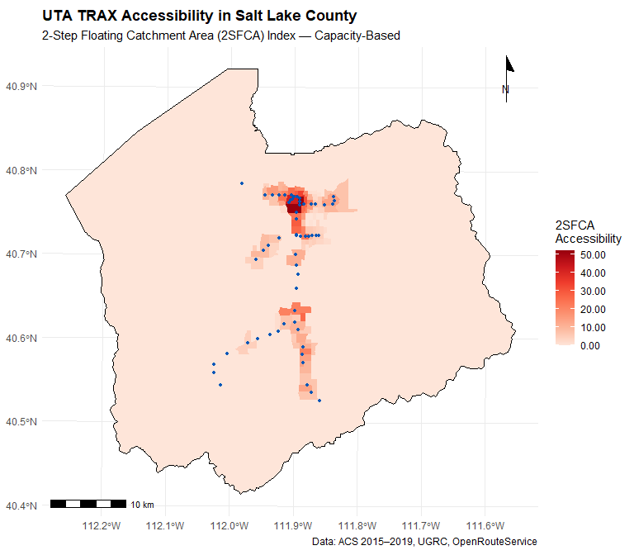
Figure 1: 2SFCA transit accessibility scores across Salt Lake County block groups (Jenks classification, 5 classes). TRAX stations shown as blue points.

7. Correlation Analysis: Equity Indicators vs. Accessibility
Before fitting regression models, we examine bivariate relationships between each equity indicator and the 2SFCA accessibility score. Pearson correlation coefficients and significance tests provide an initial sense of which social groups are associated with higher or lower transit accessibility.
A positive correlation indicates that block groups with higher proportions of a given group tend to have greater TRAX accessibility — a potentially favorable equity outcome. A negative correlation suggests the system may be underserving that group.
# Helper: build a ggplot correlation scatter for one indicator
corr_plot <- function(data, x_var, x_label, y_var = "access1",
y_label = "Transit Accessibility (2SFCA)") {
data |>
ggplot(aes(x = .data[[x_var]], y = .data[[y_var]])) +
geom_point(alpha = 0.4, size = 1.2, color = "#3c6194") +
geom_smooth(method = "lm", se = TRUE, color = "#c0392b", linewidth = 0.8) +
stat_cor(
aes(label = paste(after_stat(r.label), after_stat(p.label), sep = "~`,`~")),
p.accuracy = 0.001,
size = 3.5
) +
labs(x = x_label, y = y_label) +
theme_minimal(base_size = 10)
}
p1 <- corr_plot(TSFCA_network, "p_Race", "% Non-White Population")
p2 <- corr_plot(TSFCA_network, "p_Ethnicity", "% Hispanic/Latino Population")
p3 <- corr_plot(TSFCA_network, "p_Age", "% Dependent Age (<18 or >65)")
p4 <- corr_plot(TSFCA_network, "p_Employment", "% Unemployed Population")
p5 <- corr_plot(TSFCA_network, "p_Education", "% Without HS Diploma (25+)")
p6 <- corr_plot(TSFCA_network, "p_HMOwnership","% Renter-Occupied HH")
p7 <- corr_plot(TSFCA_network, "p_Income", "% HH Income <80% AMI")
p8 <- corr_plot(TSFCA_network, "p_VOwnership", "% Households with No Car")
ggarrange(p1, p2, p3, p4, p5, p6, p7, p8,
ncol = 4, nrow = 2)
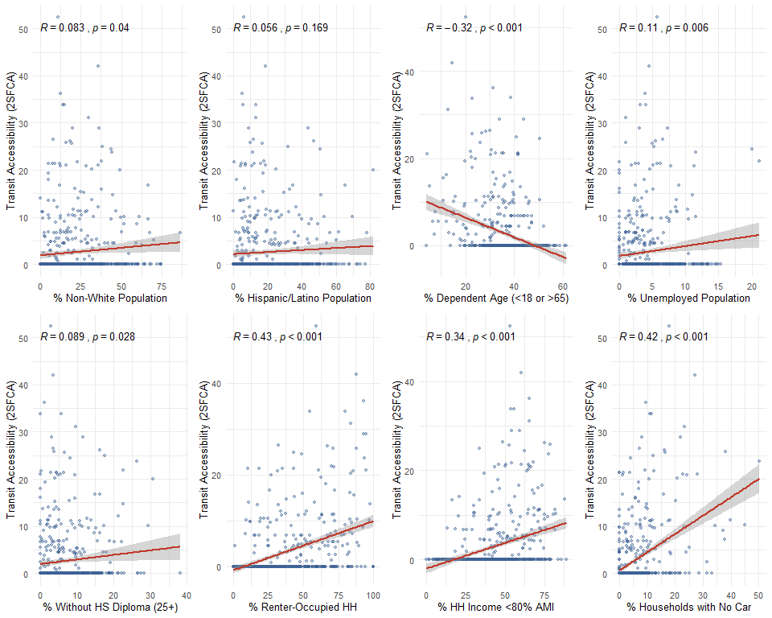
Figure 2: Bivariate correlation between each equity indicator and the 2SFCA transit accessibility score. Red line = OLS fit with 95% CI.
The correlation analysis reveals a significant positive association between transit accessibility and (1) the percentage of car-free households, (2) the percentage without a high school diploma, (3) households earning below 80% AMI, and (4) renter-occupied households. This suggests UTA-TRAX is partially serving transit-dependent and lower-income communities. However, the weaker correlation with the non-White population share may indicate residual spatial autocorrelation that a bivariate correlation cannot account for — motivating the spatial regression analysis below.

8. Spatial Autocorrelation (Moran’s I & LISA)

8.1 Rationale
The bivariate correlations and initial OLS residuals show strong positive skew and non-normality (confirmed by the histogram and Q-Q plot). This suggests the data violate the IID assumption of standard OLS, and that spatial dependency in the error structure is likely. We therefore proceed to formal spatial autocorrelation testing using Moran’s I.

8.2 Spatial Weights Matrix
We use Queen’s contiguity to define neighbors — two block groups are neighbors if they share any boundary point (edge or vertex). Weights are row-standardized.
# Clean out NaN/NA values created by 0/0 division in ACS demographics
# This MUST happen before building spatial weights to ensure perfect alignment
TSFCA_network <- TSFCA_network |>
filter(if_all(c(access1, starts_with("p_")), ~ !is.na(.) & !is.nan(.)))
# Now build the spatial weights on the clean dataset
queen <- poly2nb(TSFCA_network, queen = TRUE)
weights <- nb2listw(neighbours = queen, style = "W", zero.policy = TRUE)
cat(glue(
"Neighbors object: {length(queen)} block groups\n",
"Average neighbors per unit: {mean(card(queen)) |> round(2)}\n"
))
#> Neighbors object: 610 block groups
#> Average neighbors per unit: 6.67

8.3 Queen Contiguity Network
blockgrp_centr <- st_centroid(st_geometry(TSFCA_network),
of_largest_polygon = TRUE)
plot(st_geometry(TSFCA_network), border = "grey80", main = "Queen Contiguity")
plot(queen, blockgrp_centr, pch = 19, cex = 0.4, col = "red", add = TRUE)
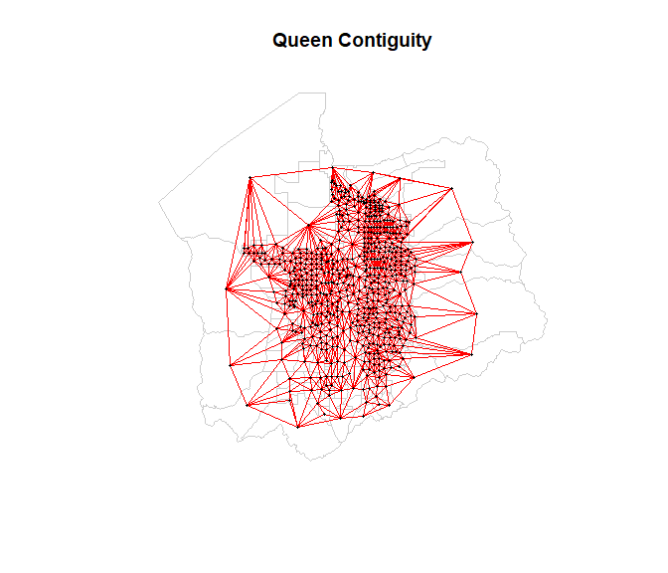
Figure 3: Queen contiguity neighbor network for Salt Lake County block groups. Red lines connect neighboring units.

8.4 Global Moran’s I
# Parametric Moran's I test
moran_test <- moran.test(TSFCA_network$access1,
listw = weights,
zero.policy = TRUE)
# Monte Carlo simulation (999 permutations)
moran_mc <- moran.mc(TSFCA_network$access1,
listw = weights,
nsim = 999,
zero.policy = TRUE)
tibble(
Test = c("Moran's I (parametric)", "Moran's I (Monte Carlo, 999 sim)"),
Statistic = c(moran_test$statistic, moran_mc$statistic),
`p-value` = c(moran_test$p.value, moran_mc$p.value)
) |>
gt() |>
fmt_number(columns = c(Statistic, `p-value`), decimals = 4) |>
tab_header(title = "Global Moran's I — TRAX Accessibility")
Table 3: Global Moran’s I — TRAX Accessibility
Table 1: Global Moran's I — TRAX Accessibility
Test | Statistic | p-value
Moran's I (parametric) | 31.1809 | 0.0000
Moran's I (Monte Carlo, 999 sim) | 0.6888 | 0.0010
hist(moran_mc$res, freq = TRUE, breaks = 25,
xlab = "Simulated Moran's I", main = "Monte Carlo Moran's I Distribution",
col = "steelblue", border = "white")
abline(v = moran_mc$statistic, col = "red", lwd = 2.5, lty = 2)
legend("topright", legend = c("Observed Moran's I"),
col = "red", lty = 2, lwd = 2)
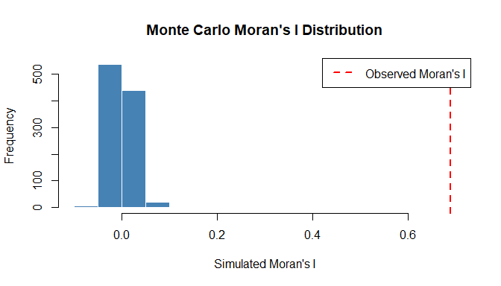
Figure 4: Distribution of simulated Moran’s I values under spatial randomness (999 permutations). The observed value far exceeds the null distribution.
TSFCA_network$zscore <- as.numeric(scale(TSFCA_network$access1))
moran.plot(
TSFCA_network$zscore, listw = weights,
pch = 19, cex = 0.5, col = "#3c6194",
main = "Moran's I Scatterplot — TRAX Accessibility",
xlab = "TRAX Accessibility (standardized)",
ylab = "Spatially Lagged TRAX Accessibility"
)
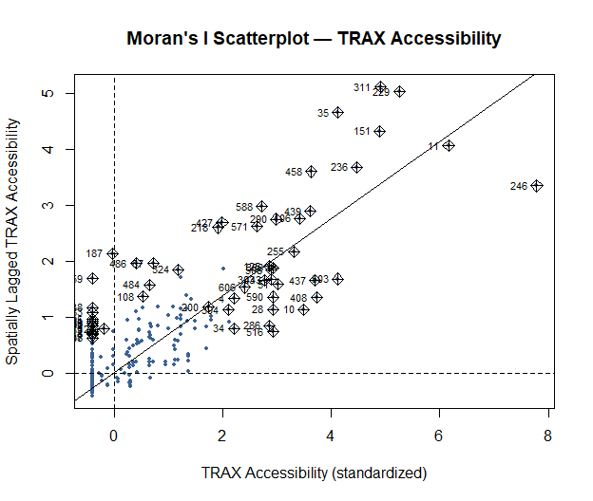
Figure 5: Moran’s I scatterplot. The positive slope confirms spatial clustering — block groups with high accessibility tend to neighbor other high-accessibility block groups.
The positive Moran’s I statistic (p < 0.001) confirms statistically significant positive spatial autocorrelation in TRAX accessibility. Block groups with high accessibility cluster together, as do those with low accessibility. Two major clusters are visible in the Moran’s I plot: one centered on downtown Salt Lake City and one around Draper.

8.5 Local Moran’s I (LISA)
Local Indicators of Spatial Association (LISA) decompose the global statistic to identify specific hot spots and cold spots of accessibility clustering.
# Use .rds to preserve column names (LISA category string would survive .shp
# but other inherited columns from TSFCA_network would be truncated).
lisa_path <- file.path(path_proc, "LISA.rds")
if (!file.exists(lisa_path)) {
LISA <- TSFCA_network |>
mutate(
moran_p = localmoran(access1, listw = weights,
zero.policy = TRUE)[, 5],
zscore = as.numeric(scale(access1)),
lagged = lag.listw(zscore, x = weights),
LISA = if_else(
zscore >= 0 & lagged >= 0 & moran_p <= 0.05,
"High-High Cluster",
"No Significant Cluster"
)
)
saveRDS(LISA, lisa_path)
message("LISA clusters computed and saved.")
} else {
LISA <- readRDS(lisa_path)
message("LISA loaded from disk.")
}
cat(glue(
"High-High Clusters: {sum(LISA$LISA == 'High-High Cluster', na.rm=TRUE)}\n",
"No Cluster: {sum(LISA$LISA == 'No Significant Cluster', na.rm=TRUE)}\n"
))
#> High-High Clusters: 67
#> No Cluster: 545

8.6 LISA Cluster Map
ggplot() +
geom_sf(data = LISA, aes(fill = LISA), color = NA) +
geom_sf(data = slco_county, fill = NA, color = "black", linewidth = 0.6) +
geom_sf(data = trax_stn, color = "#0057b8", size = 1.2) +
scale_fill_manual(
values = c(
"High-High Cluster" = "#e41a1c",
"No Significant Cluster" = "#d9d9d9"
),
name = "LISA Category"
) +
annotation_scale(location = "bl") +
annotation_north_arrow(location = "tr", style = north_arrow_minimal()) +
labs(
title = "LISA Clusters of TRAX Accessibility",
subtitle = "Local Indicator of Spatial Association (Queen Contiguity, p ≤ 0.05)",
caption = "Data: ACS 2015–2019, UGRC, OpenRouteService"
) +
theme_minimal(base_size = 11) +
theme(plot.title = element_text(face = "bold"))
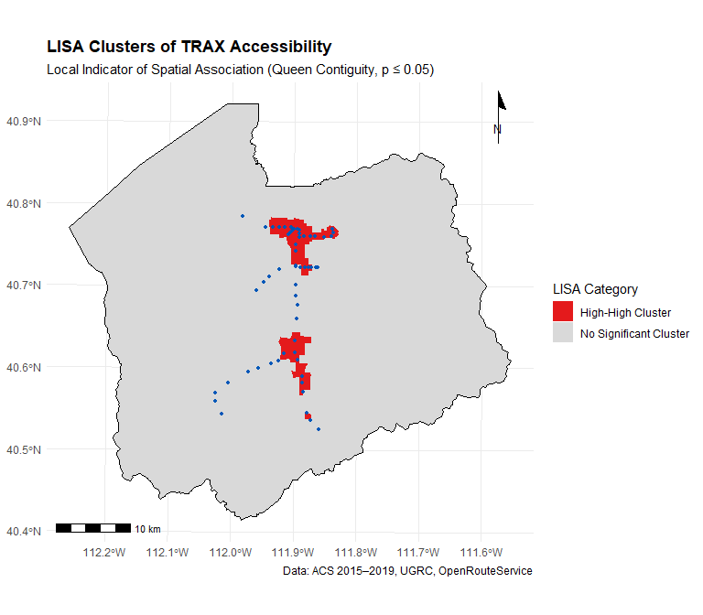
Figure 6: LISA cluster map — statistically significant High-High accessibility clusters (red) vs. non-clustered block groups (grey). TRAX stations shown as blue points.

9. Spatial Regression Models

9.1 OLS Residual Diagnostics
Before fitting spatial autoregressive models, we estimate a baseline OLS regression to assess whether its assumptions are satisfied.
Model1.OLS <- lm(
access1 ~ p_Race + p_Ethnicity + p_Employment + p_Age +
p_Education + p_HMOwnership + p_Income + p_VOwnership,
data = TSFCA_network
)
p_hist <- ggplot() +
geom_histogram(aes(x = resid(Model1.OLS)), bins = 30,
fill = "steelblue", color = "white") +
labs(x = "OLS Residuals", y = "Count",
title = "Histogram of OLS Residuals") +
theme_minimal()
# car::qqPlot returns a base-graphics plot; we capture it
p_qq <- ggplot(
data = data.frame(
theoretical = qqnorm(resid(Model1.OLS), plot.it = FALSE)$x,
sample = qqnorm(resid(Model1.OLS), plot.it = FALSE)$y
),
aes(x = theoretical, y = sample)
) +
geom_point(alpha = 0.5, color = "#3c6194") +
geom_abline(slope = 1, intercept = 0, color = "red", linetype = "dashed") +
labs(x = "Theoretical Quantiles", y = "Studentized Residuals",
title = "Q-Q Plot") +
theme_minimal()
ggarrange(p_hist, p_qq, ncol = 2)
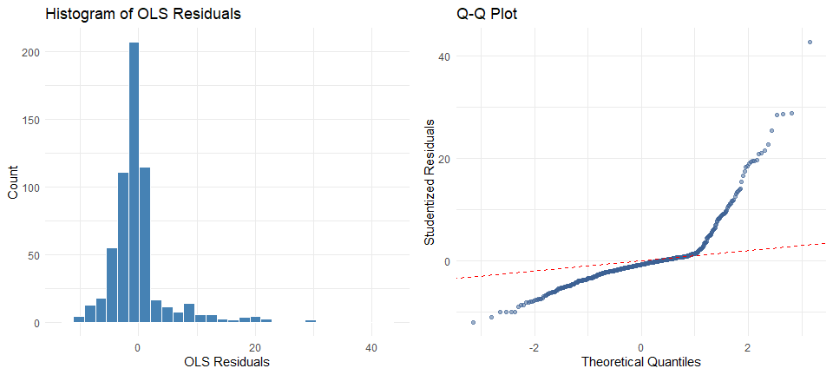
Figure 7: OLS residual diagnostics. Left: Histogram of residuals showing strong positive skew. Right: Q-Q plot showing departures from normality in the tails.
The residual histogram is strongly right-skewed, and the Q-Q plot shows substantial departures from normality in the upper tail — particularly for the high-accessibility downtown cluster. This confirms that the data violate the IID assumption, justifying the use of spatial autoregressive models.
# Moran's I on OLS residuals
lm.morantest(Model1.OLS, listw = weights, zero.policy = TRUE)
#>
#> Global Moran I for regression residuals
#>
#> data:
#> model: lm(formula = access1 ~ p_Race + p_Ethnicity + p_Employment +
#> p_Age + p_Education + p_HMOwnership + p_Income + p_VOwnership, data =
#> TSFCA_network)
#> weights: weights
#>
#> Moran I statistic standard deviate = 23.704, p-value < 2.2e-16
#> alternative hypothesis: greater
#> sample estimates:
#> Observed Moran I Expectation Variance
#> 0.5214114985 -0.0045562739 0.0004923672

9.2 Model 1: OLS Regression
tbl_regression(
Model1.OLS,
label = list(
p_Race ~ "Race: % Non-White",
p_Ethnicity ~ "Ethnicity: % Hispanic",
p_Employment ~ "Employment: % Unemployed",
p_Age ~ "Age: % Dependent (<18 or >65)",
p_Education ~ "Education: % Without HS Diploma",
p_HMOwnership ~ "Housing: % Renter-Occupied",
p_Income ~ "Income: % HH <80% AMI",
p_VOwnership ~ "Vehicle: % No-Car HH"
),
intercept = TRUE,
estimate_fun = ~ style_sigfig(.x, digits = 3),
pvalue_fun = ~ style_pvalue(.x, digits = 3)
) |>
add_glance_source_note(
include = c(r.squared, adj.r.squared, statistic, p.value, nobs)
) |>
bold_p(t = 0.05) |>
bold_labels() |>
modify_caption("**Model 1: OLS Regression** — Dependent variable: 2SFCA Accessibility") |>
as_gt()
Table 4: OLS regression results: 2SFCA accessibility regressed on eight social equity indicators.
Characteristic | Beta | 95% CI | p-value
(Intercept) | 3.77 | 1.16, 6.38 | 0.005
Race: % Non-White | -0.028 | -0.076, 0.019 | 0.242
Ethnicity: % Hispanic | 0.005 | -0.047, 0.057 | 0.857
Employment: % Unemployed | 0.122 | -0.018, 0.262 | 0.088
Age: % Dependent (<18 or >65) | -0.115 | -0.174, -0.056 | <0.001
Education: % Without HS Diploma | -0.009 | -0.135, 0.118 | 0.893
Housing: % Renter-Occupied | 0.044 | 0.013, 0.075 | 0.005
Income: % HH <80% AMI | 0.016 | -0.025, 0.056 | 0.454
Vehicle: % No-Car HH | 0.240 | 0.158, 0.321 | <0.001
Abbreviation: CI = Confidence Interval
R² = 0.252; Adjusted R² = 0.242; Statistic = 25.4; p-value = <0.001; No. Obs. = 610
The OLS model explains only about 24.2% of the variance in 2SFCA accessibility (Adjusted R² ≈ 0.242). Statistically significant predictors include the dependent age group percentage (negative), renter-occupied household percentage (positive), and vehicle-free household percentage (positive). Given the confirmed spatial autocorrelation, the OLS estimates are likely biased and inefficient.

9.3 Model 2: Spatial Lag Model (SLM)
The Spatial Lag Model accounts for spatial dependency in the dependent variable — here, the accessibility of neighboring block groups directly influences a given block group’s accessibility score. This is theoretically appropriate because transit catchments spatially overlap.
Model2.SLM <- lagsarlm(
access1 ~ p_Race + p_Ethnicity + p_Employment + p_Age +
p_Education + p_HMOwnership + p_Income + p_VOwnership,
data = TSFCA_network,
listw = weights,
zero.policy = TRUE
)

9.4 Model 3: Spatial Error Model (SEM)
The Spatial Error Model captures spatial dependency in the error term — unobserved factors (e.g., land use patterns, built environment) that cluster spatially and influence accessibility but are not explicitly measured.
Model3.SEM <- errorsarlm(
access1 ~ p_Race + p_Ethnicity + p_Employment + p_Age +
p_Education + p_HMOwnership + p_Income + p_VOwnership,
data = TSFCA_network,
listw = weights,
zero.policy = TRUE
)

9.5 Model Comparison
# Extract tidy coefficients for both spatial models
tidy_slm <- broom::tidy(Model2.SLM) |>
mutate(model = "Spatial Lag (SLM)")
tidy_sem <- broom::tidy(Model3.SEM) |>
mutate(model = "Spatial Error (SEM)")
# AIC comparison table
tibble(
Model = c("OLS", "Spatial Lag (SLM)", "Spatial Error (SEM)"),
`Log-Likelihood`= c(logLik(Model1.OLS)[1],
logLik(Model2.SLM)[1],
logLik(Model3.SEM)[1]),
AIC = c(AIC(Model1.OLS),
AIC(Model2.SLM),
AIC(Model3.SEM)),
`Adj. R² / Pseudo R²` = c(
summary(Model1.OLS)$adj.r.squared,
summary(Model2.SLM)$NK$NK, # Nagelkerke pseudo-R²
summary(Model3.SEM)$NK$NK
)
) |>
mutate(across(where(is.numeric), \(x) round(x, 2))) |>
gt() |>
tab_header(title = "Model Performance Comparison")
Table 5: Comparison of OLS, Spatial Lag Model (SLM), and Spatial Error Model (SEM) by AIC and Log-Likelihood.
Table 1: Model Performance Comparison
Model | Log-Likelihood | AIC | Adj. R² / Pseudo R²
OLS | -1908.20 | 3836.40 | 0.24
Spatial Lag (SLM) | -1641.95 | 3305.91 | 0.24
Spatial Error (SEM) | -1650.23 | 3322.46 | 0.24
bind_rows(tidy_slm, tidy_sem) |>
filter(!term %in% c("rho", "lambda")) |>
select(model, term, estimate, std.error, statistic, p.value) |>
mutate(
term = recode(term,
`(Intercept)` = "Intercept",
p_Race = "Race: % Non-White",
p_Ethnicity = "Ethnicity: % Hispanic",
p_Employment = "Employment: % Unemployed",
p_Age = "Age: % Dependent",
p_Education = "Education: % Without HS Diploma",
p_HMOwnership = "Housing: % Renter-Occupied",
p_Income = "Income: % HH <80% AMI",
p_VOwnership = "Vehicle: % No-Car HH"
),
sig = case_when(
p.value < 0.001 ~ "***",
p.value < 0.01 ~ "**",
p.value < 0.05 ~ "*",
p.value < 0.10 ~ ".",
TRUE ~ ""
)
) |>
gt(groupname_col = "model") |>
fmt_number(columns = c(estimate, std.error, statistic), decimals = 4) |>
fmt_number(columns = p.value, decimals = 4) |>
cols_label(
term = "Variable",
estimate = "Estimate",
std.error = "Std. Error",
statistic = "z-value",
p.value = "p-value",
sig = ""
)
Table 6: Coefficient estimates for the Spatial Lag and Spatial Error models.
Variable | Estimate | Std. Error | z-value | p-value
Spatial Lag (SLM)
Intercept | 0.5850 | 0.7857 | 0.7446 | 0.4565
Race: % Non-White | -0.0086 | 0.0142 | -0.6051 | 0.5451
Ethnicity: % Hispanic | -0.0066 | 0.0155 | -0.4248 | 0.6710
Employment: % Unemployed | 0.0693 | 0.0418 | 1.6575 | 0.0974 | .
Age: % Dependent | -0.0219 | 0.0177 | -1.2358 | 0.2165
Education: % Without HS Diploma | -0.0090 | 0.0376 | -0.2403 | 0.8101
Housing: % Renter-Occupied | 0.0112 | 0.0092 | 1.2173 | 0.2235
Income: % HH <80% AMI | -0.0019 | 0.0122 | -0.1559 | 0.8761
Vehicle: % No-Car HH | 0.0712 | 0.0243 | 2.9245 | 0.0035 | **
Spatial Error (SEM)
Intercept | 3.8612 | 1.7181 | 2.2473 | 0.0246 | *
Race: % Non-White | -0.0151 | 0.0156 | -0.9719 | 0.3311
Ethnicity: % Hispanic | -0.0132 | 0.0148 | -0.8949 | 0.3709
Employment: % Unemployed | 0.0442 | 0.0397 | 1.1147 | 0.2650
Age: % Dependent | -0.0316 | 0.0196 | -1.6129 | 0.1068
Education: % Without HS Diploma | -0.0098 | 0.0378 | -0.2607 | 0.7943
Housing: % Renter-Occupied | 0.0133 | 0.0094 | 1.4179 | 0.1562
Income: % HH <80% AMI | -0.0099 | 0.0133 | -0.7405 | 0.4590
Vehicle: % No-Car HH | 0.0467 | 0.0248 | 1.8782 | 0.0603 | .
Significance: *** p<0.001, ** p<0.01, * p<0.05, . p<0.10

9.6 Best Model: Spatial Lag Model Interpretation
The Spatial Lag Model (AIC = 3305.9) outperforms both OLS (AIC = 3836.4) and the Spatial Error Model (AIC = 3322.5), providing the most efficient fit to the data.
$${\hat{A}}_{i}=ρ⋅W{\hat{A}}_{i}+0.623−0.024⋅p_{Age}+0.007⋅p_{HMOwnership}+0.072⋅p_{VOwnership}$$
Key findings from the Spatial Lag Model:
- Vehicle-free households (p_VOwnership, β ≈ 0.072, p < 0.01): The only variable with statistically significant positive impact on transit accessibility. A 1 percentage point increase in car-free households is associated with a 0.072-unit increase in 2SFCA accessibility, confirming that UTA-TRAX meaningfully serves transit-dependent populations.
- Age (p_Age, β ≈ −0.025, p ≈ 0.16): Negative but not statistically significant in the spatial lag model — suggesting age-related accessibility gaps are partially explained by spatial spillovers from neighboring block groups.
- Renter-occupied households (p_HMOwnership, β ≈ 0.008, p ≈ 0.29): Positive but not significant, suggesting renters’ access benefits from co-location with transit but the relationship is not independently robust after accounting for spatial dependence.
- Race, Ethnicity, Employment, Education, Income do not reach conventional significance thresholds in the spatial autoregressive framework, possibly due to multicollinearity among these spatially correlated variables.
# Direct, indirect, and total impacts for the SLM
slm_impacts <- spatialreg::impacts(
obj = Model2.SLM,
listw = weights,
zero.policy = TRUE,
R = 500
)
summary(slm_impacts, zstats = TRUE, short = TRUE)
#> Impact measures (lag, exact):
#> Direct Indirect Total
#> p_Race dy/dx -0.011159263 -0.05836418 -0.06952344
#> p_Ethnicity dy/dx -0.008540940 -0.04467006 -0.05321100
#> p_Employment dy/dx 0.089946056 0.47042784 0.56037390
#> p_Age dy/dx -0.028478748 -0.14894701 -0.17742576
#> p_Education dy/dx -0.011745003 -0.06142767 -0.07317267
#> p_HMOwnership dy/dx 0.014554640 0.07612238 0.09067702
#> p_Income dy/dx -0.002463372 -0.01288371 -0.01534708
#> p_VOwnership dy/dx 0.092447996 0.48351327 0.57596126
#> ========================================================
#> Simulation results ( variance matrix):
#> ========================================================
#> Simulated standard errors
#> Direct Indirect Total
#> p_Race dy/dx 0.01836442 0.10316723 0.1211169
#> p_Ethnicity dy/dx 0.02140751 0.11830206 0.1393660
#> p_Employment dy/dx 0.05648428 0.34903673 0.4022752
#> p_Age dy/dx 0.02282683 0.12792126 0.1500076
#> p_Education dy/dx 0.04813566 0.26233073 0.3097690
#> p_HMOwnership dy/dx 0.01207489 0.06941837 0.0811020
#> p_Income dy/dx 0.01607367 0.09100840 0.1068294
#> p_VOwnership dy/dx 0.03257512 0.21263037 0.2412325
#>
#> Simulated z-values:
#> Direct Indirect Total
#> p_Race dy/dx -0.5829521 -0.5719487 -0.5755756
#> p_Ethnicity dy/dx -0.3444184 -0.3362180 -0.3383064
#> p_Employment dy/dx 1.6271503 1.4572769 1.4928874
#> p_Age dy/dx -1.2095651 -1.1509854 -1.1655815
#> p_Education dy/dx -0.2987744 -0.2818988 -0.2851558
#> p_HMOwnership dy/dx 1.2103588 1.1374067 1.1537552
#> p_Income dy/dx -0.1600948 -0.1711313 -0.1698754
#> p_VOwnership dy/dx 2.8530436 2.3795795 2.4827053
#>
#> Simulated p-values:
#> Direct Indirect Total
#> p_Race dy/dx 0.5599256 0.567357 0.564902
#> p_Ethnicity dy/dx 0.7305317 0.736706 0.735132
#> p_Employment dy/dx 0.1037052 0.145040 0.135467
#> p_Age dy/dx 0.2264458 0.249738 0.243784
#> p_Education dy/dx 0.7651122 0.778021 0.775525
#> p_HMOwnership dy/dx 0.2261413 0.255368 0.248601
#> p_Income dy/dx 0.8728064 0.864121 0.865108
#> p_VOwnership dy/dx 0.0043303 0.017332 0.013039

10. Discussion and Conclusions

10.1 Summary of Findings
This study examined whether UTA-TRAX moderates social equity in Salt Lake County through a rigorous geospatial accessibility framework. Our findings can be summarized as follows:
- Accessibility is spatially unequal. The 2SFCA analysis demonstrates that TRAX accessibility is not identically distributed across Salt Lake County. Downtown Salt Lake City and Sugarhouse exhibit the highest accessibility scores, owing to dense station clustering and smaller block groups that facilitate pedestrian access.
- Spatial clustering is significant. Global Moran’s I confirms strong positive spatial autocorrelation (I > 0, p < 0.001). LISA mapping identifies two major high-high clusters: one anchored in Salt Lake City’s urban core and one in Draper, corresponding to the terminal stations of the Red Line.
- Vehicle-free households are the primary equity signal. Across all model specifications, the percentage of households with no vehicle is the only equity variable consistently and positively associated with TRAX accessibility. This finding supports the hypothesis that UTA-TRAX partially moderates equity for transit-dependent residents — but does not fully resolve the equity gap.
- Other equity dimensions are not significantly served. Race, ethnicity, income, and educational attainment are not independently predictive of accessibility in the spatial lag framework, after controlling for spatial dependency. This does not mean these groups are equitably served — it may reflect the limitation that the TRAX network was not designed with explicit equity mandates, and that spatial clustering masks group-specific disparities.

10.2 Policy Recommendations
- Expand pedestrian catchments. Investments in sidewalk infrastructure, protected bike lanes, and first/last-mile connections (e.g., bike-share, micro-mobility) near TRAX stations in underserved southern and western Salt Lake County could significantly expand effective accessibility for equity populations.
- Targeted service frequency increases. High-demand equity corridors — particularly areas with elevated concentrations of non-White residents and low-income households that currently fall outside the 20-minute catchment — should be candidates for new bus routes or more frequent TRAX service.
- Integrate Title VI monitoring. UTA should adopt spatially explicit equity metrics, such as the 2SFCA accessibility index, into its ongoing Title VI compliance reporting, enabling proactive identification of disparities before they crystallize.
- Revisit the AMI threshold. The income bracket proxy used here ($0–$59,999 for <80% AMI) may undercount households in the 60th–80th percentile of income. Future analyses should use the continuous income distribution from PUMS data for a more precise low-income definition.

10.3 Limitations
Several limitations merit acknowledgment. First, the 20-minute walking isochrone threshold, while standard in the literature, may overestimate accessibility for elderly or mobility-impaired individuals. Second, the ORS isochrones assume flat terrain and a consistent pedestrian network — Salt Lake County’s topographic variation along the Wasatch Front may introduce error. Third, the 2-year ACS window (2015–2019) predates COVID-19 pandemic disruptions to transit ridership, which fundamentally altered accessibility patterns. Finally, this analysis captures spatial accessibility but not temporal accessibility (i.e., frequency of service at different times of day).

10.4 Future Work
Future research should: (1) incorporate GTFS-based temporal accessibility to capture off-peak and weekend service gaps; (2) apply the 2SFCA method to other transit modes (bus, FrontRunner commuter rail) for a system-wide equity picture; and (3) use longitudinal ACS data to track how accessibility equity has changed alongside TRAX network expansions.

This analysis was conducted as part of CMP 6455 — Advanced GIS Applications, University of Utah, Department of City & Metropolitan Planning. The companion publication is available at DOI: 10.1177/03611981231170005.

