Quantifying Economic Effects of Transportation Investments

Methods and Applications for Regional Planning

Pukar Bhandari

2025-08-07

Table of contents

## 1 My Background & Utah Connection

**Experience:**

* Graduate education at University of Utah (Transportation Planning)
* 3+ years developing economic impact methods for transportation investments
* Direct experience with Utah’s transportation planning context
* Led economic assessments for Utah’s Unified Transportation Plan 2023-2050

**What Excites Me About WFRC**

Supporting investment prioritization

2034 Olympic legacy planning

Nation’s fastest-growing region

Activity-based modeling

*Ready to contribute from day one*

**Technical Expertise:**

* Travel demand modeling: Cube, TransCAD (complementing WFRC’s existing expertise)
* Economic impact modeling: IMPLAN, TREDIS
* R-based automated workflows for reproducible analysis
* Bridging transportation modeling with economic quantification
* Brief personal intro: 3+ years experience in travel demand modeling and economic impact analysis
* Excited to discuss how these methods can support WFRC’s regional planning mission
* Draw from experience with Utah UTP 2023-2050 and multiple MPO projects

## 2 The Opportunity: From Performance to Impact

**WFRC’s Strong Foundation:** - Sophisticated travel demand modeling capabilities - Activity-based modeling transition underway - Regional transportation planning expertise - Growing region with complex investment decisions

**The Next Step I’d Love to Support:** Moving from “How does the system perform?” to “What does this investment do for our region’s economy?”

**Traditional Analysis:**

* Travel time savings
* VMT reduction
* Crash reduction
* Emissions benefits

**Enhanced Analysis:**

* Regional job creation
* Economic multiplier effects
* Business attraction potential
* Return on investment metrics

This enhanced perspective helps justify investments to stakeholders and supports competitive grant applications.

* Set up the problem: MPOs need to justify investments beyond just traffic metrics
* WFRC faces unique challenges with rapid growth and upcoming Olympics
* Economic analysis helps prioritize limited resources

## 3 Economic Impact Framework I’ve Applied

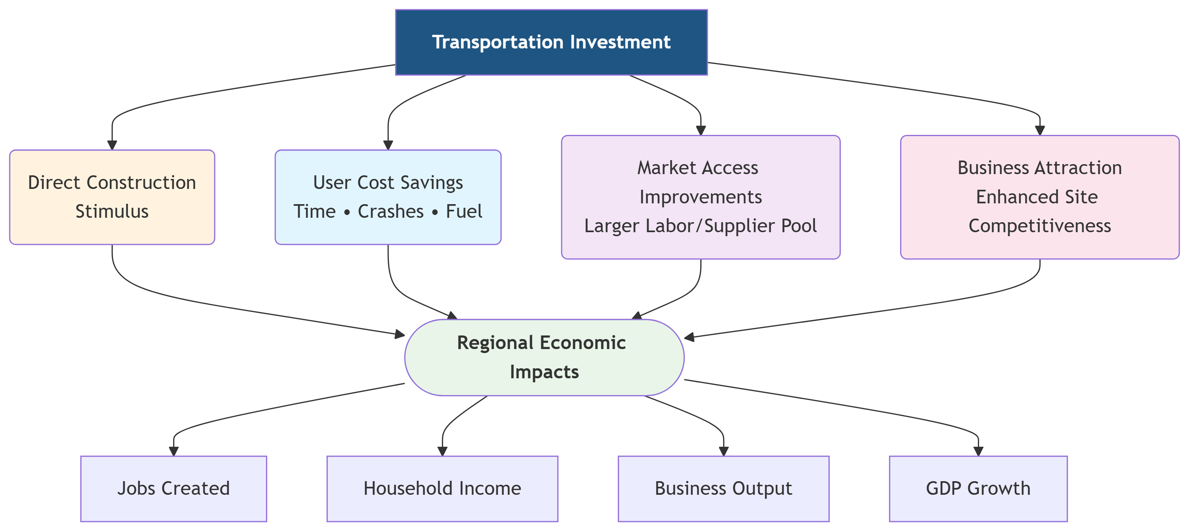

**Key insight from my experience**: Not all transportation benefits create wider economic impacts. Understanding this distinction helps prioritize projects that maximize both mobility and economic returns.

* This is where my technical skills differentiate me from other candidates
* Systematic approach that emphasizes the practical insight about different types of benefits

## 4 Real Application: Utah’s Unified Plan 2023-2050

**What I contributed to Utah’s $36 billion transportation plan:**

**Methodology:** - Integrated travel demand model outputs with benefit-cost analysis framework and economic impact analysis - Custom R and MS Excel based workflows linking transportation performance to economic metrics - Scenario-based analysis across multi-modal investment alternatives

**Key Results:** - Construction phase: 50,000+ direct jobs - Societal Benefits: $40+ B present value (28 years) - Economic Impact: $540 B regional output increase (28 years) - Return Ratio: $5.11 economic activity per dollar invested annually

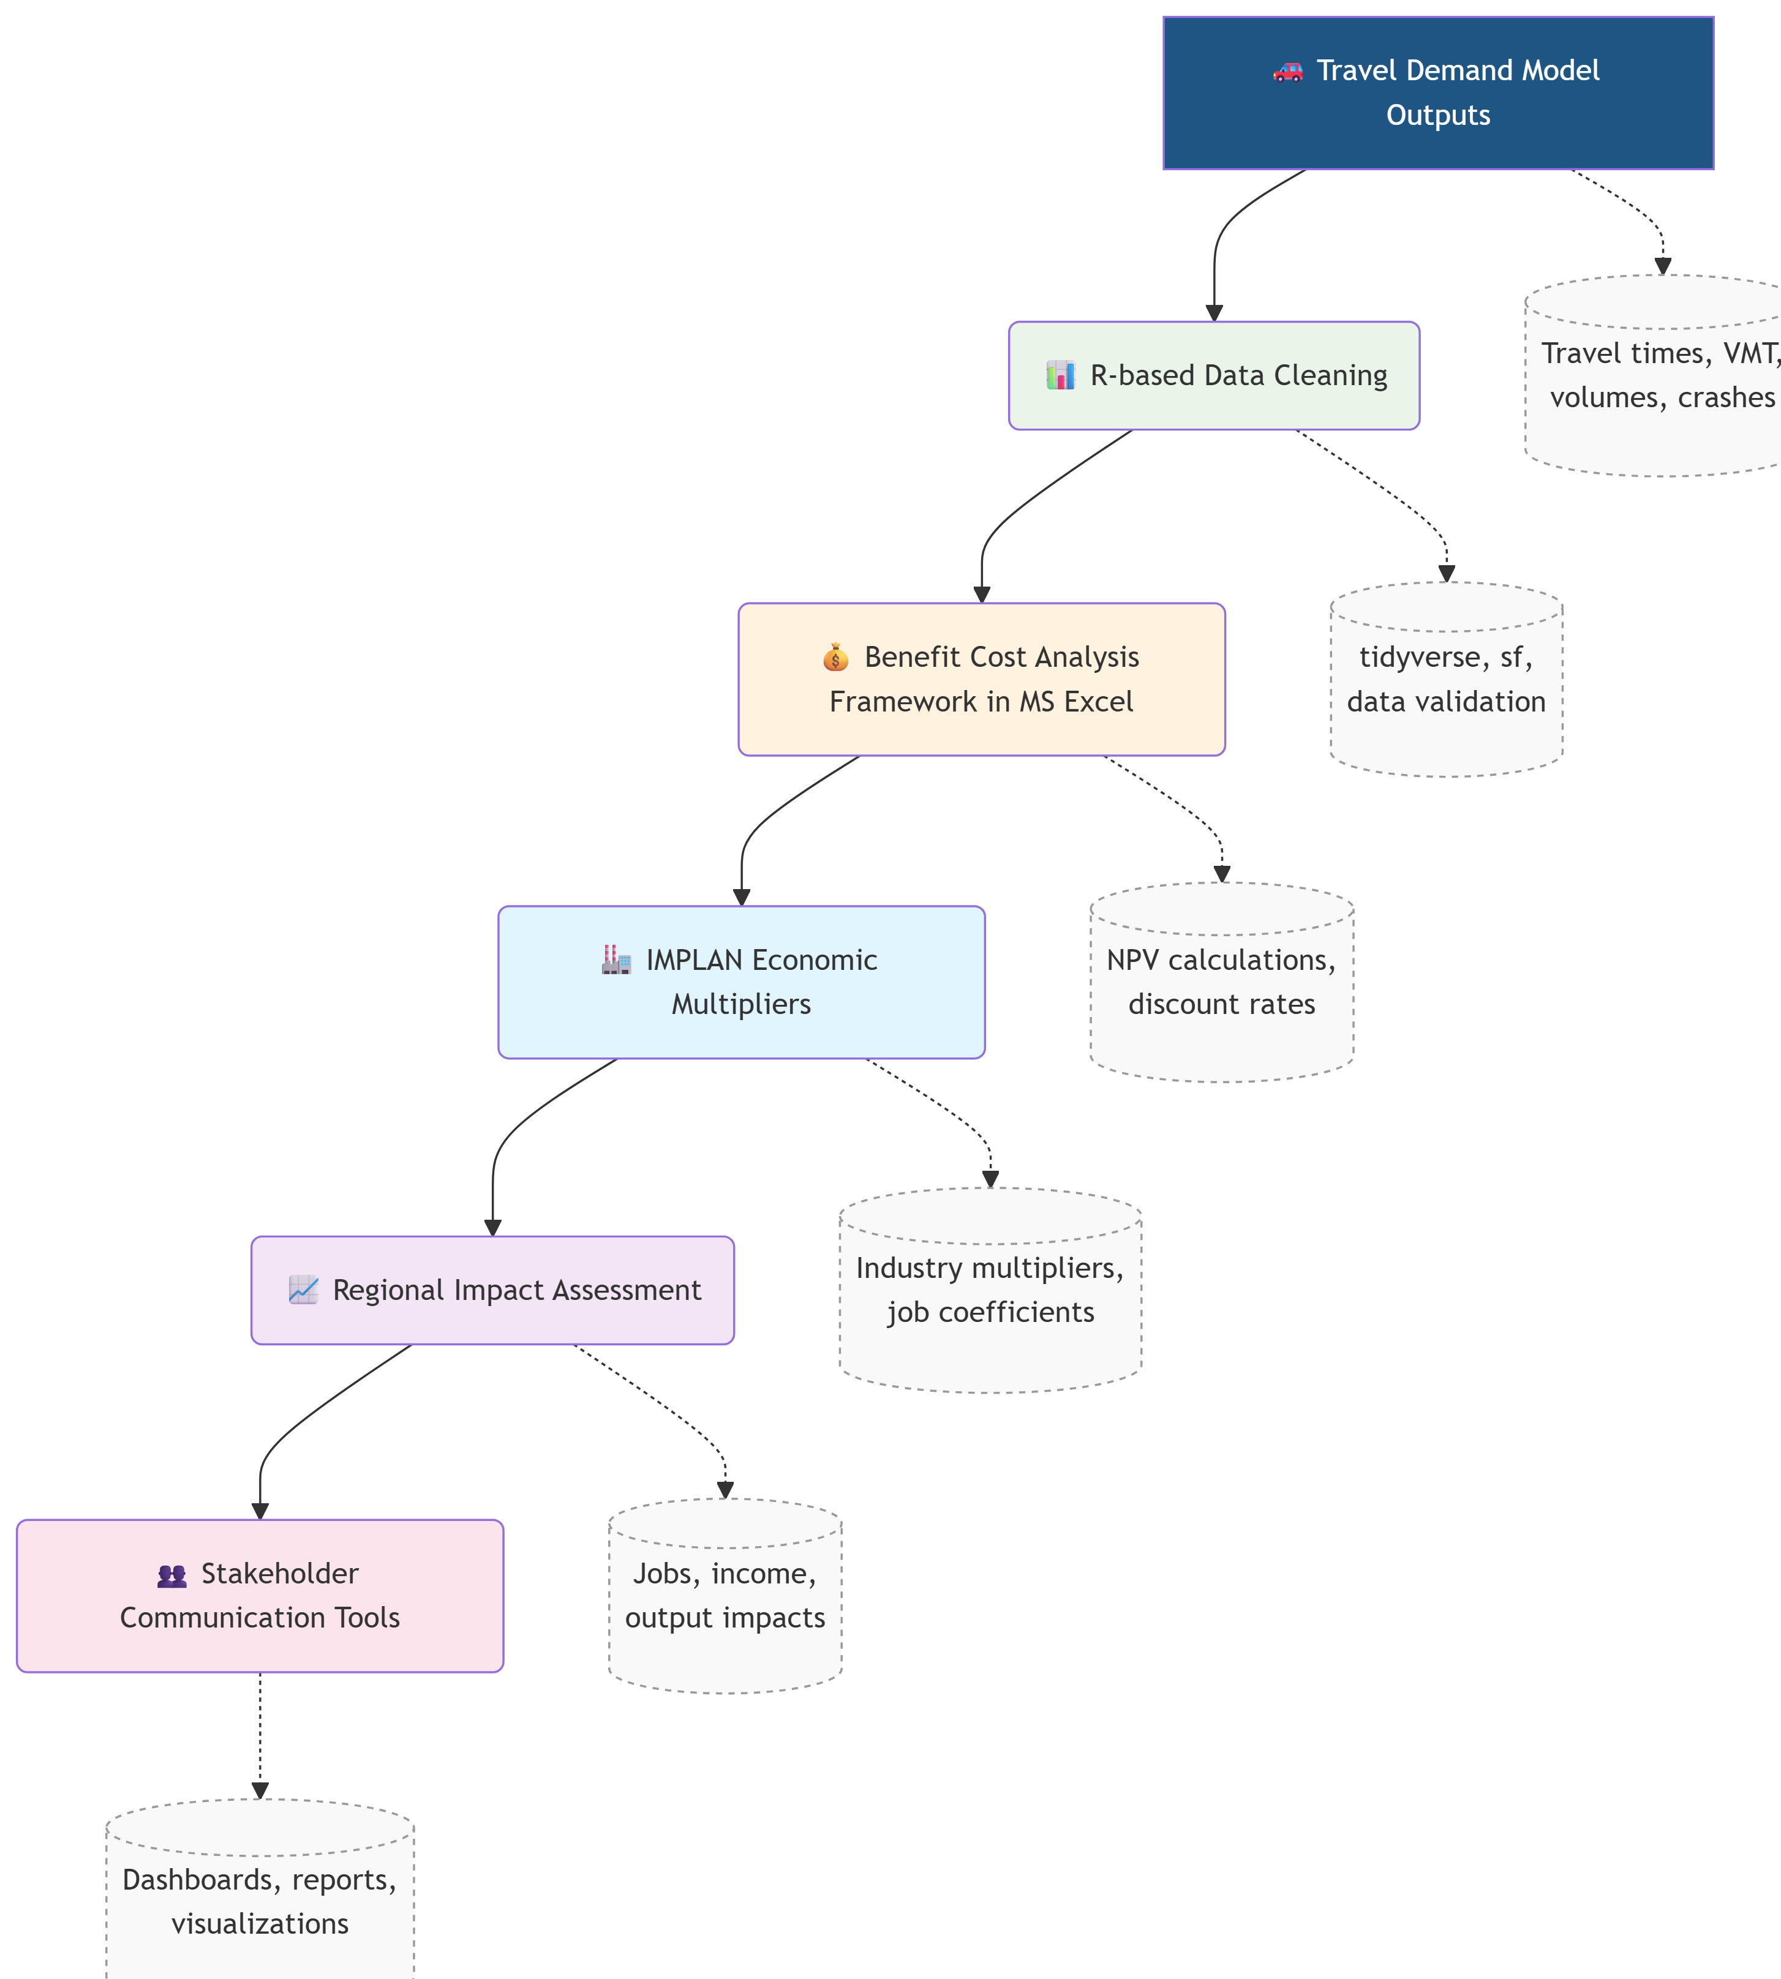

*Reproducible, automated pipeline*

**Relevance to WFRC:** This same methodology can support WFRC’s RTP development, Olympic planning, and federal grant applications.

* Show concrete results and proven methodology
* Emphasize the technical pipeline I’ve built
* Connect directly to their upcoming needs
* Numbers are impressive but not overwhelming

## 5 Potential Applications for WFRC

**Areas where economic impact analysis could enhance WFRC’s work:**

**Investment Prioritization:**

* Compare economic returns across RTP projects
* Identify investments with highest job creation potential
* Quantify equity impacts across communities

**Major Project Support:**

* FrontRunner electrification business case
* Transit routes expansion
* Point of the Mountain development
* 2034 Olympic transportation investments

**Stakeholder Communication:**

* Translate technical analysis into economic narratives
* Support federal grant applications with economic justification
* Demonstrate transportation’s role in regional competitiveness

**Technical Integration:**

* R-based workflows compatible with WFRC’s analytical environment
* Automated reporting for consistent analysis
* Integration with activity-based model transition

**My perspective:** Economic impact analysis works best when it complements and enhances existing technical capabilities rather than replacing them.

* Connect directly to WFRC’s current priorities and challenges
* Show how this isn’t just academic - it’s immediately useful
* Emphasize the R integration since that matches WFRC’s technical environment
* Shows understanding of WFRC’s major initiatives

## 6 What I’m Excited to Explore with WFRC

#### Questions I’d love to explore with the WFRC team:

* How to communicate the economic value of transportation investments to stakeholders?
* What role might economic analysis play in the activity-based modeling transition?
* How to best support economic justification for major transportation investments in the future?
* What are the priorities for federal grant applications where economic impact matters?

### **Thank you for this opportunity!**

**I’m eager to contribute to WFRC’s mission of building consensus around data-driven transportation solutions that enhance quality of life in the Wasatch Front.**

**Pukar Bhandari**

pukar.bhandari@outlook.com   |   linkedin.com/in/arpuuk   |   github.com/ar-puuk

## 7 Technical Deep-Dive {.smaller}

### R-Based Economic Impact Pipeline

# Example workflow integrating with WFRC's existing processes  
library(tidyverse); library(sf); library(targets)  
  
# 1. Process travel demand model outputs  
wfrc_benefits <- process_travel_model_results(  
 cube_outputs = "model_scenarios/",  
 performance_measures = c("time_savings", "vmt_reduction", "crashes")  
)  
  
# 2. Apply economic impact methodology  
regional_impacts <- calculate_economic_impacts(  
 benefits = wfrc_benefits,  
 construction_costs = project_investments,  
 study_area = wasatch_front_counties,  
 multipliers = utah_implan_data  
)  
  
# 3. Generate stakeholder communications  
impact_dashboard <- create_interactive_results(regional_impacts)  
grant_narrative <- generate_economic_justification(regional_impacts)

**Benefits:** Reproducible, well-documented analysis that can be adapted for different projects and scenarios.

* Have this ready if they want to dig into technical implementation
* Shows actual R code skills and modern workflow practices
* Demonstrates understanding of reproducible research principles

## 8

### Additional Experience Portfolio

**Economic impact methodologies applied across multiple contexts:**

* **Bowling Green-Warren County MPO (KY)**: $180M MTP economic analysis for 200,000+ population
* **Lower Savannah COG (SC)**: Multi-county freight corridor impact assessment
* **Des Moines Area MPO**: Scenario-based Multimodal investment economic evaluation
* **Ohio DOT Cleveland**: Intersection improvement benefit-cost analysis

**Consistent Approach**: Automated R workflows linking travel demand model outputs with regional economic impact assessment using IMPLAN and other industry-standard tools.

**What this demonstrates:** I can adapt the methodology to different regional contexts while maintaining analytical rigor and technical consistency. Each project has strengthened my ability to communicate complex economic concepts to diverse stakeholder groups.

* Shows breadth of experience across different regions and project types
* Demonstrates that the methodology is transferable and scalable
* All used similar R-based integration approaches