PROJECT TITLE: Power of Math

Sub: Hosting a static website in the using the AWS resources.

Author: Ramkumar R

Reference: https://youtu.be/7m_q1ldzw0U?si=68DJcBy3BDOOAcMx

Resources used:

* Amplify
* API gateway
* Lambda
* Dynamo DB
* IAM

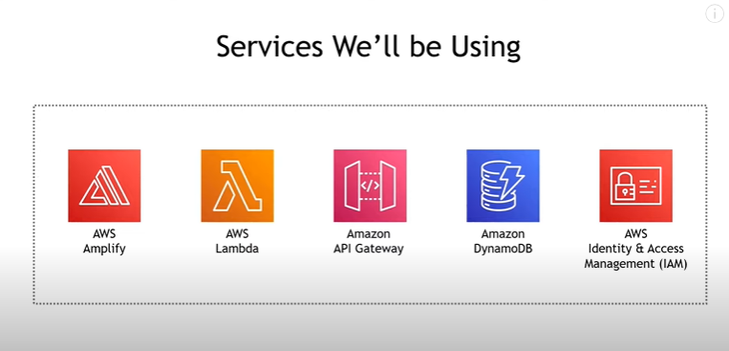

By integrating all the resources, the static website to calculate the value of numbers with exponent

E.g. (2^5=32) by only getting the value of the base and the exponent values.

Architecture:

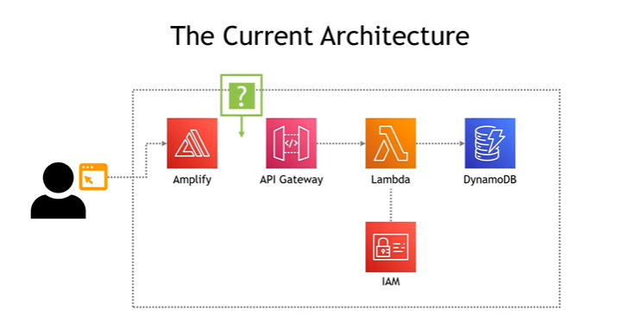

Step 1: Using the Amplify

* zip the HTML code that going to get the input values of the base and exponent.
* open the Amplify service in the AWS and host the web code int the service without using the GitHub or git lab.
* Go to the step 2.
  + Returning from the Step 5.
  + In the code include the “invoke URL” that copied from the REST API that deployed.
  + Now it got integrated with the API gateway. The input values will trigger the API.

Step 2: Using the Lambda

* In lambda create the serverless function that execute when its triggered.
* Create new lambda python function that calculates the value using the Base & Exponent.
* Deploy the python code (if you need run your own test cases to check the code written).
* Go to the step 3.
  + Returning from the step 4
  + Go to the configuration in the lambda function and create the “inline policy “
  + This inline policy is created by using the service IAM
  + Go to the step 5.

Step 3: Using the API gateway

* Create a new REST API and make it to response to the POST requests that going to come from the web app that is hosted (Note: still it’s not integrated).
* Integrate the method / Lambda function (serverless function that created previously in

step 2) using the create method option.

* After enable the cores to and activate the post method to respond for the POST requests.
* Deploy the API in the new stage.
* Copy and save the “invoke URL” which is going to needed afterwards.
* **Optional step:** Now if you want test the flow test by manually entering the values and trigger the lambda function.
* Go to the Step 4.

Step 4: Using the Dynamo DB

* Create the table and copy the ARN (Amazon Resource Name)
* **Use**: To store the result from the lambda function this Database is created.
* Integrate the lambda and DynamoDB (Lambda 🡪 DynamoDB).
  1. For this go to lambda.
  2. Go to step 2.

Step 5: Using the IAM policy

* Write an inline policy template in JSON format
* In that template paste the ARN of the DynamoDB that previously copied
* Save the inline policy
* Now the lambda and the DynamoDB is integrated, values or the results from the lambda function can now store in the database that got created.
* Final part is to only integrate Hosted web app and the API gateway
* Go to the step 1.

**FLOW CHART:**

