Auto downloader-Odyssey System.

Requirements

**Step 1:**

The software open the URL below <https://www.clarkcountycourts.us/Portal/Account/Login>

Then credentials are entered to “Sign In”

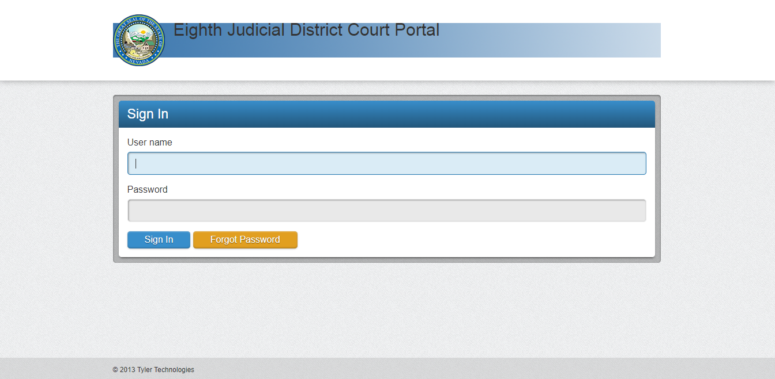

**Step 2:**

The software then accesses the below button or icon in order to proceed for searching.

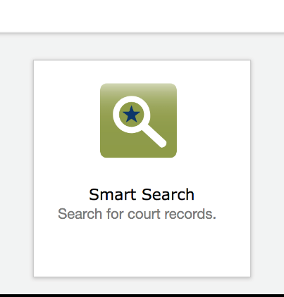

**Step 3:**

The “Advanced Filtering Option” is clicked to open further settings or options to proceed.

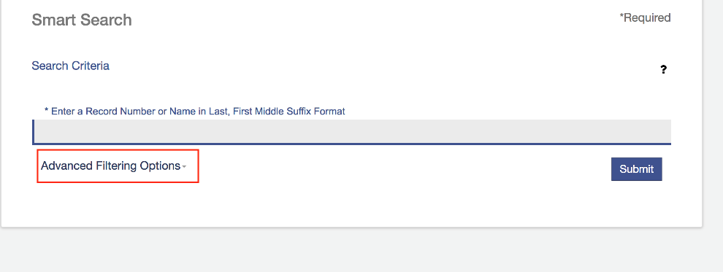

**Step 4:**

Choose “Cross-Reference Number” from dropdown under General Filtering Options settings

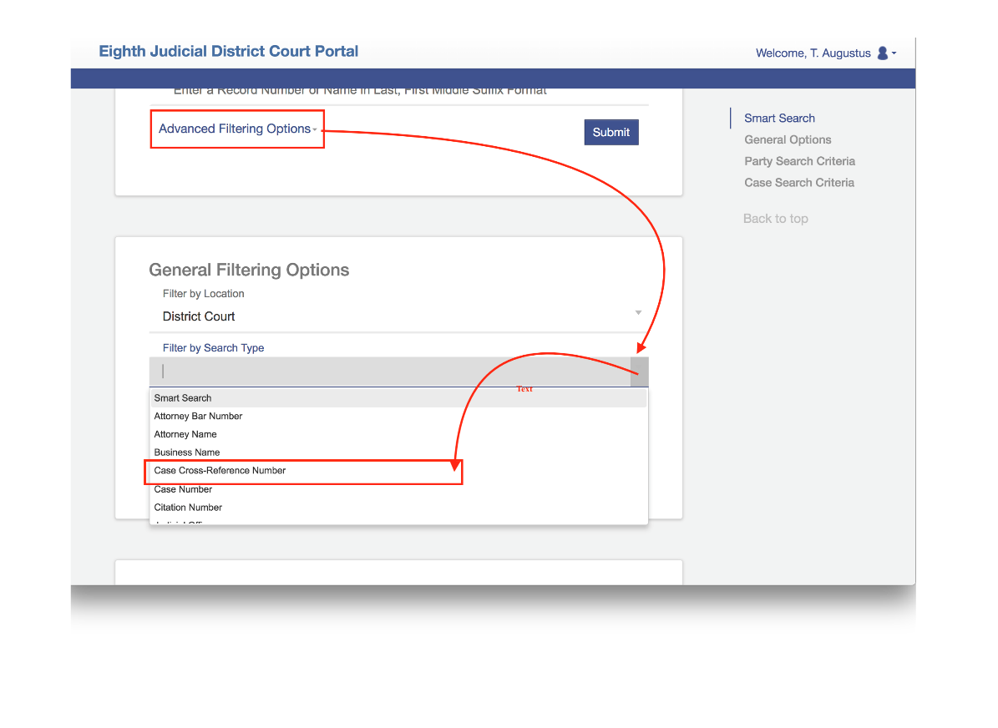

**Step 5:**

Now user will enter case number in the format as shown in constraint # 13, program will input this case range in input field of portal shown in following picture.

The program will ask user to choose directory for saving files from portal locally.

Now program presses ‘Submit’ button to proceed

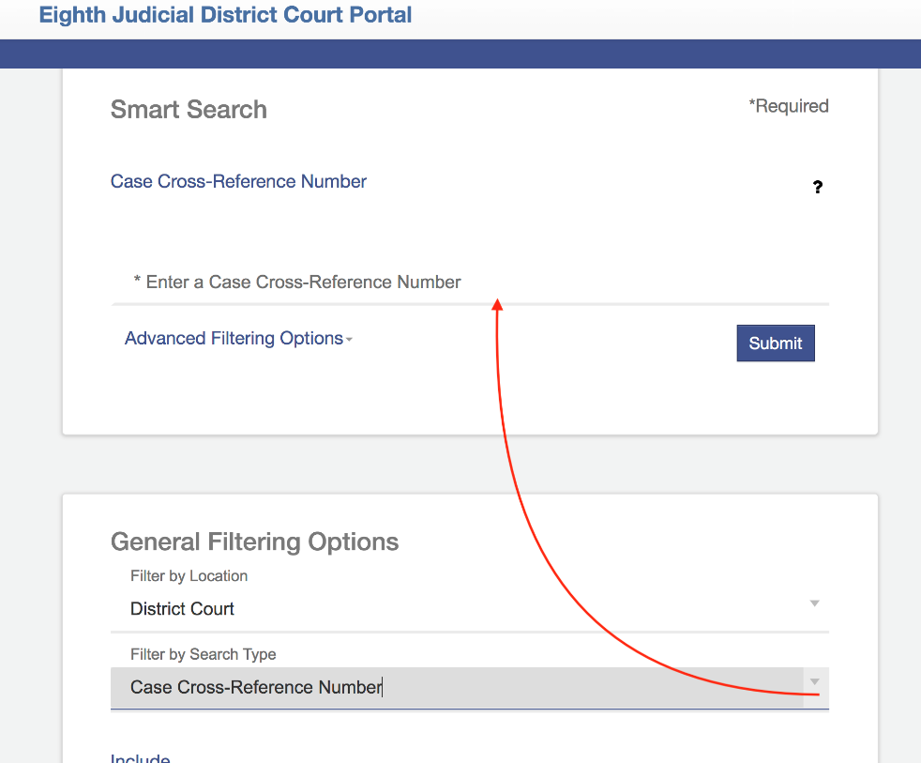

**Step 6:**

Open Case numbers in daughter windows

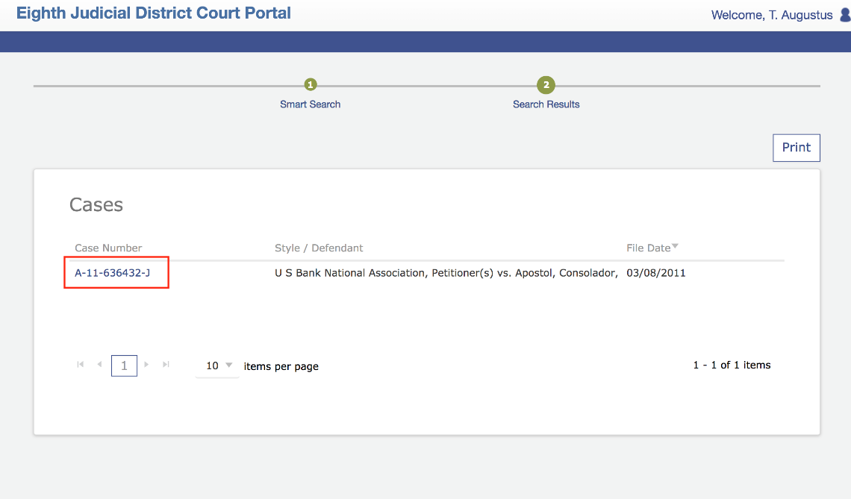

**Step 7:**

Click “Documents” and navigate to all files

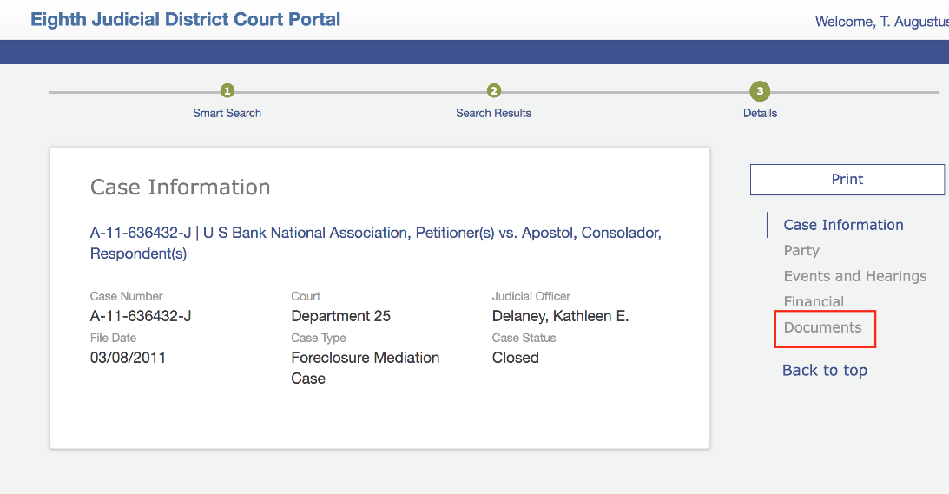

**Step 8:**

Click “View Document” and then download them to a folder and folder name should be “Case Number”

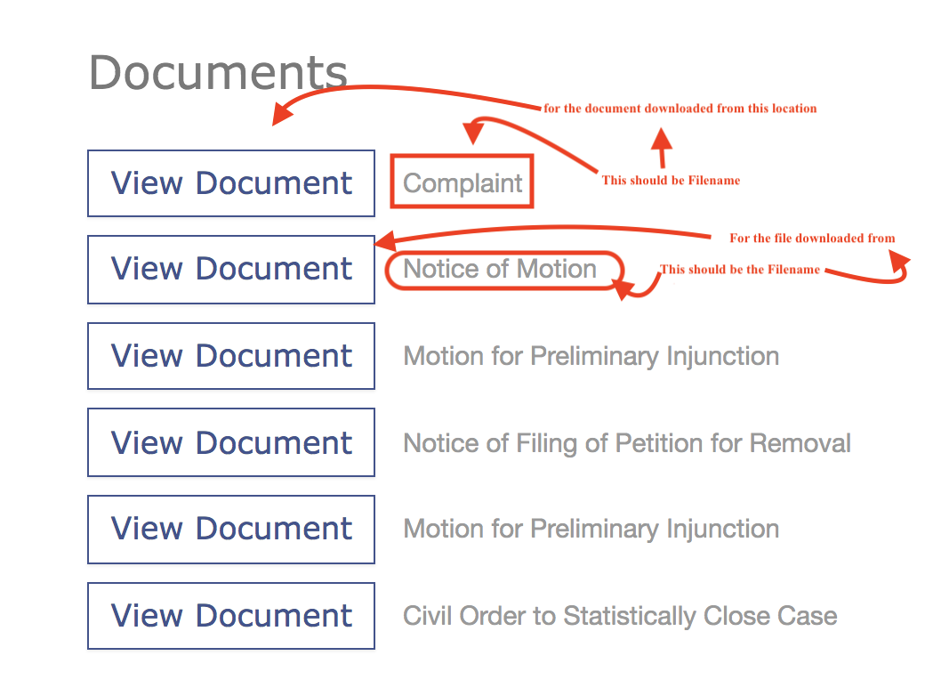

**Step9:**

If no “Documents” section is present skip that particular case.

Example Case # A238989

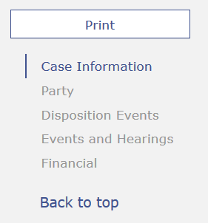

**Step10:**

Copy all the content of page of case number opened then paste it in Word file with name of Case No.

Constraints:

1. Windows has limitations of 65000 items per folder so Software must have range check limit so that any folder greater than 65000 must be created with unique identifier like if folder name is ‘A100’ and files in this folder exceeds 65000 then another folder must be ‘A100-1’ and if this folder contains a limit of 65000 then create another folder like ‘A100-2’ and so on
2. Software should remember previous stop state, pause state and resume option so user can start the program where he paused it.
3. Software should run the downloading of cases in sequence like case # A100100 on thread 1 , case # A100101 on thread 2 and so on
4. Handle all sort of runtime exception with 100% working condition.
5. Data Integrity check must be there that number of files (tiff, pdfs and sealed files) on server/portal must be consistent. No extra file must be made on local disk or machine.
6. Auto Login must be there to prevent any session out.
7. The program should restart from that case if exception or any sort of error appears.
8. File Tracking mechanism must be incorporated in program to keep track of number of files available on portal, number of sealed files, count of files available on server and local disk from where the files are downloaded, files in process of downloading or that finished downloading. Progress bars to show files downloaded and in process status.
9. User must be able to provide credentials in text boxes where credentials must be saved using **remember me option.**
10. A button that ask the User “Download in Default Path” with “Yes” and “No” button in popup, on clicking “Yes” the default path must be set as

“C:/User/PC-Name/Documents/CaseDownloader” and on clicking “No” (directory chooser) must be displayed to choose directory path.

1. **After** 100% working and testing “Browser Enable” mode will be Off so no user can interact with browser.
2. The program should work on multiple computers and instances without any runtime exceptions or bugs.
3. Input method must be of any following types to enter case number and start the program

a) aXXXXXX-aXXXXXX,aXXXXXX- aXXXXXX

b) aXXXXXX, aXXXXXX

c) aXXXXXX- aXXXXXX, aXXXXXX

d) aXXXXXX

(‘X’ can be any positive number ‘0-9’)

Download should begin in number order 0-1 for example in a range of cases a100000-a100100

First case to download will be

a100000

a100001

a100002

a100003…

to …a100100

1. Any sort of error thrown by portal must be handled in program.
2. If particular case number written as input is not found then software should skip that case and move on.
3. If portal not responding then close the browser and reopen it.
4. If portal not responding then retry till 3 min.
5. If server through any error then the software should display that error via dialogue box and stores date and time in log file with that error message like ‘404 Page Not Found’ or any general internet error.
6. Folder read only
7. File names start with int
8. User name hide