XML Web Services
Web Services:
WebService is a way of communication (OR) Technology. It allows us to develop Inter-operable distributed application.

Interoperability:
Platform independent and language independent.
Distributed API

Java/PHP format ↔ XML format ↔ Java/PHP format

Web Application:

REST Services

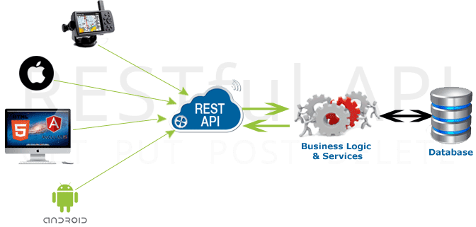

What is REST?
REST stands for REpresentational State Transfer. REST specifies a set of architectural constraints. Any service which satisfies these constraints is called RESTful Service.
The five important constraints for RESTful Web Service are
- Client - Server : There should be a service producer and a service consumer.
- The interface (URL) is uniform and exposing resources.
- The service is stateless.
- The service results should be Cacheable. HTTP cache, for example.
- Service should assume a Layered architecture. Client should not assume direct connection to server - it might be getting info from a middle layer – cache.

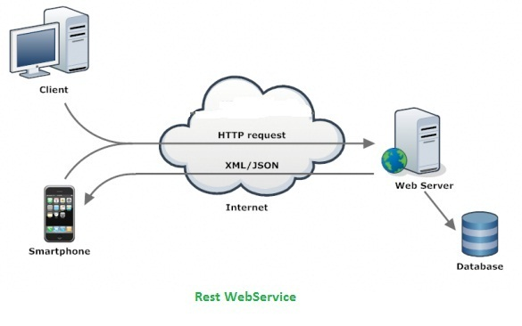

Richardson Maturity Model
Richardson Maturity Model is used to identify the maturity level of a Restful Web Service. Following are the different levels and their characteristics:
- Level 0 : Expose SOAP web services in REST style. Expose action based services (http://server/getPosts, http://server/deletePosts, http://server/doThis, http://server/doThat etc) using REST.
- Level 1 : Expose Resources with proper URI’s (using nouns). Ex: http://server/accounts, http://server/accounts/10. However, HTTP Methods are not used.
- Level 2 : Resources use proper URI’s + HTTP Methods. For example, to update an account, you do a PUT to . The create an account, you do a POST to . Uri’s look like posts/1/comments/5 and accounts/1/friends/1.
- Level 3 : HATEOAS (Hypermedia as the engine of application state). You will tell not only about the information being requested but also about the next possible actions that the service consumer can do. When requesting information about a facebook user, a REST service can return user details along with information about how to get his recent posts, how to get his recent comments and how to retrieve his friend’s list.

Using appropriate Request Methods
Always use HTTP Methods. Best practices with respect to each HTTP method is described below:
- GET : Should not update anything. Should be idempotent (same result in multiple calls). Possible Return Codes 200 (OK) + 404 (NOT FOUND) +400 (BAD REQUEST)
- POST : Should create new resource. Ideally return JSON with link to newly created resource. Same return codes as get possible. In addition : Return code 201 (CREATED) is possible.
- PUT : Update a known resource. ex: update client details. Possible Return Codes : 200(OK)
- DELETE : Used to delete a resource.

