**Cisco Certified Network Associate** (**CCNA**)

CCNA Routing and Switching is a certification program for entry-level network engineers that helps maximize your investment in foundational networking knowledge and increase the value of your employer's network.

The name "Cisco" was derived from the city name, San Francisco, which is why the company's engineers insisted on using the lower case "cisco" in its early years. The logo is intended to depict the two towers of the [Golden Gate Bridge](https://en.wikipedia.org/wiki/Golden_Gate_Bridge).

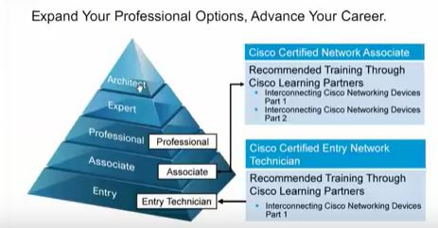

**What is network?**

A network is a collection of computers, servers, mainframes, network devices, peripherals, or other devices connected to one another allowing for data to be shared and used.

Internet is a great example of network.

Type of network:

Network are divided in 3 section

1. LAN
2. MAN
3. WAN

Local Area Network (LAN):

LAN is a computer network that interconnects computers within a limited area such as a residence, school, laboratory, or office building.

Data transfer speed: 10Mbps

Range: 100 meter

Use device: Repeater, Hub, and Network Interface Card (NIC)

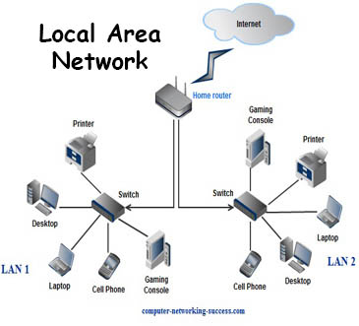

**Metropolitan area network** (MAN):

A **metropolitan area network**, or **MAN**, consists of a computer network across an entire city, college campus or small region. A MAN is larger than a LAN.

Example: Entire Dhaka city network

Data transfer speed: 1Gbps

Range: 50 – 75 mile

Use device: Router, Switch Microwave antenna etc.

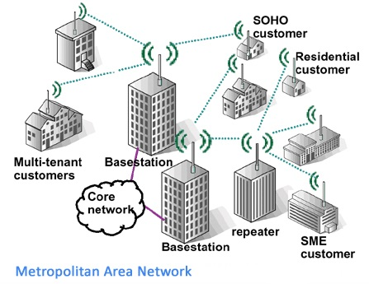

Wide area network (**WAN**):

A **wide area network**, or **WAN**, occupies a very large area, such as an entire country or the entire world. A WAN can contain multiple smaller networks, such as LANs or MANs. The Internet is the best-known example of a public WAN.

Example: Network between Dhaka and Singapore office network connection.

Data transfer speed: 1.544Mbps

Use device: Router, Modem, Wan switch.

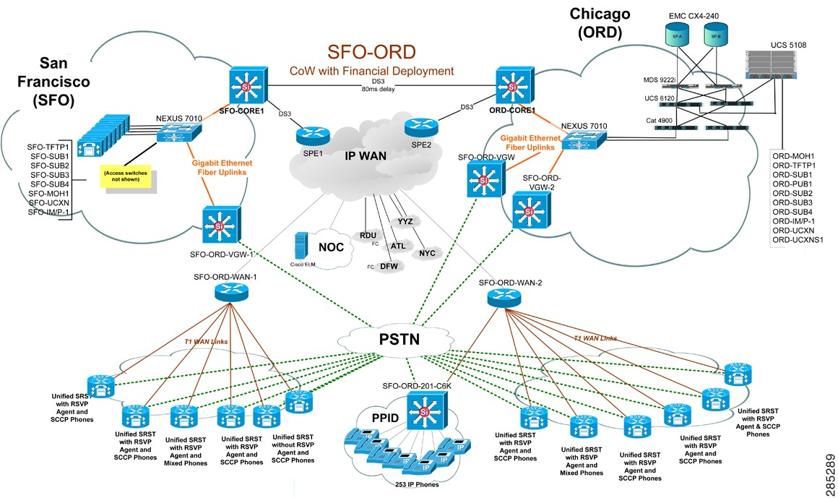

Network Connectivity:

In General network there are two type of connectivity is use. Wireless and Cable.

Cable type:

1. Coaxial cable :

Coaxial cable is the kind of copper cable used by cable TV companies between the community antenna and user homes and businesses.

Example: RG-8, RG – 11, RG – 58 etc.

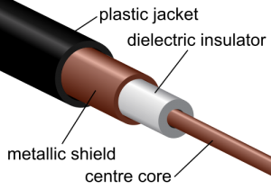

1. Twisted pair cable :

A twisted pair cable is a type of cable made by putting two separate insulated wires together in a twisted pattern and running them parallel to each other. Twisted pair cable is 2 type

## Shielded Twisted Pair Cable (STP) ** Data transfer speed 500 Mbps

## Unshielded twisted pair (UTP) ** Data transfer speed 16Mbps

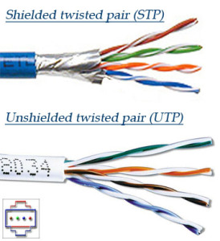

1. Fiber optic cables

A technology that uses glass or plastic fibers to transmit [data](http://www.webopedia.com/TERM/D/data.html). A fiber optic cable consists of a bundle of glass threads, each of which is capable of transmitting messages [modulated](http://www.webopedia.com/TERM/M/modulate.html) onto light waves.

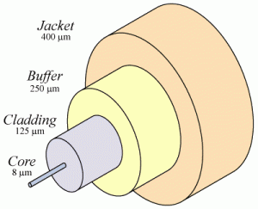

* Fiber optic cables have a much greater [bandwidth](http://www.webopedia.com/TERM/B/bandwidth.html) than metal cables. This means that they can carry more data.

*Fiber optic cables are less susceptible than metal cables to interference.

*Fiber optic cables are much thinner and lighter than metal wires.

*Data can be transmitted [digitally](http://www.webopedia.com/TERM/D/digital.html) (the natural form for [computer](http://www.webopedia.com/TERM/C/computer.html) data) rather than analogically.

**Topology:**

Network topology is the arrangement of the various elements (links, nodes, etc.) of a computer network. Essentially, it is the topological structure of a network and may be depicted physically or logically.

Example:  point-to-point, bus, star, ring or circular, mesh, tree, hybrid etc.

