**Cisco Certified Network Associate** (**CCNA**)

Networking Devices:

1. **Router :**

A router is a device that forwards data packets to different networks, commonly two LANs or WANs or a LAN and its ISP's network.

Routers are located at gateways, the places where two or more networks connect.

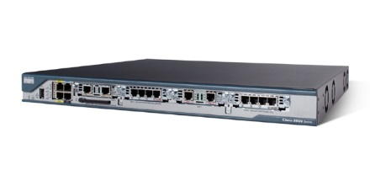

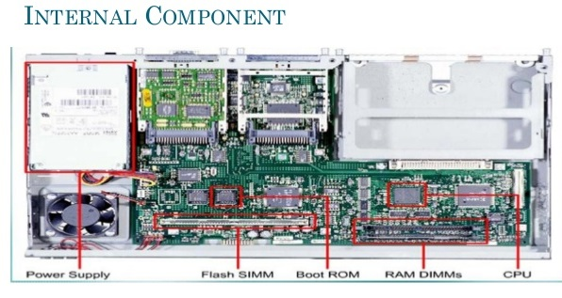

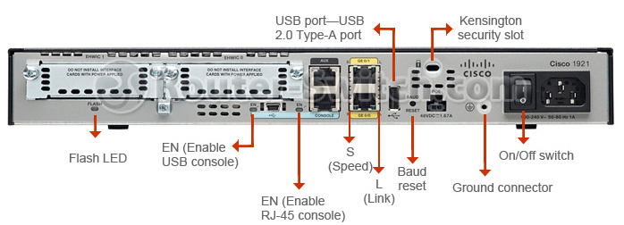

1. Switch:

A switch, in the context of networking is a high-speed device that receives incoming data packets and redirects them to their destination on a local area network (LAN).

A LAN switch operates at the data link layer (Layer 2) or the network layer of the OSI Model and, as such it can support all types of packet protocols.

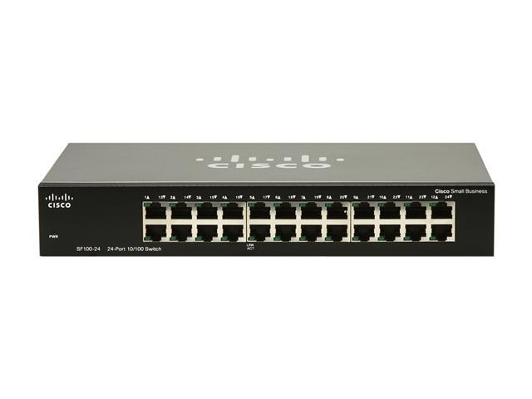

1. Repeater:

A **repeater** is an object that increases a signal's strength, so it can be transmitted and received over a greater distance without a loss in quality. These devices are commonly used with networks to help the lines running between network devices reach farther destinations.

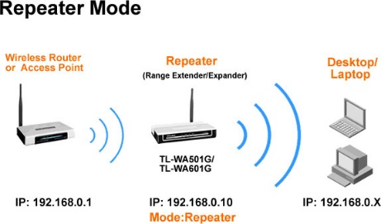

1. Hub:

A **hub** is a common connection point for devices in a network. **Hubs** are commonly used to connect segments of a LAN. A **hub** contains multiple ports. When a packet arrives at one port, it is copied to the other ports so that all segments of the LAN can see all packets

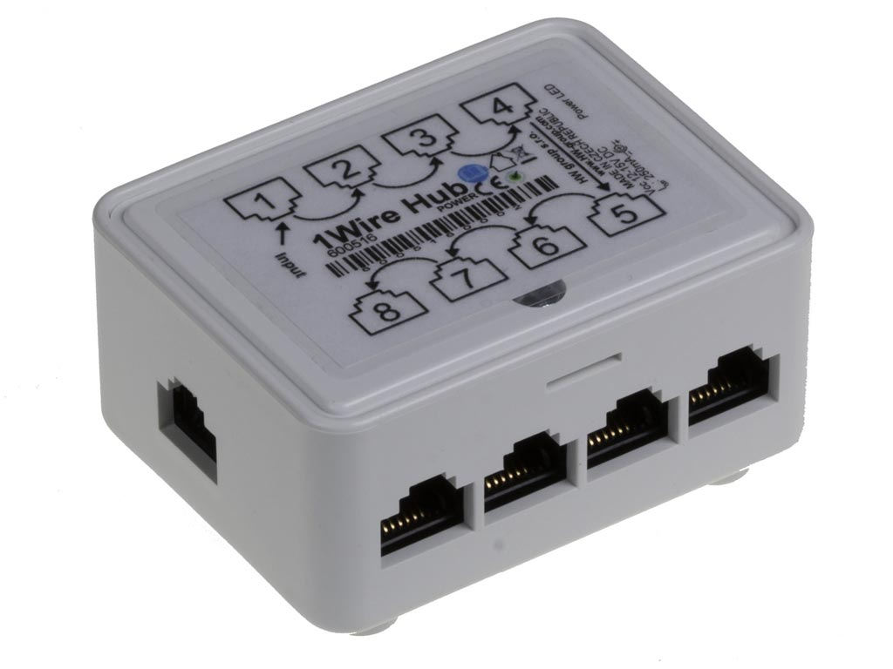

1. Gateway:

A network **gateway** is an internetworking system capable of joining together two networks that use different base protocols.

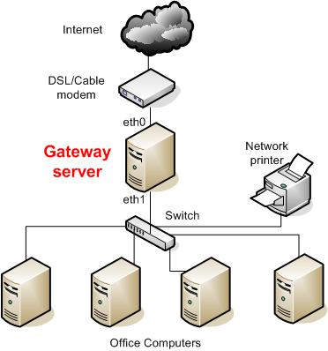

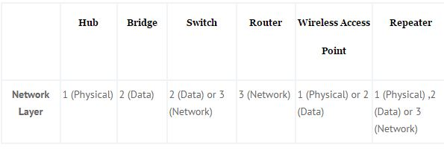**Difference and Important Note:**

## 

## Hub

## 1. Hubs cannot filter data so data packets are sent to all connected devices/computers. The end device has to make decision if it needs the packet. This can slow down the network overall.

2. Hubs do not have intelligence to find out best path for data packets. This leads to inefficiencies and wastage.

2. Pretty much repeat signal on one end to another.

3. Hubs are used on small networks where data transmission is not very high.

## Bridge

1. Bridge maintains a MAC address table for both LAN segments it is connected to.
2. Bridge has a single incoming and outgoing port.
3. Bridge filters traffic on the LAN by looking at the MAC address.
4. Bridge looks at the destination of the packet before forwarding unlike a hub. It restricts transmission on other LAN segment if destination is not found.

## Switch

A switch when compared to bridge has multiple ports.

Switches can perform error checking before forwarding data.

Switches are very efficient by not forwarding packets that error-ed out or forwarding good packets selectively to correct devices only.

Switches can support both layer 2 (based on MAC Address) and layer 3 (Based on IP address) depending on the type of switch.

Usually large networks use switches instead of hubs to connect computers within the same subnet.

## Router

A router, like a switch forwards packets based on address.

A router uses the IP address to forward packets. This allows the network to go across different protocols.

Routers forward packets based on software while a switch (Layer 3 for example) forwards using hardware called ASIC (Application Specific Integrated Circuits)

Routers support different WAN technologies but switches do not.

Wireless Routers have Access Point built in.

The most common home use for routers is to share a broadband internet connection. The router has a public IP address and that address is shared with the network. When data comes through the router it is forwarded to the correct computer.

Connector Prepare:

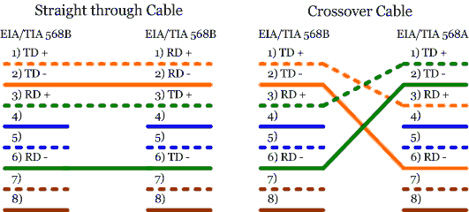

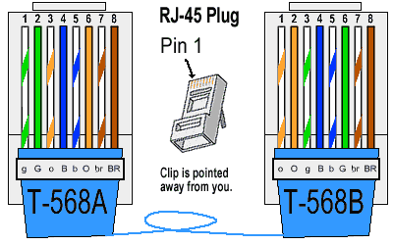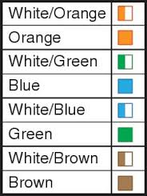

Straight: (White orange) orange (white green) blue (white blue) green (white brown) brown

Crossover: 1-3, 2-6

Rollover: 12345678 87654321

Where Use Cross & Straight: same devices use cross over like router and router, router and pc, hub and switch or in other meaning we can say those devices with same functionality.  
Straight through for different devices like router and switch, pc and switch so on.

If there is auto MDI/MDI-X feature support on the switch, hub, network card or other network devices, you don't have to use crossover cable in the situation which I mentioned above. This is because crossover function would be enabled automatically when it's needed.

=====================================

Thank you

=====================================