OSI Model

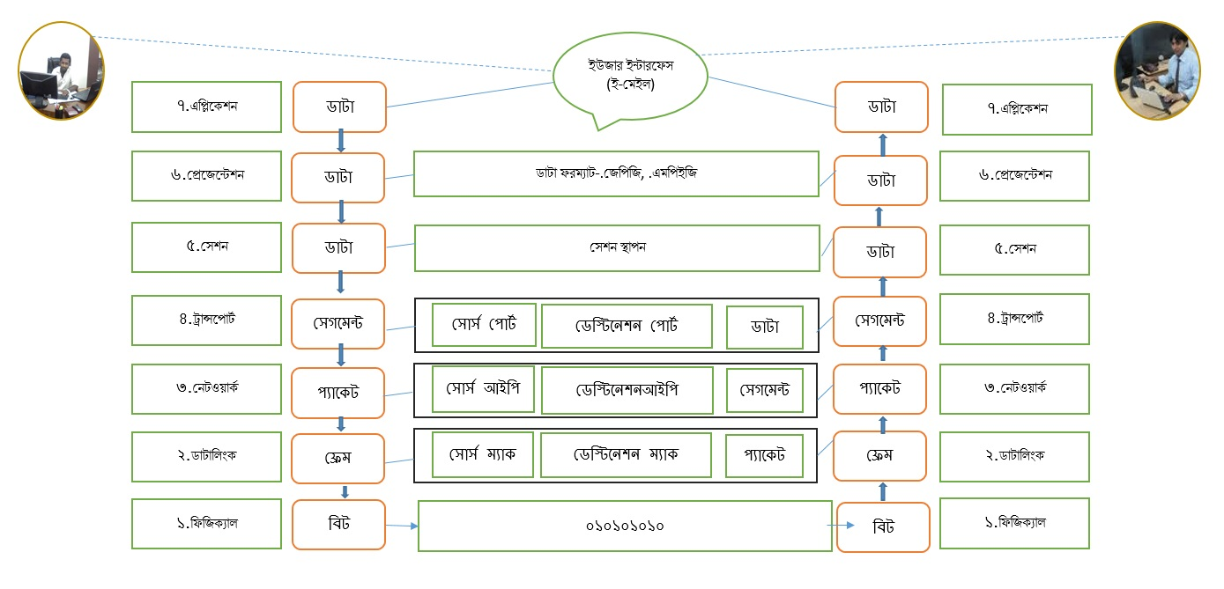

**PDU = protocol data unit**

**Note: transport-segment-port add+data**

**Network 🡪 packet-ip+segment**

**Data link-frame 🡪 mac+packet**

**Physical 🡪 bit**

**Application:** Give user Interface. Data process, remote file access, Directory Service provide. Application layer protocol and port addresses ftp-20/21 telnet-23, dhcp-67/68, dns-53, pop-110, Imap-143, smtp-25 http-80

**Presentation:** The presentation layer of the Open System Interconnection (OSI) model is responsible for how that data looks or is formatted.

**Session:** Session Layer - OSI Model. Its main aim is to establish, maintain and synchronize the interaction between communicating systems.

**Transport:**

The transport layer ensures that messages are delivered error-free, in sequence, and with no losses or duplications. It relieves the higher layer protocols from any concern with the transfer of data between them and their peers.

**Network:** The network layer controls the operation of the subnet, deciding which physical path the data should take based on network conditions, priority of service, and other factors.

**Data link:**

The data link layer provides error-free transfer of data frames from one node to another over the physical layer, allowing layers above it to assume virtually error-free transmission over the link.

**Physical:**

The physical layer, the lowest layer of the OSI model, is concerned with the transmission and reception of the unstructured raw bit stream over a physical medium. It describes the electrical/optical, mechanical, and functional interfaces to the physical medium, and carries the signals for all of the higher layers.