

IDB-BISEW IT SCHOLARSHIP

ASSIGNMENT ON ETHERNET

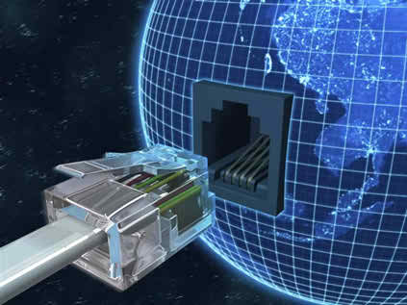

|  |  |
| --- | --- |
| ***Submitted By*** | ***Submitted To*** |
| Abdur Razzak | Mir Akbar Hossain |
| ID: 1204149 | Instructor |
| Batch: ID-NT/ACSL-01M/R28/01 | Networking Technology |
| Date: 20/02/2016 | AT Computer Solution LTD. |

1. **Objective**

**This lab is designed to demonstrate the operation of the Ethernet network. The simulation in this lab will help you examine the performance of the Ethernet network under different scenarios.**

1. **Overview**

**The Ethernet is a working example of the more general Carrier Sense, Multiple Access with Collision Detect (CSMA/CD) local area network technology. The Ethernet is a multiple-access network, meaning that a set of nodes sends and receives frames over a shared link. The “carrier sense” in CSMA/CD means that all the nodes can distinguish between an idle and a busy link. The “collision detect” means that a node listens as it transmits and can therefore detect when a frame it is transmitting has interfered (collided) with a frame transmitted by another node. The Ethernet is said to be a 1-persistent protocol because an adaptor with a frame to send transmits with probability 1 whenever a busy line goes idle. In this lab you will set up an Ethernet with 14 nodes connected via a coaxial link in a bus topology. The coaxial link is operating at a data rate of 10 Mbps. You will study how the throughput of the network is affected by the network load as well as the size of the packet**

**3. Further Readings**

**3.1 Background / Operational Description**

**Ethernet is a bus-based local area network (LAN) technology commonly used in the technical and business communities. Detailed information about the Ethernet protocol is in the IEEE 802.3 Standard.**

**3.2 Model Scope and Limitations**

**The Ethernet MAC model provided with OPNET implements the carrier sensing, collision detection, and retransmission mechanisms specified in the IEEE 802.3, IEEE 8-2.3u, and IEEE 802.3z Standard. Explicit modeling is performed for all features other than serialization of bit transfers to and from the physical layer. The following list itemizes the features provided in this model:**

**• FIFO processing of Transmission Requests**

**• Propagation Delay based on Distance between Individual Stations**

**• Carrier Sensing from Physical Layer**

**• Collision Detection from Physical Layer**

**• Truncated Binary Exponential Back off**

**• Transmission Attempt Limit of 16**

**• Inter-frame Gap Timing for Deference**

**• Jam Sequence Transmission after Collisions**

**• 802.3 Minimum and Maximum Frame Sizes**

**• Frame Bursting (1000BaseX Ethernet operating in half-duplex only)**

**• Full- and half-duplex transmissions**

**You can configure port-based VLANs on all generic bridge and switch models, and on any vendor-specific models that support this technology. Ethernet link models allow you to simulate point-to-point trunk links; a single trunk link can carry traffic for multiple VLANs as specified by IEEE 802.1q. To configure a VLAN, set the VLAN Scheme attribute to “Port-based VLAN” on the bridge or switch supporting the VLAN. You can assign VLAN identifiers to specific port numbers in the VLAN Port Configuration Table. (To find a link’s port numbers, use Link Interfaces on the Edit Attributes (Advanced) dialog box.) Note that you can assign only one VLAN identifier to a specific port. However, multiple ports can belong to the same VLAN. Model Descriptions Reference Manual 8 Ethernet Model Description MD-8-2 IT Guru/Release 9.1 The Ethernet models also support Fast EtherChannel technology. This allows multiple Ethernet point-to-point links to be bundled into one logical full-duplex channel of up to 800 Mbps (for Fast Ethernet) or 8000 Mbps (for Gigabit Ethernet). You can use a Fast EtherChannel or Gigabit EtherChannel link in place of any regular Ethernet link (10BaseT, 100BaseT, or 1000BaseX). EtherChannel links support flow-based balancing of traffic, and are useful for upgrading bottleneck links in Ethernet LAN networks. Note—You can only use EtherChannel links when Ethernet is running in full-duplex mode. The Ethernet models can be deployed either in a bus (10Base2) or a hub (10BaseT, 100BaseT or fast ethernet, and 1000BaseX or gigabit ethernet) configuration. The following list itemizes the main differences between these two configurations:**

**• Connections from the MAC processes to the hub are via duplex point-to-point links, as opposed to a bus medium.**

**• Collision Detection in the hub configuration is handled by the hub, rather than individual MAC processes.**

**• Deference mechanism is handled by the hub, rather than a separate deference process.**

**• Ethernet hubs cannot be directly connected to one another. Instead, a bridge must be used to link two or more hubs together.**

4. Ethernet Connector Pin Assignments

The Ethernet connector is an 8-pin, modular RJ-45 connector.

Table: list the Ethernet connector pin assignments.

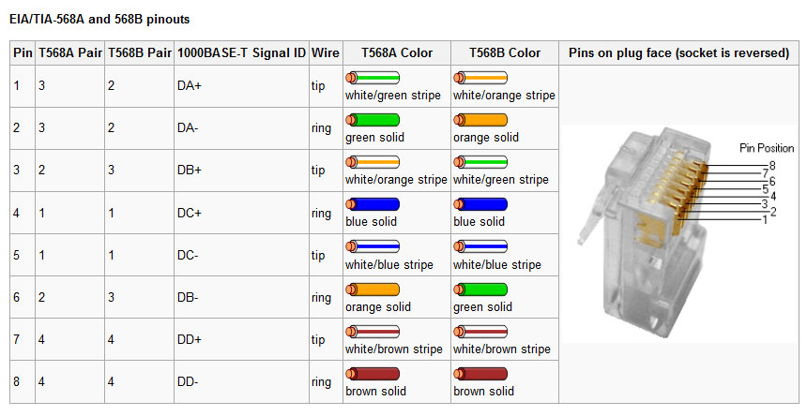

**5. How to Wire Your Own Cables – Industry Standard CAT-5 Pin-out**

The images below depict the cable pin-outs for straight-through and cross-over Cat-5 Ethernet cables that conform to EIA/TIA industry standard for 568 A and B. If the first and second pins are orange, the cable is 568B. If the first and second pins are green, the cable is 568A. If one end of the cable is A and the other end is B then you now have a cross-over.

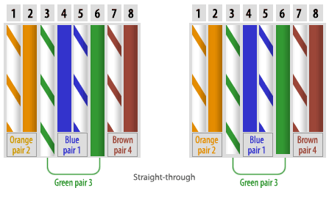**CAT-5 Straight-through Cable Pin Assignments**

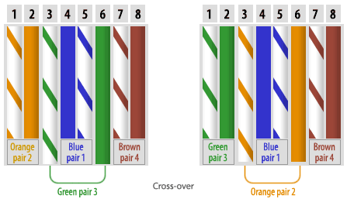**CAT-5 Cross-over Cable Pin Assignments**

5. Ethernet Port Connector

The CDEs come with an integrated dual-port Ethernet controller. This controller provides an interface for connecting to 10-Mbps, 100-Mbps, or 1000-Mbps networks; it provides full-duplex (FDX) capability, which enables simultaneous transmission and reception of data on the Ethernet LAN .To access the Ethernet port, connect a Category 3, 4, or 5 unshielded twisted-pair (UTP) cable to the RJ-45 connector on the back of the device.

Figure: RJ-45 Ethernet Port Connector

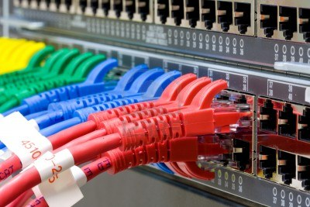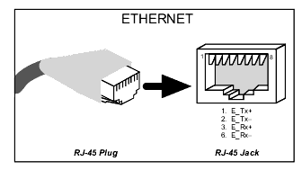

# 6. Understanding Ethernet IP Addressing

6.1 IP Address

A fundamental part of setting up a TCP/IP network is setting up IP addresses. An IP address is a 32-bit number that is generally displayed in dotted decimal format, in which each octet (8 bits) of the address is displayed in decimal format, and each value is separated by period (e.g. 192.168.0.5). A less common, but often useful, way of displaying the address is in hexadecimal. The hexadecimal equivalent of 192.168.0.5 is C0A80005. Every computer on an intranet (one or more networks connected together) must have a unique IP address.

6.2 Subnet Mask

To facilitate communicating between multiple interconnected networks, the IP address is broken into two parts. One part is the network address, and the other part is the local address. Each network has a unique network address, and every device on that network has the same network address portion in its IP address. The local address uniquely identifies a computer within a network. It is expected that local addresses will be duplicated on different networks, but the entire IP address (network address + local address) is always unique.

The method for determining which portion of the IP address is the network address and which portion is the local address is to use a value called a subnet mask. A subnet mask is also a 32-bit number often displayed in dotted decimal format. Each bit of the subnet mask that is a 1 means that the corresponding bit of the IP address is part of the network address. Each bit of the subnet mask that is a 0 means that the corresponding bit of the IP address is part of the local address.

Example:

|  |  |  |
| --- | --- | --- |
|  | Decimal Value | Hexadecimal Value |
| IP Address | 192.168.0.5 | C0A80005 |
| Subnet Mask | 255.255.255.0 | FFFFFF00 |
| Network Address | 192.168.0 | C0A800 |
| Local Address | 5 | 05 |

Therefore, from this example, we see that a device with an IP address of 192.168.0.5 and subnet mask of 255.255.255.0 will have a network address of 192.168.0 and a local address of 5.  Other devices on this network must have the same network address but different local addresses.  Therefore, some possible IP addresses for other nodes on the network include 192.168.0.6, 192.168.0.1, and 192.168.0.25.  There are two reserved local addresses: a local address with all zero bits refers to the network (e.g. 192.168.0.0), and a local address with all one bits is the broadcast address for the network (e.g. 192.168.0.255).

6.3 Default Gateway

Suppose the device given in the above example must communicate with a device on a connected network with an IP address of 192.168.1.8.  Because the device is not on the same network there is no electrical connection between the computers so it cannot send its data directly.  Instead it must go through an IP router.  An IP router is a device that sends packets it receives from one network that are intended for devices on another network to the other network.  Here is the example intranet:

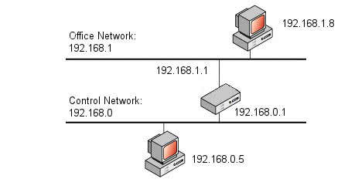

How does 192.168.0.5 send a message to 192.168.1.8?  The answer is that it must use a third parameter called the default gateway. This parameter is the IP address of the router who will take care of getting the packet to its destination. The rule for most devices is to send packets to devices with the same network address directly over its network, but to send packets to devices with a different network address to the default gateway. In the above network, the device at 192.168.0.5 would have a default gateway of 192.168.0.1, and the device at 192.168.1.8 would have a default gateway of 192.168.1.1.

The default gateway parameter is optional if the device will be on a network that is not connected to any other networks, or if you have an intranet but do not want to allow the device to communicate with devices on networks other than its own.

# 7. Ethernet MAC

Ethernet hardware addresses are 48 bits, expressed as 12 hexadecimal digits (0-9, plus A-F, capitalized). They might be written unhyphenated (e.g., 123456789ABC), or with one hyphen (e.g., 123456-789ABC), but should be written hyphenated by octets (e.g., 12:34:56:78:9A:BC). This gives a theoretical 281,474,976,710,656 addresses. This is more than 56,000 MAC addresses for each person on the planet! In practice, the address assignment policy (using fade addressing) will inevitably lead to some wastage - but even so, there are likely to be enough addresses for ever computer, piece of networking equipment and a large number of household/office devices (heating systems, ovens, washing machines, fridges, drinks dispensers, security alarms, video recorders, ...) which could in the future be internet enabled!!!

### Source Address Assignment

The 12 hex digits of source address consist of the first/left 6 digits (which should match the vendor of the Ethernet network interface) and the last/right 6 digits which specify the interface serial number for that interface controller vendor (this gives 256 cubed addresses - or 16.78 million separate serial numbers).

The special address of all zeros (as shown below) is reserved for nodes that currently have no configured MAC address:

00 00 00 00 00 00

The IEEE-assigned addresses allow each vendor to assign their own interface serial numbers (this is a flat addressing scheme), but also allows protocol monitors to examine the first 3 bytes of a frame address to determine the manufacturer of the interface card being used.

The addresses associated with interface cards are source addresses, not multicast nor broadcast, so the second hex digit (reading from the left) will be even, not odd. The following list identifies some of the blocks of assigned vendor MAC addresses (i.e. the first 3 bytes of a MAC source address). As an example, the Ethernet address:

08 00 20 00 70 DF

Corresponds to an interface manufactured by Sun Microsystems.

