Lab 2 Biol 4150/6150 Fall 2015 Pairwise Alignments

Due 1:00 pm Wednesday, September 9. Paste your responses and results below and upload to T-square Assignments folder.

1. Create and show a dot plot of an Arabidopsis calmodulin-like domain protein kinase (CDPK) mRNA (cDNA) sequence versus the corresponding genomic sequence. Adjust parameters (window size, threshold value) until the background is reduced to a suitable level. Paste a screenshot of the final dotplot.
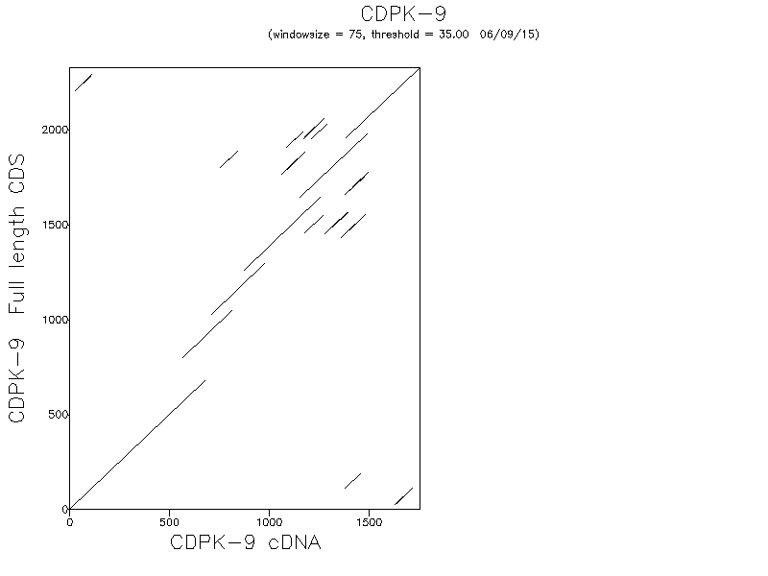

What does the resulting plot tell you?
There are 6 exons

2. Perform a global pairwise alignment between the yeast DAP1 protein (GI 6325087) and a cytochrome b5 protein from any bacterial species, using the needle program in EMBOSS or a Needleman-Wunch implementation on the web.
a) Use the BLOSUM62 matrix.
# Identity: 41/242 (16.9%)
# Similarity: 71/242 (29.3%)
# Gaps: 111/242 (45.9%)
# Score: 75.0

NP_015155.1 1 -------------------------MSFIKNLLFGGVKTSEDPTGLTGNG 25
...:...::...||.|:|.|
EHJ01201.1 1 MESNCINKQGSYSHYYINKMFIGRNSQEVSISIYFDFKTIEEPIG----- 45

NP_015155.1 26 ASNTNDSNKGSEPVVAGNFFPRTLSKFNGHDDEKIFIAIRGKVYDCTR-- 73
|::...:. .|....||:::|.:.:..::|:.|.|||.:.
EHJ01201.1 46 -----DNHLRQQK----QFILEELSQYDGSNGKSAYVAVDGIVYDLSNVE 86

NP_015155.1 74 ----GRQFYGPSGP--YTNFAGHDASR---------GLALNS--FDLDVI 106
|:.|...:|. .:.|..|...: |:.:.| .::|.|
EHJ01201.1 87 AWAGGKHFGLTAGKDLTSEFNSHHGIKKVLNDKPKVGILIESKQKNMDSI 136

NP_015155.1 107 -------------KDWDQPIDPLDDLTKEQIDALDEWQ-----EHFENKY 138
.||.:.|.||.| :||:|.. ||...||
EHJ01201.1 137 ARLTLADTYDFSPDDWIEYIMPLVD------NALEEATGGVSLEHLFQKY 180

NP_015155.1 139 PCIGTLIPEPGVNV---------------------------- 152
..||.|:.: |:..
EHJ01201.1 181 IMIGILVGQ-GMTFKEATGEIEDWEKTGISKLLDQSKGKQVY 221

b) Use the PAM250 matrix. Paste the alignment below and report the score of the alignment.
# Length: 243
# Identity: 40/243 (16.5%)
# Similarity: 85/243 (35.0%)
# Gaps: 113/243 (46.5%)
# Score: 122.0
#
#
#=======================================

NP_015155.1 1 -------------MSFIKNLLFG------------GVKTSEDPTGLTGNG 25
..:|:::::| :.||.|:|.|
EHJ01201.1 1 MESNCINKQGSYSHYYINKMFIGRNSQEVSISIYFDFKTIEEPIG----- 45

NP_015155.1 26 ASNTNDSNKGSEPVVAGNFFPRTLSKFNGHDDEKIFIAIRGKVYDCTR-- 73
:::.....:|:...||:::|.::...::|:.|.|||.:.
EHJ01201.1 46 ---------DNHLRQQKQFILEELSQYDGSNGKSAYVAVDGIVYDLSNVE 86

NP_015155.1 74 ----GRQF--YGPSGPYTNFAGHDASRG---------------------- 95
|::| .:..:..::|.:|::.:.
EHJ01201.1 87 AWAGGKHFGLTAGKDLTSEFNSHHGIKKVLNDKPKVGILIESKQKNMDSI 136

NP_015155.1 96 --LAL-NSFDLDVIKDWDQPIDPLDDLTKEQIDALDE-----WQEHFENK 137
|:| :::|:.. .||.:.|.||.| :||:| ..||:.:|
EHJ01201.1 137 ARLTLADTYDFSP-DDWIEYIMPLVD------NALEEATGGVSLEHLFQK 179

NP_015155.1 138 YPCIGTLIPEPGVNV---------------------------- 152
|..||.|:.: |:..
EHJ01201.1 180 YIMIGILVGQ-GMTFKEATGEIEDWEKTGISKLLDQSKGKQVY 221

c) Compare and contrast the two alignments - highlight any differences.

3. Perform a local alignment between the two sequences, using the water program in EMBOSS or an implementation on the web.
a) Use the BLOSUM62 matrix. Paste the alignment below, and report the score of the alignment.
# Length: 170
# Identity: 40/170 (23.5%)
# Similarity: 65/170 (38.2%)
# Gaps: 57/170 (33.5%)
# Score: 85.0
#
#
#=======================================

NP_015155.1 13 KTSEDPTGLTGNGASNTNDSNKGSEPVVAGNFFPRTLSKFNGHDDEKIFI 62
||.|:|.| |::...:. .|....||:::|.:.:..::
EHJ01201.1 38 KTIEEPIG----------DNHLRQQK----QFILEELSQYDGSNGKSAYV 73

NP_015155.1 63 AIRGKVYDCTR------GRQFYGPSGP--YTNFAGHDASR---------G 95
|:.|.|||.:. |:.|...:|. .:.|..|...: |
EHJ01201.1 74 AVDGIVYDLSNVEAWAGGKHFGLTAGKDLTSEFNSHHGIKKVLNDKPKVG 123

NP_015155.1 96 LALNS--FDLDVI-------------KDWDQPIDPLDDLTKEQIDALDEW 130
:.:.| .::|.| .||.:.|.||.| :||:|.
EHJ01201.1 124 ILIESKQKNMDSIARLTLADTYDFSPDDWIEYIMPLVD------NALEEA 167

NP_015155.1 131 Q-----EHFENKYPCIGTLI 145
. ||...||..||.|:
EHJ01201.1 168 TGGVSLEHLFQKYIMIGILV 187

b) Use the PAM250 matrix. Paste the alignment below, and highlight any differences between this alignment and the alignment generated with BLOSUM62.
# Length: 195
# Identity: 39/195 (20.0%)
# Similarity: 83/195 (42.6%)
# Gaps: 71/195 (36.4%)
# Score: 131.0
#
#
#=======================================

NP_015155.1 3 FIKNLLFG------------GVKTSEDPTGLTGNGASNTNDSNKGSEPVV 40
:|:::::| :.||.|:|.| :::...
EHJ01201.1 16 YINKMFIGRNSQEVSISIYFDFKTIEEPIG--------------DNHLRQ 51

NP_015155.1 41 AGNFFPRTLSKFNGHDDEKIFIAIRGKVYDCTR------GRQF--YGPSG 82
..:|:...||:::|.::...::|:.|.|||.:. |::| .:..:
EHJ01201.1 52 QKQFILEELSQYDGSNGKSAYVAVDGIVYDLSNVEAWAGGKHFGLTAGKD 101

NP_015155.1 83 PYTNFAGHDASRG------------------------LAL-NSFDLDVIK 107
..::|.:|::.:. |:| :::|:.. .
EHJ01201.1 102 LTSEFNSHHGIKKVLNDKPKVGILIESKQKNMDSIARLTLADTYDFSP-D 150

NP_015155.1 108 DWDQPIDPLDDLTKEQIDALDE-----WQEHFENKYPCIGTLIPE 147
||.:.|.||.| :||:| ..||:.:||..||.|:.:
EHJ01201.1 151 DWIEYIMPLVD------NALEEATGGVSLEHLFQKYIMIGILVGQ 189

c) Compare and contrast the global and local alignments. Which algorithm gave the better alignment? Write a brief explanation of why the two algorithms gave different alignments in this instance.

4. Test the effects of using a different BLOSUM scoring matrices in #3 above - which scoring matrix gives the best alignment? Explain and justify your criterion for the quality of the alignment.

5. Use the PRSS Shuffle program (http://www.ch.embnet.org/software/PRSS_form.html) to visualize the distribution of alignment scores if the second sequence is randomly shuffled. Be sure to use the same BLOSUM matrix and gap penalty as in one of your local alignments in 3 or 4 above.
a) Paste a screenshot of the resulting distribution. Based on this distribution, is the score you obtained in 3 or 4 significant? Explain.
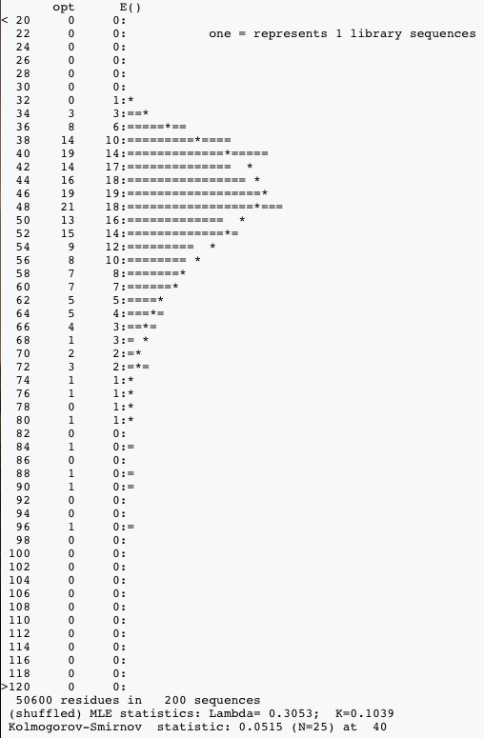
b) Redo the shuffle, but this time trim the two sequences so only the regions that align are included in the comparison. Paste a screenshot of the resulting distribution, and explain whether or not the
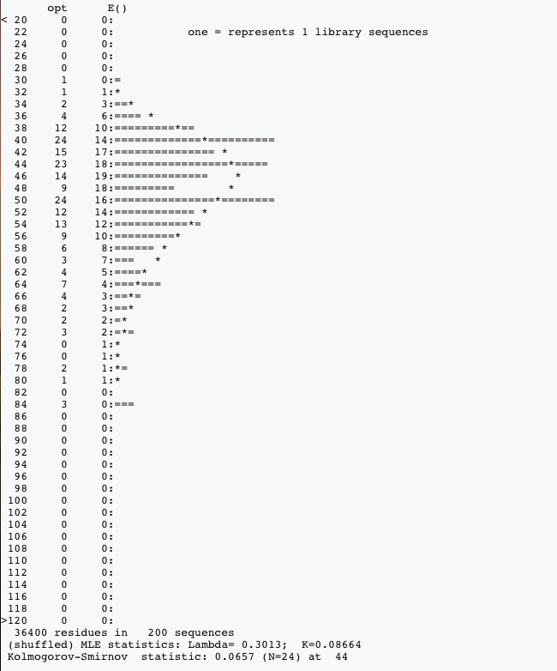
alignment score is statistically significant.

