1. 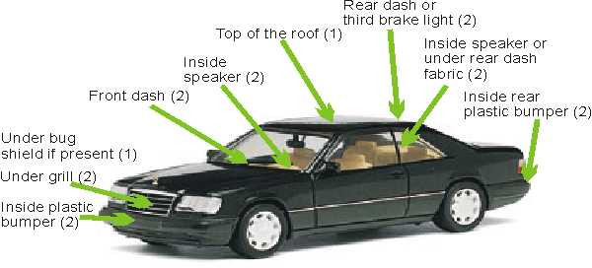Install the external peripherals on the recommended areas of the vehicle
2. 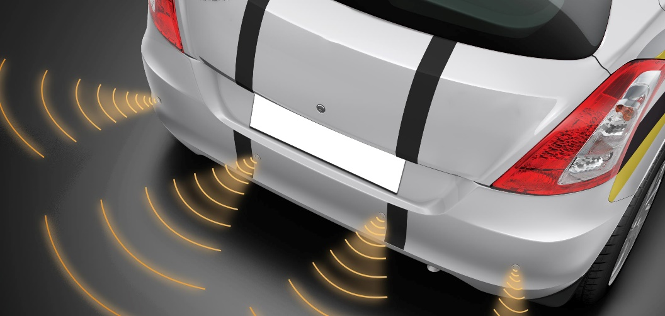Start the vehicle

**PROXIMITY SENSORS**

1. 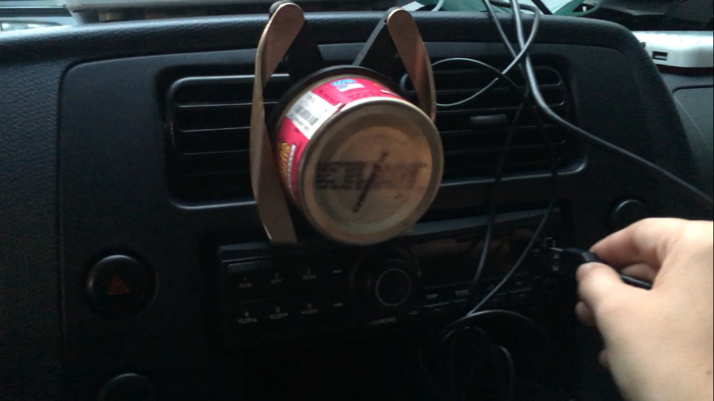Connect the device to the USB port of the vehicle or another power source such as a power bank.
2. The device will automatically check if the vehicle is nearing an obstacle. (The device will alarm continuously until there is a safe distance between the car and the obstacle)
3. In the instance of a car collision or crash, the device will alarm for 5 seconds.
   1. If the driver fails to press the cancel button and the long beep of the alarm is heard, the device will send the location of the vehicle to the authorities and family members.
   2. If the driver presses the cancel button before hearing the long beep (before 5 seconds). The automatic message to authorities will be cancelled thus saving the time and resources of multiple parties.

**Note:** Besides the installation of peripherals before the actual use of device, the user must sign a Memorandum of Agreement with the proponents in order to ensure the appropriate use of the device.