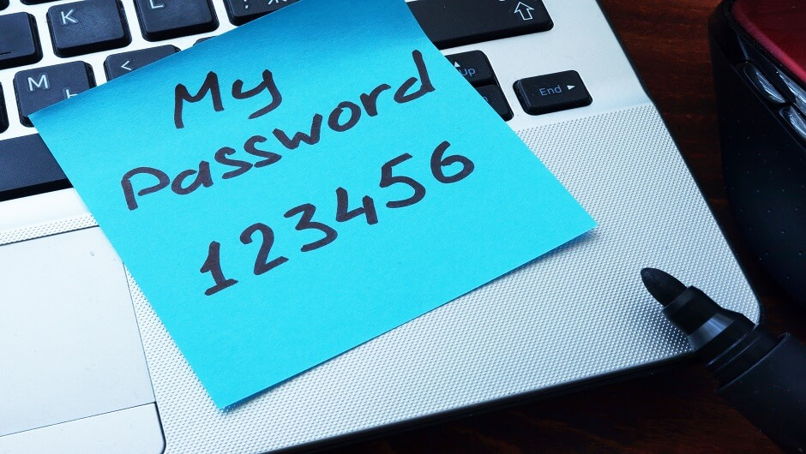

**PASSWORD STRENGTH CHECKER**

**USER GUIDE**

Created By

* Vinit Kumar
* Aman Raj
* Lavish Gulati

**CONTENTS**

1. Introduction ……………………………………………………………………………………………………………. 3
2. System Requirements …………………………………………………………………………………………….. 3
3. Quick Start Guide ……………………………………………………………………………………………………. 3
4. Check Strength of The Password ………………………………………………………………………. 4
5. Save and View Last Saved Password …………………………………………………………………. 7
6. View Suggested Password ………………………………………………………………………………… 8
7. Troubleshooting ……………………………………………………………………………………………………… 9

**1** **INTRODUCTION**

The Password Strength Checker application allows users a simple interface to check the strength of their passwords. The users can also save their passwords and view their last saved password. The application also suggests strong passwords which the user can use.

This document will provide instructions for using the application and its various features.

**2** **SYSTEM REQUIREMENTS**

* Windows 7 or higher
* Visual Studio 2013
* 1.6 GHz or faster processor
* 1 GB of RAM (1.5 GB if running on a virtual machine)
* 20 GB of available hard disk space
* 5400 RPM hard disk drive
* DirectX 9-capable video card that runs at 1024 x 768 or higher display resolution
* KB2883200 (available through Windows Update) is required

**3** **QUICK START GUIDE**

The main application window is show in the figure given below. Its components are:

* Username: The user can provide his/her username in the ‘Username’ textbox which will be used to save the password for the user.
* Password: The user provides the password in the ‘Password’ textbox to determine its strength.
* Show Password: The ‘Show Password’ checkbox is given just above the ‘Password’ textbox. The password is by default encrypted by ‘*’ character. To view the password, the user needs to check the ‘Show Password’ checkbox.
* Save: The ‘Save’ button allows the user to save the password which can be accessed by the username later.
* Show Saved: The ‘Show Saved’ button opens another form which displays the last saved password corresponding to the username entered by the user.
* Suggest Password: The ‘Suggest Password’ feature generates a random strong password which the user can use.
* Use This: The ‘Use This’ feature copies the suggested password to the ‘Password’ textbox so that the user can use it instantaneously without the hassle of typing it himself/herself.

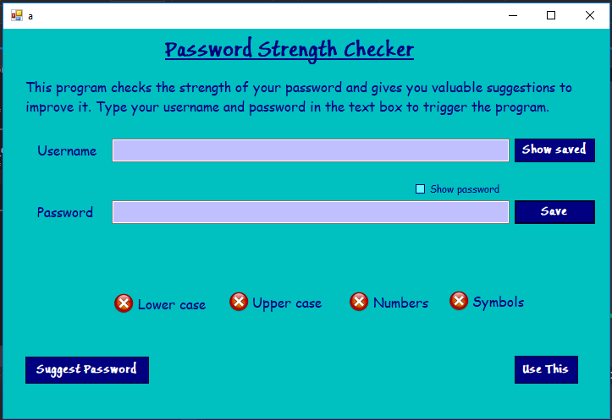

**3.1** **CHECK STRENGTH OF THE PASSWORD**

1. Type the username in the ‘Username’ textbox and the password in the ‘Password’ textbox. A message will be displayed below the ‘Password’ textbox showing the strength of the password.
2. The background color of the application will change from red to green depending on the strength of the password.

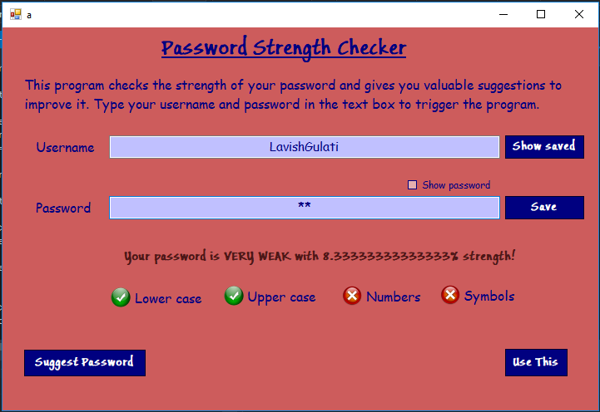

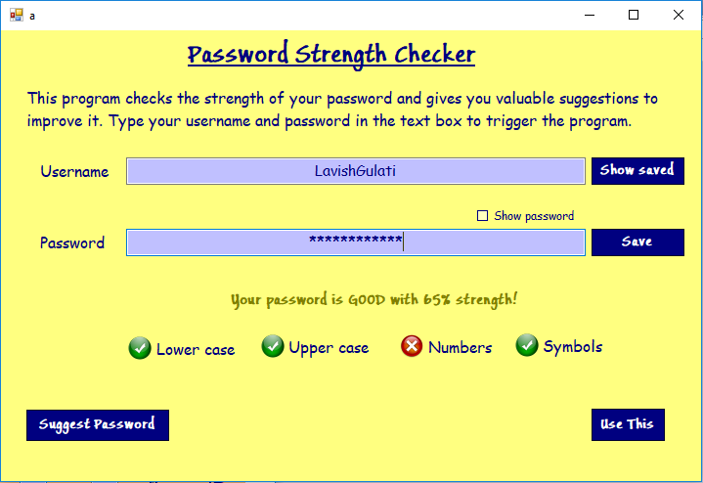

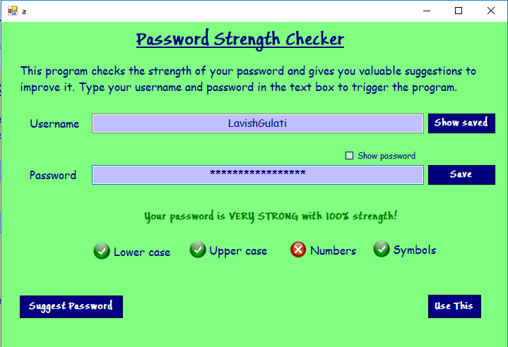

1. By default, the password is encrypted by ‘*’ characters. To view the password, click on the ‘Show Password’ checkbox.

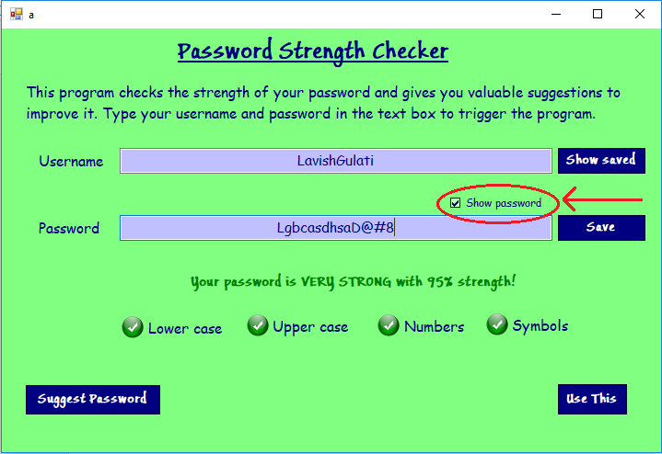

1. The user can also view whether his/her password contains at least one of the following types of characters, i.e., lowercase, uppercase, numbers or symbols, which is displayed by the tick/cross signs below the message.

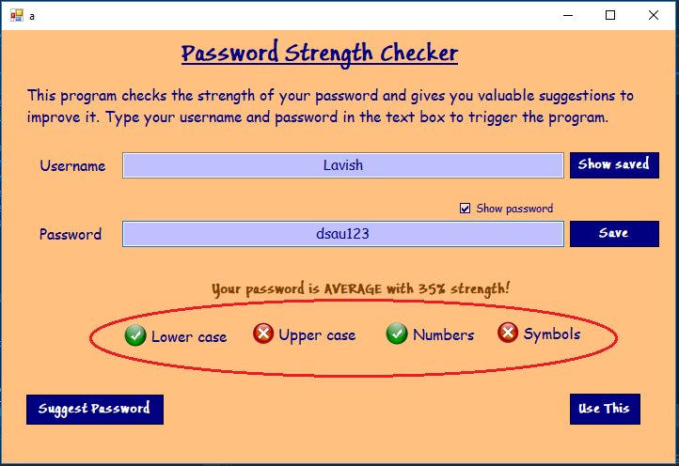

**3.2** **SAVE AND VIEW LAST SAVE PASSWORD**

1. To save the password, the user must mention his/her username and type the password to be saved in the ‘Password’ textbox. Click on the ‘Save’ button next to the ‘Password’ textbox to save the password.

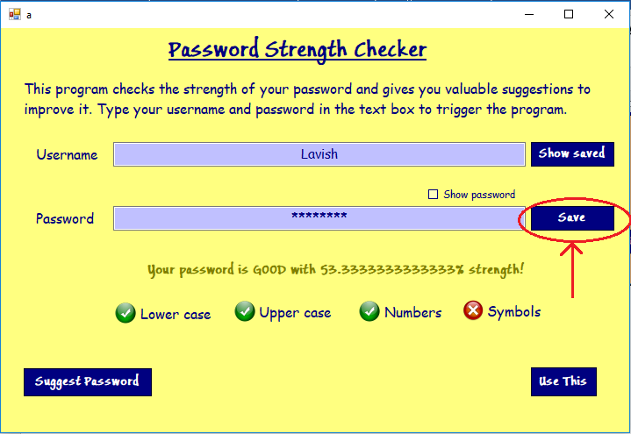

1. To view the last saved password, the user must mention his/her username in the ‘Username’ textbox. Then click on the ‘Show saved’ button. This will display a pop-up showing the username and the last saved password for that username.

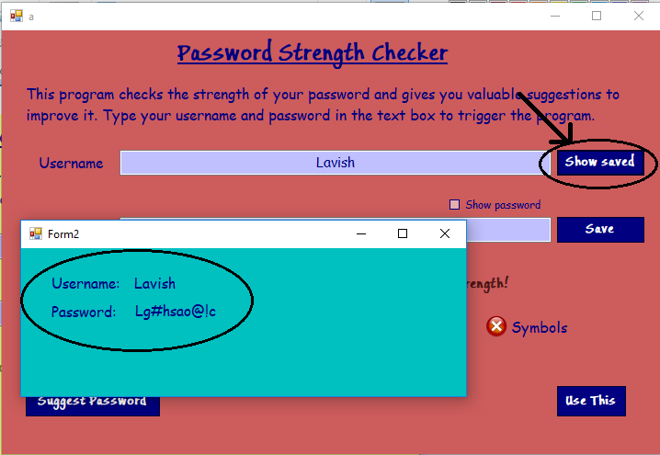

**3.3** **VIEW SUGGESTED PASSWORD**

1. If the user can’t come up with a good password, he/she can click on the ‘Suggest Password’ button which provides a randomly generated password which is guaranteed to be strong.

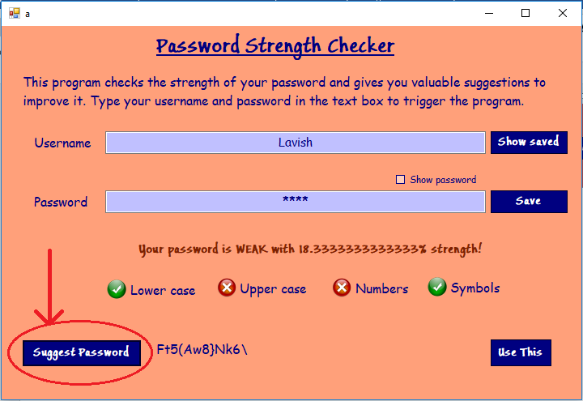

1. The user can also copy the generated password directly to the ‘Password’ textbox by clicking on the ‘Use This’ button.

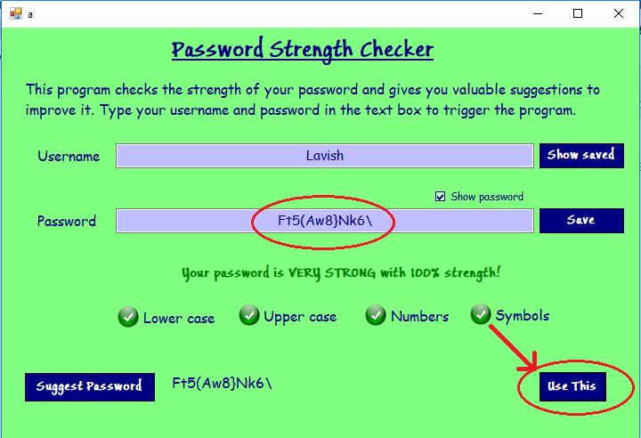

**4** **TROUBLESHOOTING**

1. The user might enter blank spaces in their password which is unacceptable on most of the login sites on the web. In such a case, an invalid message is displayed instead of the strength of the password.

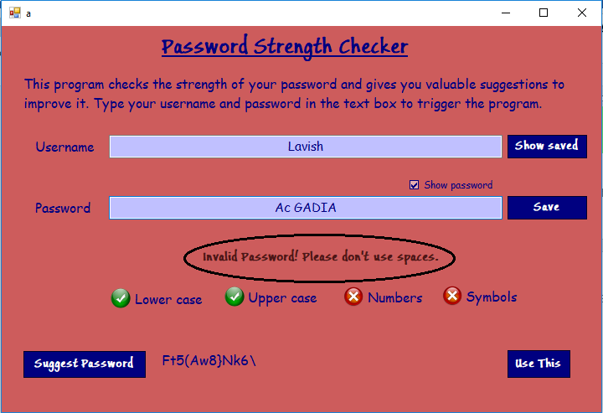

1. The user might enter common words such as ‘love’, ‘test’, ‘hello’ etc. in their passwords which makes the password weaker. Is such a case, a message suggesting the user not to use such common words is displayed instead of strength of the password.

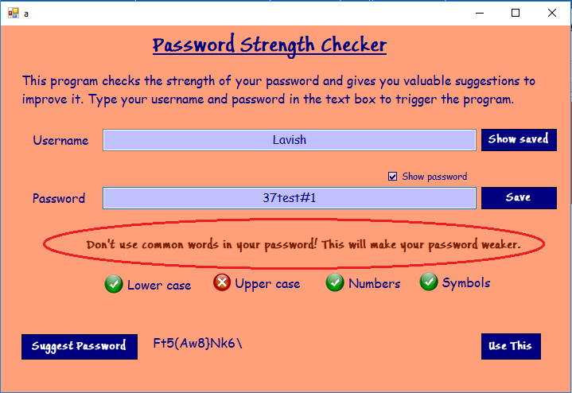

1. The user might enter a username whose password is not yet saved by the application. In such a case, if the user clicks on ‘Show Saved’ button, an error message is displayed in the ‘Password’ section mentioning there are no saved passwords corresponding to that username.

