1. PRADEEP-INTRO  
   A pleasant good morning to one and all present here,  
   Today as a team we have gathered here to present ZUKTI 3.0  
   The main theme for making this Zukti is to assist users in the process of learning.  
   Although there are many ways of learning, Zukti takes learning to a completely different level.  
   With modern advancement in cognitive science and pedagogy, it is evident that we have to move out of the traditional one-to-one learning process. Such learning tends to become monotonous, which adversely impacts the overall learning process.  
   To address this big challenge, we introduced several exciting features in this release of Zukti.  
   One such feature is assessments. Friends, Zukti now provides assessments to assess your knowledge level across different domains.  
   We have also introduced an innovative approach to allow users to read books published through the crowdsourcing approach of the other product Zynla. On top of that Zukti also allows users to publish their articles by leveraging the knowledge base of Zukti.  
   Another feature of this release of Zukti is the interaction module. Users now are not limited only to the one-to-one interaction with Zukti. At any time, user can start interaction with other members currently online the platform.Before moving ahead,  let me introduce my team…

2.Architecture-Maneesha

I will be walking you through our application architecture and the core technologies used in each tier.

Zukti is built on top of the Mongo-Express-ReactJS-Node (MERN) stack with Neo4J as the graph database. Our application is based on the n-tier application architecture.

Presentation The front-end of our application is a Single Page Application (SPA) developed using ReactJS. As we are using ReactJS, we have a highly modular component-based architecture.

Middleware: We used NodeJS as the server-side platform and Express as the Web framework on top of it.

Microservice: Microservice is one interesting part of the architecture where we have the intent and concept parsing service.

Data Storage:

Zukti have different data storage requirements. And based on those requirements, we have

• MongoDB to store user information and messages of the interaction module as JSON documents.

• Neo4J the One database for both Zukti and Zynla to store our graph ontology divided into Concept and Intent graph. In addition Zukti is additionaly using Neo4J to store assessments.

• Redis cache to store the concepts and intents from Neo4J when the application starts.

3.Acl- Anjali

Initial problems :-  
Hi goodmorning to one and all. I am Anjali and I am here to give you guys insight about ACL.  
In the present scenario security of sensitive data is major concern. Many organizations still rely on orthodox method of, user-based identity management However, as the number of users and applications increase, supporting such a system becomes time-consuming, unwieldy and expensive. Users quickly become frustrated by the need to remember multiple passwords and here ACL comes into role. ACL checks for authorization.   
Now I will call my colleague rajapavithra to give more details about ACL.

4.Rajapavithra

Thank you Anjali.  
We implemented ACL in Zukti to attach a list of permissions to a resource. In Zukti, a resource is a route. In short, with ACL we have protected our routes. The new ACL module specifies which users are granted access to routes, as well as what permissions, such as read, write, update, and delete are allowed on given routes.   
Our ACL modules have four features:

1.Add new role  
2.Assign role to a new user  
3.Edit user access, and  
4.Update role Let me present how an admin can add a new role.  
To add a role, an admin needs to specify the role name.   
Once a role is created, the admin can assign users to that role. Let’s assign the user <<>> to the new role <<>> that we just created.  
I would invite Anjali to take this forward.  
In addition to adding a new role and adding users to a role, we made the ACL module of Zukti flexible enough to meet changing security requirements of the platform. For example, if a guest A is assigned the User role, he will enjoy the privileges to access the routes applicable for Users. But for certain security constraints, an Admin can revoke privileges of one or more routes of that user.   
As you can see, The Edit Resource window displays the resources of a role. Here, an admin can remove a resource, and also add a new resource.  
I will next invite   
To change the role of an existing user, the admin can click the Change Role button. In the Change Role window that appears, the admin can select a user. His current role is displayed. The admin can change the role from the drop-down option.  
‘That was all about the ACL module. THANKS

5.Priya-Thank you Raja Pavithra,

I am going to take you through the new Books and Articles module that we have created in Zukti.  
First let me explain the motivation of doing this. Reading an article about a particular topic gives you the knowledge of the topic without any distractions of unwanted details. So, with an article we get the content that we actually want.   
Now let me present how a user can create a new article in Zukti.   
For a new article, a user can search the Zukti knowledgebase with keywords. The user can then convert the search results that Zukti returns as a PDF document. The generated PDF document gets added to his list of articles. The user can at any time refer his published articles.  
Currently, a user is allowed to create a maximum of 3 articles per day.   
Basic highlights of this article is that the pdfs are created on 2 basis.  
One is user specific-(i.e) A particular users page will contain only the articles created by him.  
The Second highlight is that these pdfs are that it is domain specific.(i.e),User can search and generate pdfs for the concepts present only his particular domain in which he is present.If he tries to create a pdf of a concept which is out of the current domain then he gets a warning alert saying that the searched topic is not present in that domain.  
This was all about articles. Next let me ask …….

6.Sindhu

Hi, let me take you through the books feature of Zukti. The concept of an article in Zukti maps to a ready made reference point for some topic. For example, if a user is interested to know about the topic React state management, the user can refer a corresponding article on state management.   
If a user needs broader knowledge, the user can use the Books feature of Zukti. For example, if a user wants to learn about the React technology, he can refer a book on React through Zukti.   
As both Zukti and Zynla have the same knowledge base, we have developed, tested, and integrated the book publishing feature in Zynla, that you have already been demonstrated. From Zukti’s platform, we have implemented the feature of viewing published books through REST API calls.   
Let's see the demo of viewing a book in Zukti.That is all about Articles and Books Modules. Now i would like to call upon my friend Vivek to explain about the next feature

7. Vivek- assessment

As everybody knows, assessment is the process of gathering and discussing information from multiple and diverse sources in order to develop a deep understanding of what students know, understand, and can do with their knowledge. The assessment process culminates when assessment results are used to improve subsequent learning  
In a nutshell, we can say that assessment is the systematic collection, review, and use of information about educational programs undertaken for the purpose of improving student learning and development.   
Assesement is an integral part of any learning platform, and therefore we have introduced a highly effective assessment module in Zukti.  
The assessment module allows a user to:  
Take practice test  
Take a graded test that is not time bound.  
Take a time-based graded testAfter each test, the test module displays reports, such as:  
Number of attempts per question in practice test  
Marks of the assessment for both practice and graded tests.

8.Kowsalya-Practice test

An important feature of the new Assessment Module is practice test. Users can now undergo practice tests on a domain, at his own time and convenience. Practice tests also allows a user to get familiar with the test environment before undertaking the real graded test.

Practice test does not assume any time boundary to complete the test. When a user undergoes the practice test, his interactions, such as number of attempts and correct answer are recorded for grading purpose.

A practice test contains five random questions. For each question, a user can make four attempts.

………

If a user answers correctly on the first attempt, 10 marks are allocated to her

For the second attempt, 5,

For the third attempt 2 marks, and

1 for the last attempt.

<<Result page>>

Once the user completes the test, he or she is presented his test score on the result page. Along with the score, the user is also presented with analytical graphs on his performance.

9.Pavithra.N-Take test

My friend …just demonstrated how practice test works. Now, I will demonstrate how Graded Test works. The main difference between practice and graded test is that, unlike practice test, you don’t get multiple attempts in graded test.

In Zukti, there are two types of graded test. Timed test and Untimed test.

As relevant from their names, a time test contains 5 questions and is limited to one minute.

<<Demo>>

As you can see, after completing the test, a user can view his marks.

Timeless test is similar, except, as I previously mention, it is not time bound. That was all about the new assessment module of Zukti.

10.Arul-Assessment admin

Thank you pradeep..  
My colleagues just explained about the assessment module. For the Assement modules to provide quality questions to assess users, we need someone to provide those questions to the module. That person should also be able to set the rules and regulations for assessments. Yes. I am referring to the assessment administrator role.Let me explain how an assessment admin adds questions with a demo…..  
Q: Is props mutable…..  
Option: true, false  
Ans: false (checkbox)  
Hint: propsIn addition to adding new set of questions and options, an assesement admin can also edit Q/A sets(demo) and delete.  
Q: Is props mutable in react ?  
Hint: mutable- can be changed.I like to call pavithra to explain about discussion module.

11.Pavithra K-**Why Interaction Module?**

* Hi everyone I'm Pavithra. I'm here to explain the new Discussion module that we introduced in Zukti.
* As my colleagues explained, in zukti there are two techniques for learning. One is learning through book and other technique is learning through bot interaction. While learning through bot interaction, user can ask a question to Zukti and Zukti responses with an answeer. For eg., if a user types 'what is react?' Zukti will process the question, and retrieves the answer from database, and presents it to the user. Zukti also has the capability to suggest additional blogspot and videos relevant to the question. By the help of these recommendations, user can gain more knowledge on a specific domain.
* When we were monitoring user experience in the initial release of Zukti, there were several aspects that required attention. A primary one is the level of engagement of Zukti with the user. As Zukti is still at its nascent stage, we found user’s engagement is limited with Zukti. Because Zukti’s knowledge base is yet to grow and often users are left with no response for questions. So in order to increase user engagement with the platform, we decided to develop a group interaction module.
* The second use case of the interaction module is related to Zynla, which you have already seen. Prior to this release, a user could follow another user. However, there was no options for a user to communicate directly with other users.
* Let me know invite my colleague Nitansh to explain the working of the interaction module.

Thank you

**12.Nitansh-Group Discussion**

* Hi everyone my name is Nitansh. I'm here to walk you through the group interaction in zukti.
* Now, whenever a user cannot understand an answer provided by Zukti, he can do three things:

1. Join an existing discussion room and start a question thread.
2. Join an existing discussion room as a domain expert and contribute knowledge to an ongoing question thread.
3. Create a new discussion and start a question thread

* By default, there is a general channel in Zukti’s group interactions related to general information. For example, in the general channel, a user can broadcast an invite to other users to join a separate channel.
* Next, I will present how a user can create a separate room to start a discussion on a particular topic.
* Next, I would like to invite my colleague Nandhini to explain One-to-One interaction.

**13.Nandhini One-to-One Chat**

As my colleague, Pavithra already explained the new Interaction module of this release of Zukti, we have implemented the capability of a user to directly interact with other users currently online on the platform.

* To start a new interaction, a user simply needs to click on the user icon. The interaction box appears, and all conversations done here will be between both the users.
* Whenever new message arrives, a user receives a notification.
* In order to view the message, the user needs to click on the notification icon.
* The user can now view or reply back to the discussion.

This was all about the one-to-one interaction. Thanks.

**Thank you**

14- Deepali Conclusion

• I would like to conclude the journey of this training.

• When we joined this training, we had no idea about how current technologies like React JS, Node JS, Express and so on works. We started with a mind-block on how we would be able to learn so many technologies and implement them in 3 months. So, we started with the learning part. We learned all of the technologies in one and a half month where our method of studying was orthodox. Our mentors suggested us the right approach to study and we referred official websites to learn the technologies.

• Then for one and half months we worked on product development where we added more functionalities to Zukti.

For the product development, we used these technologies:

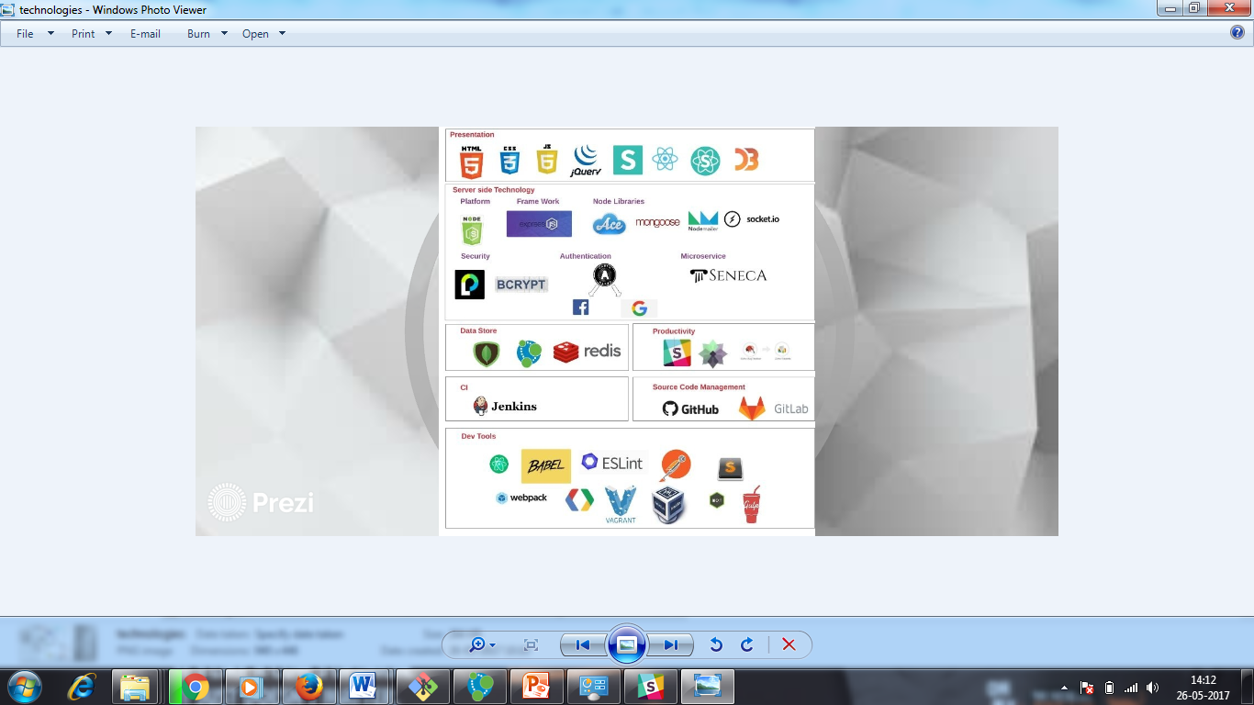

• During product development, we used agile sprint framework.

• We had 6 sprints of one week each.

• Each sprint cycle started with a planning, execution. We had daily scrum standups.

• At the end of each Sprint we demonstrated our product.

• The demonstration was followed by a Sprint retrospective meeting and review where our mentors guided us on what went right and what wrong.

• Like this we were able to develop this product and we are glad to give the demonstration in front of you all.

• We hope that you liked our product demonstration.

• Thank you all and now we are open for any queries.

