A Project Report

on

Recommendation System Using Machine Learning Techniques

carried out as part of the Minor Project IT3270 Submitted

by

Aditya Rana
209302339

in partial fulfilment for the award of the degree of

Bachelor of Technology

in

Information Technology

Under the Guidance of
Guide Name


School of Information Technology
Department of Information Technology

MANIPAL UNIVERSITY JAIPUR
RAJASTHAN, INDIA

April 2023

CERTIFICATE

Date: 21 April 2023

This is to certify that the minor project titled Recommendation System Using Machine Learning Techniques is a record of the bonafide work done by Aditya Rana (Reg No.- 209302339) submitted in partial fulfilment of the requirements for the award of the Degree of Bachelor of Technology in Information Technology of Manipal University Jaipur, during the academic year 2022-23.

Mr. Dhananjay Kumar Singh
Assistant Professor
Project Guide, Department of Information Technology
Manipal University Jaipur

Dr. Pankaj Vyas
HoD, Department of Information Technology
Manipal University Jaipur

Abstract

In the present-day scenario, the rise of e-commerce platforms has led to an increase in the volume of items available to customers, making it challenging to find the right product. Item recommendation systems help address this issue by providing personalized recommendations to users based on their past behavior. The objective of this project is to develop an item recommendation system using nearest neighbor and cosine similarity techniques.An information filtering method known as a recommendation system offers people ideas for products, services, or information based on their interests, prior behaviour, and other relevant data. It is frequently employed in many different situations, such as e-commerce, social networking, entertainment, and education. Recommendation system major objectives are to improve user engagement and happiness, direct users to related goods that may be of interest to them, and perhaps boost business income.

There are many different types of recommender systems, including content-based, collaborative filtering, hybrid, and knowledge-based systems. While content-based systems utilise item attributes to propose items, collaborative filtering systems leverage a user's behaviour and similarity to other users to do so. A hybrid system combines many recommendation methodologies to create more precise and diverse recommendations. Recommendation systems are increasingly important tools that agencies employ to improve user experience and encourage client retention.

LIST OF CONTENTS

S.no | Content | Page No.
1. | Introduction | 5
2 | Overview, Motivation, Application | 5
3 | Problem Statement | 7
4 | Objective | 7
5 | Scope | 8
6 | Background Details | 8
7 | Literature Review | 9
8 | Methodology | 13
9 | Implementation and Results | 14
10 | Timeline | 17
11 | Conclusion | 18
12 | Future Work | 19
13 | References | 19

List of Figures

Figure No | Figure Title | Page No
1. | E-R Diagram | 11
2. | Flow Chart | 11
3. | Use Case Diagram | 12

List of Tables

Table No | Table Title | Page No
1. | Literature review of Item-based collaborative filtering recommendation algorithm | 9
2. | Literature review of Collaborative filtering-based recommender system | 9

- Introduction
    - Introduction (Overview, Motivation, Applications & Advantages)
Overview
To give clients personalised recommendations, recommender systems are potent tools utilised in many applications. These systems give consumers products, services, or information based on their prior interactions, preferences, and behaviour using machine learning and data analysis techniques. Through the delivery of suggestions that are pertinent, practical, and tailored to each user's individual needs, these systems seek to enhance the user experience.

Motivation

Use of recommender systems is driven by a variety of factors, some of which are as follows:

Based on users' prior interactions, preferences, and behaviour, recommender systems may offer tailored recommendations to consumers. Users gain as a consequence, and they usually feel happy.

- Increased engagement and retention lead to greater customer loyalty: Recommender systems can increase user engagement and retention by delivering users with helpful recommendations.

- Sales and revenue growth: By proposing goods or services that customers are more likely to buy, recommender systems may boost sales and revenue.

- Increasing revenue: recommendation systems can increase company revenue by increasing sales, improving customer loyalty and reducing churn.

- Competitive advantage: Companies that use recommendation systems can gain a competitive advantage by providing a better user experience and increasing customer loyalty.

- Greater efficiency: recommendation systems can help automate the product or content search process, reducing the time and effort users spend searching for relevant information.

Overall, these factors show how important recommendation systems are in today's digital world and why they have become an indispensable tool for companies in various industries.

Applications:

- Recommender systems have numerous applications and benefits in various industries. Some of the most important applications and benefits of recommender systems are:
- E-commerce: recommendation systems can suggest products to customers based on their browsing behavior and purchase history, resulting in higher sales and customer loyalty.
- Media and entertainment: Recommender systems can suggest movies, TV shows, or music to users based on their preferences, leading to higher engagement and customer satisfaction.

- Healthcare: Recommender systems can help doctors and medical professionals make better treatment recommendations based on patient data, leading to better treatment outcomes

- Education: Recommender systems can suggest courses or learning resources to students based on their learning behavior and preferences, leading to more efficient and personalized learning experiences.

- Travel: Recommender systems can suggest destinations, hotels, or activities to users based on their past travel behavior and preferences, leading to a more personalized and enjoyable travel experience.

The benefits of recommender systems include:
- Increased sales and revenue: by suggesting products or services that customers would be more likely to buy, recommendation systems can increase sales and revenue for companies.

- Increased customer satisfaction and loyalty: Personalized recommendations can lead to higher customer satisfaction and loyalty, as customers feel understood and served by the company.

- Reduced churn: By retaining customers with personalized recommendations, recommendation systems can reduce customer churn and improve customer loyalty.

- Increased efficiency: Recommendation systems can automate the search for products or content, reducing the amount of time and effort users spend searching for relevant information.
    - Problem Statement

The real problem in the field of recommender systems using machine learning techniques with an item-based collaborative filtering approach is to improve the accuracy and efficiency of the recommendation algorithm. Collaborative filtering has shown great potential in recommender systems by considering the similarities between users or articles to make recommendations. However, the item based approach faces challenges such as the small amount of data, scalability, and the cold-start problem. The lack of data occurs when there is
a large number of items and users in the system, making it difficult to collect enough data to make accurate recommendations. Scalability can also be an issue with large datasets, affecting the speed and accuracy of the recommendation algorithm. In addition, the cold start problem can occur when new items are added to the system for which little or no data is available. Therefore, research in this area focuses on developing new machine learning techniques that can effectively address these challenges and improve the accuracy and efficiency of the item-based collaborative filtering approach in recommender systems.

Objectives
- Suggest similar movies that have a higher probability of being liked based on the movie selected by the user.
- Provide related content from the collection of relevant and irrelevant articles to online service users.
- Improve the quality of the movie recommendation system.
- Improve the accuracy of the recommendation system.
- Improve scalability, improve user experience.

    - Scope of Project
The task of this project is to develop a movie recommendation system using the Item-based Collaborative Filtering technique. The system will use nearest neighbor and cosine similarity algorithms to identify the most similar items and make recommendations based on the user's previous interactions with movies. The project includes areas such as data pre-processing, feature engineering, model selection, and evaluation. The goal is to develop a scalable and accurate recommendation system that can provide relevant and personalized movie recommendations to users based on their previous movie ratings and interactions. The project will also explore various techniques to improve the performance and accuracy of the recommender system, such as incorporating additional features and using hybrid approaches.

  - Background Detail

    - Conceptual Overview / Literature Review

Conceptual Overview
A movie suggestion system can be a type of collaborative suggestion system that suggests things (in this case, movies) to a client based on their proximity to other things the user has reviewed or associated with in the past.
The system typically works by first building a grid of user-object ratings, with each pressure point representing a customer and each column denoting a motion picture. The sections within the grid are the ratings that customers have given to the movies they have seen.
To generate suggestions for a particular customer, the system first identifies the motion pictures that the customer has rated. Then, it calculates the proximity between each of these movies and all other movies in the database
database using a similarity metric such as cosine similarity. Cosine similarity measures the cosine of the point between two vectors and is typically used in recommender systems as a measure of proximity between items.
After calculating the similarity values, the system determines the top k movies that are most comparable to the movies rated by the user. These comparable movies are then added together and ranked based on their similarity scores, and the top n movies are suggested to the user.
Nearest neighbor is another strategy used in the item recommendation framework. Here, the k nearest neighbors of a particular movie are determined based on their similarity ratings. The neighbors are then used to create suggestions for that movie.
Overall, movie recommendation systems that use nearest neighbor and cosine similarity can be an effective means of providing movie recommendations to customers based on their inclinations and past experiences. In any case, like all suggestion methods, they have limitations and should be used in conjunction with other strategies to provide customers with a comprehensive and personalized movie experience.

Literature Review:

[1] Sarwar, B., Karypis, G., Konstan, J., & Riedl, J. (2001). Item-based collaborative filtering recommendation algorithms. In Proceedings of the 10th international conference on World Wide Web (pp. 285-295). ACM.

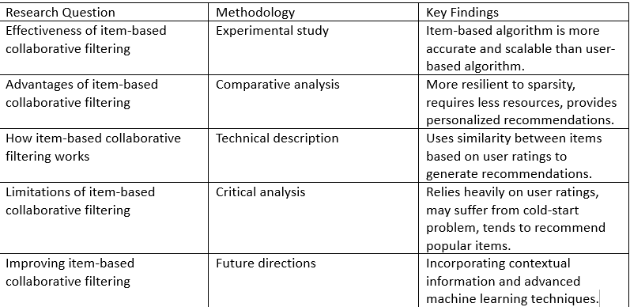
Literature review of Item-based collaborative filtering recommendation algorithm

[2] Sharma, Ritu, Dinesh Gopalani, and Yogesh Meena. "Collaborative filtering-based recommender system: Approaches and research challenges." Journal of Intelligent Information Systems 54, no. 3 (2020): 549-592.
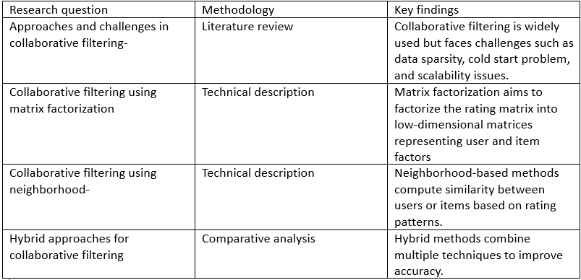
Literature review of Collaborative filtering-based recommender system

    - Other Software Engineering Methodologies

- Below are some steps after which you can create a proposal for a motion picture using closest neighbors and cosine proximity using a Agile Model
- Identify the customer stories and prioritize them based on customer needs and business value. For example, the customer stories might be "As a customer, I want to receive suggestions for motion pictures that are comparable to those I have preferred in the past," or "As a customer, I want to be able to channel suggestions by class or release date"
- Develop a Least Reasonable Item (MVP) that contains the core benefit of the proposal framework. This may include collecting and cleaning information, creating shows, and creating proposals.
- Schedule sprints and prioritize tasks based on the customer stories identified in Step 1. Break each user story into smaller, meaningful tasks that can be completed in a sprint.
- Develop and test the information pipeline that will be used to collect and pre-process the information. This includes searching for information, cleaning up information, and integrating information from different sources.
- Develop and test the content creation pipeline that will help you extract the key highlights from the information. This may include preparing content, examining images, or extracting information from customer behavior.
- Develop and test the ad preparation pipeline that trains the closest ad using cosine similarity. This may include hyperparameter tuning, cross-validation, or outfit modeling.
- Develop and test the suggestion generation pipeline that creates suggestions for customers based on their past behavior and preferences.
- Deploy the MVP in a generation environment and collect customer feedback. Use this input to refine and develop the suggestion system in future sprints.
- Repeat and evolve the recommendation framework over time, adding unused highlights and customer critiques as they become available.
By following these steps, you will create an item item movie suggestion framework that utilizes closest neighbors and cosine similarity in a skillful demonstration. Remember to prioritize client needs and trade esteem, and enhance and expand the system over time based on client critiques.

  - System Design & Methodology

    - System Architecture (Block Diagram/E-R Diagram/Flow Chart/ Use Cases—whatever applicable)

E-R Diagram

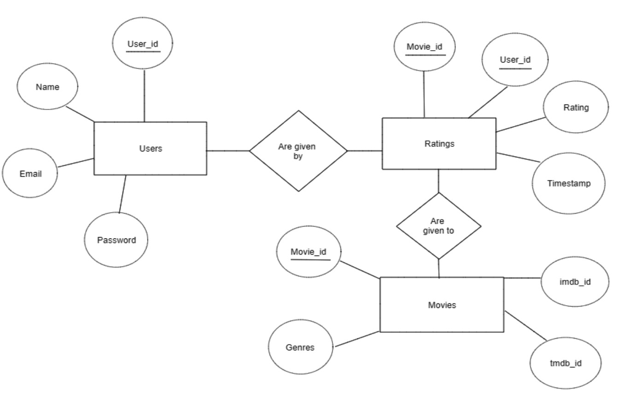

Flow Chart
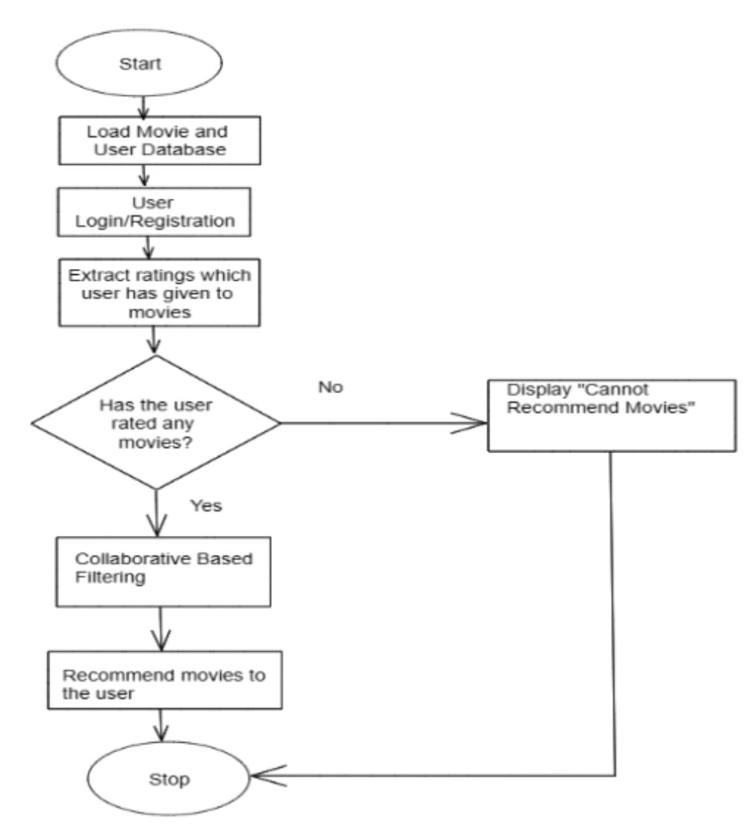

Use Case Diagram

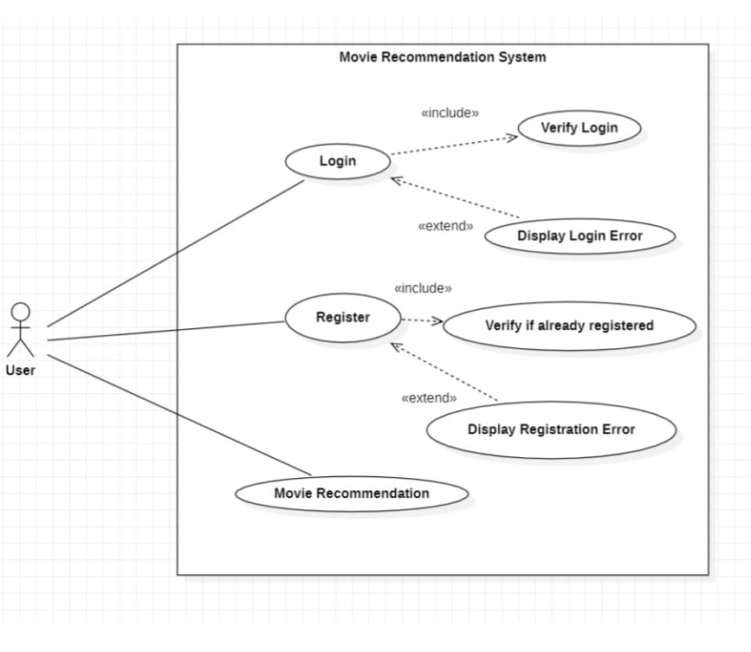

    - Development Environment. (H/w & S/W)

3.2.1 Hardware Requirements
● A PC with Windows/Linux OS
● Processor with 1.7-2.4gHz speed
● Minimum of 4GB RAM
● 2GB Graphic card

3.2.2 Software Requirements
- Operating System : Windows, Mac OS or Linux
- Python
- Python libraries - For the calculations and analyses, we need certain Python libraries that will be used to perform analyses. Packages like SKlearn, NumPy, pandas etc. are needed.

SKlearn: It provides various classification, regression, and clustering algorithms, including Support Vector Machines, Random Forests, Gradient Boosting, k-means, and DBSCAN, and is designed for interoperability with the NumPy and SciPy numerical and scientific Python libraries.
NumPy: NumPy is a general-purpose array processing package. It provides a powerful multidimensional array object and tools for working with these arrays. It is the basic package for scientific calculations with Python.
Pandas: Pandas is one of the most widely used Python libraries in data science. It provides powerful, user-friendly structures and data analysis tools. Unlike the NumPy library, which provides objects for multidimensional arrays, Pandas provides an in-memory 2d table object called Data frame
Scikit-Learn: (formerly scikits.learn and also known as sklearn) is a free machine learning software library for the Python programming language. It provides various classification, regression, and clustering algorithms, including support vector machines, random forests, gradient boosting, k-means, and DBSCAN, and is designed to work with the NumPy and SciPy numerical and scientific Python libraries. Scikit-learn is a NumFOCUS fiscally sponsored project.

- Text Editor or IDE : PyCharm , Visual Studio Code or any other IDE

    - Methodology: Algorithm/Procedures

To achieve the goal of the project, the first process is to do enough background study, so the literature study will be conducted. The whole project is based on a big amount of movie data, so we choose the quantitative research method.

For computing similarity between the different movies in the given dataset efficiently and in the least time and to reduce the computation time of the movie recommender engine we used the cosine similarity measure.

• Data collection: Collecting data from various sources like user ratings, reviews, and purchase history.

• Data cleaning: Cleaning the data by removing irrelevant data and filling missing values.

• Data pre-processing: Pre-processing the data by converting it into a user-item matrix where the rows represent the users, and the columns represent the items. The cells of the matrix represent the user-item interactions.

• Similarity computation: Computing the similarity between the items using measures like cosine similarity or Pearson correlation.

• Nearest neighbours' selection: Selecting the k-nearest neighbours based on the similarity scores.

• Rating prediction: Predicting the ratings of the items that the user has not yet interacted with based on the ratings of the items the user has interacted with and the similarity scores.

• Recommendation generation: Generating the top-n recommendations based on the predicted ratings.

• Evaluation: Evaluating the performance of the recommendation system using metrics like precision, recall, and mean average precision

  - Implementation and Result

4.1. Modules/Classes of Project

Here are some possible modules/classes that could be included in a collaborative movie recommendation system using nearest neighbor and cosine similarity:

- Data Collection Module: This module would be responsible for collecting data from various sources such as movie databases, user ratings, and reviews.

- Data Preprocessing Module: This module would preprocess the collected data to make it ready for the recommendation system. This could include tasks such as data cleaning, normalization, and feature extraction.

- Nearest Neighbor Model Class: This class would implement the nearest neighbor algorithm for finding similar movies based on their features. It would use cosine similarity as the distance metric.

- Collaborative Filtering Model Class: This class would implement a collaborative filtering algorithm for recommending movies to users based on their past behavior and preferences.

- User Interface Module: This module would provide an interface for users to interact with the recommendation system. This could include features such as search functionality, personalized recommendations, and feedback mechanisms.

- Evaluation Metrics Class: This class would implement evaluation metrics such as precision, recall, and F1-score to evaluate the performance of the recommendation system.

- Model Training and Testing Module: This module would train and test the recommendation models on a given dataset. It would use cross-validation and hyperparameter tuning to optimize the model's performance.

These are just some of the possible modules/classes that could be included in a collaborative movie recommendation system using nearest neighbor and cosine similarity. The specific design and implementation would depend on the requirements and constraints of the project

4.2. Implementation Detail

To achieve the goal of the project, the first process is to do enough background study, so the literature study will be conducted. The whole project is based on a big amount of movie data, so we choose the quantitative research method.

For computing similarity between the different movies in the given dataset efficiently and in the least time and to reduce the computation time of the movie recommender engine we used the cosine similarity measure.

• Data collection: Collecting data from various sources like user ratings, reviews, and purchase history.

• Data cleaning: Cleaning the data by removing irrelevant data and filling missing values.

• Data pre-processing: Pre-processing the data by converting it into a user-item matrix where the rows represent the users, and the columns represent the items. The cells of the matrix represent the user-item interactions.

• Similarity computation: Computing the similarity between the items using measures like cosine similarity or Pearson correlation.

• Nearest neighbours' selection: Selecting the k-nearest neighbours based on the similarity scores.

• Rating prediction: Predicting the ratings of the items that the user has not yet interacted with based on the ratings of the items the user has interacted with and the similarity scores.

• Recommendation generation: Generating the top-n recommendations based on the predicted ratings.

• Evaluation: Evaluating the performance of the recommendation system using metrics like precision, recall, and mean average precision

4.3 Results and Discussion

List of Experiments done :

Manhattan Distance

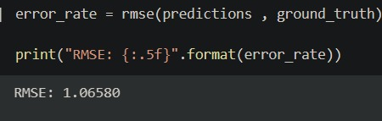

Euclidean Distance

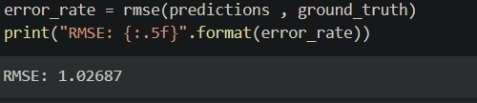

Minkowski

Chebyschev

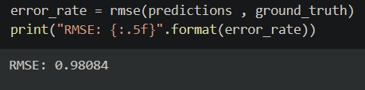

Cosine

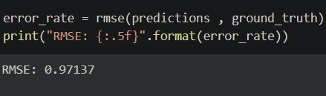

So , Cosine Similarity gave the least RMSE value so we took cosine similarity as our metric.

RESULT:-

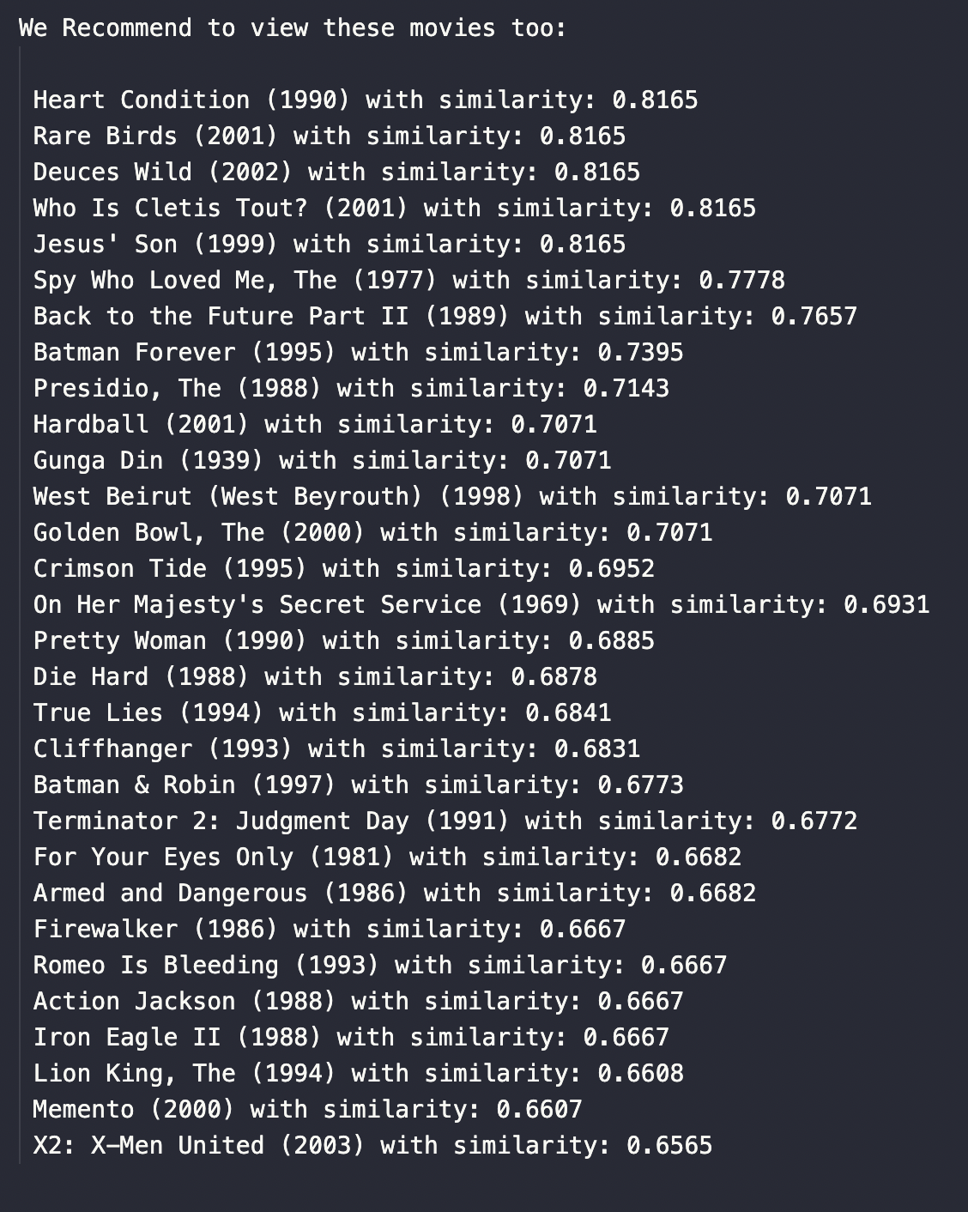

4.2 Month wise plan of work (Progress Chart/Timeline Chart)

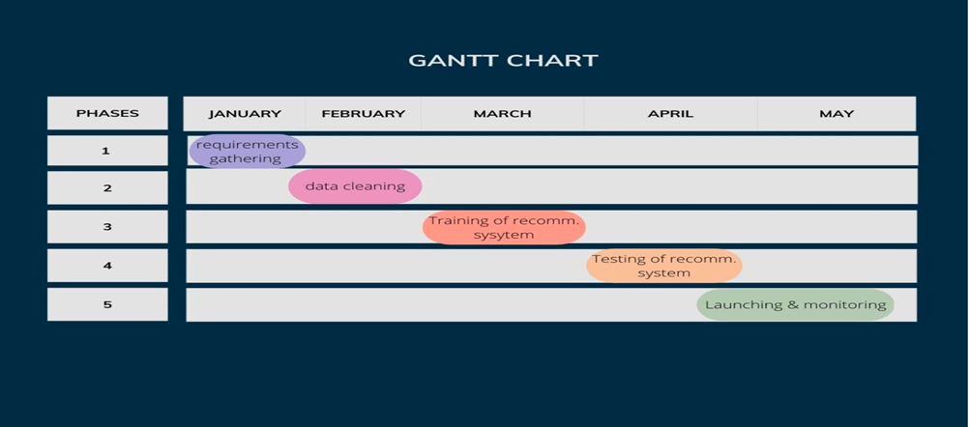

PHASE 1:
- Define the objectives and requirements for the movie recommendation system.
- Conduct research on existing movie recommendation systems and choose the appropriate machine learning algorithms.
PHASE 2:
- Collect and clean the movie dataset to be used for training the recommendation system.
- Split the dataset into training and testing datasets.
PHASE 3:
- Train the recommendation system using the training dataset.
- Evaluate the performance of the recommendation system using the testing dataset.
PHASE 4:
- Test the recommendation system with a sample group of users to get their feedback.
PHASE 5:
- Implement the recommendation system in a user-friendly interface.
- Integrate the recommendation system with the relevant movie platforms.
- Launch the movie recommendation system to the public.
- Monitor the performance of the recommendation system and collect user feedback.

  - Conclusion and Future Plan

Conclusion:
In conclusion, the closest neighbour and cosine similarity-based item-item collaborative movie recommendation system is an effective technique to provide customers tailored movie selections. The algorithm bases its recommendations on commonalities across films based on user preferences and conduct.

Prior to launching this system, care must be taken in choosing the evaluation criteria, data pretreatment, and algorithms. To maintain the system's efficiency and scalability over time, it should also be able to handle issues like the cold start problem, data sparsity, and scalability.

Using measures like accuracy, one may discuss the performance of the system and analyse the findings. For the system to continue to function properly over time, regular performance optimisation and monitoring are required.

FUTURE PLAN :

- Including more complicated algorithms: While closest neighbour and cosine similarity are useful algorithms for recommendation systems, deeper learning algorithms, for example, have the potential to increase the system's accuracy and performance.

- User input integration: By integrating user feedback into the recommendation process, the system may be improved. This may entail gathering both explicit and implicit feedback, such as ratings and reviews and information on user behaviours.

- Recommendations may be made more relevant by taking into consideration the demographics, viewing history, and individual interests of each user. In order to construct user profiles and make suggestions that are tailored to their tastes, this may include employing machine learning algorithms.

- Real-time updates: To guarantee that the system has the most recent information on new films and user preferences, real-time updates can be included to improve the system.

- Trying to make hybrid recommendation system.

References
[1] R. Sharma, D. Gopalani, and Y. Meena, "Collaborative filtering-based recommender system: Approaches and research challenges," in 2017 3rd International Conference on Computational Intelligence & Communication Technology (CICT), 2017, pp. 1-6.
[2] N. Vedavathi and R. S. Bharadwaj, "Deep Flamingo Search and Reinforcement Learning Based Recommendation System for E-Learning Platform using Social Media," Procedia Computer Science, vol. 215, pp. 192-201, 2022.
[3] B. Sarwar, G. Karypis, J. Konstan, and J. Riedl, "Item-based collaborative filtering recommendation algorithms," in Proceedings of the 10th international conference on World Wide Web, 2001, pp. 285-295.
[4] A. Kaur and M. Gupta, "A Review of Collaborative Filtering Techniques for Recommender Systems," International Journal of Engineering Research and Technology, vol. 9, no. 1, pp. 12-18, 2020.

