Anthony Rivera

* Download Django
* Install it

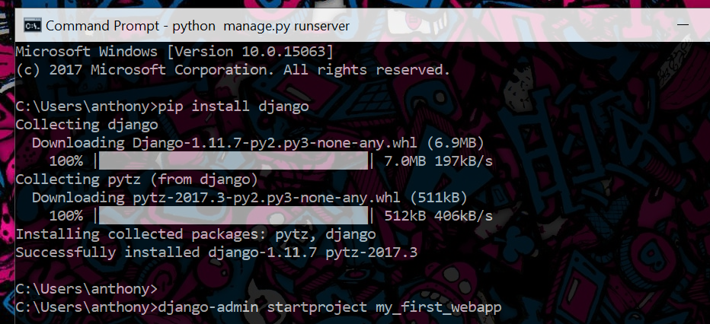

* Create a Project

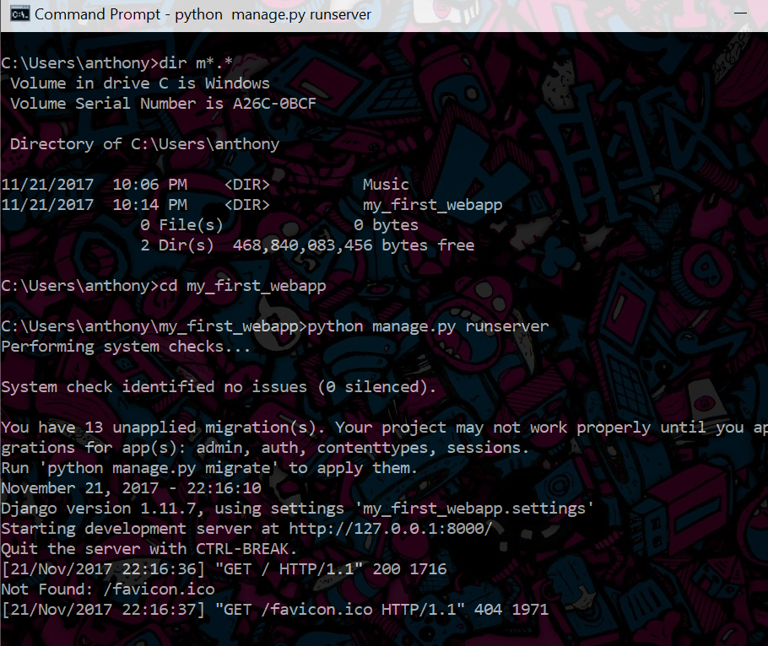

* Run the Development Server

