Anthony Rivera

[Anthonyriv2@my.smccd.edu](mailto:Anthonyriv2@my.smccd.edu)

CIS 117 OL

Create app:

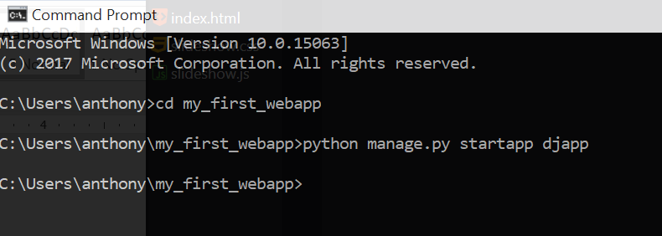

Edit settings.py – install app

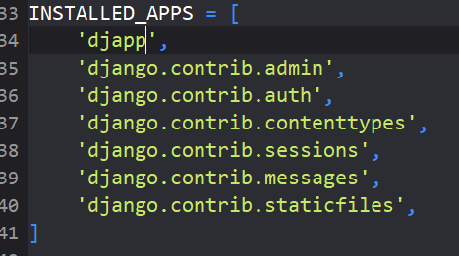

Edit urls.py

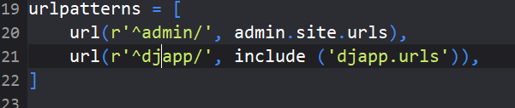

Edit views.py

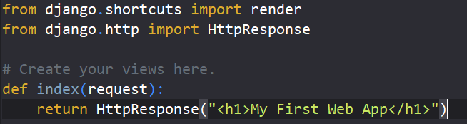

Create urls.py in new app directory

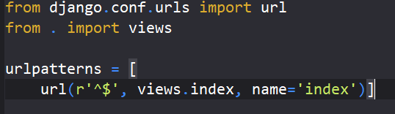

Run server

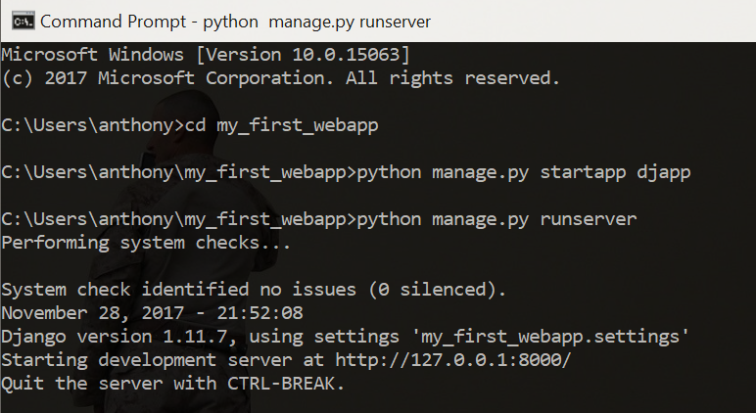

Open app in browser

