WKAI: Native Capture and Relay-Based Delivery for an AI Co-Instructor in Live Programming Workshops
Rafan Ahamad Sheik¹, Mustafa Muhammad Abdulla¹, Mohammed Shammas I¹, Mohammed Zahid Ibrahim¹, Habeeb Ur Rehman¹*

¹Department of Computer Science and Engineering, P. A. College of Engineering, Mangaluru, Karnataka, India.
Affiliated to Visvesvaraya Technological University, Belagavi, Karnataka, India.

*Corresponding Author: Habeeb Ur Rehman Email: habeeb@pace.edu.in

Abstract:
Live programming workshops leave almost nothing behind: what the instructor types, says, and debugs is transmitted once and gone, with no way back for a student who loses the thread short of interrupting class. This paper describes WKAI, a system that watches the instructor's screen and speech to produce a live guide, comprehension checks, and individual error diagnoses, with no extra work for the instructor. The system is three applications over one backend, linked by a signed-token WebSocket protocol for control and a separate media path. Two findings stand out: the binding constraint is not model quality but plumbing, moving capture into Rust and switching to a SIMD JPEG encoder cut per-frame encode from 36 ms to 17.2 ms, leaving capture itself as the ceiling at roughly 37 fps; and delivery cost, not inference cost, limits class size, since publishing one stream to a selective forwarding unit removes the instructor's uplink as the scaling limit, with a direct mesh kept as fallback. Generated content is filtered before a student sees it, rejecting blocks that merely narrate the screen, are too short to teach anything, or claim code while carrying none. The delivered system passes 60 unit and 46 end-to-end tests, transcribes 30 seconds of audio in under 0.2 s, and answers a pasted error in a few seconds.

Key Words: AI in education, live screen capture, selective forwarding unit, WebRTC, large language models, retrieval grounding, real-time systems.

1. Introduction
A live programming workshop produces a great deal of teaching material and keeps none of it: what an instructor types, says, and debugs is rendered once and discarded. Video tools treat this as opaque payload, correct for a general meeting but wrong for a class; learning management systems only organise material written in advance. Neither closes the loop between the live session and what remains after it. Feedback suffers the same way: in person an instructor reads faces and notices who has stopped typing, but remote delivery replaces that with muted thumbnails and a chat window only confident students use, so students who fall behind do so invisibly. A tool for remote technical instruction has to rebuild that channel from signals it can observe: the words spoken, the content on screen, the commands students run, and the errors those commands produce.
Recent work on intelligent tutoring has focused on the model rather than the classroom around it. Reviews of AI-based tutoring systems [3], conversational tutors such as Ruffle & Riley [7], and Tutor CoPilot [8] show that a language model can hold a useful pedagogical dialogue, including alongside a human tutor, and multimodal systems come closer to what a workshop needs: ScreenAI [10] reads interface screenshots, MultiTutor [6] coordinates agents around a student, MathBuddy [5] detects affective struggle proxies, and Video-MMLU [4] benchmarks how well a model follows taught material. In addition, LeafTutor [1] provides structured programming error diagnosis, while MMTutorBench [2] separates factual correctness from pedagogical efficacy. None of this addresses delivery, since a tutor that understands a lecture perfectly is useless if the session cannot be captured at a usable frame rate or streamed to sixty students at once.
This paper reports a system built to close that gap, and which parts of it turned out to be hard. WKAI (Workshop AI) captures the instructor's screen and microphone, runs both through LangGraph agents on hosted models, and delivers a live guide, comprehension checks, and grounded error diagnoses to students in an ordinary browser. The contribution is not a new model or prompting technique but an end-to-end account of what running such a system costs in a real classroom: where the frame rate goes, where the tokens go, where the bandwidth goes, and what must be rejected before a student sees it. Three results follow. Capture and encoding, not inference, set the ceiling on how well a session can be observed. Delivery topology, not inference cost, sets the ceiling on class size. And a vision model asked for one to three guide blocks returns one to three blocks whether or not it can see anything worth writing down, making an explicit rejection stage a functional requirement rather than a refinement.

2. System Design
WKAI is three applications sharing one backend contract: a Tauri/Rust desktop app for the instructor, an ordinary browser for students, and a Node.js service between them holding the AI layer, the session record, and media brokering. The three share no code beyond a common message vocabulary, which let the media path be rebuilt during development without touching application logic.

2.1 Architecture
Control and media travel on separate planes. Control is one WebSocket endpoint carrying a server-issued signed token, from which role, session, and student identity are derived on the server; no other parameter is trusted. Media is a second path the control plane knows nothing about, which let native capture and a relay replace browser capture and a peer mesh without changing the protocol. Durable session records live in PostgreSQL; fast-changing state (room membership, student counts, the rolling transcript, session memory, and relay position) lives in Redis with a bounded time to live, so an abandoned room clears itself (Figure 1).

2.2 Capture and Encoding
Capture runs in Rust behind a single backend trait, with a Windows implementation and Linux/macOS stubs against the same interface, and capture and encode run on separate threads so encoding frame N overlaps with capturing frame N+1. An earlier browser-based version was abandoned because its failures are silent: a stream from an unrendered element stops producing frames, and an unsupported codec fails at start rather than at configuration, with neither raising an error. The rule adopted afterwards is to assert positively on the first observed frame rather than treat an absent error as success.

2.3 Delivery
Delivery began as a direct WebRTC mesh, one peer connection per student: no media infrastructure needed, but the instructor's upstream cost grows linearly with the class, since thirty students means thirty encoders on one uplink. The delivered system instead publishes one track to a Cloudflare Realtime selective forwarding unit and lets each student subscribe, so the instructor pays once regardless of class size, with the application secret staying on the server and clients negotiating through session-token-guarded routes. The publisher's location is recorded in Redis so a mid-workshop restart does not strand a room, relay credentials for restrictive networks are minted server-side and cached until expiry, and the mesh remains a fallback where no relay is configured or a subscribe call fails.
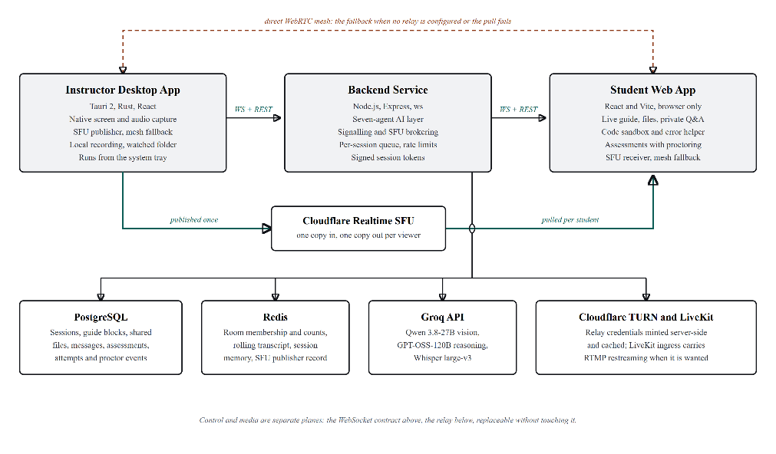
Figure 1: WKAI architecture. Control travels over one authenticated WebSocket contract; media travels on its own path through a relay, with a direct mesh as the fallback.

2.4 The Guide Pipeline
A frame is taken every 25 seconds, capped at 1280 pixels wide and JPEG-encoded, then sent to a vision model (Qwen 3.8-27B on Groq) with the recent transcript and a summary of what has already been taught. In parallel, 30-second audio chunks go to Whisper large-v3, feeding a reasoning model (GPT-OSS-120B) that explains, diagnoses, drafts comprehension questions, and answers student messages. Output is parsed against a schema; a failed parse retries a bounded number of times, then returns a degraded but honest response rather than unvalidated text rendered as authoritative. Surviving blocks are written to PostgreSQL and broadcast, so a late-joining student is replayed the whole guide (Figure 2).
Two constraints shape this stage. Agent invocations pass through a queue with bounded concurrency, since student requests are bursty: a class following the same instruction hits the same failure within seconds of each other, and without the queue that spike reaches the provider as a rate-limit violation rather than a delayed answer. Provider errors are also classified rather than uniformly retried: a per-minute limit clears on its own and is worth a backoff, while a spent daily allowance or an over-ceiling output request is permanent for that call, and retrying either only delays the real fix.

2.5 Grounding
The prompt asks the model to stay silent when it cannot see what is being taught, and a rejection stage enforces it, since a vision model asked for one to three blocks will nearly always produce them. Three rules decide: a block too short to teach anything is dropped; a block that narrates the screen rather than teaching from it is dropped, since that voice reads as content while carrying none; and a block typed as code that carries no code is dropped, since that is either mislabelled or invented. A parallel gate on the speech path discards transcription hallucinations, filler, and decoder loops before a model is billed for them. Both gates report which rule fired, since a frame that produced empty blocks is otherwise indistinguishable from one that produced nothing.

2.6 Session Security
An early revision read the client's role from a query parameter, letting any client claim instructor privileges over a session it did not own. The rework issues two signed token types, one for the instructor and one for a student join, and every connection must present a valid token from which role, session, and student identity are derived on the server. Rate limiting was added to the create and join routes, timing-safe comparison replaced a naive string comparison, and the service refuses to start in production without a signing secret. Comprehension gating and assessment proctoring remain advisory: gating is a client-side rendering property, and proctoring records rather than prevents focus-loss and paste events. The full message sequence appears in Figure 3.

3. Results and Discussion

3.1 Where the Frame Rate Goes
Measurements were taken on the development machine at a capture resolution of 1920x1200. Acquiring one frame costs about 23.7 ms, plus 2.6 ms to convert RGBA to RGB, putting capture alone at roughly 37 fps. Encoding was the slower half: the JPEG encoder in the image crate has no SIMD path and needed about 36 ms per frame, rising to around 95 ms on dense content (roughly 10 fps), where the live stream visibly came apart.
A SIMD encoder brought the same frame down to about 17.2 ms at the same quality, with a marginally smaller output. With capture and encode overlapped on separate threads, capture is now the slower stage, so the practical ceiling is about 37 fps; raising it further needs a capture path that avoids copying the whole surface, not more threads. The frame rate was set by encoder choice, not by the model.

3.2 Where the Bandwidth Goes
Under the original mesh, the instructor's upstream requirement is the product of stream bitrate and student count, and each additional student costs an encoder on the instructor's machine. At the bitrate needed for legible terminal text, a class of thirty saturates an ordinary classroom uplink before the last student joins, a topology property no codec or resolution choice can fix.
Publishing once to a relay makes the instructor's cost constant: the upstream requirement becomes one stream regardless of class size, with fan-out paid by a service built for it. The trade is a dependency the project does not operate, so the direct mesh remains a supported fallback; a room with no relay credentials, or a failed subscribe call, still runs, both paths sharing the same signalling messages.

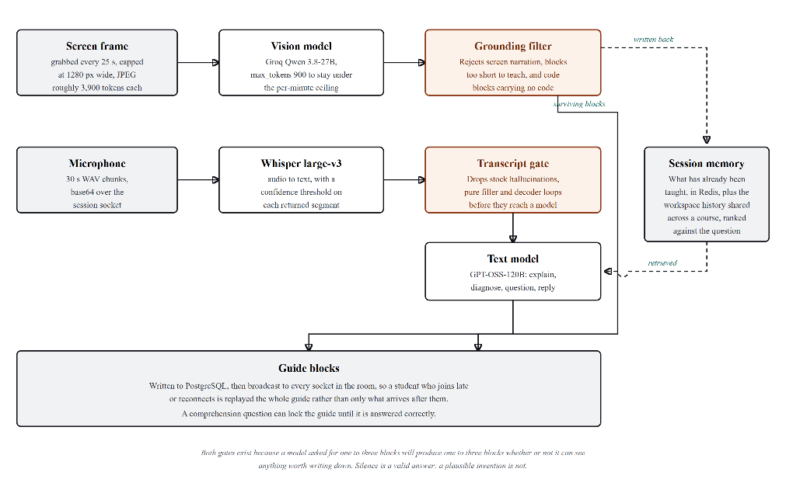
Figure 2: The capture-to-guide pipeline. Two gates reject rather than pass: one on the transcript, one on the generated blocks.

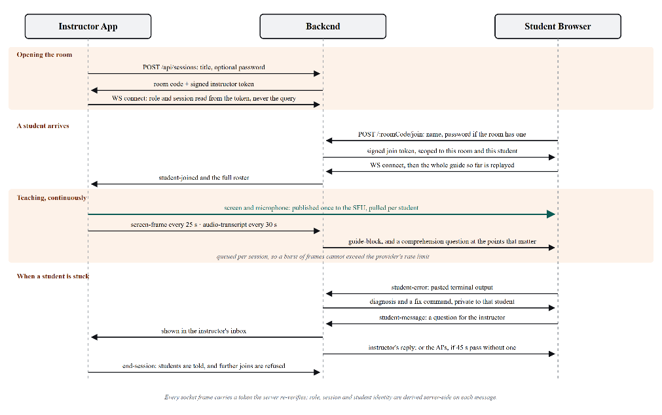
Figure 3: Session message sequence, from opening a room to answering a student who is stuck.

3.3 Where the Tokens Go
Vision is the dominant inference cost, driven by image area rather than task complexity. One frame at 1920x1200 costs roughly 3,900 tokens against a free-tier daily allowance of 200,000, about fifty frames, or twenty minutes of teaching at a frame every 25 seconds. Capping the frame at 1280 pixels wide more than halves that. Two further limits surfaced in production, both looking like silent failure: a per-minute output-token ceiling that refuses requests before the model runs, and a daily allowance returning the same status code as an ordinary rate limit. Telling the two apart turned an apparently broken pipeline into a reported budget.

3.4 What the Gates Reject
The rejection rules matter because the failure is not obvious from the output: a model that cannot read the screen writes a fluent sentence about what it can make out, which reads as instruction. Dropped blocks are logged with the reason, and the console reports the count and rule fired rather than a bare zero. An earlier version was silently inert for weeks, its word-boundary escapes saved as literal control characters so nothing ever matched, invisible by construction since a filter that passes everything looks like a model that never misbehaves. Those rules now carry unit tests of their own.

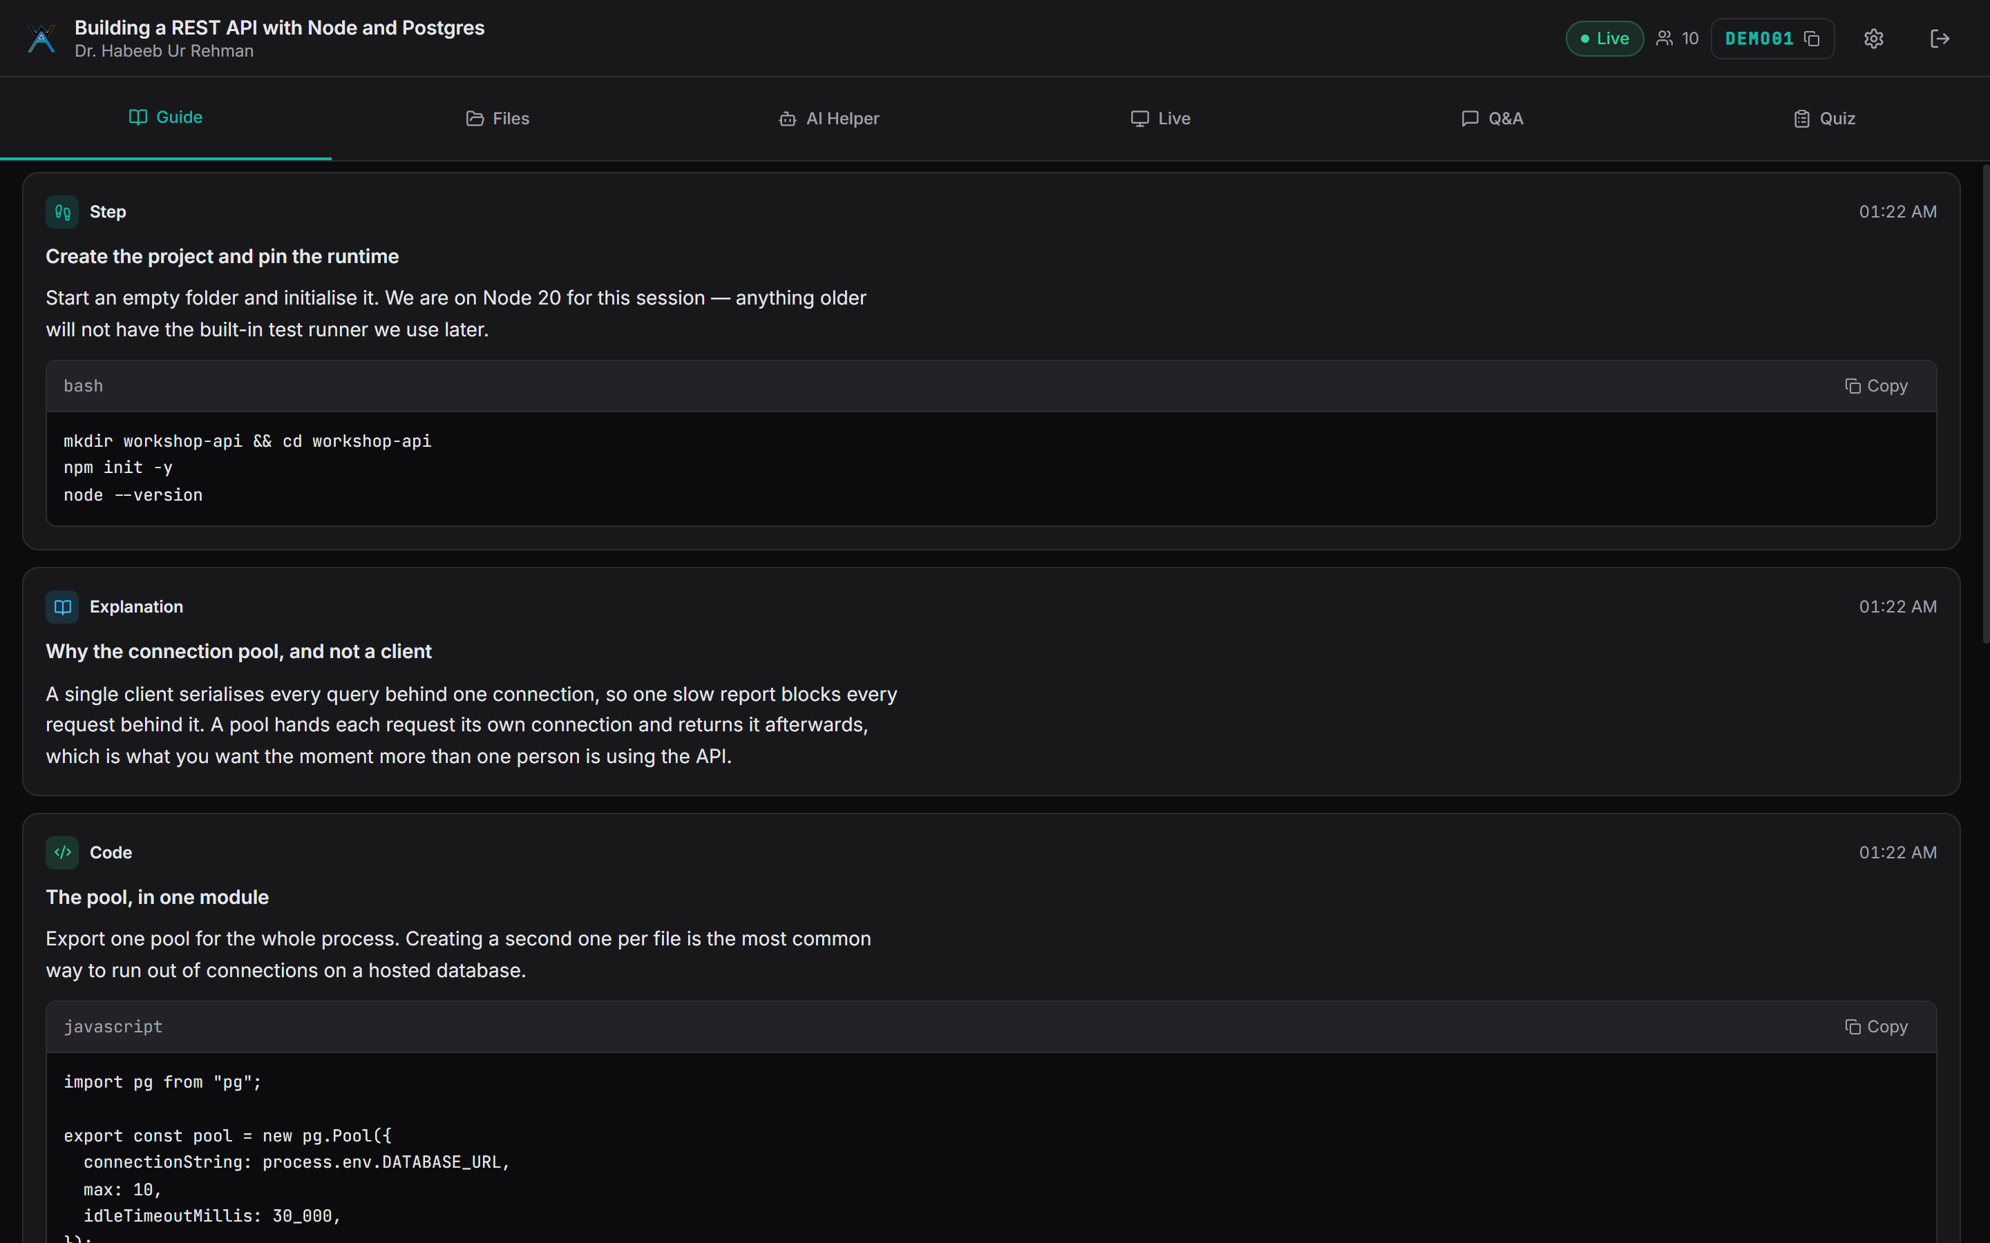
Figure 4: The student's view of a running session: the guide written from the screen and the instructor's speech.

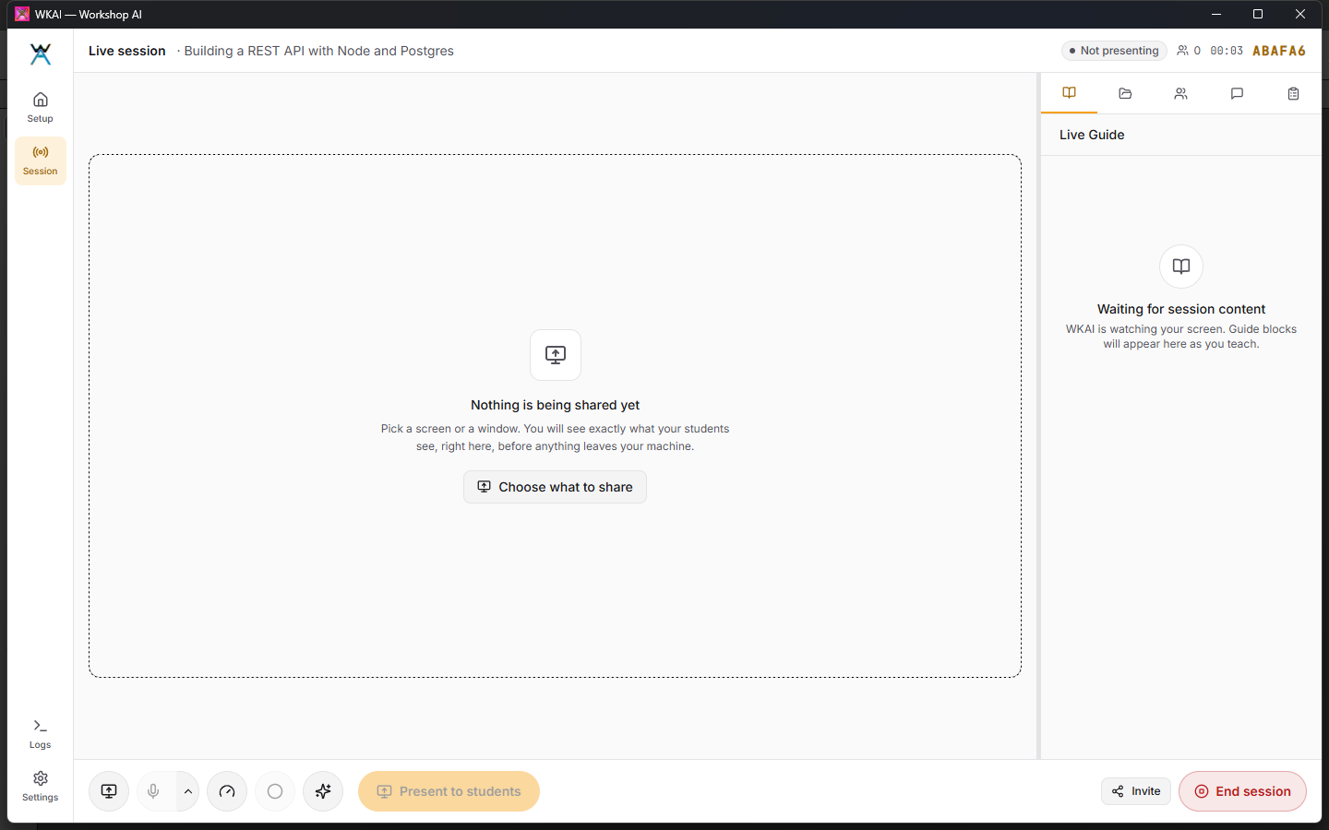
Figure 5: The instructor's live session: preview stage, present bar, and the side rail holding the guide, files, roster and question inbox.

3.5 Latency and Verification
Latency was characterised during development, not with a load-test harness, so figures reflect observed behaviour on broadband rather than guaranteed service levels. A 30-second audio chunk transcribes in well under 0.2 s, error classification is sub-second, and a full diagnosis (classify, diagnose, validate) completes in a few seconds, inside a blocked student's tolerance. A guide block appears seconds after the frame that produced it, and session join to first rendered state is sub-second.
The system carries 60 unit tests and 46 end-to-end tests. Unit tests cover what end-to-end testing cannot: token claim extraction and expiry, rejection of tokens issued for another session, bounded concurrency and slot release, rate limiter behaviour, the grounding rules, and provider-error classification. The end-to-end suites cover a backend the harness starts itself (16 tests), the agent-facing tool surface (4 tests), and the student application in a real browser (26 tests). The media pipeline is verified by hand, since its behaviour depends on OS and device specifics no harness reproduces, the one acknowledged gap.

3.6 Discussion
The result the authors did not expect is that model quality was never the binding constraint: reasoning quality was adequate throughout and prompt iteration reached diminishing returns early. What bound the system was capture fidelity, encode economics, delivery topology, and lifecycle correctness, conventional systems problems, correcting an assumption in the reviewed literature that treats model capability as the frontier [3][6]. For a live, classroom-scale system, the frontier was the plumbing. A second finding concerns separating planes: because control and media were independent from the start, the media path (browser APIs and a peer mesh) could be replaced by native capture and a relay without touching the application protocol, a tidiness decision that kept the project's largest change contained.

3.7 Limitations
Native capture is implemented for Windows only; Linux and macOS are stubs behind the same trait, so completing a platform is bounded work. The relay is a third-party service, and a room without credentials inherits the mesh's scaling limit. A free inference tier affords roughly fifty vision frames a day, a demonstration rather than a full class; sending only changed regions is the next item of work. Comprehension gating is client-side and proctoring only records rather than prevents, so neither is enforcement. This is a systems evaluation: no classroom study was run and no claim is made about learning outcomes, which would need the controlled comparison the tutoring literature uses [7][8].

4. Conclusion
WKAI was built to test one proposition: that a live technical session already contains enough signal to produce its own study material, locate its points of confusion, and support students individually, without adding work for the instructor. The delivered system supports it. A session starts from one form, students join from a browser with nothing installed, the screen is captured at roughly 37 fps, one uplink serves the whole room through a relay, and a student's error is diagnosed against what was just taught, all over a channel where no client can assert its own privileges. The transferable lesson is engineering, not modelling: frame rate was set by an encoder library, class size by delivery topology, and usable output by an explicit rejection stage. Anyone building a comparable system should expect to spend their time in the same three places.

Acknowledgement: The authors thank the Department of Computer Science and Engineering, P. A. College of Engineering, Mangaluru, for the facilities and guidance provided during this work.

References

[1] | M. Bochard, T. Conser, A. Duran, L. Martull, P. Tian, and Y. Wu, "LeafTutor: An AI Agent for Programming Assignment Tutoring," arXiv preprint arXiv:2601.02375, 2026.
[2] | T. Yang, S. Guo, M. Jia, J. Su, Y. Liu, Z. Zhang, and M. Jiang, "MMTutorBench: The First Multimodal Benchmark for AI Math Tutoring," in Proc. 64th Annu. Meeting Assoc. Computational Linguistics (ACL), 2026.
[3] | M. Zerkouk, M. Mihoubi, and B. Chikhaoui, "A Comprehensive Review of AI-based Intelligent Tutoring Systems: Applications and Challenges," arXiv preprint arXiv:2507.18882, 2025.
[4] | H. Li et al., "Video-MMLU: A Massive Multi-Discipline Lecture Understanding Benchmark," in Proc. IEEE/CVF Conf. Computer Vision and Pattern Recognition (CVPR), arXiv:2406.00424, 2025.
[5] | G. Mathur et al., "MathBuddy: A Multimodal System for Affective Math Tutoring," in Proc. 2025 Conf. Empirical Methods in Natural Language Processing (EMNLP 2025): System Demonstrations, 2025, pp. 112–121.
[6] | S. R. et al., "MultiTutor: Collaborative LLM Agents for Multimodal Student Support," in Proc. Innovation and Responsibility in AI-Supported Education (iRAISE), PMLR, vol. 248, 2025.
[7] | M. Schmucker et al., "Ruffle & Riley: Insights from Designing and Evaluating a Large Language Model-Based Conversational Tutoring System," in Proc. 25th Int. Conf. Artificial Intelligence in Education (AIED), Springer, 2024, pp. 245–258.
[8] | S. Wang et al., "Tutor CoPilot: A Human-AI Approach for Scaling Real-Time Expertise," Stanford University, National Student Support Accelerator (NSSA) Technical Report, arXiv:2403.04836, 2024.
[9] | P. Denny, J. Prather, B. A. Becker, et al., "Computing Education in the Era of Generative AI," Communications of the ACM, vol. 67, no. 2, pp. 56–67, Feb. 2024.
[10] | C.-F. Yeh, M. Poursabzi-Sangdeh, et al., "ScreenAI: A Vision-Language Model for UI and Infographics Understanding," in Proc. 33rd Int. Joint Conf. Artificial Intelligence (IJCAI 2024), 2024.
[11] | OpenAI, "Whisper Large-v3: Robust Speech Recognition via Scaled Multimodal Supervision," OpenAI Technical Documentation & Model Card, 2024. [Online]. Available: https://github.com/openai/whisper
[12] | LangChain, "LangGraph: Building Stateful, Multi-Actor Applications with LLMs," 2025. [Online]. Available: https://langchain-ai.github.io/langgraph
[13] | Groq, "Groq API Documentation: LPU Inference Engine," 2026. [Online]. Available: https://console.groq.com/docs
[14] | Cloudflare, "Cloudflare Realtime: SFU and TURN Documentation," 2026. [Online]. Available: https://developers.cloudflare.com/realtime
[15] | LiveKit, "LiveKit Server SDK and WHIP/RTMP Ingress Documentation," 2026. [Online]. Available: https://docs.livekit.io
[16] | Tauri Working Group, "Tauri v2 Documentation," 2026. [Online]. Available: https://v2.tauri.app

