
KARNATAKA STATE COUNCIL FOR SCIENCE AND TECHNOLOGY
Indian Institute of Science campus, Bengaluru – 560 012
Telephone: 080 – 23341652, 23348849 || Email: spp@kscst.org.in
Website: www.kscst.org.in/spp.html or https://kscst.karnataka.gov.in/en
FORMAT FOR STUDENT PROJECT PROPOSAL FOR THE
50th SERIES OF STUDENT PROJECT PROGRAMME 2026 – 2027
(Celebrating the Golden Jubilee of KSCST’s flagship Student Project Programme)

CALL FOR PROJECT PROPOSALS FROM FINAL-YEAR STUDENTS
B.E. | B.Arch. | M.Tech. | M.Sc. | M.Tech. / M.Sc. (Agriculture) | MBA | MCA
(Handwritten proposals will not be accepted, please fill all the details in this MS word file, insert images / diagrams wherever necessary. Convert to pdf file, get it approved from the project guide / head of the department and principal of your institution. Keep ready the scanned pdf file of 1) Declaration and Endorsement 2) details of processing fees made and fill-up the Google Form.)
NOTE: Please ensure that the details provided in the Google Form are exactly the same as those mentioned in the Project Proposal. Verify all information carefully before submitting the application.
Online Submission Period: 21 September 2026 to 30 November 2026 (5:00 PM).
https://forms.gle/VPPewZnbUhw1V8KdA

Instructions for Filling the Project Proposal
- Handwritten project proposals will not be accepted.
- Fill in all the required details in this MS Word proposal format. Insert photographs, figures, diagrams, flowcharts, tables, or illustrations wherever appropriate to explain the proposed work.
- After completing the proposal, convert the document into a single PDF file.
- Obtain the signatures and seals of the Project Guide, Head of the Department, SPP Coordinator (where applicable), and the Principal/Head of the Institution in the relevant sections before converting the proposal into PDF.
- Keep the following PDF documents ready before submitting the proposal through the Google Form:
  - Project Proposal (PDF) duly signed and approved.
  - Declaration signed by all student team members, the Project Guide, and the SPP Coordinator.
  - Endorsement issued on the Institution/Department Letterhead and duly signed by the Project Guide, SPP Coordinator, Head of the Department, and the Principal/Head of the Institution.
  - Processing Fee Payment Receipt (UPI/NEFT) of ₹1,180/- (₹1,000/- + 18% GST).
- The processing fee must be paid before submitting the project proposal. Ensure that the Transaction/UTR/Reference Number and other payment details entered in the proposal exactly match the uploaded payment receipt. Incorrect, incomplete, invalid, or unverifiable payment details, or non-payment of the processing fee, will render the project proposal liable for rejection.
- Submit the proposal only through the prescribed Google Form along with all the mandatory attachments. Hard copies of the project proposal should not be sent to KSCST.
- Before converting the proposal into PDF, delete all instructional notes, examples, suggestions, highlighted text, and any irrelevant content from this template. Ensure that the final proposal is complete, neatly formatted, and ready for evaluation.
- The Team Leader shall submit the completed project proposal only through the prescribed Google Form using the following link:
- Google Form: https://forms.gle/VPPewZnbUhw1V8KdA
- Ensure that all mandatory documents, including the duly signed project proposal, Declaration, Endorsement, and Processing Fee Payment Receipt, are uploaded before final submission. Incomplete applications or proposals submitted without the required documents will not be considered.
- KSCST shall not be responsible for delays or failure in submission due to internet connectivity issues, network failures, server problems, insufficient bandwidth, power interruptions, browser-related issues, or any other technical problems at the applicant's end.
- Applicants are strongly advised not to wait until the last date and time for submission. Complete the payment of the processing fee, prepare all required documents, and submit the proposal well in advance to avoid last-minute technical difficulties.
- No requests for extension of the submission deadline or consideration of delayed submissions due to technical or network-related issues will be entertained.
- The Google Form will be automatically disabled after the prescribed closing date and time, and no further submissions will be accepted thereafter.
* ~ * ~ *

PART–A: GENERAL INFORMATION
Project Title:
WKAI – WORKSHOP AI: A REAL-TIME AI-ASSISTED WORKSHOP PLATFORM
Keywords (5–8):
REAL-TIME AI; LARGE LANGUAGE MODELS; SPEECH RECOGNITION; INTELLIGENT TUTORING; EDUCATIONAL TECHNOLOGY; LIVE STREAMING; WEBRTC; NATIVE SCREEN CAPTURE
Broad Theme:
- Theme No.: 4
- Theme Name: ARTIFICIAL INTELLIGENCE, DATA SCIENCE AND DIGITAL TECHNOLOGIES
3. Sub-theme / Focus Area: NATURAL LANGUAGE PROCESSING (NLP) AND GENERATIVE AI
Institution Details:
- Name of Institution: P.A. COLLEGE OF ENGINEERING
- Course Name: BACHELOR OF ENGINEERING (B.E.)
- Department Name: COMPUTER SCIENCE AND ENGINEERING
- Affiliated University: VISVESVARAYA TECHNOLOGICAL UNIVERSITY (VTU), BELAGAVI
5. District of Your Institution: DAKSHINA KANNADA
6. Complete Postal Address of the Institution with Pin code: P.A. COLLEGE OF ENGINEERING, NEAR MANGALORE UNIVERSITY, MANGALURU – 574153, DAKSHINA KANNADA, KARNATAKA
Project Guide Details:
- Project Guide Name: PROF. HABEEB UR REHMAN
- Project Guide Designation: ASSISTANT PROFESSOR
- Project Guide Department: COMPUTER SCIENCE AND ENGINEERING
- Project Guide Email id: Habeeb_cs@pace.edu.in
- Project Guide Mobile Number: 7259644228
Project Co-Guide (if applicable):
- Project Co-Guide Name: NOT APPLICABLE
- Project Co-Guide Designation: —
- Project Co-Guide Department: —
- Project Co-Guide Email id: —
- Project Co-Guide Mobile Number: —
Student Team Details:

Sl. No. | Insert Passport-size Photograph | Name of the Student  (BLOCK LETTERS) | USN / Registration No. | Degree & Branch & Semester | Category as per College Records (SC/ST/  OBC/  General) | Mobile No. | Email Id
1. |  | MR. MUSTAFA MUHAMMAD ABDULLA | 4PA22CS092 | Degree: B.E.  Branch: CSE  Semester: VII | OBC | 8951034717 | 4pa22cs092@pace.edu.in
2. | 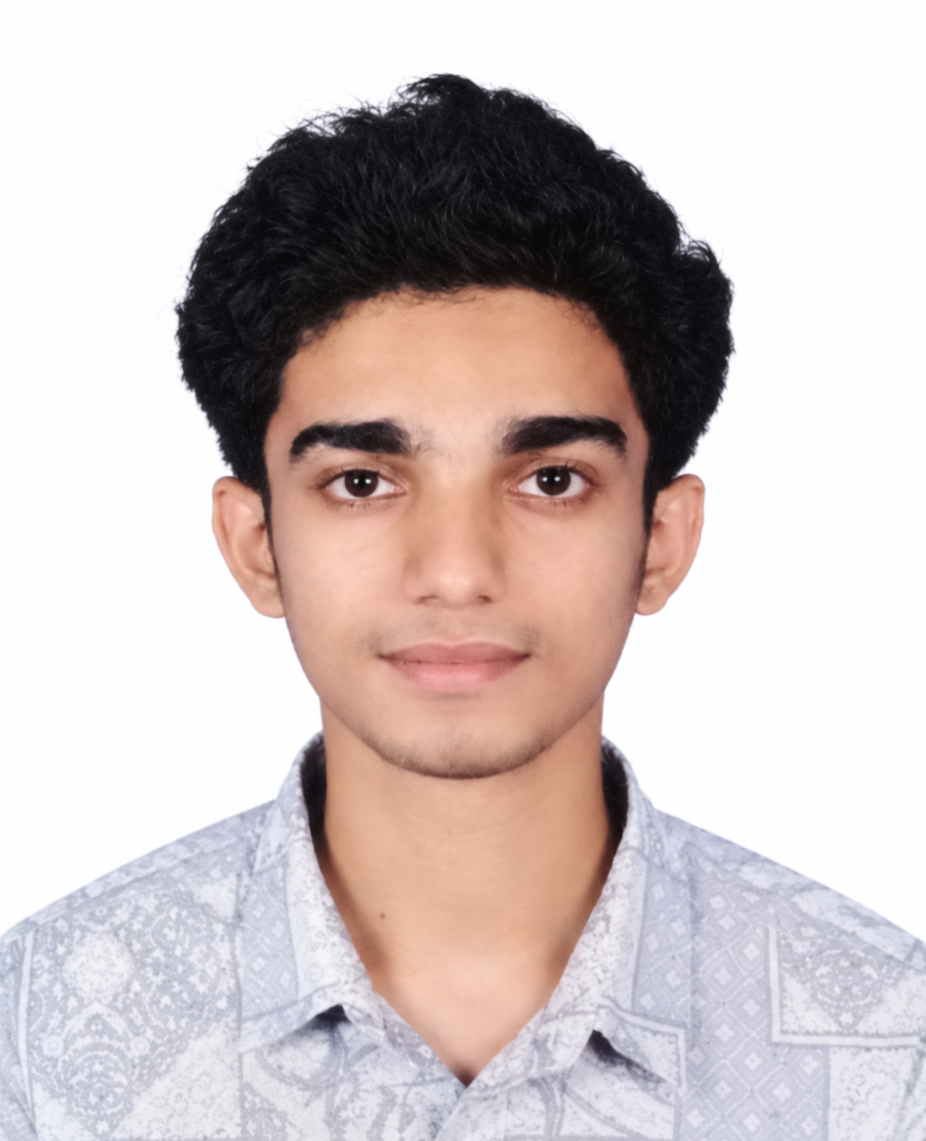 | MR. MOHAMMED SHAMMAS I | 4PA23CS083 | Degree: B.E.  Branch: CSE  Semester: VII | OBC | 9744044531 | 4pa23cs083@pace.edu.in
3. |  | MR. MOHAMMED ZAHID IBRAHIM | 4PA23CS085 | Degree: B.E.  Branch: CSE  Semester: VII | OBC | 9074262223 | 4pa23cs085@pace.edu.in
4. | 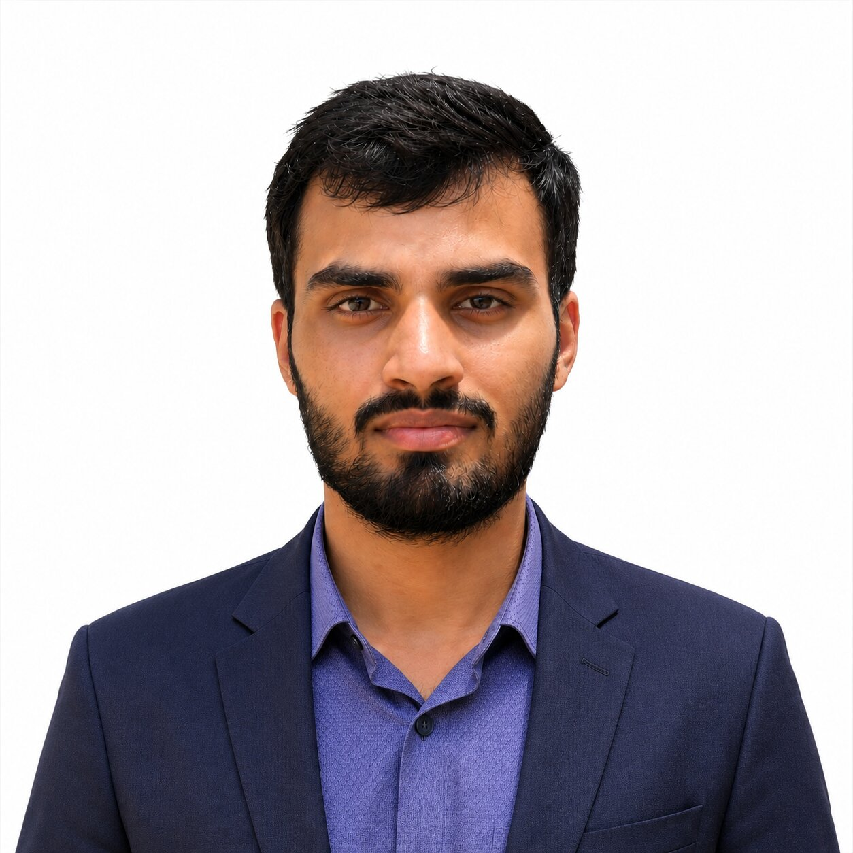 | MR. RAFAN AHAMAD SHEIK (TEAM LEADER) | 4PA23CS102 | Degree: B.E.  Branch: CSE  Semester:  VII | OBC | 9036192359 | 4pa23cs102@pace.edu.in

Note:
- The Name of each student and all other information furnished above shall be as per the official records of the College / Institution.
- The Category (SC / ST / OBC / GEN) shall be furnished strictly as per the College/Institution records. This information is collected only to ascertain the number of students from different categories who have submitted and/or been selected for projects. It shall not constitute or imply any reservation/quota in the selection or sanction of projects.
- A recent passport-size colour photograph, preferably taken within the last six months, shall be pasted/uploaded in the space provided for each student.
- Photographs shall be clear, front-facing and of good quality, with the student's face clearly visible.
- All student names shall be entered in CAPITAL LETTERS, exactly as they should appear on the certificates. The names shall be carefully checked for spelling and other errors. The same information will be used for preparation of certificates. KSCST shall not be responsible for errors in certificates arising from incorrect or misspelled names furnished in the proposal.
- The Team Leader shall be clearly indicated by adding “(TEAM LEADER)” against the respective student's name.
- A maximum of four students may be included in a project team.
- The details furnished in this section will be used by KSCST for student identification, project evaluation, official correspondence, and participation in the Annual State-Level Poster Presentation and Exhibition.
SPP Coordinator Details:
- SPP Coordinator Name: DR. PRASHANTH PAI M
- SPP Coordinator Designation: HEAD OF DEPARTMENT
- SPP Coordinator Email: prashanth_mech@pace.edu.in
- SPP Coordinator Mobile Number: 9481765907

PART - B: PROJECT DESCRIPTION
Background and Need of the Project: (Maximum 300 words)
Background: Hands-on coding workshops and laboratory sessions are the main way engineering students learn programming languages, frameworks and tools. A single instructor usually leads 30 to 60 students, sharing the screen and explaining each step aloud while students follow on their own machines.
Existing scenario: These sessions run on a projector or on general video tools such as Zoom or Google Meet. A student who misses one step loses the thread, the instructor cannot see who is stuck, doubts are raised late or not at all, and nothing structured remains afterwards except, at best, a raw recording.
Problem statement: No existing tool both delivers the live session and understands its content well enough to write a live step-by-step guide and give each student help that is grounded in what was actually taught.
Need for the project: An AI system that follows the session in real time can act as a teaching assistant for every student at once, without extra human assistants. A lightweight native instructor app makes this usable on an ordinary laptop and on the limited bandwidth common in colleges and rural centres.
Beneficiaries: Engineering colleges and polytechnics in Karnataka, training institutes, coding bootcamps, rural and online learning centres, instructors who run lab sessions, and students — especially those who need to catch up or revise at their own pace.
Review of Existing Work:
Existing technologies: Browser screen sharing (WebRTC peer connections) is CPU-heavy for the instructor and, in a mesh, the upload grows with every student. OBS Studio with RTMP needs broadcasting know-how. High-throughput speech transcription and fast language models on dedicated LPUs are now fast and accurate enough to follow a class live.
Commercial products: Zoom, Google Meet and Microsoft Teams provide streaming, captions and after-meeting summaries, but no per-student help with code. AI coding assistants help an individual but do not know what the instructor is teaching at that moment.
Research papers (2024–2026): Recent intelligent tutoring systems demonstrate that step-by-step guidance outperforms raw code generation (LeafTutor [1], Denny et al. [9]). Multimodal evaluation frameworks separate correctness from pedagogy (MMTutorBench [2], Video-MMLU [4]). Modern ITS taxonomies highlight grounded feedback loops (Zerkouk et al. [3]), while human-in-the-loop augmentation amplifies instructors during live sessions (Tutor CoPilot [8], Ruffle & Riley [7]). Affective proxies like struggle latency detect confusion without intrusive webcams (MathBuddy [5]), and decoupled state machines prevent multi-agent latency bottlenecks (MultiTutor [6]). Desktop UI comprehension verifies that screen frames are machine-interpretable for guidance (ScreenAI [10]).
Patents: No patent combining live capture, real-time content understanding and per-student diagnosis was found in our literature survey; a formal prior-art search through the KSCST Patent Information Centre is planned.
Existing solutions: Lecture-capture systems and learning management systems record and host material for later viewing, but offer no help during the session.
Shortcomings and research gaps: (i) no live understanding of the session content; (ii) summaries arrive only after the class; (iii) AI help is not grounded in the session and may hallucinate; (iv) browser capture is expensive and does not scale; (v) setup is too complex for a typical instructor.
Problem Statement:
To design and build a platform that lets one instructor stream a live coding workshop from an ordinary laptop to any number of students in a web browser, while an AI pipeline follows the session in real time to produce a grounded step-by-step guide, check the students’ understanding, and diagnose each student’s errors using only what was actually taught.
Objectives:
- To design an instructor desktop application that captures the screen and microphone through native OS APIs (without OBS or other broadcasting software) and starts a live room with one form and one button.
- To develop a backend AI pipeline that converts the live transcript and screen content into a continuously updated guide, with grounding checks that drop anything the instructor did not actually teach.
- To develop per-student assistance that detects when a student is stuck (from sandboxed code-execution errors and from questions) and returns a diagnosis grounded in the session.
- To deliver the live stream, guide, quizzes and shared files to students in a browser with nothing to install, using signed token-based room access.
- To evaluate performance against measurable targets: transcription of a 30-second audio chunk in under one second, guide blocks published within a few seconds of speech, and a single instructor uplink regardless of class size.
- To validate the platform in a pilot workshop in the department laboratory and measure student feedback.
Innovation / Novelty:
- What is new: An AI teaching assistant built into the live stream itself. It listens to the instructor and reads the screen in real time, writes a grounded guide as the class progresses, and helps each student individually based on the same session context.
- How it differs from existing work: Video tools only stream or summarise after the meeting; AI tutors and coding assistants are unaware of the live class. WKAI combines delivery and understanding, validates every AI output against a schema, and rejects content the instructor did not teach.
- Why it is innovative: Native screen capture with a single uplink to a media relay (SFU) keeps the instructor’s CPU and bandwidth constant as students join, so the system works on ordinary laptops and modest networks, while students need only a browser.
Proposed Methodology:
Overall methodology: Requirement analysis and literature survey → architecture design → parallel development of the instructor app, backend AI service and student web app → integration over a documented protocol → testing, pilot workshop and evaluation.
Block diagram / System architecture:
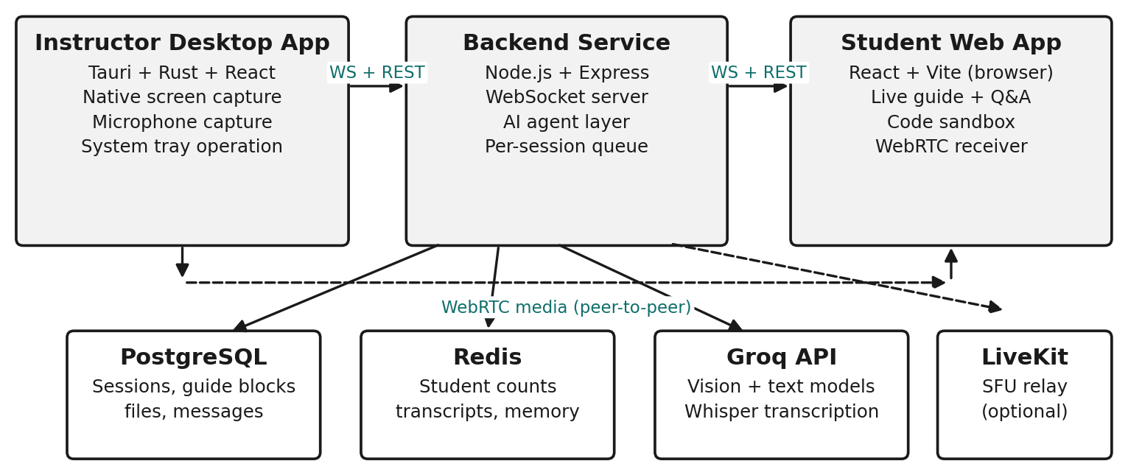
Figure 1: WKAI system architecture — instructor desktop app, backend service and student web app over one WebSocket/REST protocol, with the media relay (SFU) alongside.
Three independent applications share one backend. Control messages travel over a WebSocket protocol and video over a separate WebRTC media path. PostgreSQL holds durable records (sessions, guide blocks, files, error logs) and Redis holds room state and the rolling short-term memory read by the AI agents.
Design approach:
- Instructor app: Tauri v2 (Rust + WebView). Rust performs native screen capture (Windows Graphics Capture / DXGI on Windows, X11 on Linux) and audio capture, and drives an FFmpeg encode chain that records locally and pushes one live stream (RTMP / WHIP [9]) to the media relay. A folder watcher handles file sharing.
- Backend AI service: Node.js with Express and ws. A LangGraph agent layer performs error diagnosis, intent detection, transcript explanation, comprehension quizzes, student messaging and assessment authoring. Models run on Groq: Llama 3 70B for text, Llama 4 Scout for screen understanding and Whisper Large v3 for speech. Every model output is validated against a Zod schema before a student sees it.
- Student web app: React + TypeScript + Vite. Subscribes to the live view from the relay (direct WebRTC and TURN as fallback) and shows the guide feed, comprehension-gated content, a Monaco editor with an xterm terminal for sandboxed Python/JavaScript/TypeScript/Bash, an AI error helper, quizzes and file downloads.
- Security: Server-minted signed join tokens, role verification on every WebSocket message, session passwords and rate limiting.
Experimental plan:
Unit tests for the agents and protocol; end-to-end sessions with seeded rooms; measurement of stream latency, transcription delay, guide-generation time and instructor CPU/bandwidth as the number of students grows; and a pilot workshop in the department laboratory with a student feedback survey.
Software / Hardware to be used:
Software: Rust, Tauri v2, React 18, TypeScript, Vite, Node.js, Express, LangChain/LangGraph, Groq API (Llama 3, Llama 4 Scout, Whisper), PostgreSQL, Redis, FFmpeg, LiveKit / Cloudflare Realtime SFU, Git with CI. Hardware: development laptops/desktops (available), headset microphone for the instructor, department lab computers for the pilot. No fabrication is involved.
Expected Deliverables:
- Software: installable instructor desktop app for Windows and Linux with native capture, local recording and one-click streaming (signed installers built by CI).
- Web portal: student web app needing no install — live view, AI-generated guide, quizzes, sandboxed code editor, AI error diagnosis and shared files.
- Decision support tool: hosted backend AI service that produces grounded guide content, comprehension checks and per-student debugging help in real time.
- Standard Operating Procedure: instructor and student user guides for running a workshop with WKAI.
- Documentation: source code repository, project report and a conference paper / demonstration.
Expected Outcomes and Impact:
- Technical: near real-time delivery of one instructor stream to N students through a single uplink; sub-second transcription of 30-second audio chunks; guide blocks within seconds of speech.
- Social: every student gets individual help during class, reducing the gap between fast and slow learners; generated guides remain available for revision after the session.
- Environmental: digital guides replace printed lab handouts, and remote participation reduces travel; low-CPU native capture lets existing laptops be reused.
- Economic: reduces the need for extra teaching assistants; students need only a browser and the instructor an ordinary laptop, with no paid broadcasting software.
- Industrial: applicable to corporate training and employee onboarding; potential EdTech startup product.
- Academic: will be used in the department for lab sessions, coding workshops, hackathon training and value-added courses; results to be published as a conference paper.
- Potential users: engineering and polytechnic colleges, training institutes, coding bootcamps, rural and online learning centres, and companies running technical training.
Relevance:
☑ SDGs (Sustainable Development Goals) — SDG 4 (Quality Education)
□ Karnataka Priority Sector
☑ Rural Development
□ MSME
□ Agriculture
□ Healthcare
□ Water
□ Environment
□ Climate
□ Manufacturing
□ Smart Cities
☑ Digital India
☑ Startup
□ Women Empowerment
☑Others (Please Specify): Education / EdTech - AI-assisted technical skill development
Work Plan (Please specify the month and tick ✓)
Activity | Jan – Feb 2026 | Mar – Apr 2026 | May – Jun 2026 | Jul – Aug 2026 | Sep – Dec 2026
Literature Survey | ✓ | ✓
Design | ✓ | ✓
Development |  | ✓ | ✓ | ✓
Testing |  |  |  |  | ✓
Validation |  |  |  |  | ✓
Final Report |  |  |  |  | ✓

Project period: 27.01.2026 (commencement) to 01.12.2026 (completion).
- Project initiation (27.01.2026 – 15.02.2026): problem statement, objectives and system architecture finalised.
- Research phase (16.02.2026 – 04.04.2026): literature survey, requirement specification and technology stack finalised.
- Development phase (05.04.2026 – 31.08.2026): instructor app, backend AI pipeline and student web app built and integrated; native capture and SFU streaming rebuild completed.
- Testing phase (01.09.2026 – 30.09.2026): unit, integration and end-to-end testing; pilot workshop.
- Final review and submission (01.10.2026 – 01.12.2026): pilot feedback incorporated, documentation, final report, source code and deployment submitted.
Facilities Available:

1. Laboratory | Computer laboratories of the Department of Computer Science and Engineering
2. Equipment | Desktop computers, LAN / Wi-Fi network, projector-equipped seminar hall for the pilot workshop
3. Software | Open-source toolchain: VS Code, Git, Node.js, Rust, Python, FFmpeg, PostgreSQL, Redis
4. Instruments | NONE
5. Workshop | NONE
6. Institutional facilities | Campus internet, central library, seminar halls and department computing infrastructure

Major Requirements for the Project:
Hardware
- Development laptops / desktops (available with the team and department)
- Headset microphone for instructor audio capture
Software / Cloud
- Rust + Tauri, Node.js, React, Python, FFmpeg, PostgreSQL, Redis (open source)
- Cloud hosting for the backend, managed PostgreSQL and Redis (Render, Vercel)
- Media relay (SFU / TURN) bandwidth — LiveKit / Cloudflare Realtime
- LLM and speech-recognition API credits (Groq)
- Domain name and SSL certificate
Field Studies
- Pilot workshop with students in the department laboratory and feedback survey
- Travel to KSCST, Bengaluru for mid-term evaluation and the State-Level Exhibition
Item | Estimated Cost (₹)
Equipment / Components | Rs. 0/-
Consumables | Rs. 0/-
Fabrication | Rs. 0/-
Software / Cloud Services | Rs. 6,000/-
Field Survey / Data Collection | Rs. 0/-
Testing / Analysis | Rs. 0/-
Miscellaneous | Rs. 4,000/-
Total | Rs. 10,000/-
The budget specified in the Google Form must align with the amounts indicated in the project proposal. If no cost is associated with a subhead, indicate Rs. 0/-.
Important Note
KSCST provides only a modest financial grant for projects recommended by the Expert Committee. The sanctioned financial assistance shall be in the range and maximum up to ₹10,000 per project (or such amount as may be decided by KSCST from time to time). Students and institutions are encouraged to utilize available laboratory facilities and institutional resources. Any expenditure beyond the sanctioned assistance shall be borne by the institution and/or the project team.
References:
[1] M. Bochard, T. Conser, A. Duran, L. Martull, P. Tian, and Y. Wu, "LeafTutor: An AI Agent for Programming Assignment Tutoring," arXiv preprint arXiv:2601.02375, 2026.
[2] T. Yang, S. Guo, M. Jia, J. Su, Y. Liu, Z. Zhang, and M. Jiang, "MMTutorBench: The First Multimodal Benchmark for AI Math Tutoring," in Proc. 64th Annu. Meeting Assoc. Computational Linguistics (ACL), 2026.
[3] M. Zerkouk, M. Mihoubi, and B. Chikhaoui, "A Comprehensive Review of AI-based Intelligent Tutoring Systems: Applications and Challenges," arXiv preprint arXiv:2507.18882, 2025.
[4] H. Li et al., "Video-MMLU: A Massive Multi-Discipline Lecture Understanding Benchmark," in Proc. IEEE/CVF Conf. Computer Vision and Pattern Recognition (CVPR), arXiv:2406.00424, 2025.
[5] G. Mathur et al., "MathBuddy: A Multimodal System for Affective Math Tutoring," in Proc. 2025 Conf. Empirical Methods in Natural Language Processing (EMNLP 2025): System Demonstrations, 2025, pp. 112–121.
[6] S. R. et al., "MultiTutor: Collaborative LLM Agents for Multimodal Student Support," in Proc. Innovation and Responsibility in AI-Supported Education (iRAISE), PMLR, vol. 248, 2025.
[7] M. Schmucker et al., "Ruffle & Riley: Insights from Designing and Evaluating a Large Language Model-Based Conversational Tutoring System," in Proc. 25th Int. Conf. Artificial Intelligence in Education (AIED), Springer, 2024, pp. 245–258.
[8] S. Wang et al., "Tutor CoPilot: A Human-AI Approach for Scaling Real-Time Expertise," Stanford University, National Student Support Accelerator (NSSA) Technical Report, arXiv:2403.04836, 2024.
[9] P. Denny, J. Prather, B. A. Becker, et al., "Computing Education in the Era of Generative AI," Communications of the ACM, vol. 67, no. 2, pp. 56–67, Feb. 2024.
[10] C.-F. Yeh, M. Poursabzi-Sangdeh, et al., "ScreenAI: A Vision-Language Model for UI and Infographics Understanding," in Proc. 33rd Int. Joint Conf. Artificial Intelligence (IJCAI 2024), 2024.
Processing Fee Payment Details:
Important Instructions:
- The processing fee of ₹1,180/- (₹1,000/- + 18% GST) shall be paid before filling in and submitting the Google Form.
- The processing fee shall be paid only through UPI or NEFT to the Karnataka State Council for Science and Technology (KSCST) before submission of the project proposal through the Google Form.
- Each project team shall pay a project registration fee of exactly ₹1,180/- (inclusive of 18% GST) per project proposal in a single transaction. Payments made through multiple transactions, including split payments such as ₹1,000/- + ₹180/-, shall not be accepted.
- The Transaction / UTR / Reference Number and other payment details entered in the Google Form must exactly match the details shown on the uploaded payment receipt. A scanned copy of the UPI / NEFT payment receipt shall be uploaded along with the project proposal.
- Project proposals submitted without payment of the prescribed processing fee, or with incorrect, incomplete, invalid, or unverifiable payment/transaction details, shall be liable for rejection without further correspondence.
- The processing fee is non-transferable and non-refundable under any circumstances, including withdrawal of the proposal, duplicate submission, rejection, non-selection for sponsorship, or cancellation of the proposal.
- Submission of a project proposal and payment of the processing fee does not confer any right to sponsorship or selection under the Student Project Programme. All proposals shall be evaluated on merit by the Expert Committee, and the decision of KSCST shall be final.
- Any dispute arising out of the submission of the project proposal, payment of the processing fee, evaluation process, sponsorship, or any matter connected with the Student Project Programme shall be subject to the exclusive jurisdiction of the competent courts at Bengaluru, Karnataka.
Payment Details:
- Mode of Payment: ☐ UPI ☐ NEFT
- Transaction / UTR / Reference Number:
- Date of Payment: ____ / ____ / ____
- Amount Paid: ₹1,180/-
- Name of Account Holder:
- Name of Bank (for NEFT):
- UPI ID Used:
Attachment:
☐ Copy of UPI Payment Receipt / NEFT Transaction Receipt enclosed.
Student Details with Signature:
Sl. No. | Name of Student  (Block Letters) | USN / Registration No. | Signature | Date
1. | MUSTAFA MUHAMMAD ABDULLA | 4PA22CS092
2. | MOHAMMED SHAMMAS I | 4PA23CS083
3. | MOHAMMED ZAHID IBRAHIM | 4PA23CS085
4. | RAFAN AHAMAD SHEIK | 4PA23CS102

(Name & Signature of  SPP Coordinator with Seal)  DR. PRASHANTH PAI | Name and signature of the  Project Guide with Seal:  PROF. HABEEB UR REHMAN
Email id: prashanth_mech@pace.edu.in | Email id: Habeeb_cs@pace.edu.in
Contact No.: 9481765907 | Contact No.: 7259644228
Mandatory Attachments
☐ Project Proposal (PDF) duly signed by the Project Guide, Head of the Department and Principal/Head of the Institution.
☐ Declaration and Endorsement by the Head of the Institution.
☐ Copy of the Processing Fee Payment Receipt (UPI/NEFT).
☐ Any other supporting documents, if applicable.

DECLARATION
(From the Project Team)
(To be signed by all student members, scanned, and uploaded along with the project proposal)

Project Details
Title of the Project: WKAI – WORKSHOP AI: A REAL-TIME AI-ASSISTED WORKSHOP PLATFORM
Broad Theme: THEME 4 – ARTIFICIAL INTELLIGENCE, DATA SCIENCE AND DIGITAL TECHNOLOGIES
Sub-theme / Focus Area: NATURAL LANGUAGE PROCESSING (NLP) AND GENERATIVE AI
Department: COMPUTER SCIENCE AND ENGINEERING
Institution: P.A. COLLEGE OF ENGINEERING, MANGALURU
We, the undersigned members of the above project team, hereby declare that the information furnished in this project proposal is true, complete, and correct to the best of our knowledge and belief.
We further declare that:
- The proposed project is our original work and has not been copied, purchased, or submitted previously to any agency or institution for financial assistance or academic evaluation.
- We shall execute the project under the guidance of our Project Guide using the facilities available at our institution and maintain the highest standards of academic integrity and professional ethics. We shall abide by the financial and project policies of our institution throughout the execution and completion of the project.
- We shall not indulge in plagiarism, fabrication, falsification, manipulation, or misrepresentation of data or results or other project-related information, or inappropriate use of AI tools, including ChatGPT and similar AI-based tools. Any violation shall render the proposal / project liable for rejection or cancellation, and may attract such further action as deemed appropriate by KSCST. We shall promptly inform KSCST, through the Project Guide or the SPP Coordinator, of any changes in the project title, objectives, methodology, or team composition after obtaining the necessary approvals.
- We understand that the processing fee of ₹1,180/- (₹1,000/- + 18% GST) has to be paid before submission of the proposal through the Google Form. We certify that the payment details furnished in the proposal are true and verifiable. We also understand that the processing fee is non-transferable and non-refundable, and that proposals submitted without payment or with incorrect, incomplete, or unverifiable payment details are liable to be rejected.
- We agree to participate in all stages of the Student Project Programme, including the Mid-term Evaluation, submission of the Synopsis and Final Project Report, and the Annual State-Level Poster Presentation and Exhibition, if selected.
- We understand that if the project is sanctioned and the team fails to participate in the Mid-term Evaluation, submit the required reports, or participate in the Annual State-Level Poster Presentation and Exhibition (if selected), KSCST reserves the right to recover the financial assistance released for the project.
- We authorize KSCST to use, publish, reproduce, archive, and disseminate the project title, abstract, photographs, videos, and other non-confidential information relating to the project for academic, educational, promotional, reporting, and publication purposes, with due acknowledgement wherever applicable.
- We understand that submission of the proposal and payment of the processing fee does not guarantee sponsorship. The decision of KSCST and the Expert Committee regarding evaluation and selection of project proposals shall be final and binding.
- We agree that any dispute arising out of the submission of this proposal or participation in the Student Project Programme shall be subject to the exclusive jurisdiction of the competent courts at Bengaluru, Karnataka.
We hereby affirm that we have carefully read and understood all the guidelines, terms, and conditions of the 50th Series Student Project Programme (SPP): 2026–2027, and agree to abide by them.
Note: The use of AI tools, including ChatGPT and similar AI-based tools, shall not be used to generate or substitute the core project work, technical content, experimental results, data, analysis, or conclusions. Any use of AI tools for limited assistance, such as language improvement or formatting, shall be appropriately verified by the students and project guide and the students shall remain fully responsible for the accuracy, originality, and authenticity of the submitted work.
Student Details
Sl. No. | Name of Student | USN / Registration No. | Signature | Date
1. | MUSTAFA MUHAMMAD ABDULLA | 4PA22CS092
2. | MOHAMMED SHAMMAS I | 4PA23CS083
3. | MOHAMMED ZAHID IBRAHIM | 4PA23CS085
4. | RAFAN AHAMAD SHEIK | 4PA23CS102

(Name & Signature of  SPP Coordinator with Seal)  DR. PRASHANTH PAI | Name and signature of the  Project Guide with Seal:  PROF. HABEEB UR REHMAN
Email id: prashanth_mech@pace.edu.in | Email id: Habeeb_cs@pace.edu.in
Contact No.: 9481765907 | Contact No.: 7259644228
ENDORSEMENT
(From the Institution)
(To be issued on the Institution/Department Letterhead, signed, scanned, and uploaded along with the project proposal)
This is to certify that:
- Mr. MUSTAFA MUHAMMAD ABDULLA (4PA22CS092)
- Mr. MOHAMMED SHAMMAS I (4PA23CS083)
- Mr. MOHAMMED ZAHID IBRAHIM (4PA23CS085)
- Mr. RAFAN AHAMAD SHEIK (4PA23CS102)

are bonafide final-year students of the Department of Computer Science and Engineering, pursuing Bachelor of Engineering (B.E.) at P.A. College of Engineering, Mangaluru.
The institution has scrutinized and approved this project proposal for submission to the Karnataka State Council for Science and Technology (KSCST) under the 50th Series Student Project Programme (SPP): 2026 - 2027.
We hereby certify and undertake that:
- The project proposal has been reviewed by the Department and recommended for submission under the appropriate SPP broad theme.
- The institution shall provide the necessary laboratory facilities, equipment, software, workshop, computing facilities, infrastructure, and academic guidance required for successful completion of the project.
- The Project Guide shall monitor the progress of the project and ensure its timely completion in accordance with the approved objectives and work plan.
- The institution shall facilitate the participation of the student team in the Mid-term Evaluation, submission of the Synopsis and Final Project Report, and the Annual State-Level Poster Presentation and Exhibition, if selected.
- If the project receives financial assistance from KSCST, the institution shall ensure that the grant is utilized exclusively for the approved project and that all financial and technical requirements prescribed by KSCST are duly complied with and will submit the Utilisation Certificate and Statement of Expenditure after the completion of the project.
- If the student team fails to complete the project, submit the required reports, participate in the Mid-term Evaluation, or participate in the Annual State-Level Poster Presentation and Exhibition (if selected), the institution agrees to cooperate with KSCST in recovering the financial assistance released for the project, wherever applicable.
- The institution certifies that the information furnished in this proposal is true and correct to the best of its knowledge.
(Name & Signature of  Project Guide with Seal)  PROF. HABEEB UR REHMAN | (Name & Signature of  SPP Coordinator with Seal)  DR. PRASHANTH PAI | (Signature of HoD  with Seal)  DR. SHARMILA KUMARI M
Email id:  Habeeb_cs@pace.edu.in | Email id:  prashanth_mech@pace.edu.in | Email id:  hod_cs@pace.edu.in
Contact No.: 7259644228 | Contact No.: 9481765907 | Contact No.: 8861551073

Institutional Certification: The institution certifies that this proposal has been scrutinized by the Department and the Institutional SPP Coordinator, and is recommended as one of the officially approved project proposals of the institution for submission under the KSCST 50th Series Student Project Programme (SPP): 2026 - 2027.

(Signature of the Principal with Seal)
DR. RAMIS M. K.
Email id: principal@pace.edu.in
Contact No.:
DETAILS OF PROCESSING FEES MADE THROUGH
NEFT / UPI PAYMENT
(Note: Include this page in the softcopy of the student project proposal. The student team shall furnish the details in the Google Form. It is informed to the students to 1) keep ready the softcopy of the project proposal and other documents and 2) Furnish the payment made details as processing fees and 3) update the details in the Google Form on the same day of payment made to KSCST by NEFT / UPI payment).
For finance related queries, please contact KSCST accounts section: 080 – 23341652, 23348849, email: finance@kscst.org.in
- TITLE OF THE PROJECT | : | WKAI – WORKSHOP AI: A REAL-TIME AI-ASSISTED WORKSHOP PLATFORM
- NAME OF THE TEAM LEADER | : | RAFAN AHAMAD SHEIK
- EMAIL ID | : | 4pa23cs102@pace.edu.in
- CONTACT MOBILE NO. | : | 9036192359
PAYMENT MADE DETAILS
- BANK REF. NO. / UTR NO. / UPI No. (12 digits) | :
- TRANSACTION ID | :
- NAME OF THE SENDER / ACCOUNT HOLDER and CONTACT NUMBER | :
- NAME OF THE BANK | :
- PROCESSING FEES | : | Rs. 1,180/- (Inclusive of 18% GST)
- DATE OF PAYMENT MADE | :
- TIME | :
- MODE OF PAYMENT MADE  (NEFT / UPI, PLEASE SPECIFY) | :

(Name & Signature of  the team leader)  RAFAN AHAMAD SHEIK | (Name & Signature of  Project Guide / SPP Co-ordinator / HOD  with Seal)
KARNATAKA STATE COUNCIL FOR SCIENCE AND TECHNOLOGY
Indian Institute of Science campus, Bengaluru
50th SERIES OF STUDENT PROJECT PROGRAMME (SPP)
(Note: This page is for information about bank details of KSCST to the student team and college / institution and not to include this page in the project proposal softcopy)

BANK ACCOUNT DETAILS OF KSCST
Name and address of the Institution | Karnataka State Council for Science and Technology, IISc Campus, Bangalore -560012
Account holder’s name / Designation | Secretary, Karnataka State Council for Science and Technology
Bank Account No. & Name of the bank | Current A/C No. 0683201000024  Canara Bank, IISc Campus Branch, Bangalore-560012
IFSC Code | CNRB0000683
MICR Code | 560015023
Bank Branch Address | Canara Bank, Indian Institute of Science, Bangalore-560012

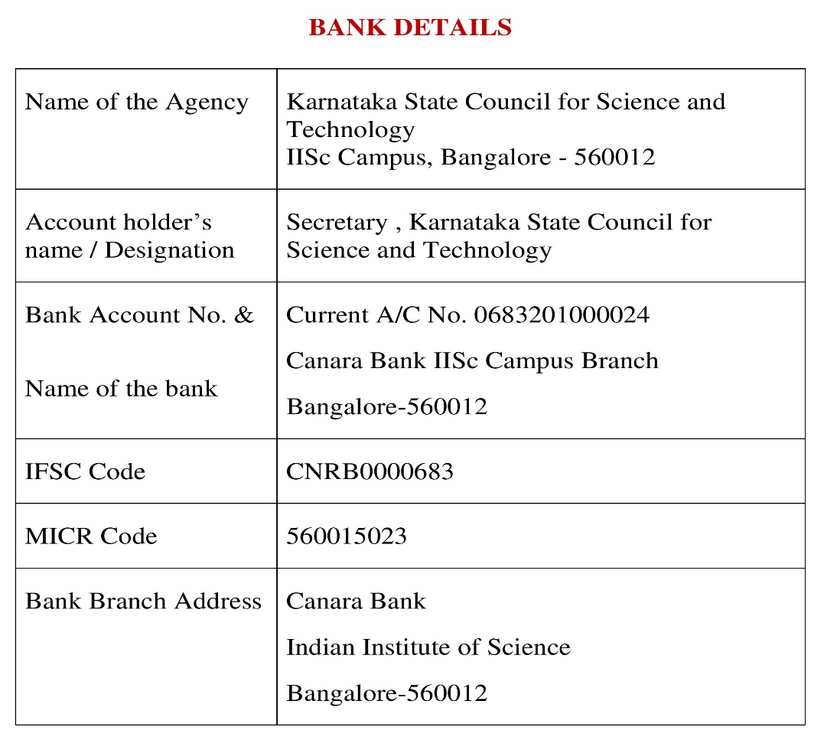
Note: For finance related queries, please contact KSCST accounts section: 080 – 23341652, 23348849 during office hours between 3.00 pm to 5 pm, email: finance@kscst.org.in with a copy to spp@kscst.org.in

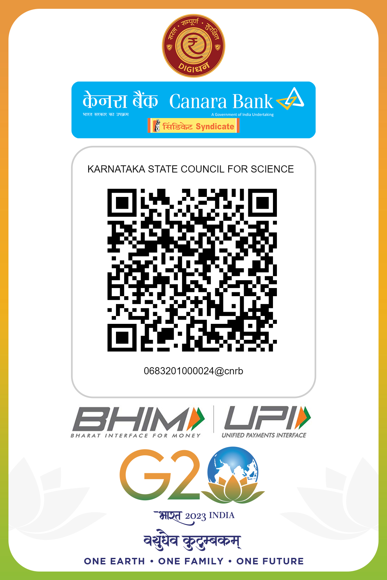
Note: For finance related queries, please contact KSCST accounts section: 080 – 23341652, 23348849 during office hours between 3.00 pm to 5 pm, email: finance@kscst.org.in with a copy to spp@kscst.org.in

