Application: DatumsModification
Revit Platform: All
Revit Version: 2015.0
First Released For: 2015.0
Programming Language: C#
Skill Level: Beginning
Category: Elements
Type: ExternalCommand and ExternalApplication
Subject: Datumplane modification
Summary:
Datumplane modification

Classes:
Autodesk.Revit.UI.IExternalApplication
Autodesk.Revit.DB.DatumPlane

Project Files:
DatumsModificationApp.cs
It contains the class DatumsModificationApp which inherits from interface IExternalApplication and implements the Startup/Shutdown method. In Startup method, add three push buttons.
DatumsModificationCmd.cs
It contains three classes to complete the style modification, the alignment and the propagation operations.

Description:
This sample provides following functionalities.
- Let user modify grids/levels style, such as the extents type, the bubble and the elbow.
- Let user align the grids/levels
- Let user apply the extents of selected grid/level to the selected views.

Instructions:
- Modify the style of selected grids/levels
- Open Revit application and select one or more grids/levels.
- Click the 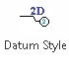button, pop up following dialog:
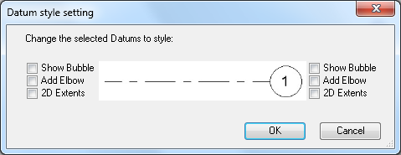

- Check the boxes which style you want to change, then click OK button.
- Align the selected grids/levels
- Open Revit application and select one or more grids/levels.

- Click the 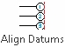 button, pop up following dialog:
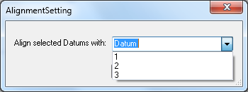
- Choose the grid/level which the other grids/levels will align to, then click OK button.
- Propagate the selected grid/level
- Open Revit application and select one grid/level.

- Click the 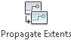button, pop up following dialog:
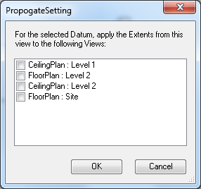
- Choose the views which the style of grid/level will be propagated to, then click OK button.

