**Steps:**

On Command Line:

>> C:\RadCube\Projects\IU_DualCredit\iuDualCredit\iuDualCreditVenv\Scripts\activate.bat (To run the virtual environment, for windows machine)

Open file:

../Code/ iuDualCredit/iuDualCredit/settings.py

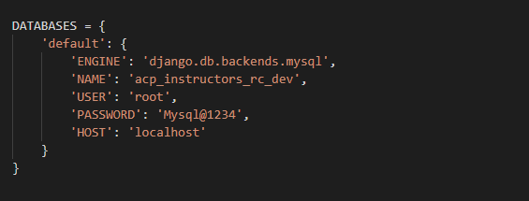

Change the below Parameter:

Host Name: bl-vpue-radcube.ovpue.indiana.edu

Password: have to confirm with ‘Z’ (Zenon Joseph)

Packages installation (if needed):

Installed packages in Virtual Environment:

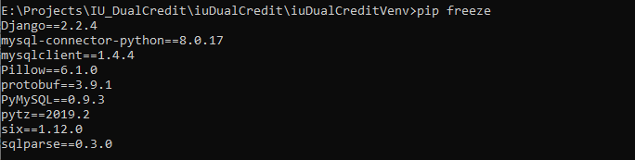

For any Package Error:

Go to directory “../Code/ [iuDualCreditVenv](https://github.iu.edu/BL-VPUE-IT/acp-dual-credit-database/tree/master/Code/iuDualCreditVenv)”

1) pip install django (if needed, to install django)

2) pip install mysqlclient (if needed, to install mysqlclient)

3) pip install mysql-connector-python (if needed, to install mysql-python connector)

4) pip install sshtunnel (if needed, to install sshtunnel package)

5) pip install psycopg2

6) pip install pylint-django (if needed, to highlighted errors only)

**If** **No Error on Command Line**:

>> python manage.py runserver (To run server, You should be in virtual environment)