FALL DETECTION AND PROTECTION BY AIRBAG SYSTEM

Ganipisetty Aravind
Department of Electronics and Communication Engineering
V R Siddhartha Engineering College
Vijayawada, India
aravindganipisetty@gmail.com
Pallikonda Sarah Suhasini
Department of Electronics and Communication Engineering
V R Siddhartha Engineering College
Vijayawada, India
sarahsuhasini@vrsiddhartha.ac.in
Vanamali Vamsi Kiran
Department of Electronics and Communication Engineering
V R Siddhartha Engineering College
Vijayawada, India
vanamalivamsikiran@gmail.com

V Moses Sukumar
Department of Electronics and Communication Engineering
V R Siddhartha Engineering College
Vijayawada, India
mosessukumar345@gmail.com

Abstract—Elderly people are the major victims of head injuries and deaths that occur due to falling. Falls are significant concern, particularly among the elderly and individuals as they often lead to serious injuries and a decline in overall quality of life. There are various methods to detect, prevent and protect the aged people from these accidents. All the existing technologies mainly deals with fall detection and alerting. However, fall protection can greatly help the aged people rather than detection. One promising solution is the development of wearable airbag systems that can provide rapid and effective protection when a fall is detected. In this project a mechanism for detecting falls was done and also a wearable airbag system is built for protection. In the designed system, fall detection is done using accelerometer using threshold-based detection techniques. Upon detecting a fall, Arduino triggers the deployment of the airbag through a solenoid valve mechanism. The solenoid valve, controlled by the Tip122 transistor acting as a switch, regulates the release of compressed air into the airbag, rapidly inflating it to provide cushioning and protection to the individual.
Keywords—Fall Detection, Air Bag Mechanism, Accelerometer Sensor, Arduino Uno, Solenoid Valve

Introduction
Abrupt, involuntary change in body posture from a higher to a lower position is called a fall[1]. Significant number of injuries, including bleeding or cuts, fractures can result from falls, which, according to statistics, affect 30% of adults over 65 every year[2].The majority of falls happen in the bedroom[3], but elderly individuals living alone or are hospitalized may have difficult falls to identify, particularly in the late night or early morning[4]. Whether in the engineering and construction, electricity and gas, or natural resources sectors, falls, along with slips and stumbles, are among the leading causes of workplace injuries and fatalities. The employees in these sectors actually frequently have to get up on platforms and use machinery that is situated quite high. 227,760 non-fatal cases involving trips, falls, and slips were reported by the US Occupational Safety 2017 [5], while 887 fatalities were reported[6].According to information from the 2017 Census of Fatal Occupational Injuries, There were 5% more fatal falls, slips, and trips in the public and private sectors of the economy last year. In the meantime, information from the US OSHA's Bureau of Labour Statistics indicates that 34% of worker falls occur from heights (such as ladders, roofs, or stairs), with 66% occurring on the same level as a result of slips and trips. To decrease the number of injuries, caused by falls, several methods for detecting falls have been proposed[7–13]. Depending on the kind and location of sensors included in the systems, these techniques are categorized as wearable-based, vision-based, and ambient-based technologies, respectively [7-9], [10-11], and [12–13].

LITERATURE SURVEY
This review gives a summary of the evolution of fall detection from a variety of perspectives. Due to the rapid growth of smart sensors and associated analytical techniques different methods are proposed in research. In paper [24] MEMS inertial sensor (MPU9150) is used for gathering human motion signals, which may be utilized for gyroscope and acceleration microprocessor(MCU, low-power microcontroller STM32F103C8T6) for data processing and associated control. Accelerometer and Gyroscope sensors are often utilized in wearable device-based approaches to gather motion data. Machine learning techniques are recently used in fall detection[25][26]. In [27] they attained 100% accuracy in determining acceleration characteristics from an artificial neural network-based wrist-mounted IMU that detect falls. By employing a Kalman filter, they managed to reduce measurement and sensor errors by capturing 3-axis acceleration data from the waist position. Fall detection accuracy was attained using their threshold-based approach, which employed the root mean square of acceleration, vertical angle, and vertical velocity[28]. Table 1 provides a thorough analysis contrasting the present approach with a few among the most complex algorithms for the construction sector. Pressure sensors, magnetometers, and webcams are less common in the literature because of their greater setup costs and less efficient operation. In contrast, accelerometers are the most usually utilized sensors because of their accessibility, low cost, and low energy consumption.
As previously mentioned, most of the suggested studies concentrated on characteristics that are solely driven by data and are often an ensemble of broad statistical features e.g., mean, standard deviation, peak values. A smaller number of algorithms, alternatively discussed applying properties based on physics., which have a stronger discriminant power , body centre of pressure velocity, for example. Within this approach, the subsequent study aims to identify potentially hazardous falls by obtaining a physics-based quantity from data obtained using a triaxial accelerometer alone. On the human body, three accelerations are continuously recorded throughout the experimental campaign. People move both before and during a fall, such as they go about their regular activities or grasping onto anything to keep from falling, which makes it particularly difficult to notice a fall from a height, as will be covered in more detail later. Reducing the sensor arrangement for a view to of extend the battery lifewhich is crucial to maintaining an operational system in case of emergencymakes the already tough detection considerably more problematic. Hence, only when an appropriate acceleration-dependent signal experiences an anomalous rise in value during a fall, the suggested algorithm cause the airbag to deploy.
Form the literature survey most of the works are focused only on fall detection. This work proposes fall detection and protection by airbag system for elderly people by using Accelerometer Sensor, Arduino Uno for processing and Solenoid Valve with air bag.

Methodology
The methodology in order to detect and provide protection using an airbag system involves a systematic approach to enhance safety. Initially, a technique to identify falls is implemented utilizing data from the accelerometer to changes in acceleration indicative of a fall event. Here threshold-based detection technique, forms the basis for identifying potential falls accurately. The Arduino microcontroller acts as the central processing unit, interfacing with the accelerometer and executing the fall detection. Upon detecting a fall, Arduino triggers the deployment of the airbag through a solenoid valve mechanism. The solenoid valve, controlled by the Tip122 transistor acting as a switch, regulates the release of compressed air into the airbag, rapidly inflating it to provide cushioning and protection to the individual. Integration of all components is followed by rigorous testing to ensure reliability, accuracy in fall detection, and effectiveness in airbag deployment. This comprehensive approach aims to mitigate the impact of falls, particularly among vulnerable populations like the elderly, by using technology for proactive safety measures.
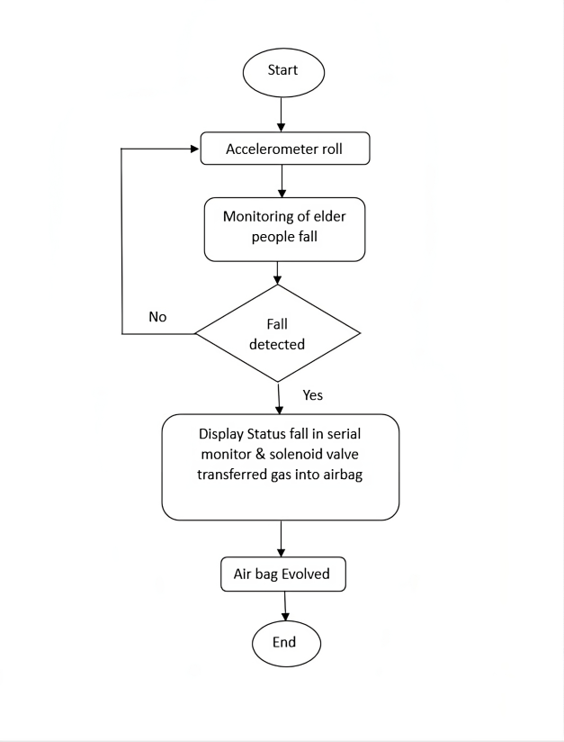
Fig. 1. Flowchart for Airbag Mechanism

The identification and mitigation of falls system utilizing an airbag follows a straightforward process, depicted in a concise flowchart. It commences with the acquisition of sensor data by an accelerometer, which detects motion and relays this information to the central processing unit, typically an Arduino microcontroller. Here, the data undergoes analysis to ascertain if a fall has occurred, typically by identifying abrupt changes in acceleration. Should a fall be detected, the system proceeds to activate the airbag mechanism. This involves the Arduino triggering a solenoid valve, which is regulated by a Tip122 transistor, to release compressed air into the airbag. Subsequently, the airbag swiftly inflates, providing a cushioning effect to mitigate the consequences of the fall and prevent potential injuries. This succinct yet comprehensive process underscores the efficacy of the system in promptly responding to fall events and safeguarding individuals from harm.

Reference | Method/ Approach | Detection Process | Parameters/Features used | Sensor Used | Sensor location
[9] | Detect falling occurrences by utilizing semi-supervised support vector machines to detect vibrations in the floor. | Based on data | Acceleration peak,  Correlation, energy | Accelerometer | N/A
[10] | Construction worker near-miss accident tracking system in real time. | Based on data | N/A | Magnitude | N/A
[11] | Wearing a safety helmet and a classification | Based on data | Exacted with FFT | Accelerometer | Head
[12] | Evaluation of healthy versus fall-prone construction workers | Based on Physics | Acceleration norm, maximal Lyapunov Exponent, and center-of-pressure velocity | Accelerometer,  Gyroscope,  Pressure | Lower back,  Right ankle
[13] | Fall detection near-miss using a single-class SVM | Based on data | Peak value correlation, inertial mean, variances, and spectral entropy, and spectral centroid | Gyroscope,  Accelerometer | Sacrum
[14] | One-class support vector machine for near-miss fall detection | Based on data | Peak value correlation, deviation and spectral centroid, inertial mean, standard | RFID,  Accelerometer,  Gyroscope | Waist
[15] | Using ANNs for activity detection, including slip/trip | Based on data | Acceleration norm mean, standard deviation, and peak | Accelerometer | Pant’s  pocket
[16] | A single-class svm to identify near-miss falls | Based on data | Correlation, standard  deviation, and inertial mean | Gyroscope, Accelerometer | Sacrum
[17] | Evaluation of the postural stability of construction workers | Based on physics | Accelerometer resultant (rAcc) based on body center of pressure velocity (COPV) | Accelerometer,  Pressure | Waist
[18] | The use of machine learning by construction workers | Based on data | Average, variance, energy, and correlation of accelerations | Accelerometer,  Gyroscope | Arm
[19] | A hierarchical threshold-based technique for fall portent detection | Based on physics | Vertical acceleration and acceleration norm | Gyroscope,  Accelerometer | Head,  chest
[20] | Sensing and categorizing imbalance loss in real time | Based on data | Standard deviation, kurtosis, spectral energy, mean pressure, variance, max, min, range, and entropy | Pressure | Foot
[21] | Using maximum Lyapunov exponents to prevent falls | Based on data | t-test on maximal Lyapunov Exponents calculated from inertial information | Accelerometer | Right ankle
[22] | Using Mahanobis distance to find anomalies in gait analysis | Based on physics | Step length and duration, horizontal speed, highest possible foot clearance, stance to swing ratio, and so on | Gyroscope,  Accelerometer | Right ankle
[23] | Utilizing the body's natural reactions to the outside world, identify safety risks | Based on data | Relative acceleration norm (mean, standard deviation, Shapiro-Wilk statistic, correlation), acceleration norm (mean, median, max, min, standard deviation) | Accelerometer | Waist
TABLE 1: Different Fall Detection Techniques – Survey

The circuit diagram and the designed fall detection system are as shown in Fig.2 and Fig.3 respectively.
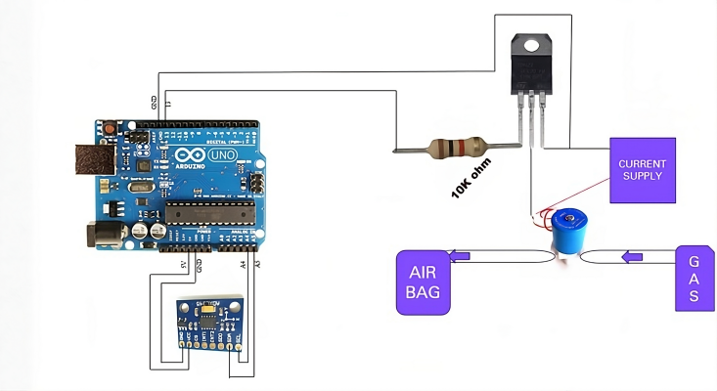
Fig. 2.Circuit Diagram of fall detection using accelerometer and airbag opening

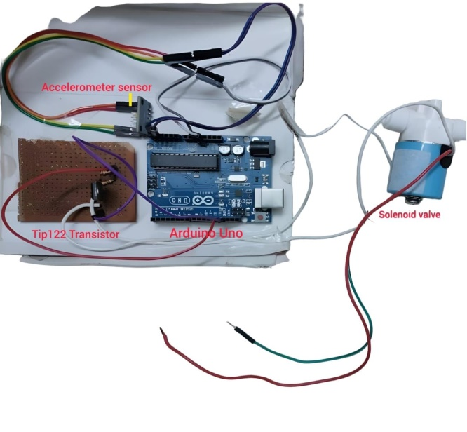
Fig.3 Designed Fall detection system

The designed prototype of air bag mechanism with solenoid valve controlled by switch which regulates the release of compressed air, and a small airbag is as shown in Fig.4
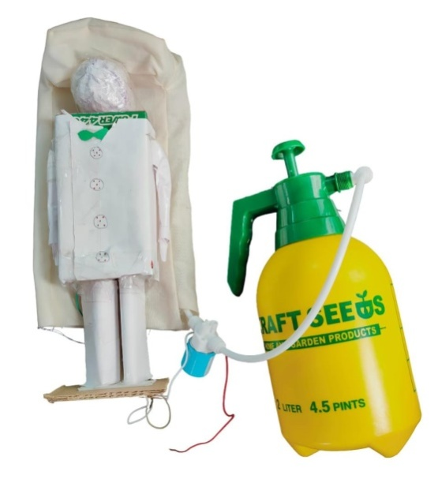
Fig. 4. Airbag Mechanism

RESULTS
To determine abrupt changes that would point to a fall, accelerometer records the acceleration data, which is then processed by arduino. According the directions, the processor will differentiate between fall and regular activities by interpreting these changes. As per the directions of accelerometer, the fall is detected which is shown in Fig.5
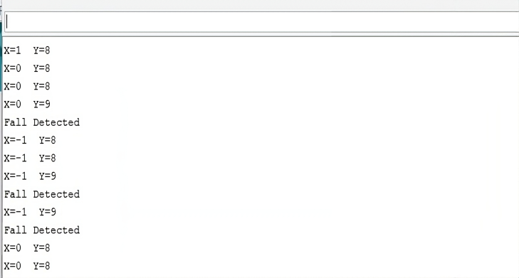
Fig. 5. Fall Detection based on orientation of person falling

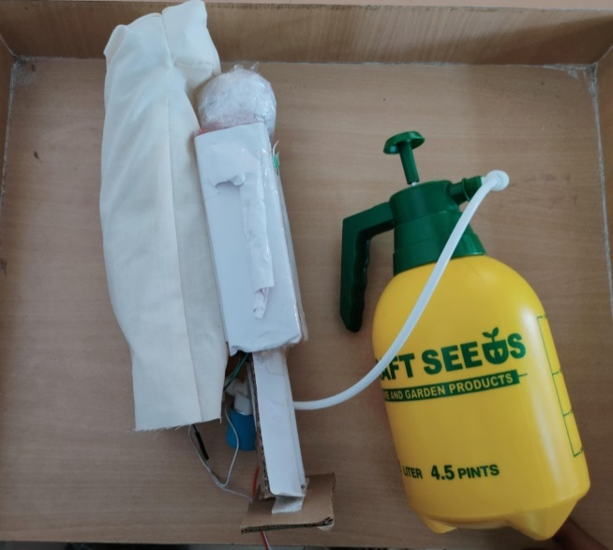Fig. 6. Air bag in operation
Prototype system developed with air bag opening when fall is detected is as shown in Fig.6. Fall protection airbag systems are made to automatically deploy when a person falls, minimizing impact force and providing cushioning. Usually, these systems are made up of wearable technology with sensors like accelerometer that are constantly monitoring motion. The airbag that encircles the person's body quickly inflates when the system detects a fall, lowering the possibility of harm, especially to the head and hips, which are sensitive regions.
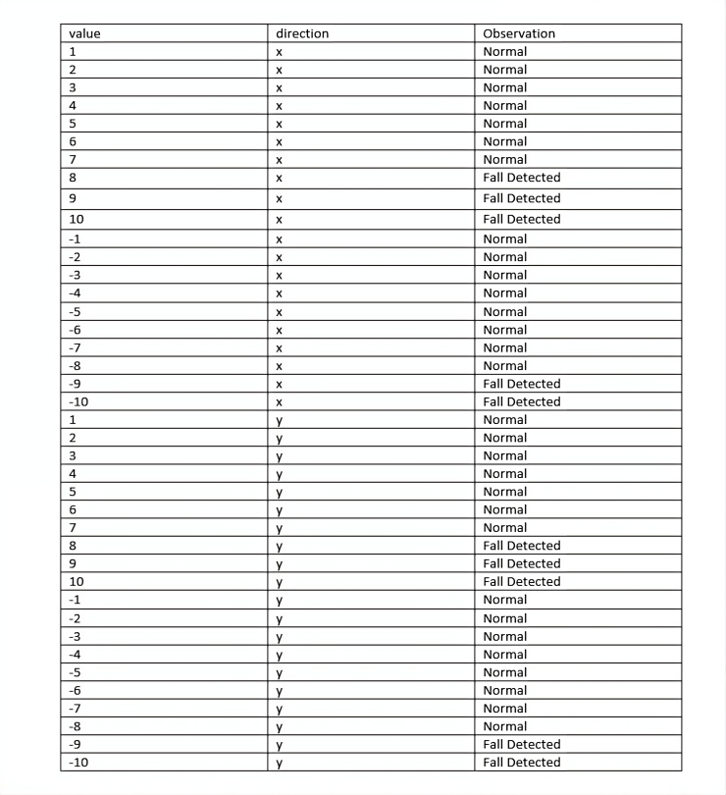
Fig. 7. Analysis of fall detection

For the airbag mechanism designed, as shown Fig.6, Airbag capacity varies according on the particular application and system design in fall detection and protection systems. An airbag's capacity is established by several elements, including its size, shape, and inflation pressure. Capacity generally refers to the volume of air the airbag can store and the amount of force it can absorb during a fall.

Capacity of Air Bag in the Prototype developed:
In the prototype system, compressed air is taken in a bottle and applied pressure by using a movable lid for pressing it.
Airbag capacity =20pushes P=350sec opened in 50 sec
Airbag capacity =25pushes P =500sec opened in 40 sec
Airbag capacity =30pushes P =500sec opened in 38 sec
Airbag capacity =35pushes P =500sec opened in 30 sec
Airbag capacity =40pushes P =1000sec opened in 25 sec
Airbag capacity =42pushes P =2000sec opened in 18 sec
Airbag capacity =38 pushes P =3000sec opened in 6 sec
Airbag capacity =38 pushes P =3200sec opened in 3 sec
Here P = waiting time for sending air into bag
For the prototype used Airbag capacity = 38 to 40 pushes & P = 3200sec
In this work prototype of the proposed system is developed. So compressed air is used in airbag. In real system, Sodium Azide may be used for faster response which is similar to the mechanism used in cars.

VII. CONCLUSION
In this work for fall detection and protection airbag protection system with an accelerometer sensor, a TIP122 transistor, a solenoid valve, and an Arduino UNO microcontroller is designed. The accelerometer sensor continuously tracks acceleration variations. When it notices sudden shifts that indicate a fall, it triggers the Arduino Uno to send a signal to the TIP122 transistor. As a switch, the transistor opens the solenoid valve, allowing the airbag to inflate quickly. This rapid inflation lowers the impact force and lowers the chance of harm by surrounding to the person in a soft cushion. The detection rate of falls is about 80% as the directions of accelerometer are along X and Y axis . It can be improved by using machine learning algorithms with proper dataset having falls in different directions. In future work, machine learning techniques may be used for better performance.

REFERENCES

- M. E. Tinetti, M. Speechley, S. F. Ginter, Risk factors for falls among elderly persons living in the community, New England Journal of Medicine, 319 (1988), 1701–1707.

- P. Hawranik, A clinical possibility: preventing health problems after the age of 65., Journal of Gerontological Nursing, 17 (1991) 20–25.

- I. D. Fischer, M. J. Krauss, W. C. Dunagan, S . Birge, E. Hitcho, Patterns and predictors of inpatient falls and fall- related injuries in a large academic hospital, Infect. Control Hosp. Epidemiol. 26 (2005) 822–827.

- S. Sadigh, A. Reimers, R. Andersson, L. Laflamme, Falls and fall-related injuries among the elderly : a survey of residential-care facilities in a swedish municipality, J. Community Health. 29 (2004) 129–140.
- US Department of Labor Bureau of Labor Statistics, Available on-line via https:// www.bls.gov/iif/oshcdnew.htm, (2017) , Accessed date: April 2020.

- US Department of Labor Bureau of Labor Statistics, Available on-line via https:// www.bls.gov/iif/oshwc/cfoi/cftb0313.htm, (2017) , Accessed date: April 2020.

- Zheng Li chapin. Fall in the body monitoring method and the device design [J]. Chinese journal of medical apparatus and instruments, 1671-7104.2009.02.006.(2009).

- Wang Jie, Hu Zhaoyan, Chen Zhenglong, Wang Weinian. Design and research of inflatable mechanism of wearable fall protection device[J]. Beijing Biomedical Engineering, 37(03): 291-296. (2019).

- C. Liu, Z. Jiang, X. Su, S. Benzoni, A. Maxwell, Detection of human fall using floor vibration and multi-features semi-supervised svm, Sensors 19 (2019) 3720, https:// doi.org/10.3390/s19173720

- W. Wu, H. Yang, D.A. Chew, S.-H. Yang, A.G. Gibb, Q. Li, Towards an autonomous real-time tracking system of near-miss accidents on construction sites, Autom. Constr. 19 (2010) 134–141, https://doi.org/10.1016/j.autcon.2009.11.017.

- S.H. Kim, C. Wang, S.D. Min, S.H. Lee, Safety helmet wearing management system for construction workers using three-axis accelerometer sensor, Appl. Sci. 8 (2018) 2400, https://doi.org/10.3390/app8122400.

- J. Liu, X. Zhang, T.E. Lockhart, Fall risk assessments based on postural and dynamic stability using inertial measurement unit, Saf. Health Work 3 (2012) 192–198, https://doi.org/10.5491/SHAW.2012.3.3.192.

- K. Yang, C.R. Ahn, M.C. Vuran, S.S. Aria, Semi-supervised near-miss fall detection for ironworkers with a wearable inertial measurement unit, Autom. Constr. 68 (2016) 194–202, https://doi.org/10.1016/j.autcon.2016.04.007.

- Aria, S. S., Yang, K., Ahn, C. R., &Vuran, M. C. (2014). Near-miss accident detection for ironworkers using inertial measurement unit sensors. Proceedings of the International Symposium on Automation and Robotics in Construction, 31, 1–6. doi:10.22260/ISARC2014/0115.

- T.-K. Lim, S.-M. Park, H.-C. Lee, D.-E. Lee, Artificial neural network–based slip-trip classifier using smart sensor for construction workplace, J. Constr. Eng. Manag. 142 (2016) 04015065, https://doi.org/10.1061/(ASCE)CO.1943-7862.0001049.

- K. Yang, H. Kim, C.R. Ahn, T.L. Stentz, A near-miss fall detection technique for ironworkers using a hybrid machine learning approach. Proceedings of the 16th
International Conference on Computing in Civil and Building Engineering, 1830–1837, Available on-line via http://www.see.eng.osaka-u.ac.jp/seeit/ icccbe2016/Proceedings/Full_Papers/230-076.pdf, (2016) , Accessed date: April 2020.

- H. Jebelli, C.R. Ahn, T.L. Stentz, Fall risk analysis of construction workers using inertial measurement units: validating the usefulness of the postural stability metrics in construction, Saf. Sci. 84 (2016) 161–170, https://doi.org/10.1016/j.ssci. 2015.12.012

- R. Akhavian, A.H. Behzadan, Smartphone-based construction workers' activity recognition and classification, Autom. Constr. 71 (2016) 198–209, https://doi.org/ 10.1016/j.autcon.2016.08.015.

- Y.-C. Fang, R.-J. Dzeng, Accelerometer-based fall-portent detection algorithm for construction tiling operation, Autom. Constr. 84 (2017) 214–230, https://doi.org/ 10.1016/j.autcon.2017.09.015.
- M.F. Antwi-Afari, H. Li, J. Seo, A.Y.L. Wong, Automated detection and classification of construction workers' loss of balance events using wearable insole pressure sensors, Autom. Constr. 96 (2018) 189–199, https://doi.org/10.1016/j.autcon. 2018.09.010.

- H. Jebelli, C.R. Ahn, T.L. Stentz, Comprehensive fall-risk assessment of construction workers using inertial measurement units: validation of the gait-stability metric to assess the fall risk of iron workers, J. Comput. Civ. Eng. 30 (2016) 04015034, , https://doi.org/10.1061/(ASCE)CP.1943-5487.0000511

- K. Yang, C.R. Ahn, M.C. Vuran, H. Kim, Collective sensing of workers' gait patterns to identify fall hazards in construction, Autom. Constr. 82 (2017) 166–178, https:// doi.org/10.1016/j.autcon.2017.04.010.

- H. Kim, C.R. Ahn, K. Yang, Identifying safety hazards using collective bodily responses of workers, J. Constr. Eng. Manag. 143 (2017) 04016090, , https://doi.org/ 10.1061/(ASCE)CO.1943-7862.0001220.

- Zheng Li chapin. Fall in the body monitoring method and the device design [J]. Chinese journal of medical apparatus and instruments, 1671-7104.2009.02.006.

- Y. Li, G. Chen, Y. Shen, Y. Zhu and Z. Cheng, "Accelerometer-based fall detection sensor system for the elderly," 2012 IEEE 2nd International Conference on Cloud Computing and Intelligence Systems, Hangzhou, China, 2012, pp. 1216-1220, doi: 10.1109/CCIS.2012.6664577
- H. Kerdegari, K. Samsudin, A.R. Ramli, and S. Mokaram, “Evaluation of Fall Detection Classification Approaches”, 2012 4th International Conference on Intelligent and Advanced Systems(ICIAS), June 12-14th, 2012, pp. 131-136.
- Yoo, S.G.; Oh, D.I. An artificial neural network-based fall detection. Int. J. Eng. Bus. Manag.
- Thanh, P.V.; Tran, C.T.; Nguyen, D.C.; Anh, N.D.; Dinh, D.N.; El-Rabaie, S.; Sandrasegara, K. Development of a real-time, simple and high-accuracy fall detection system for elderly using 3-DOF accelerometers. Arab. J. Sci. Eng. 2019, 44, 3329–3342.

