A basic introduction to R

Abhijit Dasgupta, PhD  
ARAASTAT

Prepared for Pharmerit, LLC

This work is copyright © Abhijit Dasgupta, 2013. All rights reserved.

# Preamble

Please run the file *initialize.R* first to ensure you have all the appropriate packages installed locally. For the reporting modules and examples, please install *Pandoc* directly from [here](http://johnmacfarlane.net/pandoc/installing.html).

# Starting out in R

The document *Magic.Rmd* contains a complete workflow: enter data into R from Excel, do some manipulations, draw a plot, and generate a report. The results of this can be seen in *Magic.html* and the actual R code is in *Magic.R*. You can create the report yourself using

library(knitr)  
knit2html("Magic.Rmd")

This HTML file can be easily imported into Word, for example. Alternatively, you can do

library(pander)  
library(knitr)  
knit("Magic.Rmd")  
Pandoc.convert("Magic.md", format = "docx")

to directly get a Word document.

R coding is free-form, in that you can split code over lines. If you want to put two commands on the same line of text, separate them with a ;. Lines of code can be commented out using #.

## Reading data into R from a CSV file

The most common type of data are text files, and often comma-separated files or csv files. R natively handles the import of data in csv format, using read.csv.

pheno <- read.csv("data/pheno.csv")  
pheno # This prints out the data  
head(pheno) # This prints out first 6 lines  
tail(pheno) # This prints out last 6 lines

**Tip:** you can just type an R object to see what it is or what it contains. For example, if you want to see how the function read.csv is coded, just type read.csv. You can also find out just what the arguments for a function and their default values are using the function arg, as below

read.csv

## function (file, header = TRUE, sep = ",", quote = "\"", dec = ".",   
## fill = TRUE, comment.char = "", ...)   
## read.table(file = file, header = header, sep = sep, quote = quote,   
## dec = dec, fill = fill, comment.char = comment.char, ...)  
## <bytecode: 0x7fb33621ed88>  
## <environment: namespace:utils>

args(read.csv)

## function (file, header = TRUE, sep = ",", quote = "\"", dec = ".",   
## fill = TRUE, comment.char = "", ...)   
## NULL

We see that read.csv is build on the function read.table. To see more about read.table, you can access its documentation by typing ?read.table or help(read.table)

help(read.table)

## Working with data sets

### Figuring out what's in a data set

R has two powerful functions which give you a quick feel about a data set. The two major pieces of information you need are

* What kinds of data are part of the data set (use str)
* Some summary of the data (use summary)

str(pheno) tells us that we have a data.frame object with 1000 observations of 6 variables. Each variable has a type -- in this case all are integer variables (int) and sex is a factor variable. I'll describe factor variables in a bit.

summary(pheno) gives numerical summaries for int variables (as it would for numeric variables) and frequency tabulations for factor variables. If you have a character variable (denoted chr in the output of str), it would merely say that you have a character variable of 1000 observations

str(pheno)

## 'data.frame': 1000 obs. of 6 variables:  
## $ X : int 486 79 511 304 933 47 584 585 589 659 ...  
## $ sex: Factor w/ 2 levels "FEMALE","MALE": 2 1 1 2 2 1 1 1 1 1 ...  
## $ sbp: int 132 122 173 151 148 159 149 145 158 153 ...  
## $ dbp: int 76 60 63 81 89 79 90 100 80 68 ...  
## $ bmi: int 16 17 17 18 18 19 19 19 19 19 ...  
## $ id : int 45516 21869 24512 32125 21503 30728 49088 43523 41446 28797 ...

summary(pheno)

## X sex sbp dbp bmi   
## Min. : 1 FEMALE:468 Min. : 87 Min. : 47.0 Min. :16.0   
## 1st Qu.: 251 MALE :532 1st Qu.:129 1st Qu.: 76.0 1st Qu.:26.0   
## Median : 500 Median :140 Median : 82.0 Median :29.0   
## Mean : 500 Mean :141 Mean : 82.6 Mean :30.3   
## 3rd Qu.: 750 3rd Qu.:152 3rd Qu.: 90.0 3rd Qu.:33.0   
## Max. :1000 Max. :202 Max. :117.0 Max. :51.0   
## NA's :1   
## id   
## Min. :10100   
## 1st Qu.:20168   
## Median :28914   
## Mean :29713   
## 3rd Qu.:39570   
## Max. :49911   
##

### A note on data.frame

The data.frame looks like a matrix, but it really isn't. This is one of the pitfalls and quirks of R. We can see this by

is.data.frame(pheno)

## [1] TRUE

is.matrix(pheno)

## [1] FALSE

The data.frame object is really another kind of R object, a list. We will see later how this is useful, since R has very powerful list manipulation functions. Still, some matrix operations are allowed for data.frame objects. For example, you can extract rows and columns and elements just like a matrix, using pheno[1,] (1st row), pheno[,3] (3rd column) or pheno[1,2] (the (1,2) element).

You can extract variables (stored apparently in columns) either by the above matrix notation, or by variable name. For example, to just extract the sex variable, you can use pheno$sex or pheno[,'sex']. The $ notation is useful to extract single variables, but the matrix-like notation is useful to extract multiple variables by name: pheno[,c('sex','sbp','dbp','bmi')]. As a side note,c()` is a function called "concatenate", which creates vectors.

### Merging data sets

The study I took the data from has two files, geno and pheno, which collected gene data and clinical data respectively from 1000 subjects. We now read in the gene data, but we need to match up the two data sets so that the rows correspond. The simplest way to do this is to sort the rows of the data frame by the id variable, so both have the same order. The data set pheno is already sorted. We need to do this for pheno. We will use the order function on the id variable to figure out its sort order. Basically, the rule is that, to sort a vector x, you can do sort(x) or x[order(x)]. Here what we need is the correct re-ordering, not just the sorted values. So order(x) is what's needed to re-order the rows.

**A general practice:** Never change data (be it a vector or a data.frame) in place. Always copy it to differently-named object and change that. That way, if you goof up, you're not having to re-generate everything. So, I saved the re-ordered pheno to pheno2. This keeps pheno unchanged.

geno <- read.table("data/geno.csv", sep = ",", header = T)  
head(geno)

## snp1 snp2 snp3 snp4 snp5 snp6 snp7 snp8 snp9 snp10 snp11 id  
## 1 CC TT TT TT CC AG TT CC TT CT TT 10100  
## 2 TT TT CC CC CC AA AT CT CT CC TT 10110  
## 3 CT AT TC TT <NA> AG AT CC TT CT TT 10177  
## 4 CT TT CC CC CC AA AT CC TT CT CT 10180  
## 5 TT TT CC CC CC AA TT CC TT CT TT 10244  
## 6 CT AT <NA> CT CT AG AT CT CT CC CT 10245

head(pheno)

## X sex sbp dbp bmi id  
## 1 486 MALE 132 76 16 45516  
## 2 79 FEMALE 122 60 17 21869  
## 3 511 FEMALE 173 63 17 24512  
## 4 304 MALE 151 81 18 32125  
## 5 933 MALE 148 89 18 21503  
## 6 47 FEMALE 159 79 19 30728

o = order(pheno$id)  
# pheno$id[o]  
pheno2 = pheno[o, ]  
# pheno2 <- pheno[order(pheno$id),]  
head(pheno2)

## X sex sbp dbp bmi id  
## 193 479 MALE 152 88 25 10100  
## 621 711 FEMALE 187 88 31 10110  
## 578 987 MALE 135 93 30 10177  
## 80 110 FEMALE 148 92 23 10180  
## 271 712 FEMALE 133 69 26 10244  
## 33 472 FEMALE 112 47 21 10245

A better way to match the ordering of two data sets based on a common variable is to use the function match

args(match)

## function (x, table, nomatch = NA_integer_, incomparables = NULL)   
## NULL

ind <- match(geno$id, pheno$id)  
pheno3 <- pheno[ind, ]

You can check for yourself whether pheno2 and pheno3 are the same.

You can also merge the two datasets into a single data set based on a common variable, using the function merge. This does not require the common variable (in this case, id) to be sorted, unlike in SAS.

args(merge)

## function (x, y, ...)   
## NULL

combined.data <- merge(pheno, geno, by = "id")  
head(combined.data)

## id X sex sbp dbp bmi snp1 snp2 snp3 snp4 snp5 snp6 snp7 snp8  
## 1 10100 479 MALE 152 88 25 CC TT TT TT CC AG TT CC  
## 2 10110 711 FEMALE 187 88 31 TT TT CC CC CC AA AT CT  
## 3 10177 987 MALE 135 93 30 CT AT TC TT <NA> AG AT CC  
## 4 10180 110 FEMALE 148 92 23 CT TT CC CC CC AA AT CC  
## 5 10244 712 FEMALE 133 69 26 TT TT CC CC CC AA TT CC  
## 6 10245 472 FEMALE 112 47 21 CT AT <NA> CT CT AG AT CT  
## snp9 snp10 snp11  
## 1 TT CT TT  
## 2 CT CC TT  
## 3 TT CT TT  
## 4 TT CT CT  
## 5 TT CT TT  
## 6 CT CC CT

### Factor variables

Factor variables are very useful, but can be quirky. Factors look like character variables, but are really stored as numeric variables. They are meant to store categorical variables rather than strings.

s2 = as.character(pheno$sex)  
str(s2)

## chr [1:1000] "MALE" "FEMALE" "FEMALE" "MALE" "MALE" ...

summary(s2)

## Length Class Mode   
## 1000 character character

head(as.numeric(pheno$sex))

## [1] 2 1 1 2 2 1

head(as.numeric(s2))

## [1] NA NA NA NA NA NA

When we read in data sets, R, by default, converts any string variable to a factor. This is often not what we want. For example, an identifier variable needs to remain a character, not a factor. Most of us suggest making sure that strings are imported as characters, not factors. There is an option stringsAsFactors which can be set globally using options(stringsAsFactors=FALSE). You can also set it on the fly when you import data

pheno <- read.csv("data/pheno.csv", stringsAsFactors = F)

You can also pre-specify what the types of variables are in each column you are importing, using the option colClasses (note the camel-case). This is much faster if you are importing large data sets

pheno <- read.csv("data/pheno.csv", colClasses = c("integer", "factor", "integer",   
 "integer", "integer", "integer"))

## Reading from databases

R has packages to import data from most standard relational databases. The generic package is RODBC which connects R to ODBC-compliant databases. Popular databases also have dedicated packages, including

* MySQL (RMySQL),
* Postgresql (RPgSQL),
* SQLite (RSQLite),
* MonetDB (MonetDB.R)

More recently, there are packages to import from MongoDB and CouchDB, two popular NoSQL databases.

I'm demonstrating using RSQLite, since it installs the sqlite database automatically. The other package you need is sqldb, which allows you to manipulate R data frames and database objects using SQL commands. If you are coming from a SQL background, this is a life saver.

library(RSQLite)  
sqlite <- dbDriver("SQLite")  
exampledb <- dbConnect(sqlite, "data/mydb.sqlite")  
dbListTables(exampledb)

## [1] "genotype" "phenotype"

library(sqldf)  
sqldf("select * from phenotype limit 5", dbname = "data/mydb.sqlite")

## X sex sbp dbp bmi id  
## 1 486 MALE 132 76 16 45516  
## 2 79 FEMALE 122 60 17 21869  
## 3 511 FEMALE 173 63 17 24512  
## 4 304 MALE 151 81 18 32125  
## 5 933 MALE 148 89 18 21503

sqldf("select * from pheno limit 5") # use the data.frame pheno

## X sex sbp dbp bmi id  
## 1 486 MALE 132 76 16 45516  
## 2 79 FEMALE 122 60 17 21869  
## 3 511 FEMALE 173 63 17 24512  
## 4 304 MALE 151 81 18 32125  
## 5 933 MALE 148 89 18 21503

## Subsetting

We will use another data set that comes with R to demonstrate some other functionalities. You can see all the data sets that are loaded with R and other R packages you might have installed by typing data(). We will use the mtcars data set, which is a data set of car road tests published by Motor Trend magazine in 1974.

First, we will look at subsetting data by values of some variable. Note, if you wanted to subset particular rows, say the first 10 rows, you could just use matrix notation and do mtcars[1:10,].

The notation 1:10 denotes the sequence 1,2,3,4,5,6,7,8,9,10, stored in a numeric vector. This is similar to the function range in Python.

Note that R starts counting at 1, so the first element of a vector x is x[1]. This is unlike Python or C, which start counting at 0. This is because of R's close history with Fortran, which was a column-dominant language counting from 1.

We start by extracting the subset of data where number of cylinders is 6. Note that we are using == and not =. You can also put multiple conditions in your subset conditions, either using & (and) or | (or)

str(mtcars)

## 'data.frame': 32 obs. of 11 variables:  
## $ mpg : num 21 21 22.8 21.4 18.7 18.1 14.3 24.4 22.8 19.2 ...  
## $ cyl : Factor w/ 3 levels "4","6","8": 2 2 1 2 3 2 3 1 1 2 ...  
## $ disp: num 160 160 108 258 360 ...  
## $ hp : num 110 110 93 110 175 105 245 62 95 123 ...  
## $ drat: num 3.9 3.9 3.85 3.08 3.15 2.76 3.21 3.69 3.92 3.92 ...  
## $ wt : num 2.62 2.88 2.32 3.21 3.44 ...  
## $ qsec: num 16.5 17 18.6 19.4 17 ...  
## $ vs : num 0 0 1 1 0 1 0 1 1 1 ...  
## $ am : num 1 1 1 0 0 0 0 0 0 0 ...  
## $ gear: Factor w/ 3 levels "3","4","5": 2 2 2 1 1 1 1 2 2 2 ...  
## $ carb: num 4 4 1 1 2 1 4 2 2 4 ...

head(mtcars)

## mpg cyl disp hp drat wt qsec vs am gear carb  
## Mazda RX4 21.0 6 160 110 3.90 2.620 16.46 0 1 4 4  
## Mazda RX4 Wag 21.0 6 160 110 3.90 2.875 17.02 0 1 4 4  
## Datsun 710 22.8 4 108 93 3.85 2.320 18.61 1 1 4 1  
## Hornet 4 Drive 21.4 6 258 110 3.08 3.215 19.44 1 0 3 1  
## Hornet Sportabout 18.7 8 360 175 3.15 3.440 17.02 0 0 3 2  
## Valiant 18.1 6 225 105 2.76 3.460 20.22 1 0 3 1

subset(mtcars, cyl == 6)

## mpg cyl disp hp drat wt qsec vs am gear carb  
## Mazda RX4 21.0 6 160.0 110 3.90 2.620 16.46 0 1 4 4  
## Mazda RX4 Wag 21.0 6 160.0 110 3.90 2.875 17.02 0 1 4 4  
## Hornet 4 Drive 21.4 6 258.0 110 3.08 3.215 19.44 1 0 3 1  
## Valiant 18.1 6 225.0 105 2.76 3.460 20.22 1 0 3 1  
## Merc 280 19.2 6 167.6 123 3.92 3.440 18.30 1 0 4 4  
## Merc 280C 17.8 6 167.6 123 3.92 3.440 18.90 1 0 4 4  
## Ferrari Dino 19.7 6 145.0 175 3.62 2.770 15.50 0 1 5 6

subset(mtcars, cyl == 6 & mpg < 20)

## mpg cyl disp hp drat wt qsec vs am gear carb  
## Valiant 18.1 6 225.0 105 2.76 3.46 20.22 1 0 3 1  
## Merc 280 19.2 6 167.6 123 3.92 3.44 18.30 1 0 4 4  
## Merc 280C 17.8 6 167.6 123 3.92 3.44 18.90 1 0 4 4  
## Ferrari Dino 19.7 6 145.0 175 3.62 2.77 15.50 0 1 5 6

## Transformation and creating new variables

The non-destructive way of creating new variables in a data set is the function transform. First we want to say that if a car gets less than 20 mpg, it is a gas guzzler. R has a convenient ifelse function to do this (much like th ? function in Python/C). Ideally you want to make this new variable a factor.

You can create multiple variables in one command using transform. For example, I also convert mpg to kmpg.

ifelse(mtcars$mpg < 20, "gas.guzzler", "Econ")

## [1] "Econ" "Econ" "Econ" "Econ" "gas.guzzler"  
## [6] "gas.guzzler" "gas.guzzler" "Econ" "Econ" "gas.guzzler"  
## [11] "gas.guzzler" "gas.guzzler" "gas.guzzler" "gas.guzzler" "gas.guzzler"  
## [16] "gas.guzzler" "gas.guzzler" "Econ" "Econ" "Econ"   
## [21] "Econ" "gas.guzzler" "gas.guzzler" "gas.guzzler" "gas.guzzler"  
## [26] "Econ" "Econ" "Econ" "gas.guzzler" "gas.guzzler"  
## [31] "gas.guzzler" "Econ"

blah <- transform(mtcars, gas = ifelse(mpg < 20, "gas.guzzler", "econ"), kmpg = 1.6 *   
 mpg)  
str(blah)

## 'data.frame': 32 obs. of 13 variables:  
## $ mpg : num 21 21 22.8 21.4 18.7 18.1 14.3 24.4 22.8 19.2 ...  
## $ cyl : Factor w/ 3 levels "4","6","8": 2 2 1 2 3 2 3 1 1 2 ...  
## $ disp: num 160 160 108 258 360 ...  
## $ hp : num 110 110 93 110 175 105 245 62 95 123 ...  
## $ drat: num 3.9 3.9 3.85 3.08 3.15 2.76 3.21 3.69 3.92 3.92 ...  
## $ wt : num 2.62 2.88 2.32 3.21 3.44 ...  
## $ qsec: num 16.5 17 18.6 19.4 17 ...  
## $ vs : num 0 0 1 1 0 1 0 1 1 1 ...  
## $ am : num 1 1 1 0 0 0 0 0 0 0 ...  
## $ gear: Factor w/ 3 levels "3","4","5": 2 2 2 1 1 1 1 2 2 2 ...  
## $ carb: num 4 4 1 1 2 1 4 2 2 4 ...  
## $ gas : Factor w/ 2 levels "econ","gas.guzzler": 1 1 1 1 2 2 2 1 1 2 ...  
## $ kmpg: num 33.6 33.6 36.5 34.2 29.9 ...

blah <- transform(mtcars, gas = ifelse(mpg < 20, "gas.guzzler", "econ"), kmpg = 1.6 *   
 mpg, score = 3 * cyl + 0.1 * wt - 0.01 * mpg)

## Warning: * not meaningful for factors

str(blah)

## 'data.frame': 32 obs. of 14 variables:  
## $ mpg : num 21 21 22.8 21.4 18.7 18.1 14.3 24.4 22.8 19.2 ...  
## $ cyl : Factor w/ 3 levels "4","6","8": 2 2 1 2 3 2 3 1 1 2 ...  
## $ disp : num 160 160 108 258 360 ...  
## $ hp : num 110 110 93 110 175 105 245 62 95 123 ...  
## $ drat : num 3.9 3.9 3.85 3.08 3.15 2.76 3.21 3.69 3.92 3.92 ...  
## $ wt : num 2.62 2.88 2.32 3.21 3.44 ...  
## $ qsec : num 16.5 17 18.6 19.4 17 ...  
## $ vs : num 0 0 1 1 0 1 0 1 1 1 ...  
## $ am : num 1 1 1 0 0 0 0 0 0 0 ...  
## $ gear : Factor w/ 3 levels "3","4","5": 2 2 2 1 1 1 1 2 2 2 ...  
## $ carb : num 4 4 1 1 2 1 4 2 2 4 ...  
## $ gas : Factor w/ 2 levels "econ","gas.guzzler": 1 1 1 1 2 2 2 1 1 2 ...  
## $ kmpg : num 33.6 33.6 36.5 34.2 29.9 ...  
## $ score: num NA NA NA NA NA NA NA NA NA NA ...

Note that the original mtcars remains unchanged

str(mtcars)

## 'data.frame': 32 obs. of 11 variables:  
## $ mpg : num 21 21 22.8 21.4 18.7 18.1 14.3 24.4 22.8 19.2 ...  
## $ cyl : Factor w/ 3 levels "4","6","8": 2 2 1 2 3 2 3 1 1 2 ...  
## $ disp: num 160 160 108 258 360 ...  
## $ hp : num 110 110 93 110 175 105 245 62 95 123 ...  
## $ drat: num 3.9 3.9 3.85 3.08 3.15 2.76 3.21 3.69 3.92 3.92 ...  
## $ wt : num 2.62 2.88 2.32 3.21 3.44 ...  
## $ qsec: num 16.5 17 18.6 19.4 17 ...  
## $ vs : num 0 0 1 1 0 1 0 1 1 1 ...  
## $ am : num 1 1 1 0 0 0 0 0 0 0 ...  
## $ gear: Factor w/ 3 levels "3","4","5": 2 2 2 1 1 1 1 2 2 2 ...  
## $ carb: num 4 4 1 1 2 1 4 2 2 4 ...

## Missing data

R codes missing data as NA, and provides the function is.na to find missing values. Many of R's functions give a missing value or NA if one of the components in the computation is missing. This behavior can be suppressed within the functions which accept it by the option na.rm=TRUE. The summary function we saw before already does this, and tells you how many values are missing for each variable in the data set

blah$mpg[3] <- NA  
head(blah)

## mpg cyl disp hp drat wt qsec vs am gear carb  
## Mazda RX4 21.0 6 160 110 3.90 2.620 16.46 0 1 4 4  
## Mazda RX4 Wag 21.0 6 160 110 3.90 2.875 17.02 0 1 4 4  
## Datsun 710 NA 4 108 93 3.85 2.320 18.61 1 1 4 1  
## Hornet 4 Drive 21.4 6 258 110 3.08 3.215 19.44 1 0 3 1  
## Hornet Sportabout 18.7 8 360 175 3.15 3.440 17.02 0 0 3 2  
## Valiant 18.1 6 225 105 2.76 3.460 20.22 1 0 3 1  
## gas kmpg score  
## Mazda RX4 econ 33.60 NA  
## Mazda RX4 Wag econ 33.60 NA  
## Datsun 710 econ 36.48 NA  
## Hornet 4 Drive econ 34.24 NA  
## Hornet Sportabout gas.guzzler 29.92 NA  
## Valiant gas.guzzler 28.96 NA

mean(blah$mpg)

## [1] NA

mean(blah$mpg, na.rm = T)

## [1] 20

## 'Apply'ing a function over components of a data set

R provides a family of functions, all ending in apply, which are meant to evaluate a function over different aspects of a data set. The function apply works on matrices.

args(apply)

## function (X, MARGIN, FUN, ...)   
## NULL

X = matrix(rnorm(100), ncol = 10) # rnorm generates normal random numbers  
apply(X, 2, mean)

## [1] 0.30206 -0.22703 0.26977 0.02580 -0.18515 -0.23471 0.10943  
## [8] -0.10705 0.02807 0.04476

lapply does the same for components of a list. Recall I said that a data.frame object is really a list. So the following works:

args(lapply)

## function (X, FUN, ...)   
## NULL

lapply(pheno, mean, na.rm = T)

## Warning: argument is not numeric or logical: returning NA

## $X  
## [1] 500.5  
##   
## $sex  
## [1] NA  
##   
## $sbp  
## [1] 141.4  
##   
## $dbp  
## [1] 82.61  
##   
## $bmi  
## [1] 30.26  
##   
## $id  
## [1] 29713

## Aggregation

R provides many ways to aggregate data, including the functions by and aggregate. The most powerful group of functions are from the package plyr. These functions are all of the form (x)(y)ply, where (x) and (y) can be any of *d* (data.frame),*a* (array), and *l* (list). (x) denotes the type of data that is input, and (y) denotes the type of data being output. These functions implement what Wickham calls the "split-apply-combine" paradigm, i.e., you split the data by some variable (usually of type factor), apply a function to the split pieces, and put the results of the functions back together. The documentation is rather unfortunate for these functions, so I'll demonstrate by example.

We will first look at the average mpg of the cars in mtcars by number of cylinders. This can be done by splitting the data set by cyl, passing the split data sets through the function summarise, and then putting the results back together into a data frame. For more information on the summarise function, look at its documentation. There are two ways of denoting the splitting variable. I prefer ~cyl, since it is similar to the formula interface for modeling in R that I am familiar with, and that you will learn later. You can also split on two or more factors quite easily. With summarise, you can also compute more than one measure

library(plyr)  
mtcars <- transform(mtcars, cyl = as.factor(cyl), gear = as.factor(gear)) #this creates a local copy  
avg.by.cyl <- ddply(mtcars, ~cyl, summarise, mpg = mean(mpg, na.rm = T))  
# avg.by.cyl <- ddply(mtcars, .(cyl), summarise, mpg = mean(mpg, na.rm=T))  
avg.by.cyl

## cyl mpg  
## 1 4 26.66  
## 2 6 19.74  
## 3 8 15.10

avg.by.cyl.gear <- ddply(mtcars, ~cyl + gear, summarise, mean.mpg = mean(mpg,   
 na.rm = T), median.mpg = median(mpg, na.rm = T))  
avg.by.cyl.gear

## cyl gear mean.mpg median.mpg  
## 1 4 3 21.50 21.50  
## 2 4 4 26.93 25.85  
## 3 4 5 28.20 28.20  
## 4 6 3 19.75 19.75  
## 5 6 4 19.75 20.10  
## 6 6 5 19.70 19.70  
## 7 8 3 15.05 15.20  
## 8 8 5 15.40 15.40

If you want to just split the data set up by a variable, that is very easy as well

dlply(mtcars, ~cyl)

# Basic plotting

R provides several plotting frameworks. The basic one is known as base graphics, and one of the more popular frameworks is in the package [ggplot2](http://docs.ggplot2.org). To make a few quick and dirty plots....

plot(mpg ~ disp, data = mtcars)

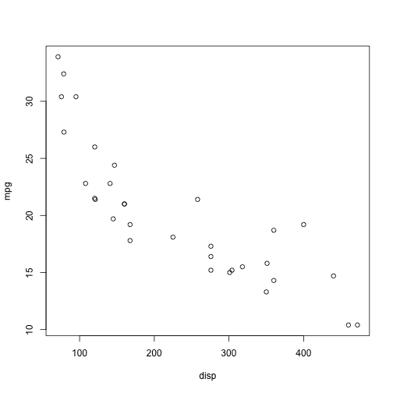

plot of chunk plots1

plot(mpg ~ disp, data = mtcars, xlab = "Displacement", ylab = "Miles per gallon",   
 main = "Fuel effiency by engine size") # adding labels

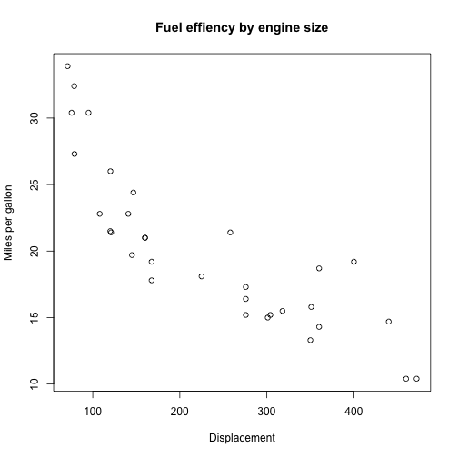

plot of chunk plots1

boxplot(mpg ~ cyl, data = mtcars)

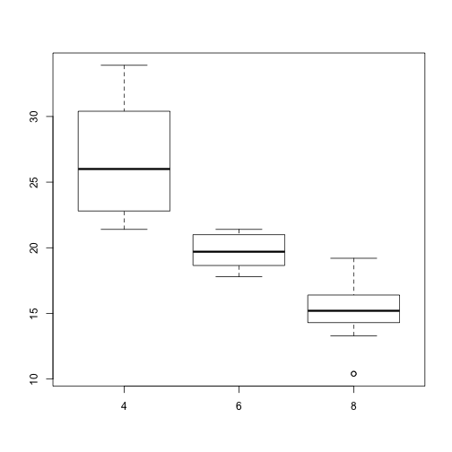

plot of chunk plots1

You can make prettier plots with better defaults using ggplot2 which is based on the Grammar of Graphics. The idea is, like a painter, to layer different components of the plot on top of each other. The syntax is quirky again, but once you learn it, it is really very powerful.

library(ggplot2)  
print(ggplot(mtcars, aes(x = disp, y = mpg)) + geom_point())

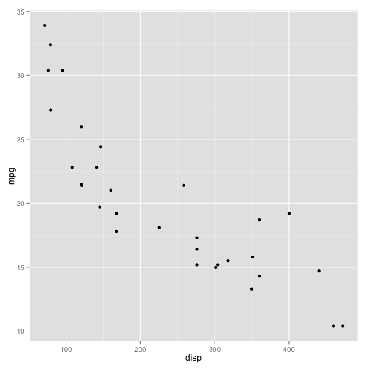

plot of chunk ggplot

print(ggplot(mtcars, aes(x = disp, y = mpg)) + geom_point() + geom_smooth() +   
 labs(x = "Displacement", y = "Miles per gallon") + ggtitle("Fuel efficiency by engine size"))

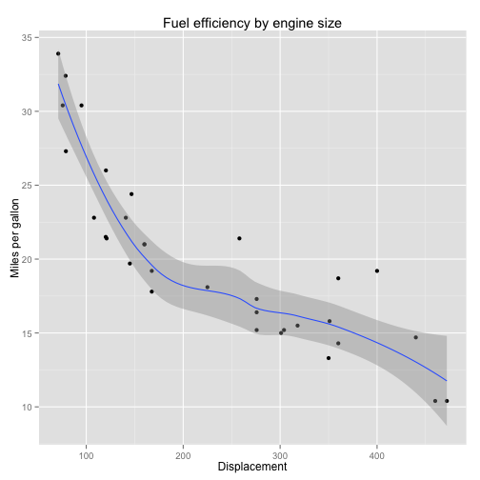

plot of chunk ggplot

print(ggplot(mtcars, aes(x = disp, y = mpg)) + geom_point() + geom_smooth() +   
 facet_wrap(~cyl, ncol = 1) + labs(x = "Displacement", y = "Miles per gallon"))

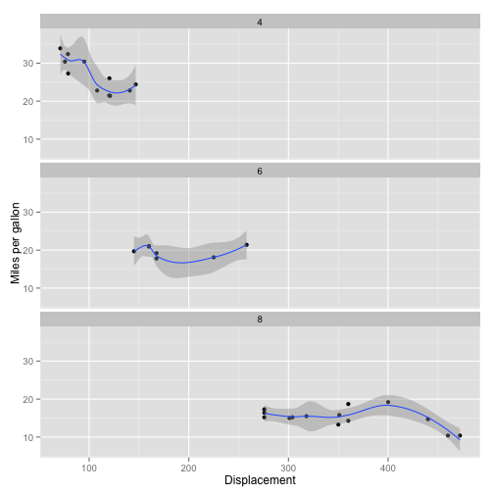

plot of chunk ggplot

If you want to look at several variables and their inter-relationships, the functions pairs (base graphics) and plotmatrix (ggplot2) work

pairs(pheno[, c("sbp", "dbp", "bmi")])

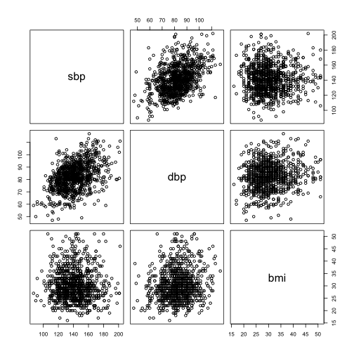

plot of chunk pm

print(plotmatrix(pheno[, c("sbp", "dbp", "bmi")]))

## This function is deprecated. For a replacement, see the ggpairs function  
## in the GGally package. (Deprecated; last used in version 0.9.2)

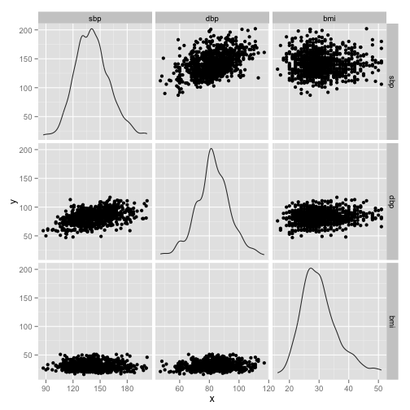

plot of chunk pm

### Javascript-based interactive charts

I believe the future is in web-based content-rich interactive charts. The package rCharts provides an interface from R to several Javascript graphing libraries. Running the following code will open up your web browser to display the charts. These charts can be integrated into HTML documents, but that's another day. See the [rCharts](http://ramnathv.github.io/rCharts/) webpage for more details.

library(rCharts)  
r1 <- rPlot(mpg ~ wt | cyl, data = mtcars, type = "point")  
r1

# Some basic modeling

Fitting a linear regression model to two variables is a pretty basic task. R provies an intuitive formula interface for all its modeling functions, which reads just like an equation. The linear regression model is fit using the function lm (linear model). Other modeling functions include glm (generalized linear models), lrm (logistic regression, in package rms), coxph (Cox regression, in package survival), and several machine learning methods in the package caret. There are many more.

**Huge tip:** Go to the [Task Views](http://cran.rstudio.com/web/views/) page on CRAN to find packages addressing different topics in analytics

model1 <- lm(mpg ~ disp, data = mtcars)  
model1

##   
## Call:  
## lm(formula = mpg ~ disp, data = mtcars)  
##   
## Coefficients:  
## (Intercept) disp   
## 29.5999 -0.0412

summary(model1)

##   
## Call:  
## lm(formula = mpg ~ disp, data = mtcars)  
##   
## Residuals:  
## Min 1Q Median 3Q Max   
## -4.892 -2.202 -0.963 1.627 7.231   
##   
## Coefficients:  
## Estimate Std. Error t value Pr(>|t|)   
## (Intercept) 29.59985 1.22972 24.07 < 2e-16 ***  
## disp -0.04122 0.00471 -8.75 9.4e-10 ***  
## ---  
## Signif. codes: 0 '***' 0.001 '**' 0.01 '*' 0.05 '.' 0.1 ' ' 1  
##   
## Residual standard error: 3.25 on 30 degrees of freedom  
## Multiple R-squared: 0.718, Adjusted R-squared: 0.709   
## F-statistic: 76.5 on 1 and 30 DF, p-value: 9.38e-10

You can now export components of the results for use in your report. The most useful tools (in Windows) is the package R2wd which will take the result of the model, format it and put it into your open Word document.

My preferred way now is using [markdown](http://daringfireball.net/projects/markdown/), [pandoc](http://johnmacfarlane.net/pandoc/) and the R package [knitr](http://yihui.name/knitr/), as demonstrated [here](http://yihui.name/knitr/demo/pandoc/). knitr is a very powerful tool which is relatively easy to use (I'm using it right now), so is worth a look. This file uses these tools, and the process of converting it to Word and HTML are described at the end of this document. The results of the model above is formatted below:

require(pander)  
pander(model1)

|  |  |  |  |  |
| --- | --- | --- | --- | --- |
|  | Estimate | Std. Error | t value | Pr(>|t|) |
| **(Intercept)** | 29.6 | 1.23 | 24.07 | 3.577e-21 |
| **disp** | -0.04122 | 0.004712 | -8.747 | 9.38e-10 |

Fitting linear model: mpg ~ disp

R treats graphs as printable objects, and so provides several "printers" to convert graphs to PDF, PNG, JPG, etc.

dev.off()  
pdf(file = "graph.pdf")  
# png(file='graph.png') jpeg(file='graph.jpg')  
plot(mpg ~ disp, data = mtcars, xlab = "Displacement", ylab = "Miles per gallon")  
dev.off()

### Finally

You should be writing R in a script file and passing it to R, rather than writing directly in the R console. However, R automatically saves all your commands in a history file, so you can save that directly

savehistory("~/Downloads/workshop-master/WorkshopHistory.R")

# Resources

No endorsement is implied in this list. There are many many R resources out there. This is the tip of the iceberg.

## Learning R

1. [Learning R](http://learnr.workpress.com)
2. [UCLA IDRE](http://www.ats.ucla.edu/stat/r/)
3. [R Bloggers](http://www.r-bloggers.com)
4. [CRAN Task Views](http://cran.r-project.org/web/views)
5. [Code school](http://www.codeschool.com/courses/try-r)
6. [How to learn R](http://www.inside-r.org/howto/how-learn-r)
7. [A R mindmap](http://www.xmind.net/m/LKF2/)
8. [statistics.com](http://www.statistics.com)
9. Google [tutorial videos](http://www.youtube.com/playlist?list=PLOU2XLYxmsIK9qQfztXeybpHvru-TrqAP)
10. Two-minue tutorials at [Twotorials](http://www.twotorials.com)
11. Survey data analysis using R at [asdfree](http://www.asdfree.com)

## R documentation

1. [Online](http://www.rdocumentation.org)

## Coming from another software

1. [SAS and R](http://sas-and-r.blogspot.com)
2. [r4stats](http://r4stats.com/examples/)
3. [RExcel](http://rcom.univie.ac.at)

## Creating reports and web pages

1. [knitr](http://www.knitr.org)
2. [slidify](http://www.slidify.org)
3. [Markdown](http://daringfireball.net/projects/markdown/)
4. [pandoc](http://johnmacfarlane.net/pandoc/)

## Locally (shameless plug)

1. [Statistical Programming DC](http://datacommunitydc.org/blog/stats-prog-dc/)
2. [Data Science DC](http://datacommunitydc.org/blog/data-science-dc/)
3. [Data Visualization DC](http://datacommunitydc.org/blog/data-visualization-dc/)

# Acknowledgements

I would like to thank Sonya Snedecor and Varun Ektare for their help in organizing this workshop.

This document is written in the file *WorkshopHistory.Rmd*, which is converted to Markdown using the command knitr::knit('WorkshopHistory.Rmd') to create the file *WorkshopHistory.md*. This was then converted to HTML (*WorkshopHistory.md.html*) and Word (*WorkshopHistory.md.docx*) using [pandoc](http://johnmacfarlane.net/pandoc/) and the function Pandoc.convert from the R package *pander*. The code has been extracted into a separate file *code.R*. This document contains both the text and the R code and can be reproduced locally by the commands

library(knitr)  
library(pander)  
Pandoc.convert("WorkshopHistory.md", format = "docx")  
Pandoc.convert("WorkshopHistory.md", format = "html")

The R code can be extracted following the previous commands, using the commands

library(knitr)  
purl("WorkshopHistory.Rmd", output = "WorkshopHistory.R")

I hope you have fun exploring R and the many tools it provides for data analytics.