Anonymous

Anonymous's report

Fri Aug 23 11:19:16 2013

|  |  |  |  |  |
| --- | --- | --- | --- | --- |
|  | Estimate | Std. Error | z value | Pr(>|z|) |
| **(Intercept)** | -6.391 | 1.063 | -6.012 | 1.832e-09 |
| **agegp35-44** | 1.586 | 1.068 | 1.485 | 0.1375 |
| **agegp45-54** | 2.983 | 1.024 | 2.914 | 0.003573 |
| **agegp55-64** | 3.35 | 1.02 | 3.286 | 0.001017 |
| **agegp65-74** | 3.729 | 1.025 | 3.637 | 0.0002754 |
| **agegp75+** | 3.655 | 1.067 | 3.426 | 0.0006123 |
| **tobgp10-19** | 1.147 | 0.4835 | 2.373 | 0.01763 |
| **tobgp20-29** | 1.21 | 0.5941 | 2.037 | 0.04163 |
| **tobgp30+** | 1.785 | 0.6142 | 2.907 | 0.003653 |
| **alcgp120+** | 2.818 | 0.4814 | 5.853 | 4.838e-09 |
| **alcgp40-79** | 1.678 | 0.3941 | 4.258 | 2.061e-05 |
| **alcgp80-119** | 2.033 | 0.4376 | 4.647 | 3.362e-06 |
| **tobgp10-19:alcgp120+** | -1.046 | 0.7073 | -1.479 | 0.1391 |
| **tobgp20-29:alcgp120+** | -0.8923 | 0.856 | -1.042 | 0.2972 |
| **tobgp30+:alcgp120+** | -1.567 | 0.8279 | -1.893 | 0.05834 |
| **tobgp10-19:alcgp40-79** | -0.9879 | 0.5894 | -1.676 | 0.0937 |
| **tobgp20-29:alcgp40-79** | -0.979 | 0.6919 | -1.415 | 0.1571 |
| **tobgp30+:alcgp40-79** | -0.8804 | 0.7614 | -1.156 | 0.2475 |
| **tobgp10-19:alcgp80-119** | -0.9717 | 0.6188 | -1.57 | 0.1164 |
| **tobgp20-29:alcgp80-119** | -1.082 | 0.8138 | -1.33 | 0.1836 |
| **tobgp30+:alcgp80-119** | -0.9878 | 0.8355 | -1.182 | 0.2371 |

Fitting generalized (binomial/logit) linear model: cbind(ncases, ncontrols) ~ agegp + tobgp * alcgp

|  |  |  |  |  |
| --- | --- | --- | --- | --- |
|  | Estimate | Std. Error | z value | Pr(>|z|) |
| **(Intercept)** | -6.391 | 1.063 | -6.012 | 1.832e-09 |
| **agegp35-44** | 1.586 | 1.068 | 1.485 | 0.1375 |
| **agegp45-54** | 2.983 | 1.024 | 2.914 | 0.003573 |
| **agegp55-64** | 3.35 | 1.02 | 3.286 | 0.001017 |
| **agegp65-74** | 3.729 | 1.025 | 3.637 | 0.0002754 |
| **agegp75+** | 3.655 | 1.067 | 3.426 | 0.0006123 |
| **tobgp10-19** | 1.147 | 0.4835 | 2.373 | 0.01763 |
| **tobgp20-29** | 1.21 | 0.5941 | 2.037 | 0.04163 |
| **tobgp30+** | 1.785 | 0.6142 | 2.907 | 0.003653 |
| **alcgp120+** | 2.818 | 0.4814 | 5.853 | 4.838e-09 |
| **alcgp40-79** | 1.678 | 0.3941 | 4.258 | 2.061e-05 |
| **alcgp80-119** | 2.033 | 0.4376 | 4.647 | 3.362e-06 |
| **tobgp10-19:alcgp120+** | -1.046 | 0.7073 | -1.479 | 0.1391 |
| **tobgp20-29:alcgp120+** | -0.8923 | 0.856 | -1.042 | 0.2972 |
| **tobgp30+:alcgp120+** | -1.567 | 0.8279 | -1.893 | 0.05834 |
| **tobgp10-19:alcgp40-79** | -0.9879 | 0.5894 | -1.676 | 0.0937 |
| **tobgp20-29:alcgp40-79** | -0.979 | 0.6919 | -1.415 | 0.1571 |
| **tobgp30+:alcgp40-79** | -0.8804 | 0.7614 | -1.156 | 0.2475 |
| **tobgp10-19:alcgp80-119** | -0.9717 | 0.6188 | -1.57 | 0.1164 |
| **tobgp20-29:alcgp80-119** | -1.082 | 0.8138 | -1.33 | 0.1836 |
| **tobgp30+:alcgp80-119** | -0.9878 | 0.8355 | -1.182 | 0.2371 |

Fitting generalized (binomial/logit) linear model: cbind(ncases, ncontrols) ~ agegp + tobgp * alcgp

|  |  |  |  |  |
| --- | --- | --- | --- | --- |
|  | Estimate | Std. Error | z value | Pr(>|z|) |
| **(Intercept)** | 3.045 | 0.1709 | 17.81 | 5.427e-71 |
| **outcome2** | -0.4543 | 0.2022 | -2.247 | 0.02465 |
| **outcome3** | -0.293 | 0.1927 | -1.52 | 0.1285 |
| **treatment2** | 1.338e-15 | 0.2 | 6.69e-15 | 1 |
| **treatment3** | 1.421e-15 | 0.2 | 7.105e-15 | 1 |

Fitting generalized (poisson/log) linear model: counts ~ outcome + treatment 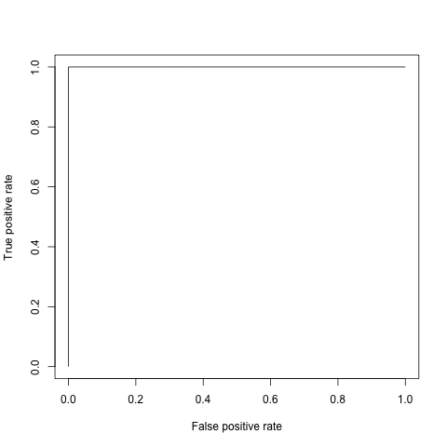

|  |  |  |  |  |
| --- | --- | --- | --- | --- |
|  | Estimate | Std. Error | t value | Pr(>|t|) |
| **(Intercept)** | 34.59 | 7.345 | 4.709 | 9.609e-05 |
| **disp** | 0.008195 | 0.01446 | 0.5666 | 0.5765 |
| **hp** | -0.0349 | 0.01866 | -1.87 | 0.07421 |
| **drat** | -0.01774 | 1.846 | -0.009611 | 0.9924 |
| **wt** | -3.279 | 1.309 | -2.505 | 0.01979 |
| **as.factor(cyl)6** | -3.104 | 1.653 | -1.878 | 0.07318 |
| **as.factor(cyl)8** | -2.221 | 3.34 | -0.6649 | 0.5127 |
| **as.factor(gear)4** | 1.746 | 2.17 | 0.8046 | 0.4293 |
| **as.factor(gear)5** | 2.169 | 2.378 | 0.9121 | 0.3712 |

Fitting linear model: mpg ~ disp + hp + drat + wt + as.factor(cyl) + as.factor(gear)

|  |  |  |  |  |
| --- | --- | --- | --- | --- |
|  | Estimate | Std. Error | z value | Pr(>|z|) |
| **(Intercept)** | 3.045 | 0.1709 | 17.81 | 5.427e-71 |
| **outcome2** | -0.4543 | 0.2022 | -2.247 | 0.02465 |
| **outcome3** | -0.293 | 0.1927 | -1.52 | 0.1285 |
| **treatment2** | 1.338e-15 | 0.2 | 6.69e-15 | 1 |
| **treatment3** | 1.421e-15 | 0.2 | 7.105e-15 | 1 |

Fitting generalized (poisson/log) linear model: counts ~ outcome + treatment 

|  |  |  |  |  |
| --- | --- | --- | --- | --- |
|  | Estimate | Std. Error | t value | Pr(>|t|) |
| **(Intercept)** | 34.59 | 7.345 | 4.709 | 9.609e-05 |
| **disp** | 0.008195 | 0.01446 | 0.5666 | 0.5765 |
| **hp** | -0.0349 | 0.01866 | -1.87 | 0.07421 |
| **drat** | -0.01774 | 1.846 | -0.009611 | 0.9924 |
| **wt** | -3.279 | 1.309 | -2.505 | 0.01979 |
| **as.factor(cyl)6** | -3.104 | 1.653 | -1.878 | 0.07318 |
| **as.factor(cyl)8** | -2.221 | 3.34 | -0.6649 | 0.5127 |
| **as.factor(gear)4** | 1.746 | 2.17 | 0.8046 | 0.4293 |
| **as.factor(gear)5** | 2.169 | 2.378 | 0.9121 | 0.3712 |

Fitting linear model: mpg ~ disp + hp + drat + wt + as.factor(cyl) + as.factor(gear)

|  |  |  |  |  |
| --- | --- | --- | --- | --- |
|  | Estimate | Std. Error | z value | Pr(>|z|) |
| **(Intercept)** | 3.045 | 0.1709 | 17.81 | 5.427e-71 |
| **outcome2** | -0.4543 | 0.2022 | -2.247 | 0.02465 |
| **outcome3** | -0.293 | 0.1927 | -1.52 | 0.1285 |
| **treatment2** | 1.338e-15 | 0.2 | 6.69e-15 | 1 |
| **treatment3** | 1.421e-15 | 0.2 | 7.105e-15 | 1 |

Fitting generalized (poisson/log) linear model: counts ~ outcome + treatment

Now here's a plot!! 

|  |  |  |  |  |
| --- | --- | --- | --- | --- |
|  | Estimate | Std. Error | t value | Pr(>|t|) |
| **(Intercept)** | 34.59 | 7.345 | 4.709 | 9.609e-05 |
| **disp** | 0.008195 | 0.01446 | 0.5666 | 0.5765 |
| **hp** | -0.0349 | 0.01866 | -1.87 | 0.07421 |
| **drat** | -0.01774 | 1.846 | -0.009611 | 0.9924 |
| **wt** | -3.279 | 1.309 | -2.505 | 0.01979 |
| **as.factor(cyl)6** | -3.104 | 1.653 | -1.878 | 0.07318 |
| **as.factor(cyl)8** | -2.221 | 3.34 | -0.6649 | 0.5127 |
| **as.factor(gear)4** | 1.746 | 2.17 | 0.8046 | 0.4293 |
| **as.factor(gear)5** | 2.169 | 2.378 | 0.9121 | 0.3712 |

Fitting linear model: mpg ~ disp + hp + drat + wt + as.factor(cyl) + as.factor(gear)

|  |  |  |  |  |
| --- | --- | --- | --- | --- |
|  | Estimate | Std. Error | z value | Pr(>|z|) |
| **(Intercept)** | 3.045 | 0.1709 | 17.81 | 5.427e-71 |
| **outcome2** | -0.4543 | 0.2022 | -2.247 | 0.02465 |
| **outcome3** | -0.293 | 0.1927 | -1.52 | 0.1285 |
| **treatment2** | 1.338e-15 | 0.2 | 6.69e-15 | 1 |
| **treatment3** | 1.421e-15 | 0.2 | 7.105e-15 | 1 |

Fitting generalized (poisson/log) linear model: counts ~ outcome + treatment

Now here's a plot!! 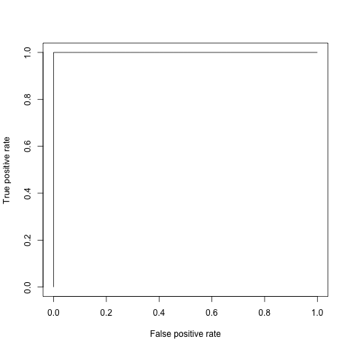

This report was generated with [R](http://www.r-project.org/) (3.0.1) and [pander](https://github.com/rapporter/pander) (0.3.7) in 1.891 sec on x86_64-apple-darwin10.8.0 platform.