Abhijit

demo

Fri Aug 23 12:17:36 2013

|  |  |  |  |  |
| --- | --- | --- | --- | --- |
|  | Estimate | Std. Error | t value | Pr(>|t|) |
| **(Intercept)** | 34.59 | 7.345 | 4.709 | 9.609e-05 |
| **disp** | 0.008195 | 0.01446 | 0.5666 | 0.5765 |
| **hp** | -0.0349 | 0.01866 | -1.87 | 0.07421 |
| **drat** | -0.01774 | 1.846 | -0.009611 | 0.9924 |
| **wt** | -3.279 | 1.309 | -2.505 | 0.01979 |
| **as.factor(cyl)6** | -3.104 | 1.653 | -1.878 | 0.07318 |
| **as.factor(cyl)8** | -2.221 | 3.34 | -0.6649 | 0.5127 |
| **as.factor(gear)4** | 1.746 | 2.17 | 0.8046 | 0.4293 |
| **as.factor(gear)5** | 2.169 | 2.378 | 0.9121 | 0.3712 |

Fitting linear model: mpg ~ disp + hp + drat + wt + as.factor(cyl) + as.factor(gear)

|  |  |  |  |  |
| --- | --- | --- | --- | --- |
|  | Estimate | Std. Error | z value | Pr(>|z|) |
| **(Intercept)** | 3.045 | 0.1709 | 17.81 | 5.427e-71 |
| **outcome2** | -0.4543 | 0.2022 | -2.247 | 0.02465 |
| **outcome3** | -0.293 | 0.1927 | -1.52 | 0.1285 |
| **treatment2** | 1.338e-15 | 0.2 | 6.69e-15 | 1 |
| **treatment3** | 1.421e-15 | 0.2 | 7.105e-15 | 1 |

Fitting generalized (poisson/log) linear model: counts ~ outcome + treatment

Now here's a plot!! 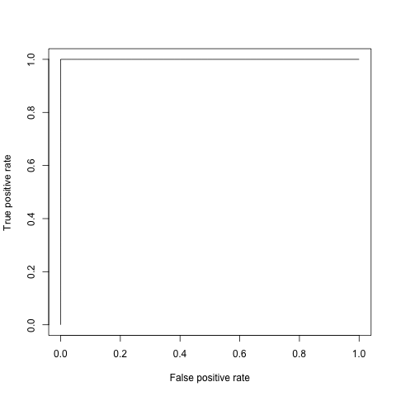

This report was generated with [R](http://www.r-project.org/) (3.0.1) and [pander](https://github.com/rapporter/pander) (0.3.7) in 0.139 sec on x86_64-apple-darwin10.8.0 platform.