DSA LAB ASSIGNMENT
NAME: ARYAN NARANG
ROLL NO:244ca009

Q1. Circular queue implementation
Code:
#include<iostream>
#define maxsize 5
using namespace std;

class Queue {
int first, last, curSize;
int arr[maxsize];
public:
Queue() {
first = 0;
last = 0;
curSize = 0;
}
int front() {
if (isEmpty()) {
cout << "Queue is empty." << endl;
return -1;
}
return arr[first];
}
void pop() {
if (isEmpty()) {
cout << "Queue is empty." << endl;
return;
}
cout<<"Popped:"<<front();
first = (first+1) % maxsize;
curSize--;
}
void push(int val) {
if (curSize >= maxsize) {
cout << "Queue is full." << endl;
return;
}
arr[last] = val;
last = (last+1) % maxsize;
curSize++;
}
bool isEmpty() {
return curSize == 0;
}
int size() {
return curSize;
}
};

int main() {
Queue q;

bool flag = true;

while (flag) {
cout << "=======================================" << endl;
cout << "Choose an operation:\n" << endl;
cout << "1. Push" << endl;
cout << "2. Pop" << endl;
cout << "3. Front" << endl;
cout << "4. Size" << endl;
cout << "5. IsEmpty" << endl;
cout << ">> ";
int choice, val, size;
bool empty;
cin >> choice;
switch(choice) {
case 1:
while(true){
cout << "Enter val (To stop input -1): ";
cin >> val;
if(val==-1){
break;
}
q.push(val);
}
val=0;
break;
case 2:
q.pop();
break;
case 3:
val = q.front();
if (val > 0) cout << "Front val is " << val << endl;
break;
case 4:
size = q.size();
cout << "Queue size is " << size << endl;
break;
case 5:
empty = q.isEmpty();
if (empty) {
cout << "Queue is empty." << endl;
} else {
cout << "Queue is not empty." << endl;
}
break;
default:
flag = false;
break;
}
}
return 0;
}

OUTPUT:
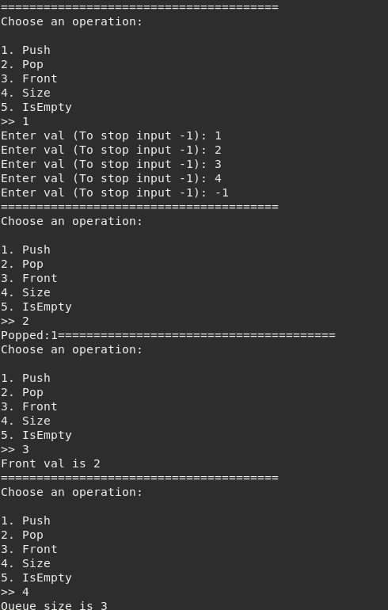
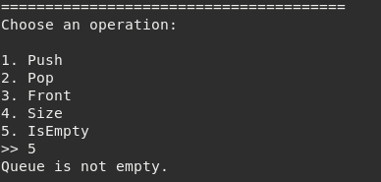
Q2. Banking Program that came in midsem exam
Code:
#include<iostream>
#include<math.h>
using namespace std;

class Account {
int balance;
float rate;
public:
Account(int bal, float r) {
balance = bal;
rate = r;
}
void deposit(int amount) {
balance += amount;
cout << "Deposited " << amount << "." << endl;
}
void withdraw(int amount) {
if (balance < amount) {
cout << "Balance not enough." << endl;
return;
}
balance -= amount;
cout << "Withdrawn " << amount << "." << endl;
}
float calculateCI(int t) {
float p = balance;
float r = rate;
float ci = p * pow(1 + r/100, t);
return ci;
}
int getBalance() {
return balance;
}
void displayMenu() {
cout << "Enter choice:" << endl;
cout << "1. Deposit" << endl;
cout << "2. Withdraw" << endl;
cout << "3. Get Balance" << endl;
cout << "4. Get CI" << endl;
cout << "5. Destroy Account" << endl;
}
~Account() {
cout << "Account Destroyed!" << endl;
}
};

int main() {
int balance;
float rate;
cout << "Enter balance and rate of interest: ";
cin >> balance >> rate;
Account *acc = new Account(balance, rate);
bool flag = true;
while (flag) {
int choice, amount, time;
acc->displayMenu();
cin >> choice;
switch(choice) {
case 1:
cout << "Enter amount: ";
cin >> amount;
acc->deposit(amount);
break;
case 2:
cout << "Enter amount: ";
cin >> amount;
acc->withdraw(amount);
break;
case 3:
cout << "Balance : " << acc->getBalance() << endl;
break;
case 4:
cout << "Enter time: ";
cin >> time;
cout << "Compound Interest : " << acc->calculateCI(time) << endl;
break;
case 5:
flag = false;
delete acc;
break;
default:
cout << "Invalid." << endl;
break;
}
}
return 0;
}

OUTPUT:
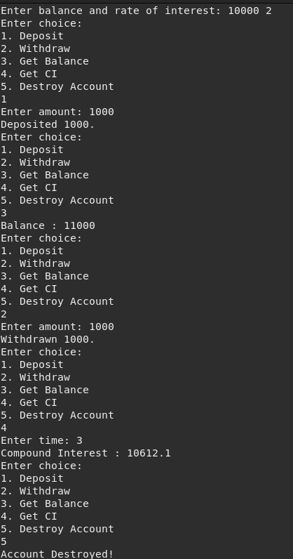

Q3. Two single inheritance programs
SINGLE INHERITANCE 1:
Code:
#include<iostream>
using namespace std;

class A {
int a;
protected:
int prot_a;
void set_prot_a() {
cout << "Enter prot_a: ";
cin >> prot_a;
}
public:
void set_a() {
cout << "Enter a: ";
cin >> a;
}
int get_a() {
return a;
}
};

class B: public A {
int b;
public:
void set_b() {
cout << "Enter b: ";
cin >> b;
}
int get_b() {
return b;
}
int get_prot_a() {
return prot_a;
}
void set_prot() {
set_prot_a();
}
};

int main() {
B b;
b.set_a();
b.set_b();
b.set_prot();
cout << "a: " << b.get_a() << endl;
cout << "b: " << b.get_b() << endl;
cout << "prot_b: " << b.get_prot_a() << endl;
return 0;}
OUTPUT:
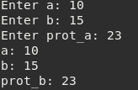
SINGLE INHERITANCE 2:
Code:
#include <iostream>
using namespace std;

class Vehicle {
public:
string make;
string model;

Vehicle(string m, string mo) : make(m), model(mo) {}

void drive() {
cout << "The " << make << " " << model << " is driving." << endl;
}
};

class Car : public Vehicle {
public:
int doors;

Car(string m, string mo, int d) : Vehicle(m, mo), doors(d) {}

void drive() {
cout << "The " << make << " " << model << " car with " << doors << " doors is driving." << endl;
}
};

int main() {
Car myCar("Toyota", "Corolla", 4);
myCar.drive();
return 0;
}

OUTPUT:

Q4. Multilevel Inheritance program
Code:
#include<iostream>
using namespace std;

class Thing {
string name;
protected:
void set_name() {
cout << "Enter name: ";
cin >> name;
}
void get_name() {
cout << "Name: " << name << endl;
}
};

class Animal: public Thing {
string animal_type;
protected:
void set_animal_type() {
cout << "Enter Animal type: ";
cin >> animal_type;
}
void get_animal_type() {
cout << "Animal Type: " << animal_type << endl;
}
};

class Dog: public Animal {
string breed;
protected:
void set_breed() {
cout << "Enter breed: ";
cin >> breed;
}
void get_breed() {
cout << "Breed: " << breed << endl;
}
public:
void set_info() {
set_name();
set_animal_type();
set_breed();
}
void get_info() {
get_name();
get_animal_type();
get_breed();
}
};

int main() {
Dog myDog;
myDog.set_info();
cout << endl;
myDog.get_info();
}
OUTPUT:
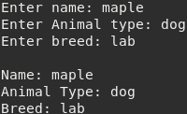

Q5. Hybrid Inheritance program
Code:
#include<iostream>
using namespace std;

class GrandParent {
private:
string name;
protected:
string getName() {
return name;
}
void showName() {
cout << "My name is " << name << endl;
}
void setName() {
cout << "Enter name: ";
cin >> name;
}
};

class Parent1 : virtual public GrandParent {
private:
int age;
protected:
void showAge() {
cout << "My age is " << age << endl;
}
int getAge() {
return age;
}
void setAge() {
cout << "Enter age: ";
cin >> age;
}
};

class Parent2 : virtual public GrandParent {
private:
long long phoneNo;
protected:
void setPhoneNo() {
cout << "Enter phone no.: ";
cin >> phoneNo;
}
void showPhoneNo() {
cout << "My phone no. is " << phoneNo << endl;
}
long long getPhoneNo() {
return phoneNo;
}
};

class Child : public Parent1, public Parent2 {
private:
int gender;
public:
void setInfo() {
setName();
setAge();
setPhoneNo();
}
void getInfo() {
showName();
showAge();
showPhoneNo();
}
};

int main() {
Child c;
c.setInfo();
c.getInfo();
return 0;
}

OUTPUT:

