Make sure to insert suitable records in the table, such that there exists at least 2 records for
each query.

1. List all students with a total credit count of 0.
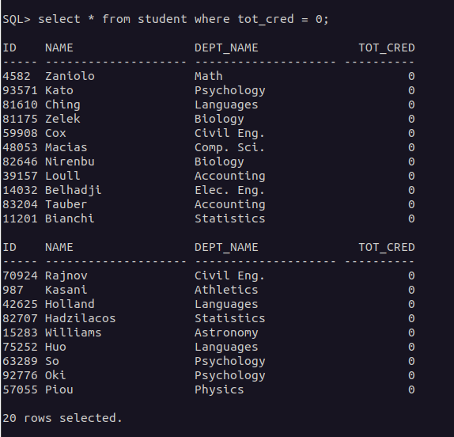
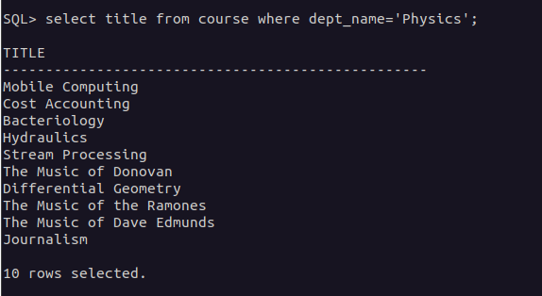
2. Find the names of all courses offered by the "Physics" department.

3. Retrieve the names of all instructors who earn exactly ₹50,000.
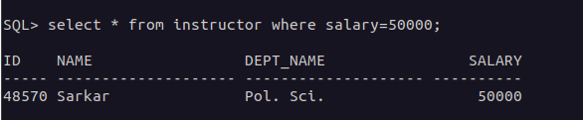
4. List all classrooms with a capacity of exactly 100.
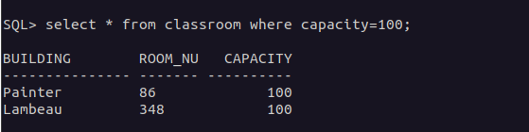

5. Find the total number of courses offered in the "Summer" semester.
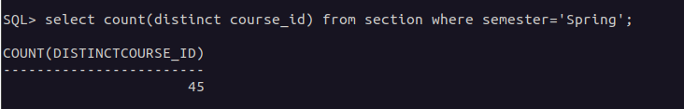
6. List all students who have taken exactly 30 total credits.
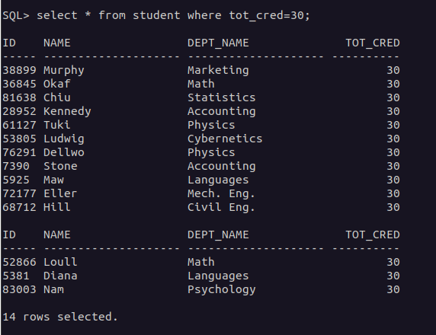
7. Find the names of all courses offered by the "Chemistry" department.
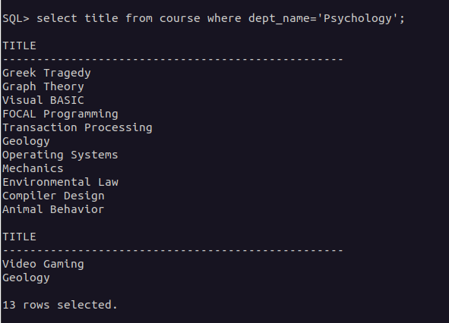
8. Retrieve the names of all instructors who earn more than ₹100,000.
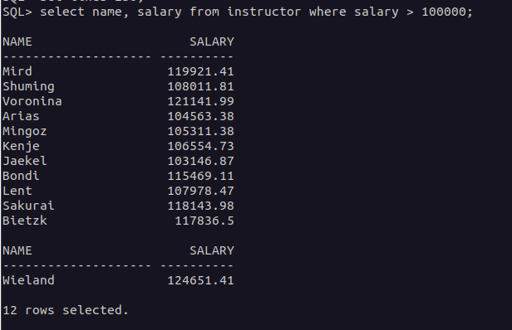

9. List all classrooms located in the "Taylor" building.
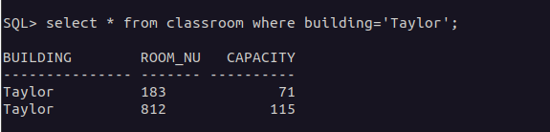
10. Find the total number of courses offered in the "Winter" semester.
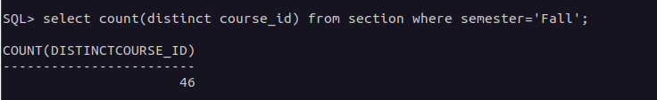
11. List all students who have taken courses with a grade of "C" or lower.
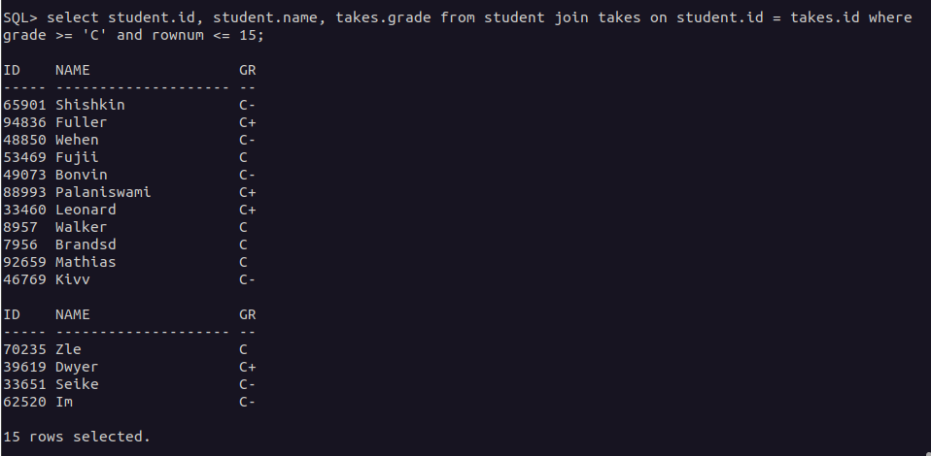
12. Retrieve the names of instructors who have taught in the "Fall" semester of 2022.
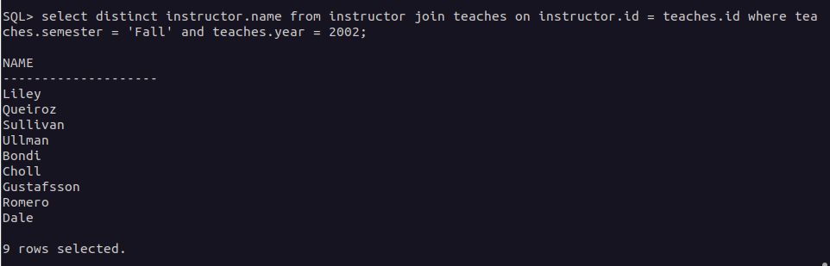
13. Find the average capacity of classrooms in each building.
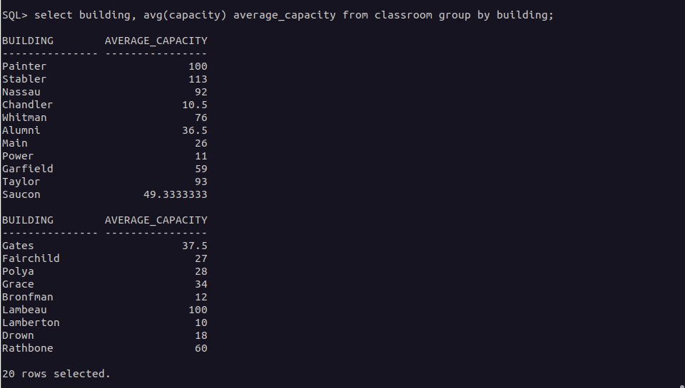
14. List all courses that have more than 3 credits.
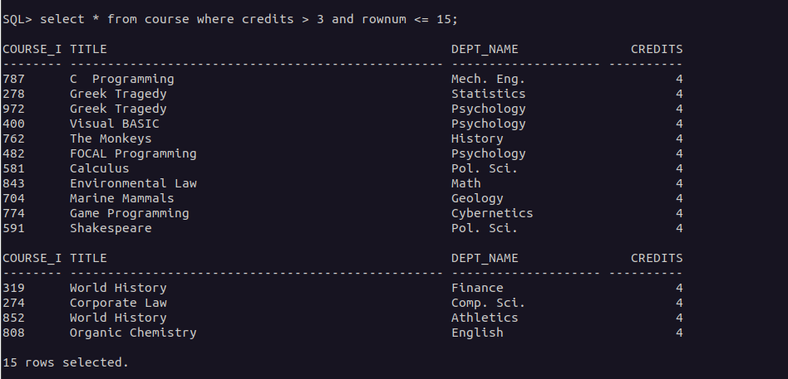
15. Retrieve the names of students who have taken courses in the "Watson" (“Taylor”) building.
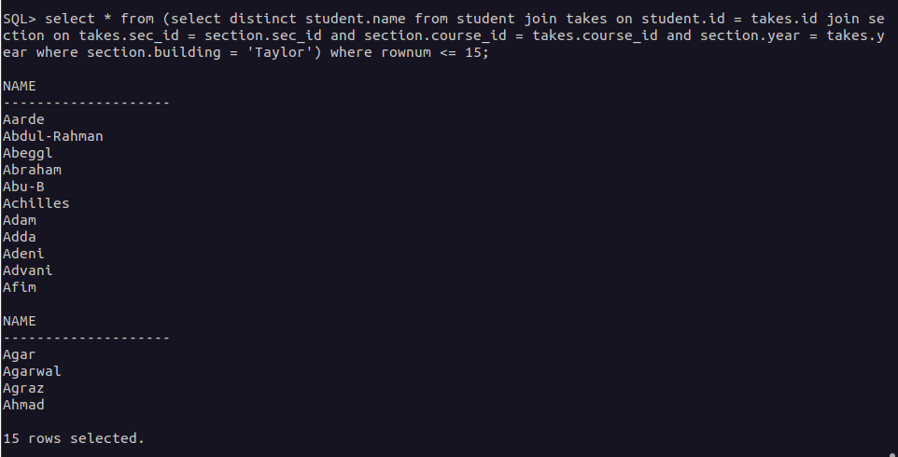
16. Find the total number of students advised by each instructor.
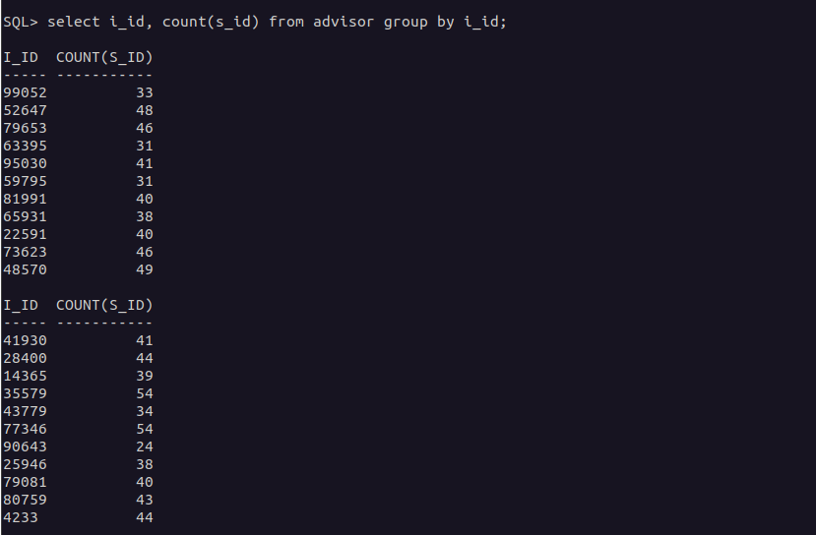
17. List all sections that do not have a classroom assigned.
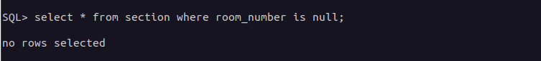
18. Retrieve the names of students who have taken courses with the highest number of
credits.
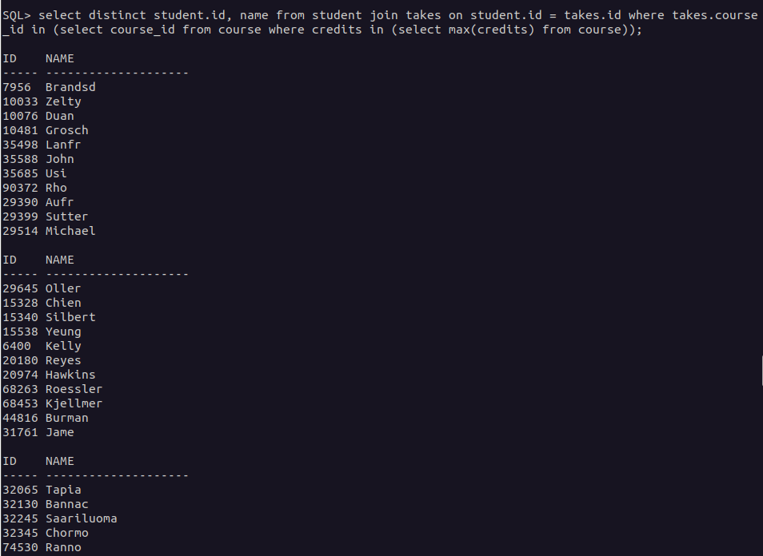
19. Find the departments with the highest average instructor salary.
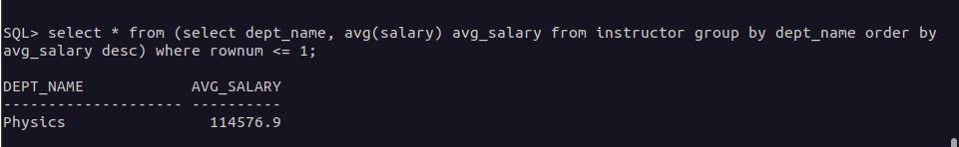
20. List all courses that have been taught by more than one instructor.
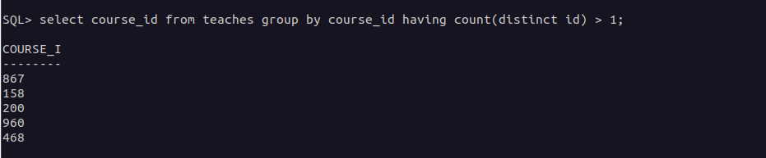
21. List all students who have taken courses with a grade of "A" in the "Fall" semester of
2022 (2002).
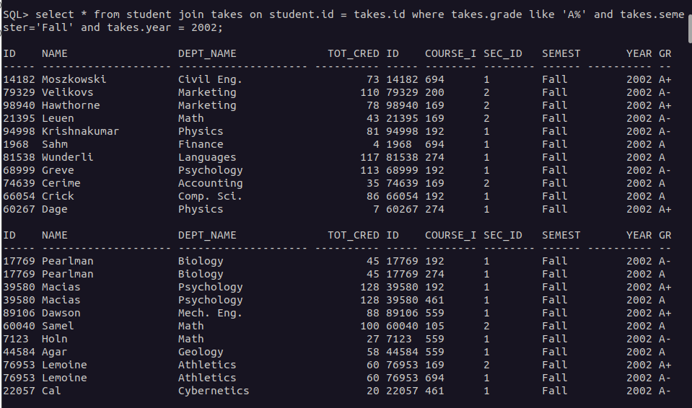
22. Retrieve the names of instructors who have taught in the "Spring" semester of 2023.
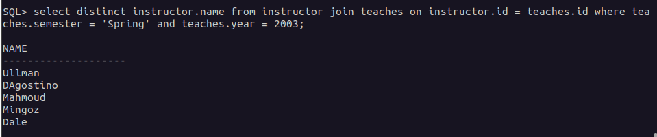
23. Find the average number of students enrolled in each course.
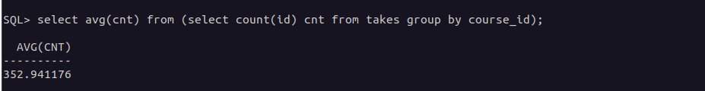
24. List all courses that have exactly 4 credits.
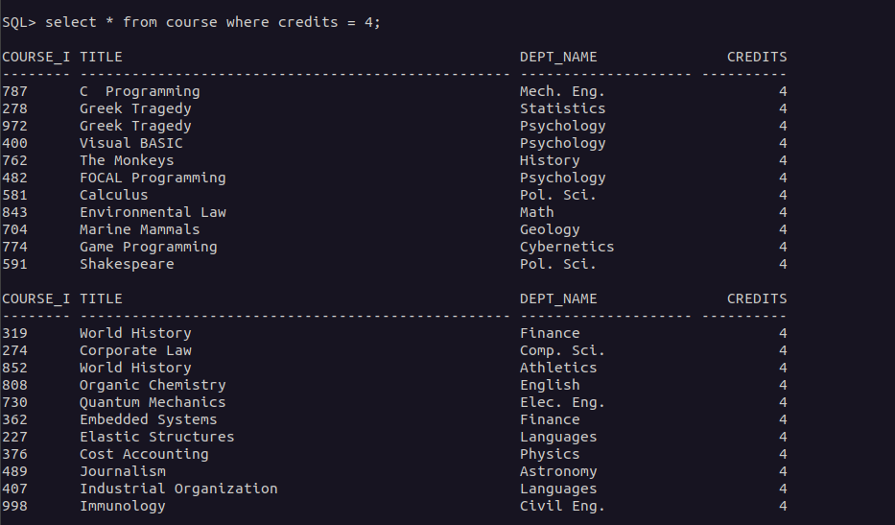
25. Retrieve the names of students who have taken courses in the "Packard" (“Whitman”) building.
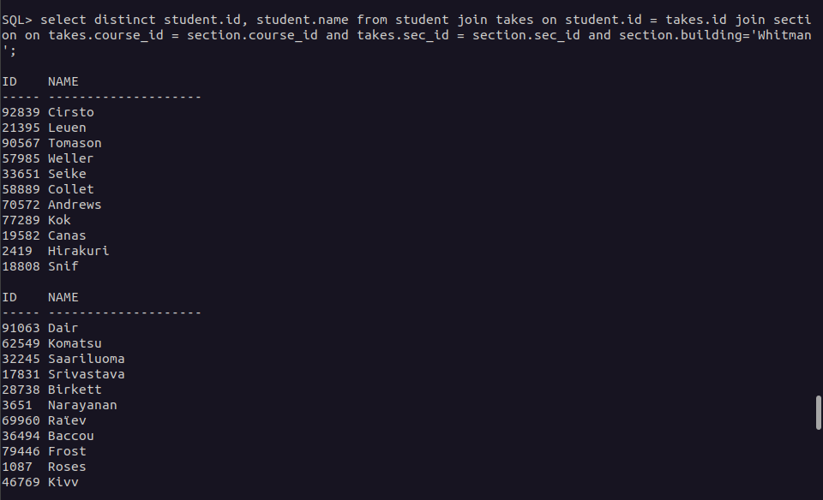
26. Find the total number of sections taught by each instructor.
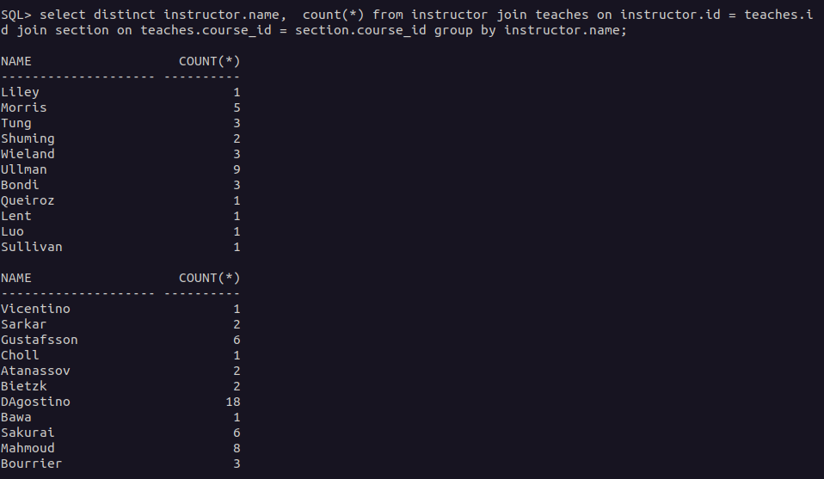
27. List all sections that are held in rooms with a capacity of less than 50.
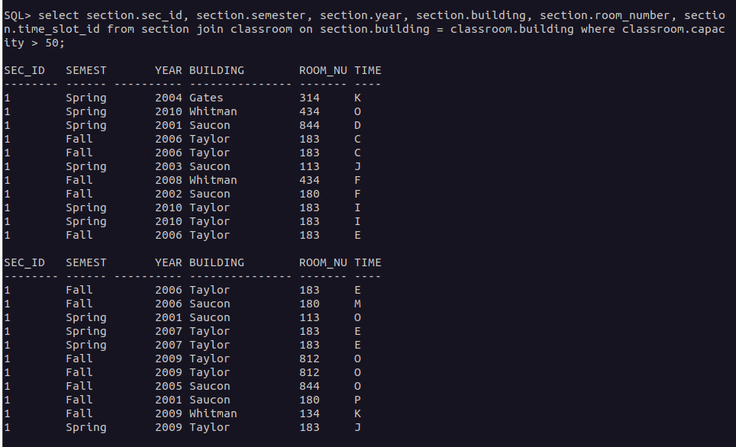
28. Retrieve the names of students who have taken courses with the lowest number of
credits.
29. Find the departments with the lowest average instructor salary.
30. List all courses that have been taught by only one instructor.
31. Find the students who have taken courses with every instructor in the university.
32. Retrieve the names of instructors who have taught courses in all available semesters.
33. List all courses that have been taught in every building.
34. Find the students who have taken the most number of courses in a single year.
35. Retrieve the names of students who have taken courses with overlapping time slots in
the same semester.
36. List all courses that have been taught by the same instructor in consecutive semesters.
37. Find the departments where the total student credits are less than the department
budget.
38. Retrieve the names of students who have taken courses with every time slot.
39. List all courses that have been taught in every year.
40. Find the students who have taken the most number of courses with the same instructor.
41. Find the students who have taken courses from at least 3 different departments.
42. Retrieve the names of instructors who have taught the same course in consecutive
years.
43. List all courses that are prerequisites for exactly 2 other courses.
44. Find the departments where the total student credits are equal to the department budget.
45. Retrieve the names of students who have taken courses with every time slot in a single
semester.
46. List all courses that have been taught in every building except one.
47. Find the students who have taken the most number of courses in a single department.
48. Retrieve the names of instructors who have taught courses in all available time slots.
49. List all students who have taken courses with overlapping time slots in different
semesters.
50. Find the courses that have the lowest enrollment across all semesters.

