Make sure to insert suitable records in the table, such that there exists at least 2 records for
each query.
1.​ List all students who have taken exactly 120 total credits.
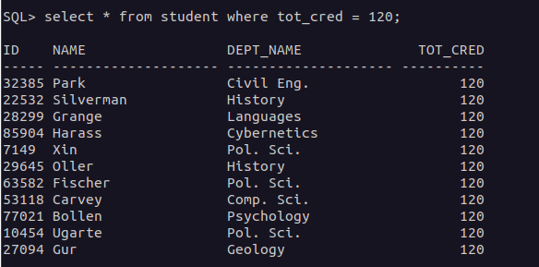
2.​ Find the names of all courses offered by the "Civil Engineering" department.
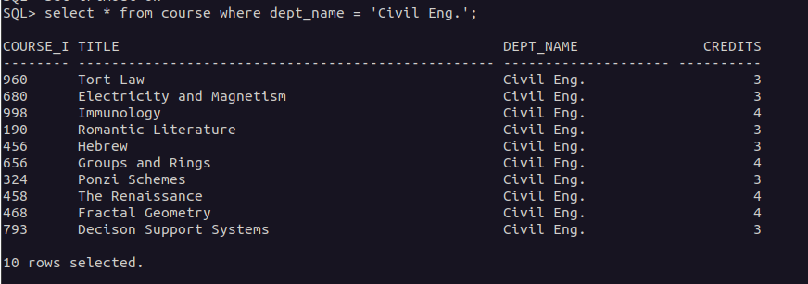
3.​ Retrieve the names of all instructors who earn exactly ₹60,000.
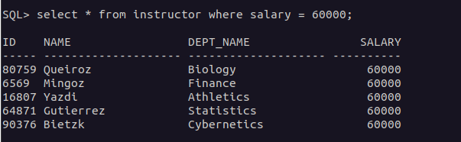
4.​ List all classrooms located in the "Dunn" building.
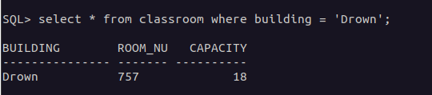
5.​ Find the total number of courses offered in the "Summer" semester of 2023.
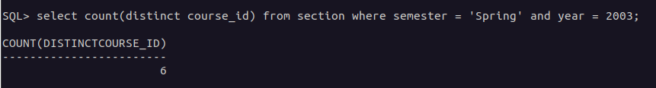
6.​ List all students who have taken exactly 150 total credits.
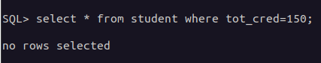

7.​ Find the names of all courses offered by the "Aerospace Engineering" department.
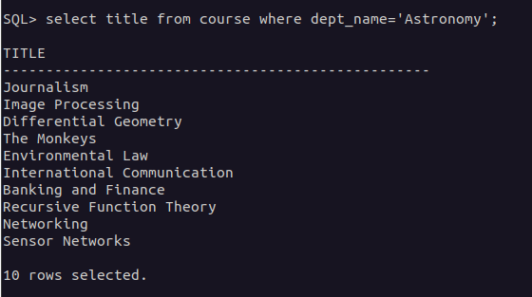
8.​ Retrieve the names of all instructors who earn exactly ₹80,000.
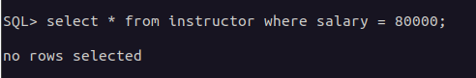
9.​ List all classrooms located in the "Smith" building.
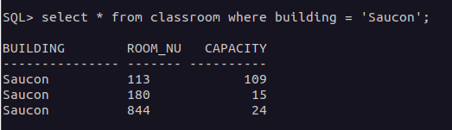
10.​Find the total number of courses offered in the "Fall" semester of 2022.
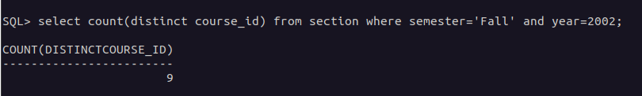
11.​List all students who have taken courses with a grade of "A" in the "Spring" semester of
2022.
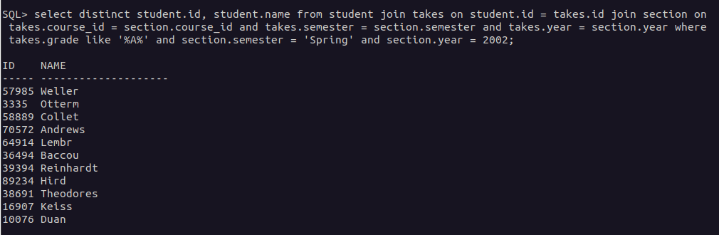
12.​Retrieve the names of instructors who have taught in the "Winter" semester of 2022.
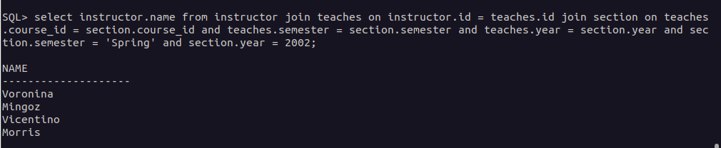
13.​Find the average number of students per section in each course.

14.​List all courses that have exactly 5 credits.
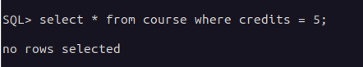
15.​Retrieve the names of students who have taken courses in the "Main" building.
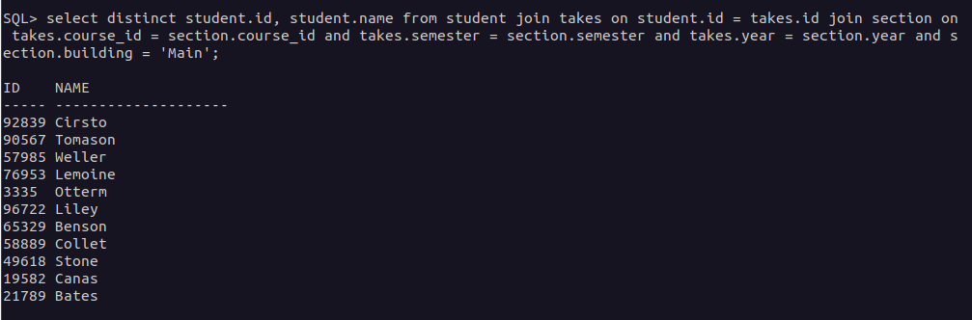
16.​Find the total number of sections held in each building.
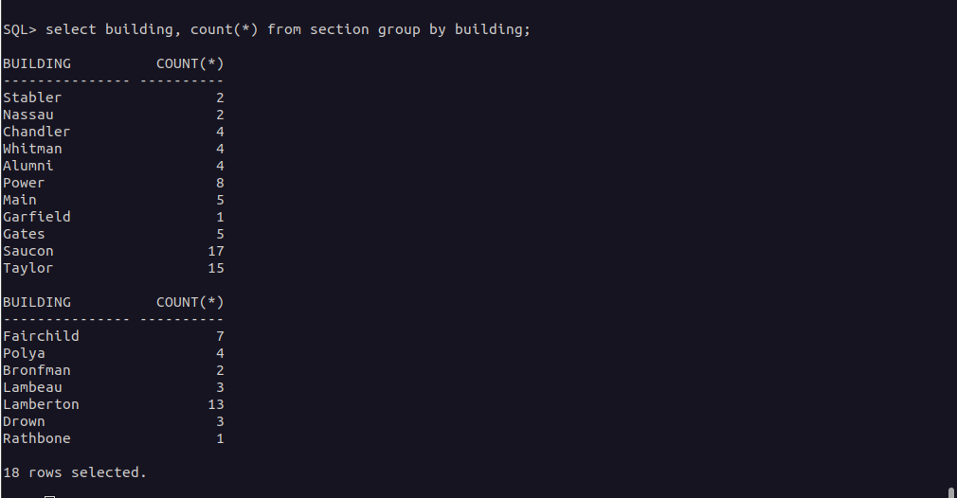
17.​List all sections that are held in rooms with a capacity of exactly 50.
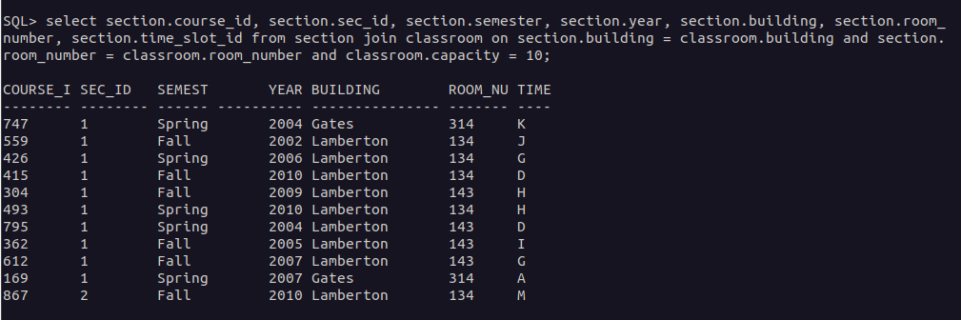
18.​Retrieve the names of students who have taken courses with the highest number of
credits in the university.
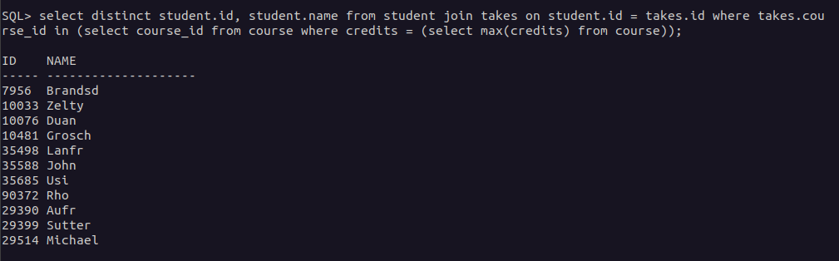
19.​Find the departments with the highest number of courses.
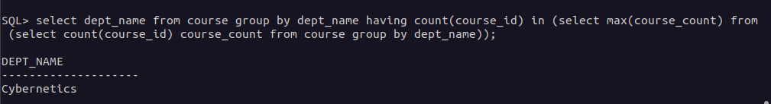
20.​List all courses that have been taught by exactly 2 instructors.
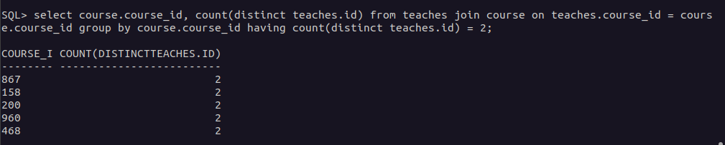
21.​List all students who have taken courses with a grade of "B" in the "Summer" semester
of 2023.
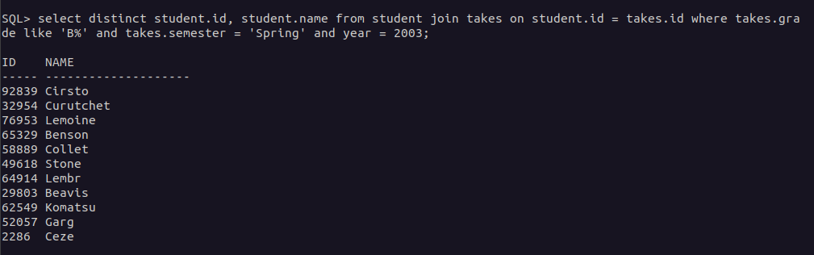
22.​Retrieve the names of instructors who have taught in the "Spring" semester of 2021.
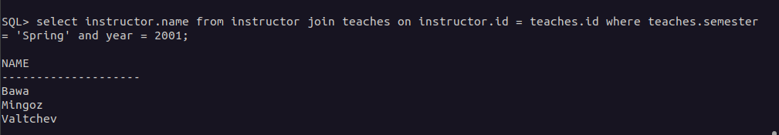
23.​Find the average number of credits per student in each department.
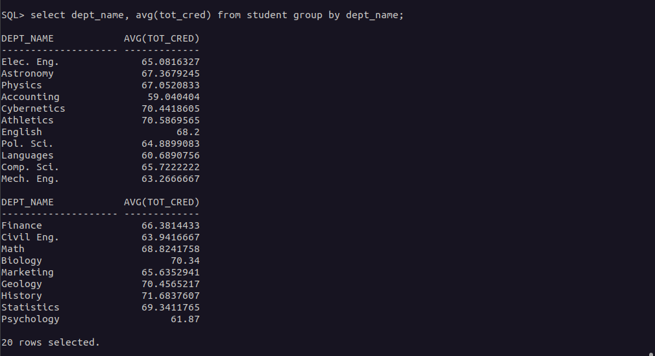
24.​List all courses that have exactly 6 credits.
25.​Retrieve the names of students who have taken courses in the "Lambert" (“Lamberton”) building.
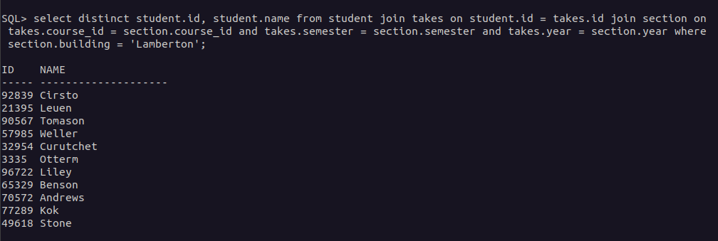
26.​Find the total number of sections taught in each semester.
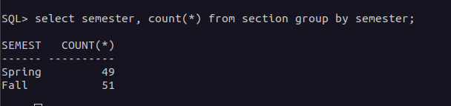

27.​List all sections that are held in rooms with a capacity of exactly 200.
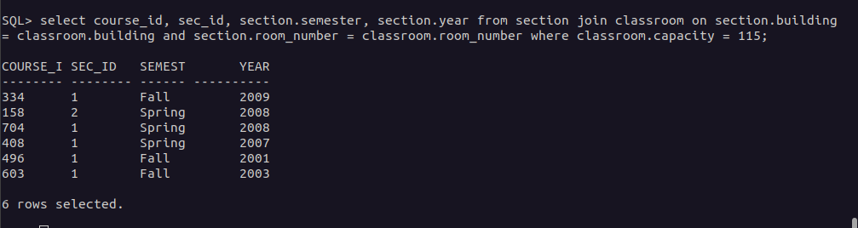
28.​Retrieve the names of students who have taken courses with the lowest number of
credits in the university.
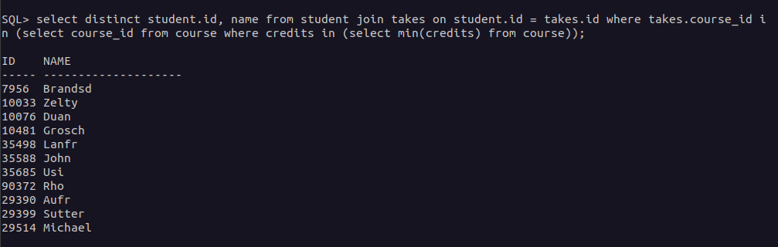
29.​Find the departments with the lowest number of courses.
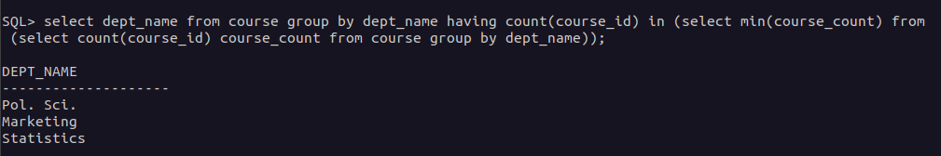
30.​List all courses that have been taught by exactly 4 instructors.
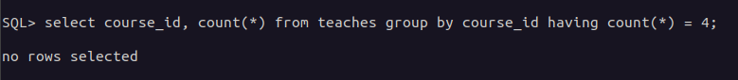
31.​Find the students who have taken courses from at least 6 different departments.
32.​Retrieve the names of instructors who have taught the same course in multiple
semesters and years.
33.​List all courses that are prerequisites for exactly 5 other courses.
34.​Find the departments where the total student credits are greater than twice the
department budget.
35.​Retrieve the names of students who have taken courses with every time slot in multiple
semesters and years.
36.​List all courses that have been taught in every building except four.37.​Find the students who have taken the most number of courses in a single semester
across all departments.
38.​Retrieve the names of instructors who have taught courses in all available semesters
and time slots.
39.​List all students who have taken courses with overlapping time slots in the same
semester and year.
40.​Find the courses that have the highest enrollment in a single year.
41.​Find the students who have taken courses from at least 7 different departments.
42.​Retrieve the names of instructors who have taught the same course in multiple
semesters and years.
43.​List all courses that are prerequisites for exactly 6 other courses.
44.​Find the departments where the total student credits are less than one-third of the
department budget.
45.​Retrieve the names of students who have taken courses with every time slot in multiple
semesters and years.
46.​List all courses that have been taught in every building except five.
47.​Find the students who have taken the most number of courses in a single year across all
departments.
48.​Retrieve the names of instructors who have taught courses in all available buildings and
time slots.
49.​List all students who have taken courses with overlapping time slots in different
semesters and years.
50.​Find the courses that have the lowest enrollment in a single year.

