>>>Delay5-zeta

E(impvol-rvol | z(t-l) > X), l = 15

Days during testing = 1759

X days AvgPayoff

0.000 1757 3.729

0.100 1713 3.687

0.200 1612 3.540

0.300 1446 3.322

0.400 1240 3.037

0.500 916 2.029

0.600 626 1.059

0.700 399 0.099

0.800 228 -1.106

0.900 131 -1.648

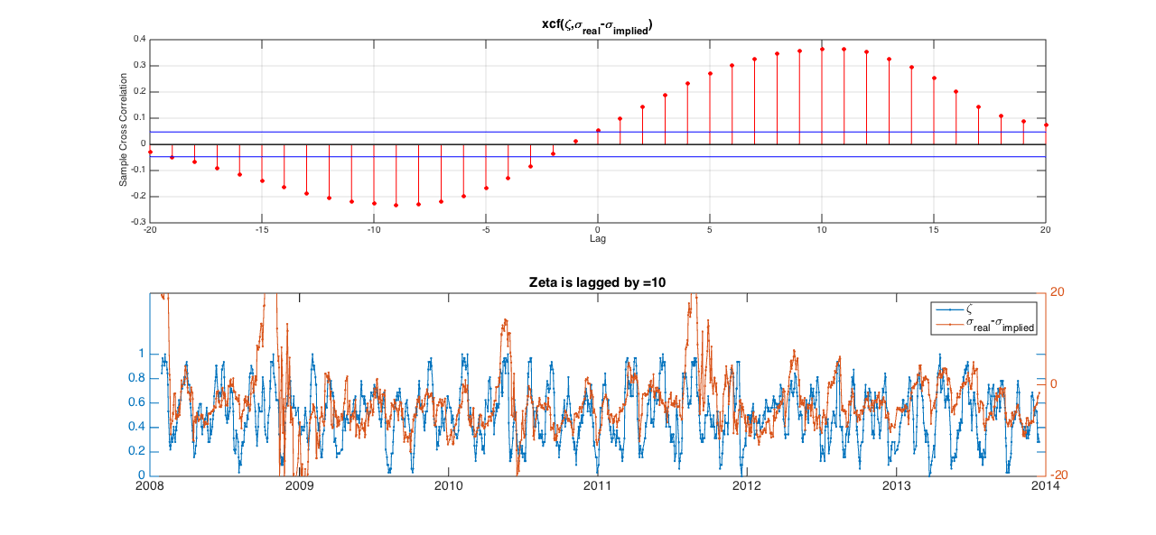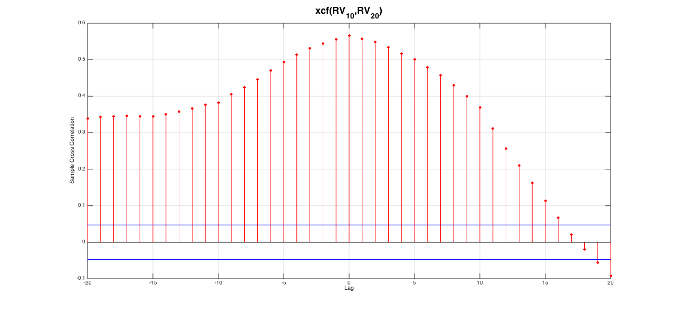

>>>Mean10-zeta

E(impvol-rvol | z(t-lag) > X), lag = 8

Days during testing = 1785

X days AvgPayoff

0.000 1785 2.886

0.100 1785 2.886

0.200 1761 2.842

0.300 1630 2.555

0.400 1335 1.827

0.500 898 0.331

0.600 531 -1.338

0.700 235 -4.033

0.800 36 -6.829

0.900 NaN

E(impvol-rvol | z(t-lag) > X), lag = 15

Days during testing = 1778

X days AvgPayoff

0.000 1778 2.906

0.100 1778 2.906

0.200 1754 2.877

0.300 1623 2.731

0.400 1328 2.453

0.500 891 1.550

0.600 528 0.456

0.700 234 -1.440

0.800 36 -3.410

0.900 NaN

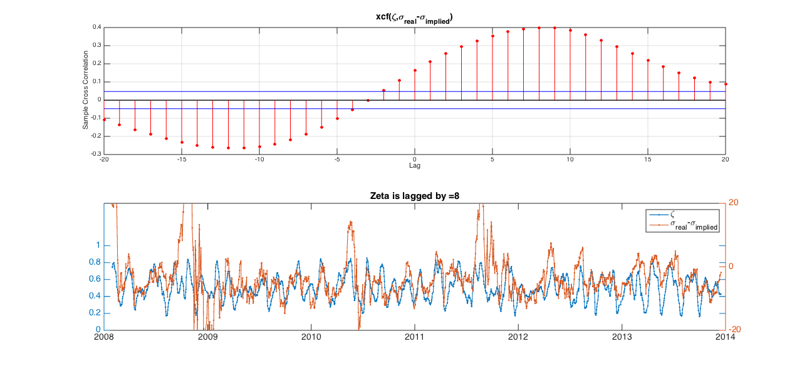

>>>Windowed-zeta

E(impvol-rvol | z(t-lag) > X), lag = 14

Days during testing = 1779

X days AvgPayoff

0.000 1779 2.898

0.100 1776 2.892

0.200 1606 2.619

0.300 1430 2.549

0.400 1224 2.391

0.500 984 2.136

0.600 722 2.360

0.700 474 2.564

0.800 201 1.951

0.900 3 -4.536

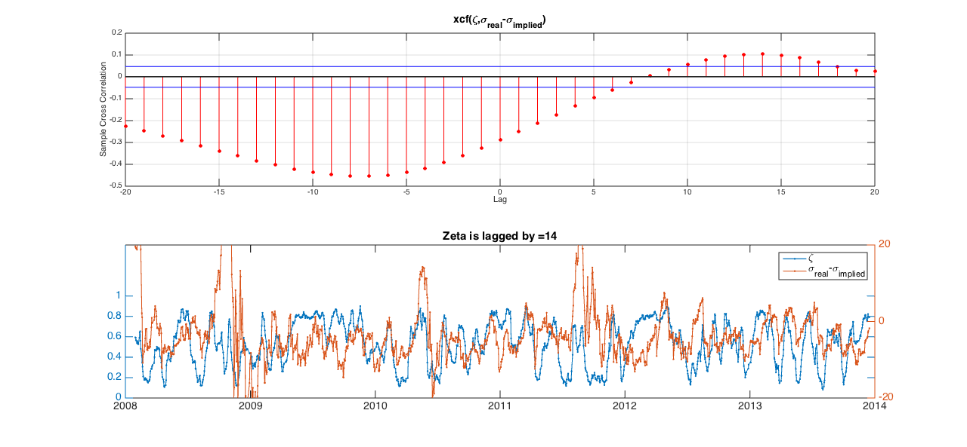

Nodelay-zeta

E(impvol-rvol | z(t-lag) > X), lag = 20

Days during testing = 1773

X days AvgPayoff

0.000 1407 3.158

0.100 1275 3.160

0.200 1119 3.162

0.300 1011 3.099

0.400 923 3.065

0.500 858 3.132

0.600 806 3.240

0.700 732 3.378

0.800 627 3.612

0.900 510 4.090

