I’m using two versions of $ζ$:   
One with delay of 5,

$$ζ_{D5}\left(t\right)= ζ(t-5)$$

Another one with is an average of ten delays i.e.,

$$ζ_{M10}\left(t\right)=\frac{1}{10}∑_{i=0}^{9} ζ(t-i)$$ By choosing lag that maximizes, $$cor\left(zeta\left(t-lag\right), σ_{realized}\left(t\right)-σ_{implied}\left(t-20\right)\right),$$ 
 two time series are highly correlated that we can spot it by eyes.

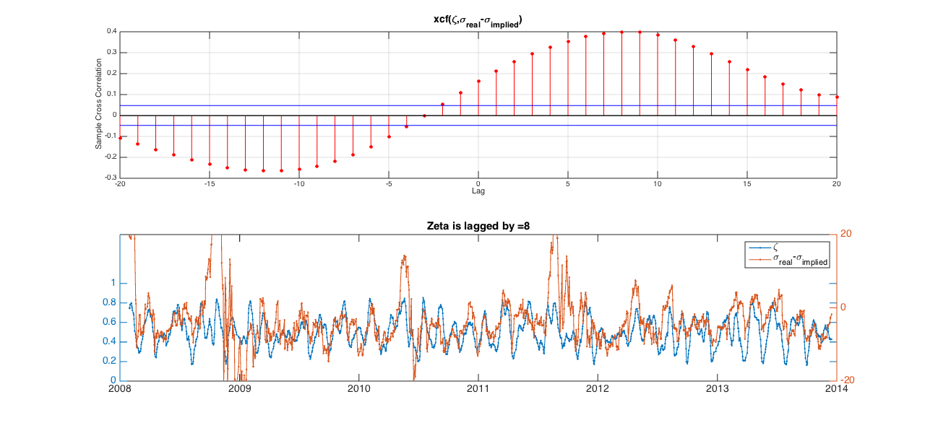If the lag=20 we’re done because zeta(t-20) predicts rv(t)-iv(t-20).   
But unfortunately what make it highly correlated really is lag = 10 for zeta with 5 delay, and lag = 8 for averaging zeta

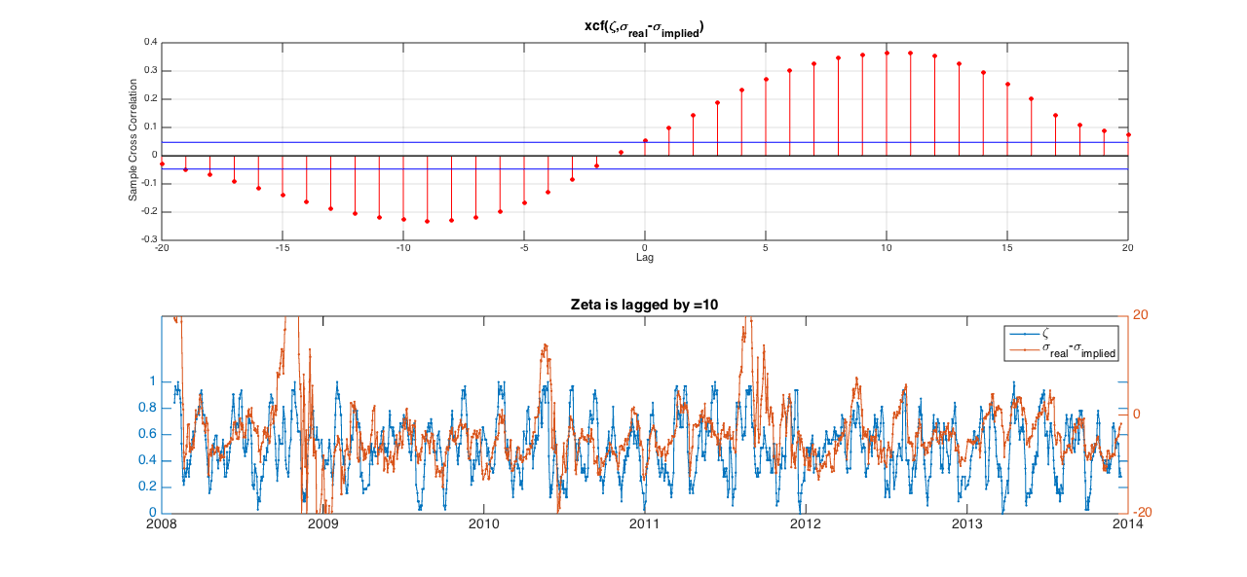

By the way, as can be seen from their cross correlation, even at lag 15 the correlation is still high. To see how lag 15 plays role in effect, I show you the average payoff (notice that I now subtract realized from implied vol.) $$E\left({ σ}_{implied}\left(t-20\right)-σ_{realized}\left(t\right) | ζ\left(t-15\right)> X \right)$$

>>>Delay5-zeta

E(impvol-rvol | z(t-l) > X), l = 15

Days during testing = 1759

X days AvgPayoff

0.000 1757 3.729

0.100 1713 3.687

0.200 1612 3.540

0.300 1446 3.322

0.400 1240 3.037

0.500 916 2.029

0.600 626 1.059

0.700 399 0.099

0.800 228 -1.106

0.900 131 -1.648

>>>Avg10-zeta

E(impvol-rvol | z(t-l) > X), l = 15

Days during testing = 1759

X days AvgPayoff

0.000 1759 3.734

0.100 1759 3.734

0.200 1738 3.728

0.300 1591 3.605

0.400 1328 3.212

0.500 937 2.190

0.600 550 0.854

0.700 218 -0.889

0.800 27 -4.050

0.900 NaN

What this implies is that an investor only know he will lose in the next 15 days after he formed the position 5 days ago. So it means that my current zetas respond to slow to the market. The next picture illustrates this.

Miscellaneous

1. zeta detects drawdown after it happens
2. drawdown(t) causes rise in RV(s) for s > t, but it does always mean that RV(s) – IV(s-20) > 0.
   1. One way to separate between a rise that lead to sign change or a rise that does not, is to look at trend of the market, i.e., bull or bear