*The following scenario describes a hospital in-patient system:*

An in-patient in a hospital is identified by a patient record number, and details of their name, address, date of birth and GP are recorded. Patients are assigned to a single ward in the hospital. Each ward is identified by the ward number and also has a name. A ward has a designated number of beds and may or may not be fully occupied. The number of patients in a ward must be equal to or less than the number of beds. Some wards may have no patients assigned to them. Each ward is staffed by at least one nurse. Within a ward a designated nurse is in charge of the ward and of the other nurses in the ward. Patients in the hospital may be allocated to one of the consultants working in the hospital. Each consultant has a recorded specialism and heads a team of personnel consisting of junior doctors who may be either registrars or housemen. All doctors in the hospital (i.e. both junior doctors and consultants) have staff numbers and their names are also recorded. The teams in the hospital are identified by a team code; the number of doctors in each team is recorded.

**Entities**

WARD(WNo, Name, Number_of_beds)

NURSE(Nid, Name, Date_qualified)

PATIENT(Pid,Name, Address, Date_of_Birth)

DOCTOR(Staff_number, Name, Appointment_date)

CONSULTANT(Staff_number, Specialism)

JUNIOR_DOCTOR(Staff_number)

HOUSEMAN(Staff_number)

REGISTRAR(Staff_number)

TEAM(Team_code,Contact_number)

The wards in the hospital.

The nurses who work in the wards

Out-patients who attend the hospital.

A super-entity to incorporate all docs.

Sub-enitiy of doctor

Another sub-entity of doctor.

One of the kinds of junior doctors

Another kind of junior doctor

The teams to which doctors are attached

**Relationships:**

|  |  |  |  |
| --- | --- | --- | --- |
| Name | Entities | Degree | Optionality |
| IS_ASSIGNED_TO | WARD, PATIENT | 1:N | Obligatory on PATIENT, Optional on WARD |
| WORKS_IN | NURSE, WARD | N:1 | Obligatory on both |
| LOOKS_AFTER | CONSULATNT, PATIENT | 1:N | Optional on both |
| IS_MEMBER_OF | JUNIOR_DOCTOR, TEAM | N:1 | Obligatory on both |
| SUPERVISES | NURSE, NURSE | 1:N | Optional on both |
| IS_HEAD_OF | CONSULTANT, TEAM | 1:1 | Obligatory on both |

**EER Diagram**

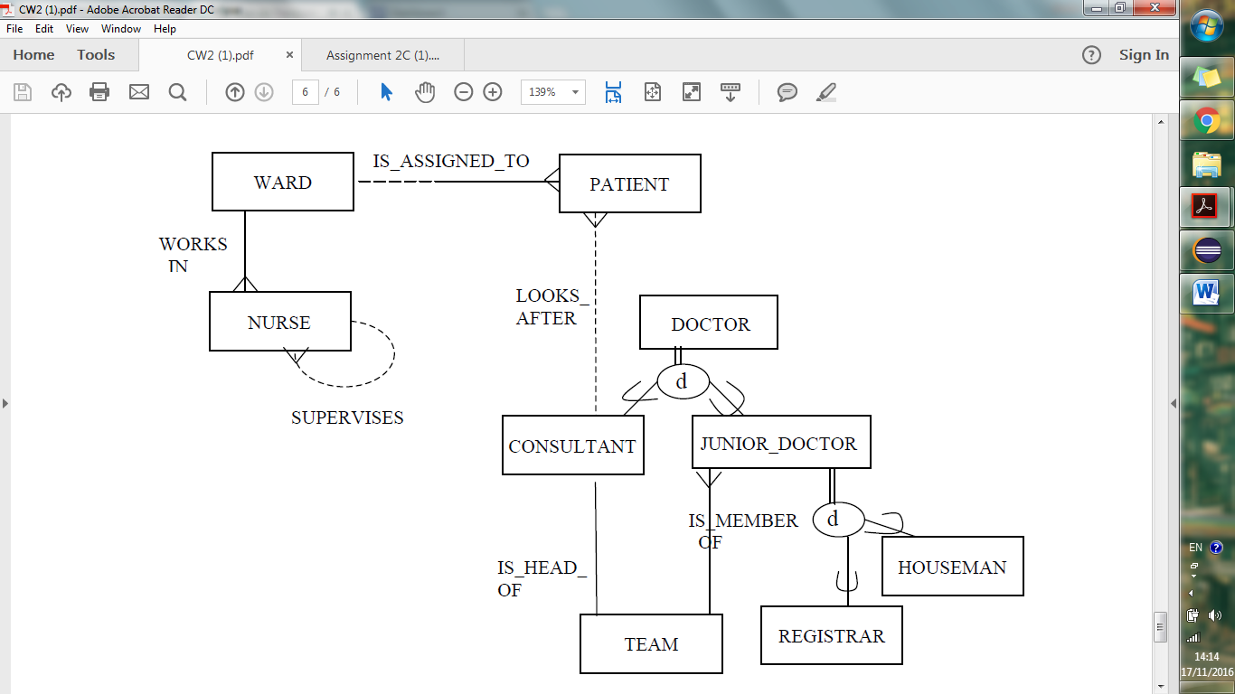

*Write down a table structure for each of the entities involved in the EER structure attached at the end of this document.*

**WARD**

|  |  |  |
| --- | --- | --- |
| WNo | Name | Number_of_beds |
|  |  |  |

**NURSE**

|  |  |  |
| --- | --- | --- |
| Nid | Name | Date_qualified |
|  |  |  |

**PATIENT**

|  |  |  |  |
| --- | --- | --- | --- |
| Pid | Name | Address | Date_of_Birth |
|  |  |  |  |

**DOCTOR**

|  |  |  |
| --- | --- | --- |
| Staff_number | Name | Appointment_date |
|  |  |  |

**CONSULTANT**

|  |  |
| --- | --- |
| Staff_number | Specialism |
|  |  |

**JUNIOR_DOCTOR**

|  |
| --- |
| Staff_number |
|  |

**HOUSEMAN**

|  |
| --- |
| Staff_number |
|  |

**REGISTRAR**

|  |
| --- |
| Staff_number |
|  |

**TEAM**

|  |  |
| --- | --- |
| Team_code | Contact_number |
|  |  |

*Write down an advantage and a disadvantage of each method of representation.*

|  |  |  |
| --- | --- | --- |
|  | Advantage | Disadvantage |
| One table | Using a single table means a structure will be more readable and more efficient data retrieval. | Using a single table means a structure will have many null values throughout. |
| Separate tables to represent subtypes only. | Using a separate table for each subtype means that no null values will exist. | Using separate tables will result in many tables for users to work with which can be cumbersome |
| Separate tables to represent subtypes and supertypes | Using a separate table for each subtype means that no null values will exist. | Using separate tables will result in many tables for users to work with which can be cumbersome |

*Write down table structures or modify existing structures to represent relationships in the system.*

**NURSE**

|  |  |  |  |  |
| --- | --- | --- | --- | --- |
| Nid | Name | Date_qualified | Supervisor | Ward |
|  |  |  | Nid | WNo |

**PATIENT**

|  |  |  |  |  |  |
| --- | --- | --- | --- | --- | --- |
| Pid | Name | Address | Date_of_Birth | Ward | Consultant |
|  |  |  |  | WNo | Staff_number |

**CONSULTANT**

|  |  |  |
| --- | --- | --- |
| Staff_number | Specialism | Leads |
|  |  | Team_code |

**JUNIOR_DOCTOR**

|  |  |
| --- | --- |
| Staff_number | Team |
|  | Team_code |