数値解析

J15337

堀井萌希

１－２

ソース

#include<stdio.h>

int main(void){

long long int i, j, bit[64];

double x;

printf(" Input a number.\n");

scanf("%lf", &x);

printf("%lf -> ",x); j = \*(long long int \*)&x;

for(i = 0; i <= 63; i++) bit[i] = (j>>i)& 1;

for(i = 63; i >= 0; i--){

printf("%d", bit[i]);

if (i % 4 == 0) printf(" ");

}

printf("\n"); return 0;

結果

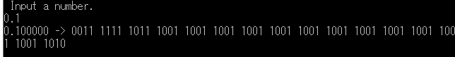}

１－３

ソース

#include<stdio.h>

int main(void){

double a, b, c, d, eps = 1.0, x = 1.0 + eps; int i = 0;

while (x > 1){

i++;eps /= 2.0;x = 1.0 + eps;

}eps \*= 2.0; i--;

printf(" eps = %11.4e (2^(%d))\n", eps, -i);

a = 1.0 + eps;

b = a -1.0;

c = 1.0 + eps / 2.0;

d = c -1.0;

printf(" 1 + eps -1 => %11.4e \n", b);

printf(" 1 + eps / 2 -1 => %11.4e \n", d);

return 0;

}

結果

