Practical-3:
Part-A:
Problem 1: - 1. Distinct points: -
(a) Create class Point with private int x, y and a constructor.
(b) Override toString() to return “(x, y)”.
(c) Override equals(Object) to be true when both x and y match, and hashCode() to agree
(e.g. Objects.hash(x, y)).
(d) In Driver.main: build a Point[] with some repeated coordinates.
(e) Count distinct points: for each point, use equals() to check whether it already
appeared earlier; count those that did not.
(f) Print “Distinct: N”.

Solution: -
import java.util.Scanner;
import java.util.Objects;

class Point {
private int x;
private int y;

Point(int x,int y){
this.x=x;
this.y=y;
}

@Override
public String toString() {
return "(" + x + " , " + y + ")";
}

@Override
public boolean equals(Object obj){
if(this==obj) return true;
if(obj==null || getClass()!=obj.getClass()){
return false;
}
Point p=(Point)obj;
return x==p.x && y==p.y;
}
@Override
public int hashCode(){
return Objects.hash(x,y);
}

}

public class Extra {
public static void main(String [] args){
Point[] p={
new Point(1,2),
new Point(3,4),
new Point(5,6),
new Point(3,4)

};
int distinct=0;
for(int i=0;i<p.length;i++){
boolean found=false;
for(int j=0;j<i;j++){
if(p[i].equals(p[j])){
found=true;
break;
}
}
if(!found) distinct++;
}
System.out.println("Distinct: "+distinct);
}
}
OUTPUT: -

Problem 2: - Duplicate card check: -
(a) Create class Card with private String rank, suit and a constructor.
(b) Override toString() to return rank + “ of ” + suit (e.g. “Queen of Hearts”).
(c) Override equals()/hashCode() by rank + suit.
(d) In Driver.main: add cards to a Card[] one at a time; before adding each, use equals()
to check it against the earlier cards.
(e) Print “Duplicate found: <card>” the first time a repeat appears.
Solution: -
import java.util.Scanner;
import java.util.Objects;

class Card{
private String rank;
private String suit;
Card(String rank,String suit){
this.rank=rank;
this.suit=suit;
}
@Override
public String toString(){
return rank+" of "+suit;
}
@Override
public boolean equals(Object obj){
if(this==obj){
return true;
}
if(obj==null || getClass()!=obj.getClass()){
return false;
}
Card c=(Card)obj;
return rank.equals(c.rank) && suit.equals(c.suit);

}
@Override
public int hashCode(){
return Objects.hash(rank,suit);
}
}

public class Driver {
public static void main(String [] args){
int size=0;

Card[] newcard=new Card[5];
Card[] c={
new Card("Ace","Spades"),
new Card("King","Hearts"),
new Card("Ace","Spades"),
new Card("Queen","Clubs"),
new Card("10","Diamonds")
};
for(Card card:c){
boolean duplicates=false;
for(int i=0;i<size;i++){
if(card.equals(newcard[i])){
System.out.println("Duplicate found:"+card);
duplicates=true;
break;
}
}
if(!duplicates){
newcard[size]=card;
size++;
}
}
}
}

OUTPUT: -

Part-B: -
Problem: - In Practical 2 you created the Account and Customer classes. Here you make their objects
behave correctly — they print as readable text (toString) and are compared by account
number (equals/hashCode) — and you add a nested Address class. Correct equals/hashCode
is essential because Practical 12 will store accounts in collections that rely on it.
1. In Account, override the toString() method to return a readable line containing
accountNumber, ownerName and balance.
2. In Account, override equals(Object o) and hashCode() so that two accounts are equal
when their accountNumber values are equal.
3. In Customer, add a public static nested class named Address with String fields line, city
and pincode plus getters; add an Address field to Customer and a getAddress() method.
4. In Customer, add a clone() method (implement Cloneable) that returns a copy of the
customer.
5. In main, print accounts using toString(), compare two Account objects with equals(), and
use instanceof to check an object’s type.
Solution: -
package Project;

import java.util.Scanner;

class Customer implements Cloneable{
private String name;
private String email;
private String mobile;
private final String customerId;
private Address address;

private static long customerCounter = 101;

private static String generateCustomerId() {
return "CUST" + customerCounter++;
}

public Customer(String name, String email, String mobile) {
this.name = name;
this.email = email;
this.mobile = mobile;
this.customerId = generateCustomerId();
this.address = new Address("Main Road", "Botad", "364710");
}

public String getName() {
return name;
}

public String getEmail() {
return email;
}

public String getMobile() {
return mobile;
}

public String getCustomerId() {
return customerId;
}
public Address getAddress() {
return address;
}

@Override
public Customer clone(){
try {
return (Customer)super.clone();
} catch (CloneNotSupportedException e) {
return null;
}
}
public static class Address {
private String line;
private String city;
private String pincode;

public Address(String line, String city, String pincode) {
this.line = line;
this.city = city;
this.pincode = pincode;
}
public String getline(){
return line;
}
public String getcity(){
return city;
}
public String getpincode(){
return pincode;
}
}
}

class Account {

private final String accountNumber;
private String ownerName;
private long balance;
private boolean active;

private static int accountCounter = 1;

private static String generateAccountNumber() {
return String.format("AC%04d", accountCounter++);
}

public Account(String ownerName, long balance) {
this.ownerName = ownerName;
this.balance = balance;
this.active = true;
this.accountNumber = generateAccountNumber();
}

public Account(String ownerName) {
this(ownerName, 0);
}

public void deposit(long amount) {
balance += amount;
}

public boolean withdraw(long amount) {
if (amount <= balance) {
balance -= amount;
return true;
}
return false;
}

public String getAccountNumber() {
return accountNumber;
}

public String getOwnerName() {
return ownerName;
}

public long getBalance() {
return balance;
}

public boolean isActive() {
return active;
}
@Override
public String toString(){
return "AccountNumber: "+accountNumber+", Owber: "+ownerName+", Balance: "+balance;
}
@Override
public boolean equals(Object o){
if(this==o) return true;
if(!(o instanceof Account)) return false;
Account account=(Account)o;
return accountNumber.equals(account.accountNumber);
}
@Override
public int hashCode(){
return accountNumber.hashCode();
}

}
public class Minibank {
record BankInfo(String name, String branch) {
};

enum MenuOption{
OPEN_ACCOUNT,
DEPOSIT,
WITHDRAW,
TRANSFER,
EXIT
}

public static void main(String[] args){
Scanner scanner=new Scanner(System.in);
int choice;
BankInfo bank=new BankInfo("SBI", "Botadbank");
do{

System.out.println("1.OPEN_ACCOUNT");
System.out.println("2.DEPOSIT");
System.out.println("3.WITHDRAW");
System.out.println("4.TRANSFER");
System.out.println("5.EXIT");

System.out.println("Enter Your Choice: ");
choice=scanner.nextInt();
MenuOption option=switch(choice){
case 1->MenuOption.OPEN_ACCOUNT;
case 2->MenuOption.DEPOSIT;
case 3->MenuOption.WITHDRAW;
case 4->MenuOption.TRANSFER;
case 5->MenuOption.EXIT;
default->null;
};
if(option==null){
System.out.println("Invalid choice.Please enter a choice between 1 and 5");
}

switch (option){
case OPEN_ACCOUNT->{

Customer c1 = new Customer("Uzair", "uzair@gmail.com", "9876543210");
Customer c2 = new Customer("Ali", "ali@gmail.com", "9999999999");
Customer c3 = new Customer("Ahmed", "ahmed@gmail.com", "8888888888");

Account[] accounts = new Account[3];
accounts[0] = new Account(c1.getName(), 1000);
accounts[1] = new Account(c2.getName());
accounts[2] = new Account(c3.getName(), 500);
for(Account acc:accounts){
System.out.println(acc);
}
System.out.println("Account-1 equals Account-2: "+accounts[0].equals(accounts[1]));
Object obj = accounts[0];

if (obj instanceof Account) {
System.out.println("obj is an Account object.");
}
Customer copy=c1.clone();
System.out.println("Original Customer: "+c1.getName());
System.out.println("Copy of Customer: "+copy.getName());

System.out.println("Line"+c1.getAddress().getline());
System.out.println("City: "+c1.getAddress().getcity());
System.out.println("PinCode: "+c1.getAddress().getpincode());

accounts[0].deposit(500);
accounts[0].withdraw(200);

accounts[1].deposit(1000);
accounts[1].withdraw(300);

accounts[2].withdraw(600);
accounts[2].deposit(200);

System.out.println("\nAccount Details");

for (int i = 0; i < accounts.length; i++) {

System.out.println("Customer ID : " +
(i == 0 ? c1.getCustomerId()
: i == 1 ? c2.getCustomerId()
: c3.getCustomerId()));

System.out.println("Owner: " + accounts[i].getOwnerName());
System.out.println("Account No.: "+ accounts[i].getAccountNumber());
System.out.println("Balance: "+accounts[i].getBalance());
System.out.println("Active: "+accounts[i].isActive());
System.out.println();
}
}
case DEPOSIT->
System.out.println("Deposit - to be implemented in a later lab");
case WITHDRAW->
System.out.println("Withdraw - to be implemented in a later lab");
case TRANSFER->
System.out.println("Transfer - to be implemented in a later lab");
case EXIT->
System.out.println("Thank you for using MiniBank. Goodbye!");
}
}while(choice!=5);
scanner.close();
}
}
OUTPUT: -

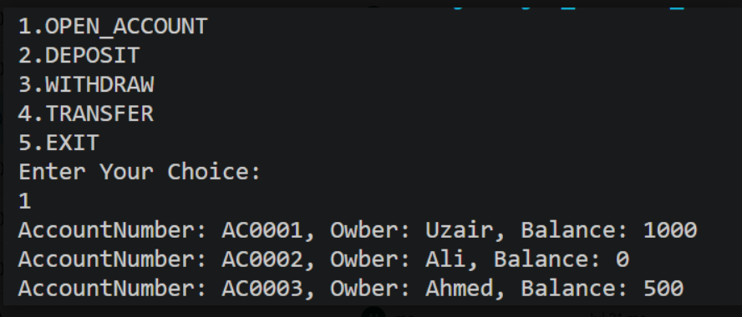
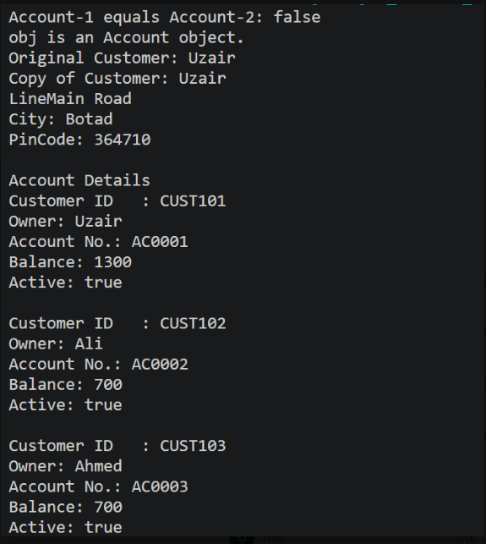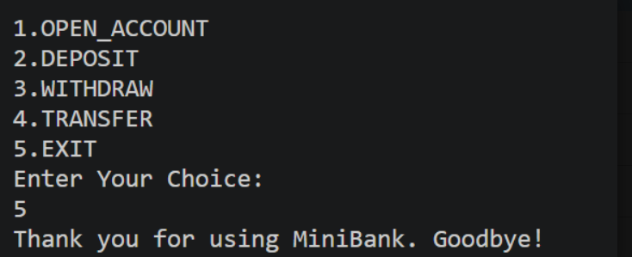

Key Question Answer:
- Why must equals() and hashCode() be overridden together?
equals() and hashCode() must be overridden together because they follow a contract:
- If two objects are equal using equals(), they must have the same hashCode().
- This is especially important when using collections like HashMap, HashSet, etc.
- If you override only equals() but not hashCode(), two logically equal objects may have different hash codes, causing collections to treat them as different objects.

- What does the default Object.toString() return, and why override it?
The default toString() returns the class name, @, and the object's hash code.
We override it to display meaningful and readable details of the object. This makes the object easier to understand when printed.
- What is the difference between a static nested class and an inner class?
A static nested class belongs to the outer class and can be used without creating an outer-class object. An inner class is associated with an object of the outer class and can access its instance members.

Conclusion: -
In this practical we can learn how we can override Object class methods and how we can use Object class pre-built methods.

