Practical-4:
Part-A:
Problem 1: - 1. Password strength: -
(a) In PasswordChecker, check four rules — length ≥ 8, contains an uppercase letter,
contains a digit, contains a special character — using regex (e.g. “.*[A-Z].*”) or
String methods.
(b) Write strength(String pw) that counts how many rules pass and returns “Weak” (0–
1), “Medium” (2–3) or “Strong” (4).
(c) In Driver.main: test several passwords; for each, print which rules passed and the
final label.
Solution: -
class PasswordChecker {
static boolean lengthrule(String pw){
return pw.length()>=8;
}
static boolean uppercaserule(String pw){
return pw.matches(".*[A-Z].*");
}
static boolean digitrule(String pw){
return pw.matches(".*[0-9].*");
}
static boolean specialcharacterrull(String pw){
return pw.matches(".*[^A-Za-z0-9].*");
}
static String strength(String pw){
int count=0;
if(lengthrule(pw)) count++;
if(uppercaserule(pw)) count++;
if(digitrule(pw)) count++;
if(specialcharacterrull(pw)) count++;

if(count<=1){
return "Weak";
}else if(count<=3){
return "Medium";
}else{
return "Strong";
}
}
}

public class Regex {
public static void main(String args[]) {
String passwords[]={
"abc",
"abcdefg",
"Abcd123",
"Abcd123!"
};
for(String pw:passwords){
System.out.println("Password: "+pw);
System.out.println("Length >= 8: "+PasswordChecker.lengthrule(pw));
System.out.println("Uppercase: "+PasswordChecker.uppercaserule(pw));
System.out.println("Digit: "+PasswordChecker.digitrule(pw));
System.out.println("Special character: "+PasswordChecker.specialcharacterrull(pw));
System.out.println("Strength: "+PasswordChecker.strength(pw));
}
}
}

OUTPUT: -
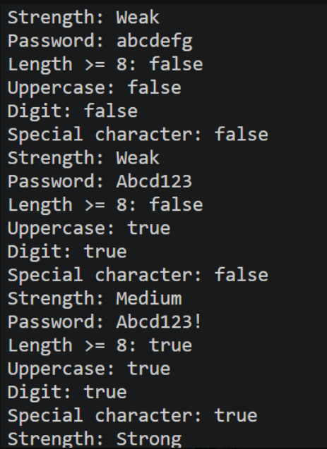
Problem 2: - Chat-log filter: -
(a) In Driver.main, define a String[] of log lines like “10:05 alice Hello there” (include
one malformed line with fewer than 3 parts).
(b) Read a keyword from the user.
(c) For each line, split into time/user/message with split(“ ”, 3); skip lines that do not
have 3 parts.
(d) If the message contains the keyword (case-insensitive), increment a counter and
append “time user: message” to a StringBuilder.
(e) Print “Matches: N” and the built report.
Solution: -
import java.util.Scanner;

class CharFilter {
static boolean containskeyword(String message, String Keyword) {
return message.toLowerCase().contains(Keyword.toLowerCase());
}
}

public class Keyword {
public static void main(String args[]){
String[] logs = {
"10:05 alice Hello there",
"10:10 bob How are you",
"10:15 Charlie Good morning",
"10:20 David"
};
Scanner sc=new Scanner(System.in);
System.out.println("Enter the Keyword: ");
String Keyword=sc.nextLine();
int count=0;
StringBuilder report=new StringBuilder();
for(String lines:logs){
String[] parts=lines.split(" ",3);
if (parts.length < 3) {
continue;
}
String time=parts[0];
String user=parts[1];
String message=parts[2];
if(CharFilter.containskeyword(message, Keyword)){
count++;
report.append(time)
.append(" ")
.append(user)
.append(": ")
.append(message)
.append("\n");
}

}
System.out.println("Matchea: "+count);
System.out.println(report);
sc.close();
}
}

OUTPUT: -
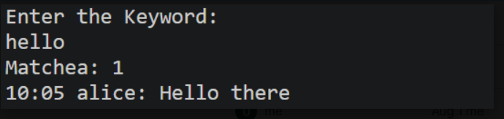

Part-B: -
Problem: - Part B — Project Work (Hour 2): MiniBank
Your classes exist, but the bank must never trust raw user input. In this lab you build
MiniBank’s validation and command-parsing layer — regex checks for mobile, email, PAN
and IFSC, and a parser that turns a typed line such as “DEPOSIT AC0001 500” into a
Command object. Practical 14 will run every menu action through this layer.
1. Create a class named Validator with public static methods that use compiled regular
expressions (Pattern): isValidMobile(String), isValidEmail(String), isValidPan(String)
and isValidIfsc(String); each returns a boolean.
2. Define an enum named TransactionType with the constants DEPOSIT, WITHDRAW
and TRANSFER. Then define a record named Command with three fields: a
TransactionType type, a String accountNumber and a long amount.
3. Create a class named CommandParser with a public static method parse(String line) that
splits a line such as “DEPOSIT AC0001 500” with split(), converts the parts, and returns
a Command object.
4. Create a class named StatementFormatter with a public static method
buildStatement(Account account) that uses a StringBuilder to assemble a multi-line
account statement string.
5. In main, test each validator with one correct and one wrong input, then parse a sample
command and print its three parts.
Solution: -
package Project;

import java.util.Scanner;
import java.util.regex.Pattern;

class Customer implements Cloneable {
private String name;
private String email;
private String mobile;
private final String customerId;
private Address address;

private static long customerCounter = 101;

private static String generateCustomerId() {
return "CUST" + customerCounter++;
}

public Customer(String name, String email, String mobile) {
this.name = name;
this.email = email;
this.mobile = mobile;
this.customerId = generateCustomerId();
this.address = new Address("Main Road", "Botad", "364710");
}

public String getName() {
return name;
}

public String getEmail() {
return email;
}

public String getMobile() {
return mobile;
}

public String getCustomerId() {
return customerId;
}

public Address getAddress() {
return address;
}

@Override
public Customer clone() {
try {
return (Customer) super.clone();
} catch (CloneNotSupportedException e) {
return null;
}
}

public static class Address {
private String line;
private String city;
private String pincode;

public Address(String line, String city, String pincode) {
this.line = line;
this.city = city;
this.pincode = pincode;
}

public String getline() {
return line;
}

public String getcity() {
return city;
}

public String getpincode() {
return pincode;
}
}
}

class Account {

private final String accountNumber;
private String ownerName;
private long balance;
private boolean active;

private static int accountCounter = 1;

private static String generateAccountNumber() {
return String.format("AC%04d", accountCounter++);
}

public Account(String ownerName, long balance) {
this.ownerName = ownerName;
this.balance = balance;
this.active = true;
this.accountNumber = generateAccountNumber();
}

public Account(String ownerName) {
this(ownerName, 0);
}

public void deposit(long amount) {
balance += amount;
}

public boolean withdraw(long amount) {
if (amount <= balance) {
balance -= amount;
return true;
}
return false;
}

public String getAccountNumber() {
return accountNumber;
}

public String getOwnerName() {
return ownerName;
}

public long getBalance() {
return balance;
}

public boolean isActive() {
return active;
}

@Override
public String toString() {
return "AccountNumber: " + accountNumber + ", Owber: " + ownerName + ", Balance: " + balance;
}

@Override
public boolean equals(Object o) {
if (this == o)
return true;
if (!(o instanceof Account))
return false;
Account account = (Account) o;
return accountNumber.equals(account.accountNumber);
}

@Override
public int hashCode() {
return accountNumber.hashCode();
}

}

class Validator {
public static final Pattern MOBILE = Pattern.compile("^[6-9][0-9]{9}$");
public static final Pattern EMAIL = Pattern.compile("^[A-Za-z0-9+_.-]+@[A-Za-z0-9_.]+$");
public static final Pattern PAN = Pattern.compile("^[A-Z]{5}[0-9]{4}[A-Z]$");
public static final Pattern IFSC = Pattern.compile("^[A-Z]{4}[0][A-Z0-9]{6}$");

public static boolean isValidMobile(String mobile) {
return mobile != null && MOBILE.matcher(mobile).matches();
}

public static boolean isValidEmail(String email) {
return email!= null && EMAIL.matcher(email).matches();
}

public static boolean isValidPan(String pan) {
return pan!= null && PAN.matcher(pan).matches();
}

public static boolean isValidIfsc(String ifsc) {
return ifsc!= null && IFSC.matcher(ifsc).matches();
}
}
enum TransactionType {
DEPOSIT,
WITHDRAW,
TRANSFER
}

record Command(TransactionType type, String accountNumber, long amount) {
}

class CommandParser {
public static Command parse(String line){
String parts[]=line.split(" ");
TransactionType type=TransactionType.valueOf(parts[0]);
String accountNumber=parts[1];
long amount=Long.parseLong(parts[2]);
return new Command(type, accountNumber, amount);
}
}
class StatementFormatter{
public static String buildStatement(Account account){
StringBuilder sb=new StringBuilder();
sb.append("Account Statement\n");
sb.append("Account Number: ")
.append(account.getAccountNumber())
.append("\n");

sb.append("Owner Name: ")
.append(account.getOwnerName())
.append("\n");

sb.append("Balance: ")
.append(account.getBalance())
.append("\n");

sb.append("Active: ")
.append(account.isActive())
.append("\n");

return sb.toString();
}
}

public class Minibank {
record BankInfo(String name, String branch) {
};

enum MenuOption {
OPEN_ACCOUNT,
DEPOSIT,
WITHDRAW,
TRANSFER,
EXIT
}

public static void main(String[] args) {
Scanner scanner = new Scanner(System.in);
System.out.println("Validator Testing");

System.out.println("Mobile 9876543210: " + Validator.isValidMobile("9876543210"));

System.out.println("Mobile 1234567890: " + Validator.isValidMobile("1234567890"));

System.out.println("Email uzair@gmail.com: " + Validator.isValidEmail("uzair@gmail.com"));

System.out.println("Email uzairgmail.com: " + Validator.isValidEmail("uzairgmail.com"));

System.out.println("PAN ABCDE1234F: " + Validator.isValidPan("ABCDE1234F"));

System.out.println("PAN ABC1234F: " + Validator.isValidPan("ABC1234F"));

System.out.println("IFSC SBIN0001234: " + Validator.isValidIfsc("SBIN0001234"));

System.out.println("IFSC SBI1234: " + Validator.isValidIfsc("SBI1234"));

System.out.println("\nCommand Parsing");

Command command = CommandParser.parse("DEPOSIT AC0001 500");
System.out.println("Type: " + command.type());
System.out.println("Account Number: " + command.accountNumber());
System.out.println("Amount: " + command.amount());

Account testAccount = new Account("Uzair", 5000);
System.out.println("\nAccount Statement");
System.out.println(StatementFormatter.buildStatement(testAccount));
int choice;
BankInfo bank = new BankInfo("SBI", "Botadbank");
do {

System.out.println("1.OPEN_ACCOUNT");
System.out.println("2.DEPOSIT");
System.out.println("3.WITHDRAW");
System.out.println("4.TRANSFER");
System.out.println("5.EXIT");

System.out.println("Enter Your Choice: ");
choice = scanner.nextInt();
MenuOption option = switch (choice) {
case 1 -> MenuOption.OPEN_ACCOUNT;
case 2 -> MenuOption.DEPOSIT;
case 3 -> MenuOption.WITHDRAW;
case 4 -> MenuOption.TRANSFER;
case 5 -> MenuOption.EXIT;
default -> null;
};
if (option == null) {
System.out.println("Invalid choice.Please enter a choice between 1 and 5");
}

switch (option) {
case OPEN_ACCOUNT -> {

Customer c1 = new Customer("Uzair", "uzair@gmail.com", "9876543210");
Customer c2 = new Customer("Ali", "ali@gmail.com", "9999999999");
Customer c3 = new Customer("Ahmed", "ahmed@gmail.com", "8888888888");

Account[] accounts = new Account[3];
accounts[0] = new Account(c1.getName(), 1000);
accounts[1] = new Account(c2.getName());
accounts[2] = new Account(c3.getName(), 500);
for (Account acc : accounts) {
System.out.println(acc);
}
System.out.println("Account-1 equals Account-2: " + accounts[0].equals(accounts[1]));
Object obj = accounts[0];

if (obj instanceof Account) {
System.out.println("obj is an Account object.");
}
Customer copy = c1.clone();
System.out.println("Original Customer: " + c1.getName());
System.out.println("Copy of Customer: " + copy.getName());

System.out.println("Line" + c1.getAddress().getline());
System.out.println("City: " + c1.getAddress().getcity());
System.out.println("PinCode: " + c1.getAddress().getpincode());

accounts[0].deposit(500);
accounts[0].withdraw(200);

accounts[1].deposit(1000);
accounts[1].withdraw(300);

accounts[2].withdraw(600);
accounts[2].deposit(200);

System.out.println("\nAccount Details");

for (int i = 0; i < accounts.length; i++) {

System.out.println("Customer ID : " +
(i == 0 ? c1.getCustomerId()
: i == 1 ? c2.getCustomerId()
: c3.getCustomerId()));

System.out.println("Owner: " + accounts[i].getOwnerName());
System.out.println("Account No.: " + accounts[i].getAccountNumber());
System.out.println("Balance: " + accounts[i].getBalance());
System.out.println("Active: " + accounts[i].isActive());
System.out.println();
}
}
case DEPOSIT ->
System.out.println("Deposit - to be implemented in a later lab");
case WITHDRAW ->
System.out.println("Withdraw - to be implemented in a later lab");
case TRANSFER ->
System.out.println("Transfer - to be implemented in a later lab");
case EXIT ->
System.out.println("Thank you for using MiniBank. Goodbye!");
}
} while (choice != 5);
scanner.close();
}
}

OUTPUT: -
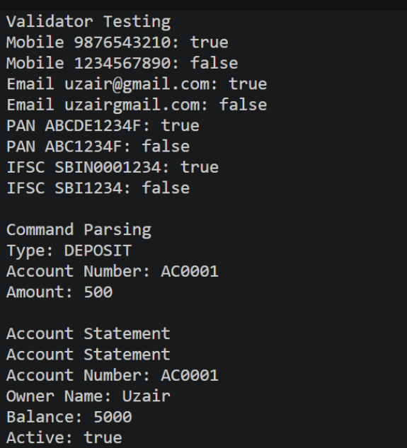

Key Question Answer:
1. What is the difference between String, StringBuilder and StringBuffer, and when is each
preferred?
- String: Immutable; preferred when the text does not change frequently.
- StringBuilder: Mutable and faster; preferred for frequent string changes in single-threaded programs.
- StringBuffer: Mutable and thread-safe; preferred when strings are modified in multiple threads.

2. What does the regular expression [6-9][0-9]{9} match, and why use anchors?
The regular expression [6-9][0-9]{9} matches a 10-digit mobile number starting with 6, 7, 8, or 9.
Anchors (^ and $) are used to ensure the entire input matches the pattern, not just part of it.

3. Why should input be validated at the boundary before it is used?
Input should be validated at the boundary to detect invalid data early, prevent errors, and ensure that only correct and safe data enters the program.
Conclusion: -
In this practical we can learn the how we can secure private detail like mobile number, bank-Account Number etc with using of Regex.

