Practical-1:
Part-A:
Problem 1: - Vending machine: -
(a) Define an enum Coin with constants ONE, TWO, FIVE, TEN.
(b) In main, set a snack price of 15 and a running total of 0; create a Scanner.
(c) Loop: read a coin name, use a switch expression to convert the Coin to its value
(ONE→1, TWO→2, FIVE→5, TEN→10), add it to the total, and print the total so
far.
(d) Stop the loop once the total reaches 15 or more.
(e) Print the change to return (total − 15).

Solution: -
import java.util.Scanner;
public class Vending{
enum Coin{
ONE,
TWO,
FIVE,
TEN
}
public static void main(String[] args){
int snack=15;
int total=0;
Scanner scanner= new Scanner(System.in);
while(total<snack){
String userInput=scanner.next().toUpperCase();
Coin insertCoin=Coin.valueOf(userInput);
int value=switch(insertCoin){
case ONE->1;
case TWO->2;
case FIVE->5;
case TEN->10;

};
total+=value;

}
int change=total-snack;
System.out.println("Sanck Price is: " + snack);
System.out.println("Total Price: " + total);
System.out.println("Return value is " + change);
scanner.close();
}
};
OUTPUT: -
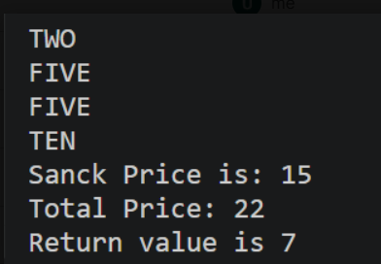
Problem 2: - Toll booth: -
(a) Define a record Vehicle(String number, String type).
(b) In main, keep a running toll total and three counters (bike, car, truck).
(c) Loop until the user types “done” for the number: build a Vehicle, use a switch
expression on its type for the toll (bike→20, car→50, truck→150), add to the total,
and increment that type’s counter.
(d) After the loop, print the total toll and the type with the highest count.
Solution: -
import java.util.Scanner;

public class Toolboth {
record Vehicle(String number, String type) {
};

public static void main(String[] args){
Scanner scanner= new Scanner(System.in);
int Totaltoll=0;
int biketotal=0;
int carcount=0;
int truckcount=0;
while (true) {

System.out.print("Enter vehicle number (or done): ");
String number = scanner.next();

if (number.equalsIgnoreCase("done")) {
break;
}
System.out.println("Enter te type of Vehical: ");
String type= scanner.next().toLowerCase();
Vehicle v= new Vehicle(number, type);
int totl=switch(v.type()){
case "bike" -> 20;
case "car" -> 50;
case "truck" -> 150;
default -> 0;
};
Totaltoll+=totl;
switch (v.type()) {
case "bike"->biketotal++;
case "car"->carcount++;
case "truck"->truckcount++;
}
}
System.out.println("Total bill is: "+Totaltoll);
if (biketotal >= carcount && biketotal >= truckcount) {
System.out.println("Most frequent: bike");
} else if (carcount >= biketotal && carcount >= truckcount) {
System.out.println("Most frequent: car");
} else {
System.out.println("Most frequent: truck");
}

scanner.close();
}

};
OUTPUT: -
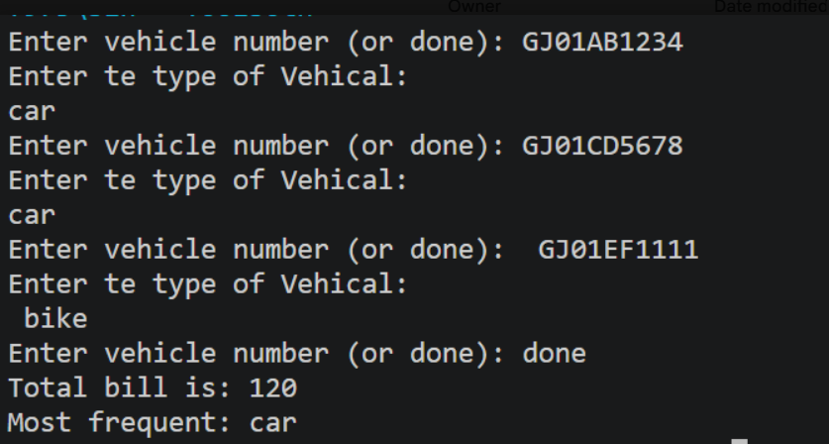

Part-B: -
Problem: - MiniBank is the console banking application you will build across the whole semester. In
this first lab you set up your tools and create the project and its menu shell — the screen the
user navigates. Every later lab attaches one real banking feature behind these menu options.
1. Set up your environment: open the project in GitHub Codespaces (or install JDK 17+ and an IDE locally), and create a private GitHub repository named oop-minibank-<rollno>; add the faculty as a collaborator.
2. Create a public class named MiniBank that contains the main method.
3. Define a record named BankInfo with two String fields, name and branch (a record is a short, read-only class; Java auto-generates its constructor and field accessors). Print one BankInfo object as the application header.
4. Define an enum named MenuOption with the constants OPEN_ACCOUNT, DEPOSIT, WITHDRAW, TRANSFER and EXIT — these are the actions MiniBank will offer.
5. Display the numbered menu to the user and read the chosen number with a Scanner.
6. Use a switch expression on the choice to print a short placeholder for that option (for
example, “Deposit — to be implemented in a later lab”). Keep showing the menu in a loop until the user selects EXIT, then print a goodbye message.

Solution: -
package Project;

import java.util.Scanner;

public class Minibank {
record BankInfo(String name, String branch) {
};

enum MenuOption {
OPEN_ACCOUNT,
DEPOSIT,
WITHDRAW,
TRANSFER,
EXIT
}

public static void main(String[] args){
Scanner scanner=new Scanner(System.in);
int choice;
BankInfo bank=new BankInfo("SBI", "Botadbank");
do{

System.out.println("1.OPEN_ACCOUNT");
System.out.println("2.DEPOSIT");
System.out.println("3.WITHDRAW");
System.out.println("4.TRANSFER");
System.out.println("5.EXIT");

System.out.println("Enter Your Choice: ");
choice=scanner.nextInt();
MenuOption option=switch(choice){
case 1->MenuOption.OPEN_ACCOUNT;
case 2->MenuOption.DEPOSIT;
case 3->MenuOption.WITHDRAW;
case 4->MenuOption.TRANSFER;
case 5->MenuOption.EXIT;
default->null;
};
if(option==null){
System.out.println("Invalid choice.Please enter a choice between 1 and 5");
}

switch (option){
case OPEN_ACCOUNT->
System.out.println("Open Account - to be implemented in a later lab");
case DEPOSIT->
System.out.println("Deposit - to be implemented in a later lab");
case WITHDRAW->
System.out.println("Withdraw - to be implemented in a later lab");
case TRANSFER->
System.out.println("Transfer - to be implemented in a later lab");
case EXIT->
System.out.println("Thank you for using MiniBank. Goodbye!");
}
}while(choice!=5);
scanner.close();
}
}
OUTPUT: -
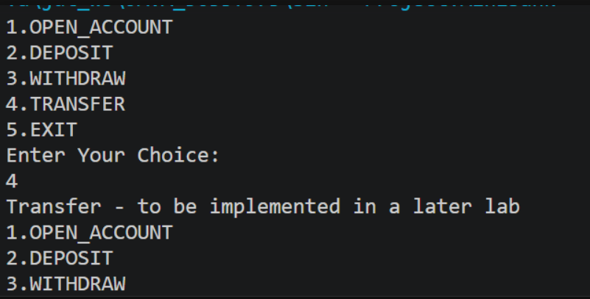

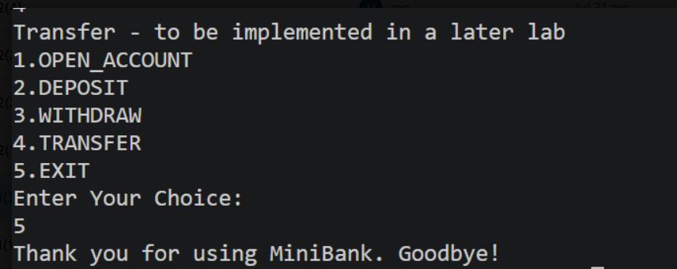

Key Question Answer:
- What is the role of the JVM, and what file does the javac compiler produce?
The JVM (Java Virtual Machine) runs Java bytecode and makes Java platform-independent.
The javac compiler converts .java source code into a .class bytecode file.

- How does a switch expression differ from a traditional switch statement?
A switch expression returns a value and can use yield, while a traditional switch statement mainly performs actions and does not directly return a value.
In short: Switch expression = returns a value; switch statement = performs actions.
3. Why is an enum a good choice for a fixed set of menu options, and a record for read-only
data?
An enum is good for a fixed set of menu options because it allows only predefined values.
A record is good for read-only data because it automatically provides final fields, constructor, getters, equals(), hashCode(), and toString().

Conclusion: -
In this practical we can understand the concept of enum, switch and class.

