Practical-2:
Part-A:
Problem 1: - Smart thermostat: -
import java.util.Scanner;
class Temprature {
private String location;
private int temprature;
private static final int MIN = 16;
private static final int MAX = 30;
private static int activeCount = 0;

Temprature(String location, int statrtTemp) {
this.location=location;
if (statrtTemp>= MIN && statrtTemp<= MAX) {
temprature=statrtTemp ;
} else {
temprature= 22;
}
activeCount++;
}

Temprature(String l){
this(l,22);
}

void raise() {
if (temprature< MAX) {
temprature++;
} else {
System.out.println("Already at maximum(30)");
}
}

void lower() {
if (temprature> MIN) {
temprature--;
} else {
System.out.println("Already at minimun(16)");
}
}

int getTemprature() {
return temprature;
}

static int getActiveCount() {
return activeCount;
}
}

public class Thermostat {
public static void main(String [] args) {
Temprature t1 = new Temprature("Hotel");
Temprature t2 = new Temprature("Office", 25);
for (int i = 0; i < 10; i++) {
t1.raise();
System.out.println(t1.getTemprature());
}
for (int i = 0; i < 20; i++) {
t1.lower();
System.out.println(t1.getTemprature());
}
System.out.println("Active Count = " + Temprature.getActiveCount());
}
}
OUTPUT: 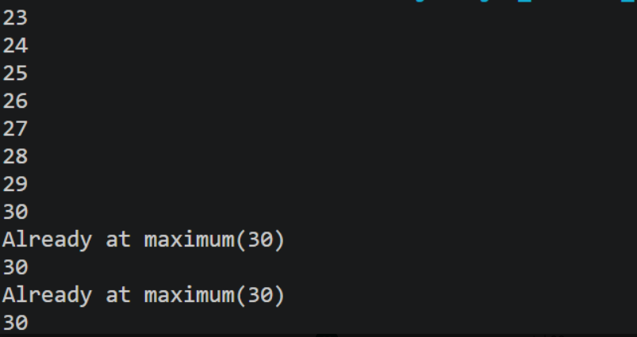 -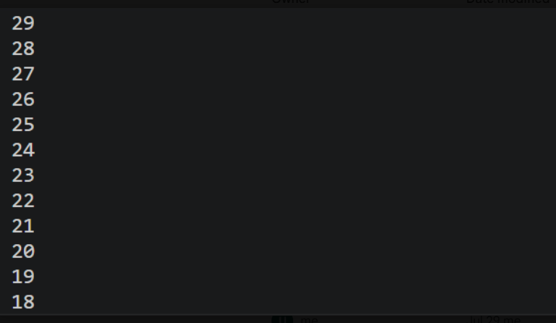
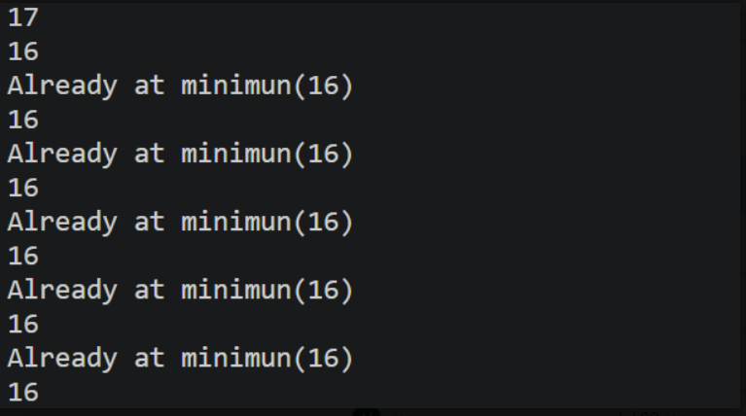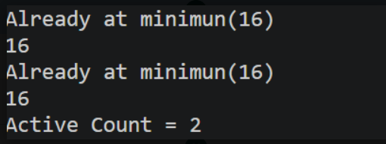
Problem 2: - Toll booth: -
(a) Create class CinemaShow with private String title, private int seatsAvailable, private
final int capacity, and private static int totalBooked=0.
(b) Constructor(title, capacity): set both and seatsAvailable = capacity.
Constructor(title): chain with this(title, 100).
(c) book(int n): if n ≤ seatsAvailable, reduce seatsAvailable by n, add n to totalBooked,
return true; else return false unchanged.
(d) cancel(int n): increase seatsAvailable by n but never above capacity.
(e) Add getSeatsAvailable() and static getTotalBooked().
(f) In main: run a sequence of book and cancel calls, printing the result and seats after
each, then print getTotalBooked().
Solution: -
import java.util.Scanner;

class Booking {
private String title;
private int Seatavailable;
private final int capacity;
private static int totalBooked = 0;

Booking(String title, int capacity) {
this.title = title;
this.Seatavailable = capacity;
this.capacity=capacity;
totalBooked++;
}

Booking(String title) {
this(title, 100);
}

boolean book(int n) {
if (n <= Seatavailable) {
Seatavailable -= n;
totalBooked += n;
return true;
} else {
return false;
}
}

void cancel(int n) {
Seatavailable += n;
if (Seatavailable>capacity) {
Seatavailable=capacity;
}
}

int getSeatsAvailable() {
return Seatavailable;
}

static int getTotalBooked() {
return totalBooked;
}
}

public class CinameShow {
public static void main(String[] args) {
Booking b1 = new Booking("Kalki2");
Booking b2 = new Booking("Kalki", 150);
System.out.println("Book 30 seats: " + b1.book(30));
System.out.println("Seats Available: " + b1.getSeatsAvailable());

System.out.println("Book 80 seats: " + b1.book(80));
System.out.println("Seats Available: " + b1.getSeatsAvailable());

b1.cancel(20);
System.out.println("After Cancel 20 Seats: " + b1.getSeatsAvailable());

System.out.println("Book 50 seats: " + b2.book(50));
System.out.println("Seats Available: " + b2.getSeatsAvailable());

System.out.println("Total Booked Seats: " + Booking.getTotalBooked());
}
}
OUTPUT: -
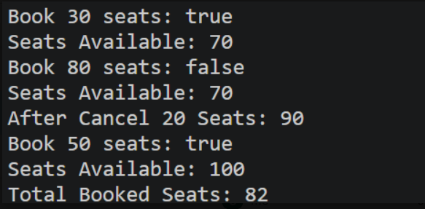

Part-B: -
Problem: - In Practical 1 you built the empty menu shell. Now you create the data the bank works on —
the Customer and Account classes. Using encapsulation, an account’s balance can change
only through deposit() and withdraw(), never directly. These two classes are the foundation every later lab extends.
1. Create a class named Customer with private fields name, email and mobile (all String) and a private final field customerId (String). Use a private static long field
customerCounter and a private static method generateCustomerId() to create ids such as
“CUST101”. Add a constructor and public getter methods.
2. Create a class named Account with private fields: a final String accountNumber, a String ownerName, a long balance (whole rupees) and a boolean active. Generate accountNumber with a private static counter (for example “AC0001”).
3. Add two constructors to Account: one taking ownerName and an opening balance; one taking only ownerName that calls the first using this(ownerName, 0).
4. Add a public method deposit(long amount) that adds amount to balance. Add a public method withdraw(long amount) that subtracts amount and returns true when the balance
is sufficient, otherwise returns false without changing the balance. Add getter methods.
Do NOT add a public setter for balance.
5. In main, create three Account objects inside an Account[] array, perform a few deposits and withdrawals, and print each balance.
Solution: -
package Project;

import java.util.Scanner;

class Customer {

private String name;
private String email;
private String mobile;
private final String customerId;

private static long customerCounter = 101;

private static String generateCustomerId() {
return "CUST" + customerCounter++;
}

public Customer(String name, String email, String mobile) {
this.name = name;
this.email = email;
this.mobile = mobile;
this.customerId = generateCustomerId();
}

public String getName() {
return name;
}

public String getEmail() {
return email;
}

public String getMobile() {
return mobile;
}

public String getCustomerId() {
return customerId;
}
}

class Account {

private final String accountNumber;
private String ownerName;
private long balance;
private boolean active;

private static int accountCounter = 1;

private static String generateAccountNumber() {
return String.format("AC%04d", accountCounter++);
}

public Account(String ownerName, long balance) {
this.ownerName = ownerName;
this.balance = balance;
this.active = true;
this.accountNumber = generateAccountNumber();
}

public Account(String ownerName) {
this(ownerName, 0);
}

public void deposit(long amount) {
balance += amount;
}

public boolean withdraw(long amount) {
if (amount <= balance) {
balance -= amount;
return true;
}
return false;
}

public String getAccountNumber() {
return accountNumber;
}

public String getOwnerName() {
return ownerName;
}

public long getBalance() {
return balance;
}

public boolean isActive() {
return active;
}
}
public class Minibank {
record BankInfo(String name, String branch) {
};

enum MenuOption{
OPEN_ACCOUNT,
DEPOSIT,
WITHDRAW,
TRANSFER,
EXIT
}

public static void main(String[] args){
Scanner scanner=new Scanner(System.in);
int choice;
BankInfo bank=new BankInfo("SBI", "Botadbank");
do{

System.out.println("1.OPEN_ACCOUNT");
System.out.println("2.DEPOSIT");
System.out.println("3.WITHDRAW");
System.out.println("4.TRANSFER");
System.out.println("5.EXIT");

System.out.println("Enter Your Choice: ");
choice=scanner.nextInt();
MenuOption option=switch(choice){
case 1->MenuOption.OPEN_ACCOUNT;
case 2->MenuOption.DEPOSIT;
case 3->MenuOption.WITHDRAW;
case 4->MenuOption.TRANSFER;
case 5->MenuOption.EXIT;
default->null;
};
if(option==null){
System.out.println("Invalid choice.Please enter a choice between 1 and 5");
}

switch (option){
case OPEN_ACCOUNT -> {

Customer c1 = new Customer("Uzair", "uzair@gmail.com", "9876543210");
Customer c2 = new Customer("Ali", "ali@gmail.com", "9999999999");
Customer c3 = new Customer("Ahmed", "ahmed@gmail.com", "8888888888");

Account[] accounts = new Account[3];

accounts[0] = new Account(c1.getName(), 1000);
accounts[1] = new Account(c2.getName());
accounts[2] = new Account(c3.getName(), 500);

accounts[0].deposit(500);
accounts[0].withdraw(200);

accounts[1].deposit(1000);
accounts[1].withdraw(300);

accounts[2].withdraw(600);
accounts[2].deposit(200);

System.out.println("\nAccount Details");

for (int i = 0; i < accounts.length; i++) {

System.out.println("Customer ID : " +
(i == 0 ? c1.getCustomerId()
: i == 1 ? c2.getCustomerId()
: c3.getCustomerId()));

System.out.println("Owner: " + accounts[i].getOwnerName());
System.out.println("Account No.: "+ accounts[i].getAccountNumber());
System.out.println("Balance: "+accounts[i].getBalance());
System.out.println("Active: "+accounts[i].isActive());
System.out.println();
}
}
case DEPOSIT->
System.out.println("Deposit - to be implemented in a later lab");
case WITHDRAW->
System.out.println("Withdraw - to be implemented in a later lab");
case TRANSFER->
System.out.println("Transfer - to be implemented in a later lab");
case EXIT->
System.out.println("Thank you for using MiniBank. Goodbye!");
}
}while(choice!=5);
scanner.close();
}
}
OUTPUT: -
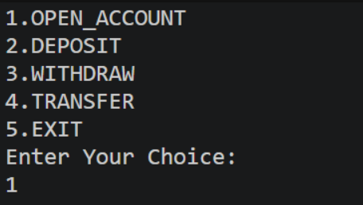
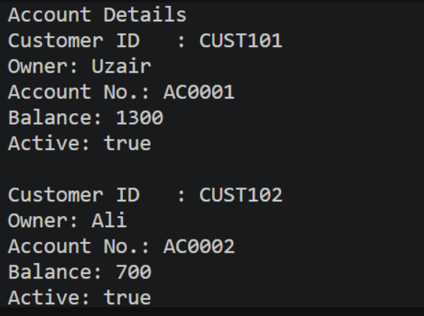
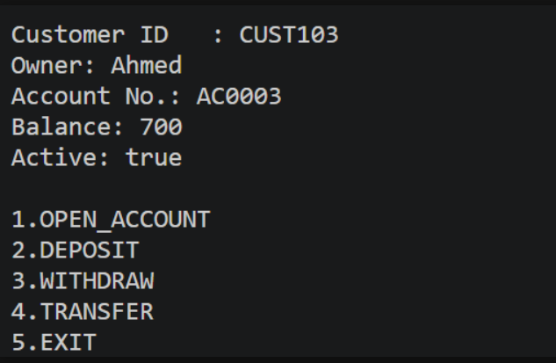

Key Question Answer:
- What is encapsulation, and how do private fields with public getters enforce it?
Encapsulation means hiding an object's internal data and controlling access to it. Private fields prevent direct access, while public getters provide controlled access to their values.
- Why is accountNumber declared final?
accountNumber is declared final because it should not change after the account is created. This ensures the account has a unique and permanent identity.
- What is the difference between a static field and an instance field when generating ids?
A static field is shared by all objects, so it can generate a unique ID sequence for every object. An instance field belongs to each object separately, so each object has its own value.

Conclusion: -
In this Practical we can learn the concept of constructor.

