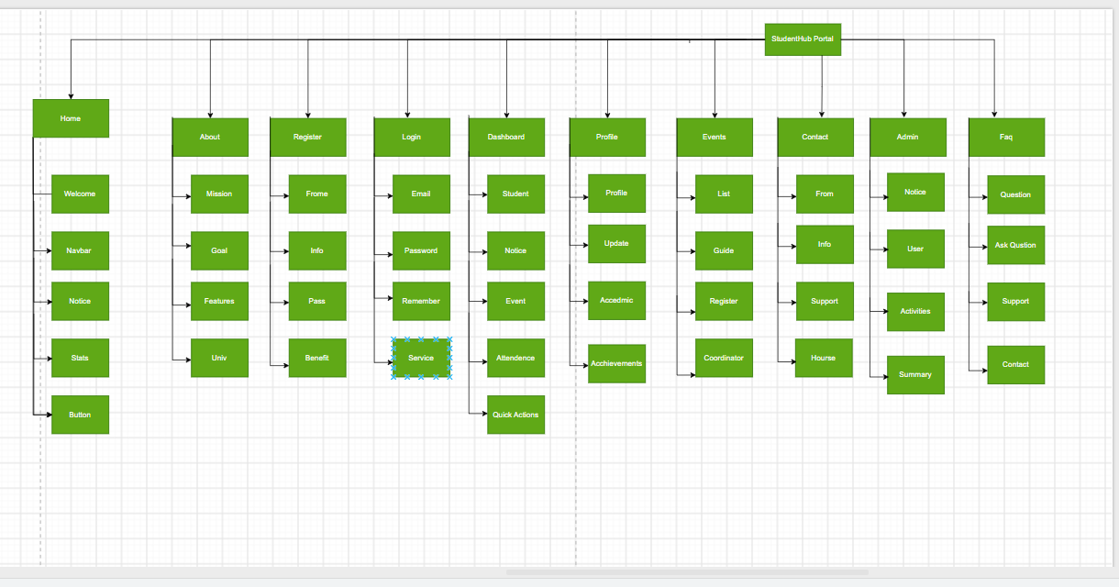
Figure 1-Sitemap

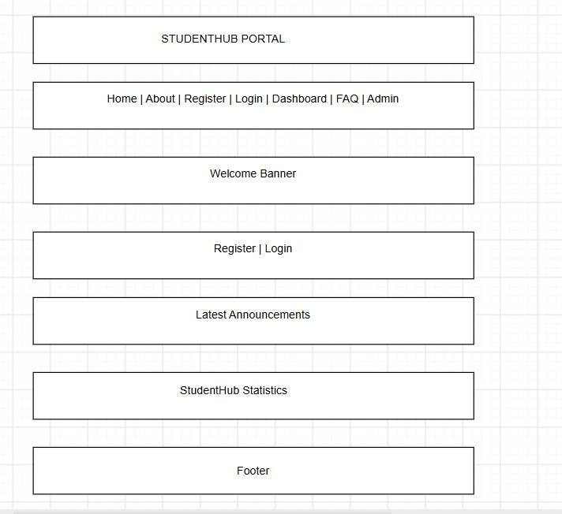
Figure 2-Wire Frame for Homepage

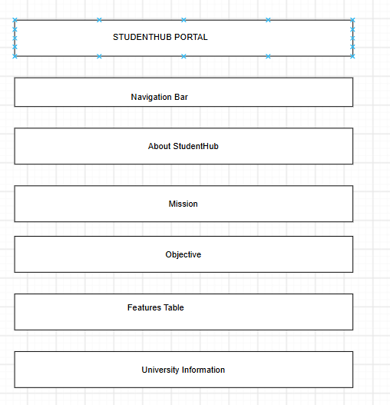
Figure 3-Wire Frame for Aboutpage

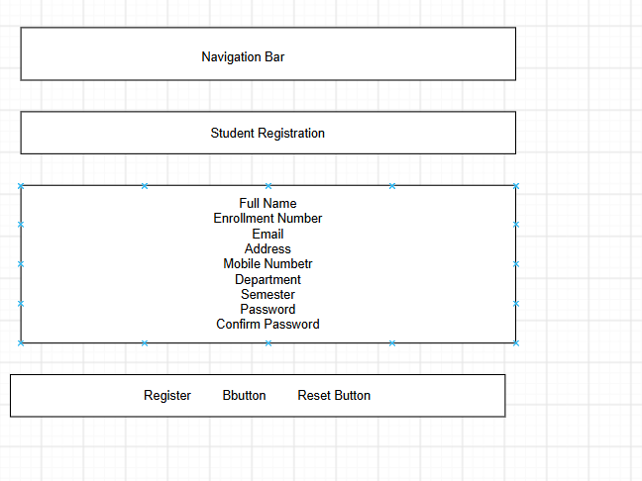
Figure 4-Wire Frame for Register page
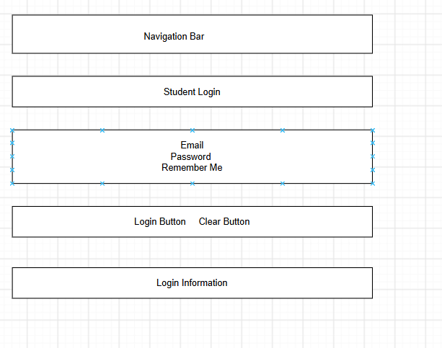
Figure 5-Wire Frame for Login Page
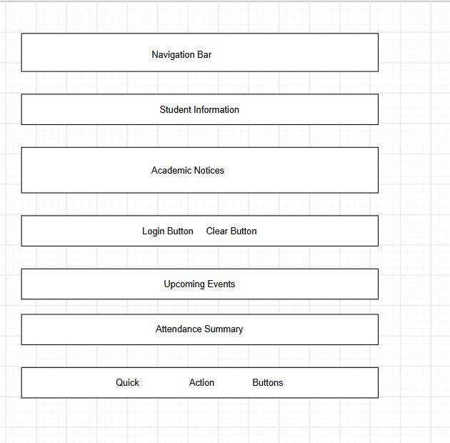
Figure 6-Wire Frame for Dashboard
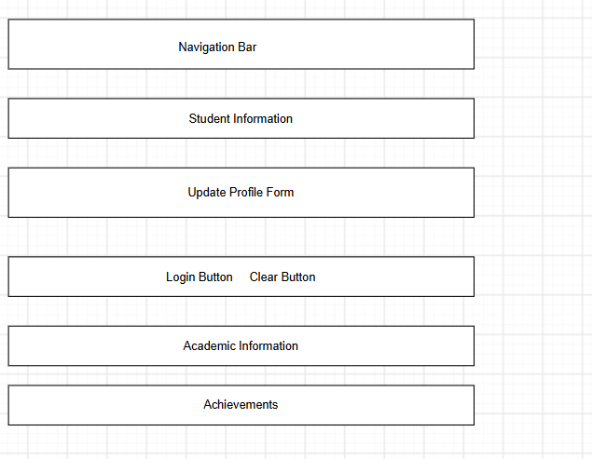
Figure 7-Wire Frame for Event Page
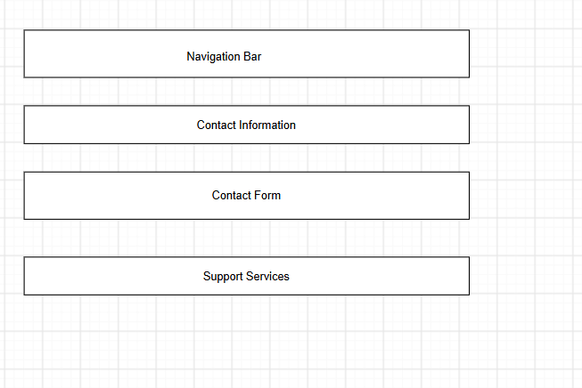
Figure 8-Wire Frame for Profile Page

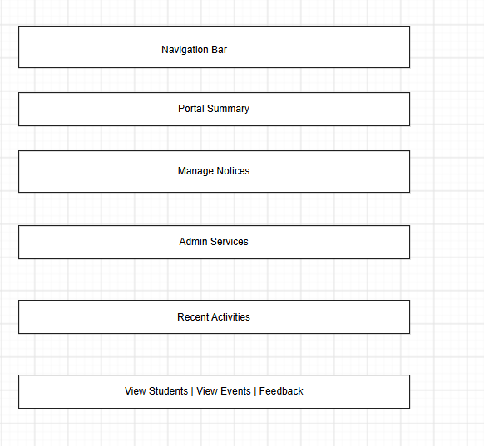
Figure 9-Wire Frame for Contact Page
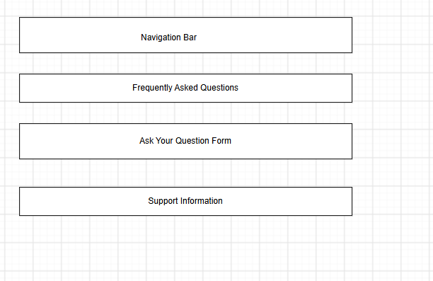
Figure 10-Wire Frame for FAQ Page

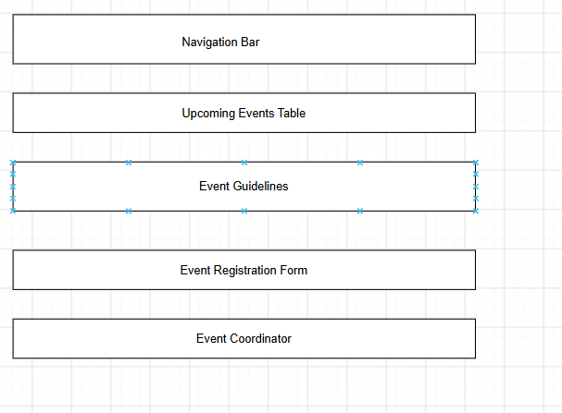
Figure 11-Wire Frame for Admin Page

