# Introduction

This project will be a continuation of earlier rateMyLab work by the School of Computing: it would allow for further development of an app for Android tablets that would be placed in student labs/lecture theatres to gather from students: (1) end-of-class ratings; (2) text comments; (3) (possibly) attendance information.

The project will also provide a system which will allow for analysis of the feedback data (e.g. for particular lecturers, modules, etc.), which will be stored in a server-side database. The system will be accessible to all lecturers for their relevant classes and modules.

Throughout this project, the end user is to be the focal point. Various user-centred design techniques and strategies will be used, including rapid prototyping and user profiling. User testing will be thorough, with the app being tested in the end user environment (i.e. in a lab/lecture) in order to ensure that feedback is as relevant as possible.

# Background

Student feedback is an important tool that benefits all contributors to a lecture or lab class: (i) giving students a mechanism to report their assessment of the class in question and thereby influence related classes and (ii) helping lecturers to identify and tackle issues experienced by their students and thereby subsequently develop the curriculum accordingly (Johnson, 2009).

There is an already existing app (rateMyLab), developed by the School of Computing, which aimed to provide a mechanism for obtaining such feedback, but it needed improvement – although it was simple and quick to use, the feedback it obtained was seriously lacking in detail (it allowed users to specify whether a lab was good, bad or average – without specifying *why*). This problem is what we aim to solve with this new phase of development. The aim is to provide a mechanism which allows for richer feedback, whilst maintaining the simplicity and accessibility of the original rateMyLab app.

### Previous Work

On a more global scale, there has been similar work done in the form of Classroom Communication Systems (CCS). These systems have evolved, from being based on multiple-choice remote controls and then PDAs, to the more modern medium of Tablet PCs with wireless connectivity, the idea being that every student in a lab/lecture has one of these devices, and they are all connected through the medium of the CCS. These systems are very useful for bringing classes together in a collaborative effort, giving the mechanism for feedback and allowing for live in-class polling, and demonstration of both good and bad examples and scenarios. Group work is also made much easier as student do not have to physically move around to work together. (Theys, Lawless, & George, 2005)

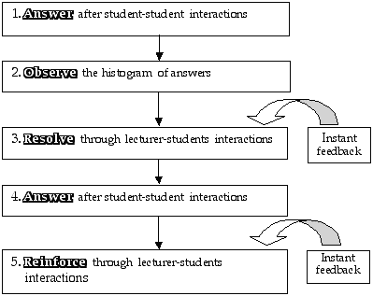

Figure 1: A schematic of the learning cycle used with the CCS

The main difference between rateMyClass and the traditional CCS is that, while CCS’s are more geared towards live feedback and dynamic lecture content (with increased student engagement the priority) (Dufresne, Gerace, Leonard, Mestre, & Wenk, 1996, p. 2), rateMyClass is a more static, narrowly-focused mechanism, with feedback being given only after the conclusion of classes; the main rationale being that lecturers can gain valuable insight which allows them to make improvements to these classes. The rateMyClass app is primarily for the benefit of lecturers, unlike the CCS.

Another similar piece of work involves the use of augmented reality (AR) systems (e.g. Google Glass) to provide lecturers with live feedback from students in a seamless fashion, through the use of various visualisations.

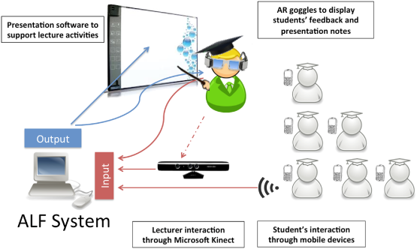

Figure 2: Architecture of the proposed 'augmented reality feedback system' (ALFs)

The proposed benefits of such a system would include the fact that such a system would avoid breaking the ‘flow’ of lectures, which often occurs when lecturers have to directly communicate with and ask questions of students, and that it encourages more students to give feedback by keeping their anonymity, removing the need for them to speak up in class (Zarraonandia, Aedo, Díaz, & Montero, 2013).

Additionally, there has been development of a smart phone app which allows student to check in to class and leave feedback (Foth, Fitz-Walter, Ti, Russell-Bennett, & Kuhn, 2012).

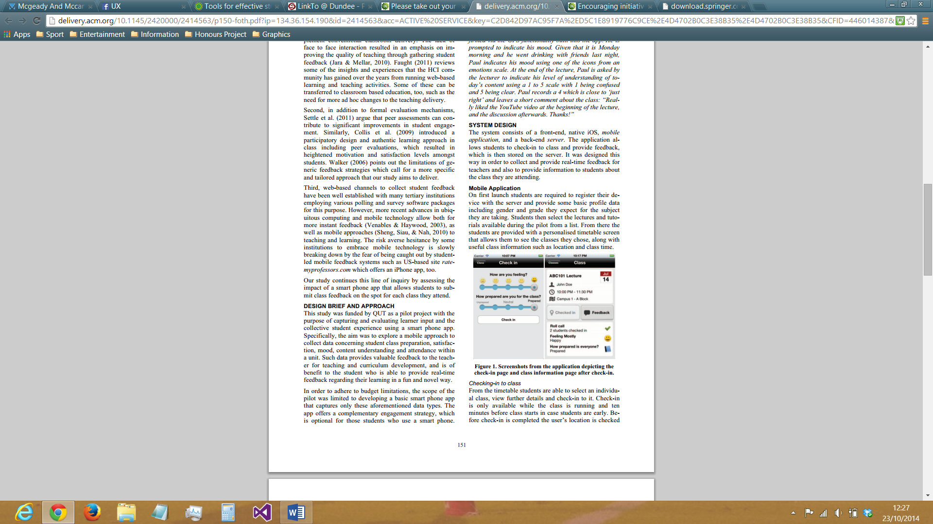

Figure 3: Screenshots from the app depicting the check-in page and class information page after check-in.

This app provides the following functionality:

* Checking-in to class
  + Students are able to select a class from a list of classes and ‘check-in’ to it. This can only be done during the class (and 10 minutes before it starts). GPS is used to check that students are actually physically present at the class. Students can provide initial feedback as to ‘how they are feeling’ (ranging from bad to very unhappy (smiley) to very happy (smiley)) and ‘how prepared they are for class’ (ranging from ‘Unprepared’ to ‘Prepared’)
* Revealing feedback from other students
  + As soon as students ‘check-in’, they can view certain collective items of information about the other students who have also done so. For example, the total number of students who are checked in, and the average levels of happiness and preparedness of the class.
* Providing class feedback
  + Final class feedback can be given by student in the form of two 5-point Likert scales, one rating the class in general and the other rating how well they understood the information given in the class. Students are sent reminders 10 minutes before the class ends in order to make sure none of them forgets to give feedback

As regards tablet-based systems which more closely mirror the functionality, architecture and rationale of rateMyClass, there are no doubt many real-world examples, but, in terms of documented commercial solutions, it appears there are no systems which are really comparable.*

*Searches were made across Google Scholar, Dundee University Library and ACM Digital Library

# Specification

# Design

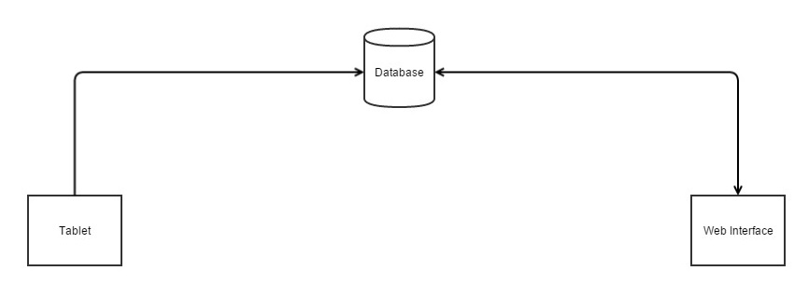

Figure 4: Architecture of the rateMyClass system

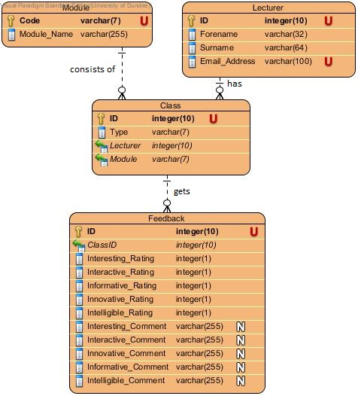

Figure 5: Entity-Relationship Model of the rateMyClass database

# Implementation and Testing

# Evaluation

### 6.1

### 6.2

Etc

# Summary and Conclusions

# Acknowledgements

# References

Dufresne, R. J., Gerace, W. J., Leonard, W. J., Mestre, J. P., & Wenk, L. (1996). Classtalk: A Classroom Communication System for Active Learning. *Journal of Computing in Higher Education*, 3-47.

Foth, M., Fitz-Walter, Z., Ti, J., Russell-Bennett, R., & Kuhn, K.-A. (2012). Please Take Out Your Phones: On the Spot Solicitation of Student Feedback in Class . *Proceedings of the 24th Australian Computer-Human Interaction Conference* (pp. 150-153). Melbourne: ACM.

Johnson, B. (2009, February 3). *Student Feedback Helps Teachers Grow*. Retrieved from eduTopia: http://www.edutopia.org/student-feedback-accountability-teachers

Theys, M. D., Lawless, K., & George, S. (2005). Tablet computers and the traditional lecture. *Frontiers in Education, 2005. FIE '05. Proceedings 35th Annual Conference* (pp. T2G-7). Indianapolis, IN: IEEE.

Zarraonandia, T., Aedo, I., Díaz, P., & Montero, A. (2013). An augmented lecture feedback system to support learner and teacher communication. *British Journal of Educational Technology*, 616-628.

# Appendices