**What is Covariance?**

In mathematics and [statistics](https://corporatefinanceinstitute.com/resources/knowledge/basic-statistics-concepts/), covariance is a measure of the relationship between two random variables. The metric evaluates how much – to what extent – the variables change together. In other words, it is essentially a measure of the variance between two variables (note that the variance of one variable equals the variance of the other variable). However, the metric does not assess the dependency between variables.

Unlike the correlation coefficient, covariance is measured in units. The units are computed by multiplying the units of the two variables. The variance can take any positive or negative values. The values are interpreted as follows:

* **Positive covariance**: Indicates that two variables tend to move in the same direction.
* **Negative covariance**: Reveals that two variables tend to move in inverse directions.

In [finance](https://corporatefinanceinstitute.com/resources/knowledge/finance/), the concept is primarily used in portfolio theory. One of its most common applications in portfolio theory is the [diversification](https://corporatefinanceinstitute.com/resources/knowledge/strategy/diversification/) method, using the covariance between assets in a portfolio. By choosing assets that do not exhibit a high positive covariance with each other, the undiversifiable risk can be partially eliminated.

CFI’s [**Math for Corporate Finance Course**](https://courses.corporatefinanceinstitute.com/courses/financial-math-corporate-finance)explores the financial mathematics concepts required for [Financial Modeling.](https://corporatefinanceinstitute.com/resources/knowledge/modeling/what-is-financial-modeling/)

**Formula for Covariance**

The covariance formula is similar to the formula for correlation and deals with the calculation of data points from the average value in a dataset. For example, the covariance between two random variables X and Y can be calculated using the following formula (for population):

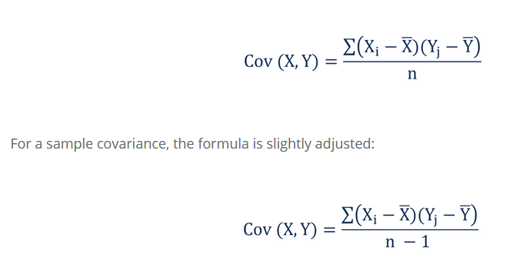

Where:

* **Xi**– the values of the X-variable
* **Yj**– the values of the Y-variable
* **X̄**– the mean (average) of the X-variable
* **Ȳ** – the mean (average) of the Y-variable
* **n** – the number of the data points

**Covariance vs. Correlation**

Covariance and correlation both primarily assess the relationship between variables. The closest analogy to the relationship between them is the relationship between the variance and [standard deviation](https://corporatefinanceinstitute.com/resources/knowledge/standard-deviation/).

**Covariance** measures the total variation of two random variables from their expected values. Using covariance, we can only gauge the direction of the relationship (whether the variables tend to move in tandem or show an inverse relationship). However, it does not indicate the strength of the relationship, nor the dependency between the variables.

On the other hand, **correlation** measures the strength of the relationship between variables. Correlation is the scaled measure of covariance. It is dimensionless. In other words, the correlation coefficient is always a pure value and not measured in any units.

The relationship between the two concepts can be expressed using the formula below:

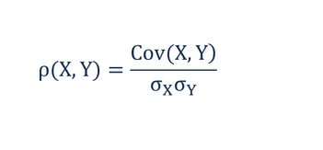

Where:

* **ρ(X,Y)** – the correlation between the variables X and Y
* **Cov(X,Y)** – the covariance between the variables X and Y
* **σX**– the standard deviation of the X-variable
* **σY**– the standard deviation of the Y-variable