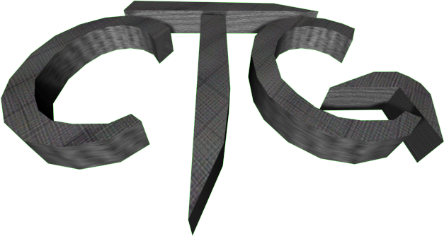
By Michael Henson
and Friends

Document Version 1.1

Game Design Document

Modification History
Version | Remarks
1.0 | Initial draft.
1.1 | Minor corrections.

Introduction
CTG is the demolition derby of the future! Players select from a variety of futuristic hovercraft armed with laser cannons and missile launchers and enter tournaments to win the money they need to upgrade the craft.
This game is not a new idea, nor was it ever very original. The basic gameplay was inspired by simple, old-school classics like Space War and Combat. The tournament and upgrade concepts were inspired by games like Scorched Earth and One Must Fall. In truth, CTG is simply a combination of elements from several past games that I have enjoyed.

User Interface

Screens
Main Menu
- Game logo
- Start button
- Exit button
Vehicle Selector
- Vehicle image
- Next Vehicle button
- Previous Vehicle button
- Vehicle stats: Speed, Agility, Armor
Parts Shop
- Player Name
- Player Budget
- Current vehicle stats
- Upgrade Vehicle Speed button
- Upgrade Armor button
- Upgrade Laser Fire Rate button
- Upgrade Laser Power Button
- Upgrade Missile Capacity button
- Upgrade Missile Payload button
Game Screen
- Game view
- HUD and scoreboard
Standings Screen
- Players ranked by wins, then by points
- Continue button
- Quit button

HUD
- Round number
- Data for each player:
  - Vehicle icon
  - Name
  - Score
  - Armor (HP)
  - Missiles remaining

Game Play Controls
Action | Player 1 Control | Player 2 Control
Move | W | Up arrow
Turn Right | D | Right arrow
Turn Left | A | Left arrow
Fire Lasers | Tab | Enter
Launch Missile | ~ | Backspace

Scoring
In this game, points are money. They can be spent between rounds to upgrade various attributes of the player’s vehicle.
Event | Point Value
Damage another player’s vehicle | 1 point per unit of damage dealt
Destroy another player’s vehicle | 10 points
Your vehicle gets destroyed | 25 points
Pick up random scrap on field | Random value (1-5 points)

Vehicles
 | Vehicle Name | Speed Class | Agility Class | Armor Class
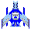 | Classic Blue | 6 | 6 | 6
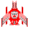 | Classic Red | 6 | 6 | 6
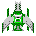 | Classic Green | 6 | 6 | 6
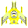 | Classic Yellow | 6 | 6 | 6
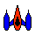 | Arrow | 10 | 7 | 1
 | B.G.M. | 1 | 7 | 10
 | Dart | 5 | 5 | 8
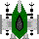 | Model E | 2 | 9 | 7
 | Interceptor | 8 | 3 | 7
 | Luna | 9 | 7 | 2
 | Parhelia | 4 | 5 | 9
 | Star Warrior | 7 | 7 | 4
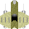 | Terra | 3 | 6 | 9

Weapons
There are two categories of weapons: Lasers and Warheads

Lasers
Lasers are the basic weapons. They have unlimited ammunition and are governed by the following properties.
Property | Effect | Minimum Value | Maximum Value
Damage | Number of hit points taken by a vehicle hit by the beam. | 1 | Unlimited
Firing Rate | Delay between shots fired | 1 | 20

Warheads
Warheads are not automatically loaded into a vehicle. Instead, they must be purchased. Warheads are governed by the following properties.
Property | Effect | Minimum Value | Maximum Value
Direct Damage | Number of hit points taken from a vehicle hit directly by the warhead. | 4 | Unlimited
Radius Damage | Amount of damage taken by a vehicle in the blast radius (always half of direct damage) | 2 | Unlimited
Blast Radius | Distance away from center of explosion where vehicles still take damage. | 0 | 40
Capacity | Number of warheads that can be loaded onto a vehicle | 3 | Unlimited

Upgrades
Before each round, players can purchase the following upgrades to increase the attributes of their equipment.
- Vehicle speed
- Vehicle agility
- Vehicle armor
- Laser damage
- Laser firing rate
- Warhead damage
- Warhead blast radius
- Warhead capacity

Level Designs
(On paper. Need to be added here.)

