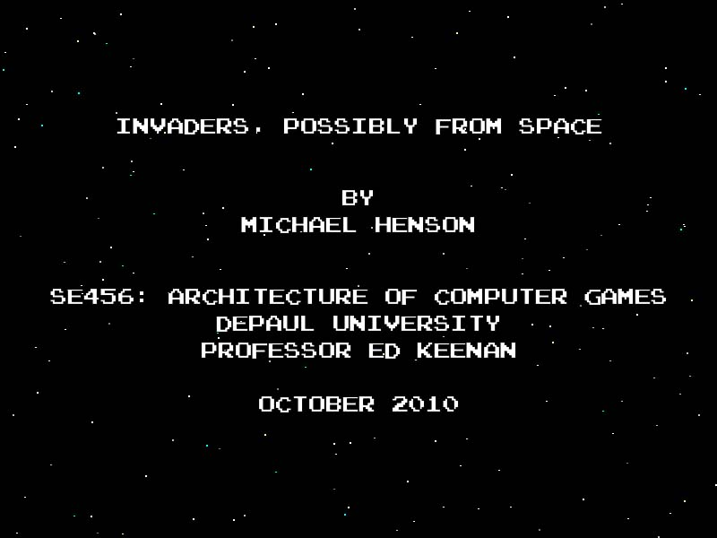

**Game Design Document**

Table of Contents

[Overview 3](#_Toc274418546)

[Rules and Objectives 3](#_Toc274418547)

[Game Play Overview 3](#_Toc274418548)

[Game End 3](#_Toc274418549)

[Scoring 4](#_Toc274418550)

[User Interface and Controls 4](#_Toc274418551)

[Attract Loop Controls 4](#_Toc274418552)

[Game Controls 4](#_Toc274418553)

[HUD 5](#_Toc274418554)

[Multimedia Assets 5](#_Toc274418555)

[Graphics 5](#_Toc274418556)

[Audio 6](#_Toc274418557)

# Overview

*Space Invaders*, originally released in 1979, is a vitally important piece of our history as game developers. It was among the very first games to introduce concepts that later became cliché, such as the idea of waves to gradually increase difficulty, the “three lives” system, and a high score record.

As required by the SE456 assignment, my game will attempt to reproduce the rules, game play, and scoring system of the original *Space Invaders*.

# Rules and Objectives

## Game Play Overview

The player’s avatar is a gun platform that can be moved horizontally across the bottom of the game board. The primary objective of the game is to destroy all of the invaders by firing a projectile at them. The invaders march back and forth in a grid formation, coming slightly closer to the ground with each pass. At the same time, they fire projectiles back at the player’s avatar.

Also in play are three shields between the player avatar and the invaders. Projectiles from both the player and the invaders will destroy the shields in sections, which crumble away and no longer block the projectiles coming through. The shields also crumble when the invaders collide with them.

An optional bonus objective is present in the form of a “mystery ship” UFO that randomly flies across the top of the screen.

## Game End

The game ends under any one of these two conditions:

1. The player runs out of lives from being shot by the invaders.
2. One or more of the invaders reaches the ground.

## C:\Users\Michael\Documents\My Dropbox\Dev\SpaceInvaders\Design\Reference Images\tip_whoswho.gifScoring

Scoring is explained in a “Score Advance Table” that appears as part of the attract loop. The UFO is not given a score value in the attract loop because its point value is randomly selected from a list of 50, 100, 150, and 300. The other three kinds of invaders have point values of 10, 20, and 30 points.

I was unable to find a reference describing at which point value a player wins a free life. In my version, I will set a constant at 1000 points. If I can find the original rule, I will change the value of the constant to match it.

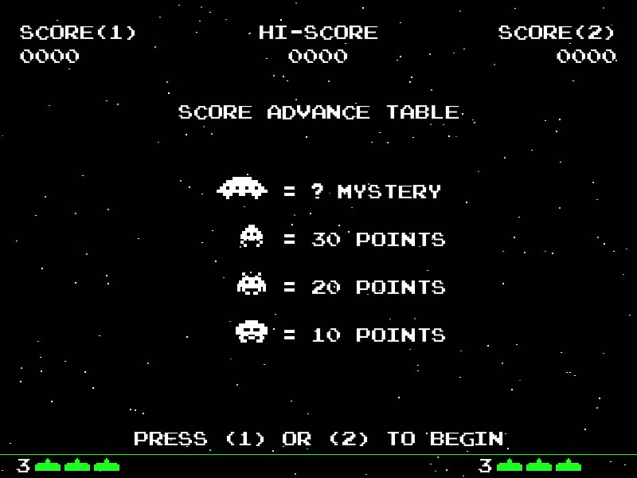

The Score Advance Table as it appears in *Invaders, Possibly From Space*

# User Interface and Controls

|  |  |  |  |  |  |  |  |  |  |  |  |  |  |  |  |  |  |  |  |  |  |  |  |  |
| --- | --- | --- | --- | --- | --- | --- | --- | --- | --- | --- | --- | --- | --- | --- | --- | --- | --- | --- | --- | --- | --- | --- | --- | --- |
| Attract Loop Controls  |  |  | | --- | --- | | **Command** | **Key** | | Begin 1-player game | 1 | | Begin 2-player game | 2 | | Exit program | Escape |  Game Controls  |  |  |  | | --- | --- | --- | | **Command** | **Player 1 Key** | **Player 2 Key** | | Move left | A | Left Arrow | | Move right | D | Right Arrow | | Fire | W | Up Arrow | | Quit game | Escape | Escape | | C:\Users\Michael\Documents\My Dropbox\Dev\SpaceInvaders\Design\ScreenShots\ScreenShotControls.jpg |

## C:\Users\Michael\Documents\My Dropbox\Dev\SpaceInvaders\Design\ScreenShots\ScreenShotGamePlay.jpgHUD

The HUD is straightforward. It shows the current scores for two players, the highest score attained since the program was launched, and the number of lives remaining for each player. One odd thing about the arcade version of *Space Invaders* is that the HUD remains visible through most of the screens in the attract loop. My game will continue the tradition, but I will not display the HUD on the title and credits screen.

Screen shot of game play showing HUD elements.

# Multimedia Assets

There are only brief lists of assets needed for this project. Listed here is an initial brainstorm.

## Graphics

* Player avatar
* Three invader types, two animation frames each.
* Five types of shield bricks
* Player projectile
* Invader projectile
* Mystery ship

## Audio

* Player fires
* Player gets shot
* Alien type 1 fires
* Alien type 2 fires
* Alien type 3 fires
* Alien gets shot
* Shield gets hit
* UFO enters
* UFO gets shot
* Player earns extra life
* New round begins
* Aliens hit ground/Game ends