Uniprocessor Scheduling Simulator

Operating Systems Lab Exercise 4

Skyelar Craver & Steven Pitts

March 26, 2019

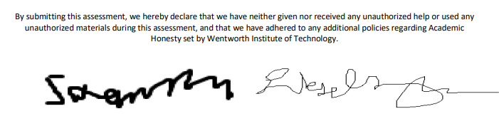

Part 1 FCFS:

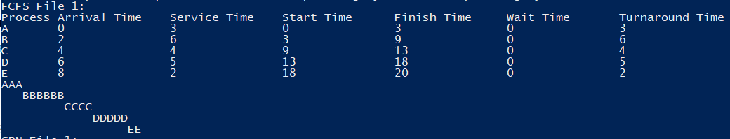

Part 1 SPN:

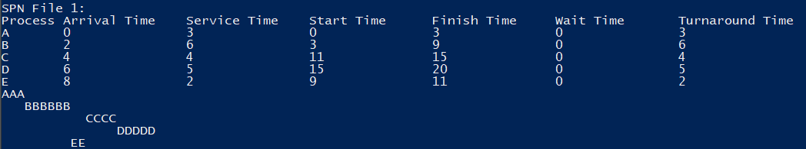

Part 1 SRT:

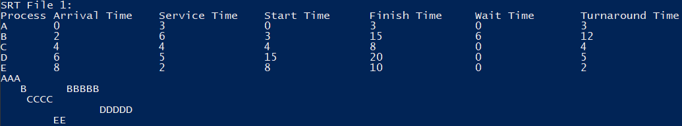

Part 2 FCFS:

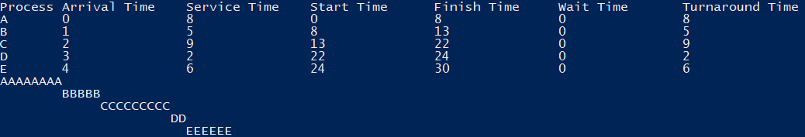

Part 2 SPN:

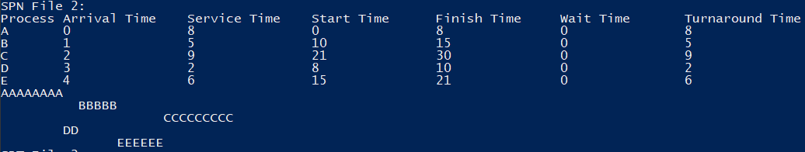

Part 2 SRT:

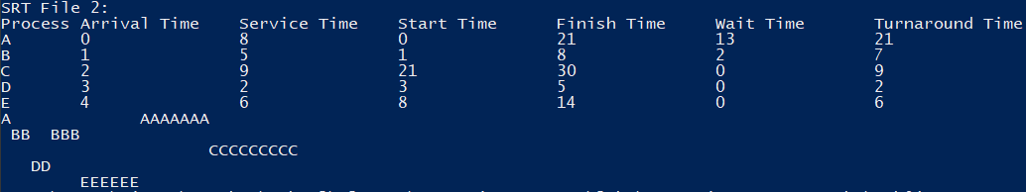

Bonus 2 included in screenshots above, bonus 1 available in code files.

Please note some assumptions were made:  
\*”Turnaround time” describes the time it took from the process to be available to the process to complete

\*”Wait time” describes the turnaround time without the time the process spends running