Comparing experimental and simulation results of Fast Neutron Flux generation, Neutron

Flux moderation and Thermal Neutron Flux Detection utilizing nuclear

electronic equipment(s) versus Monte-Carlo simulation (Geant4)

**Report**

A proportional counter is a gas-filled detector widely used for neutron flux detection. It relies on the gas multiplication to amplify the charge induced by the ionization radiation. In this work, a data acquisition system is constructed using electronic equipment(s) like a high voltage supplier, single channel analyzer and an oscilloscope. Furthermore, a Geant4 toolkit was used to develop a Monte-carol model and simulate a similar configuration to investigate the utilization of a BF3 counter for neutron flux detection. To obtain a thermal neutron flux, a experimental neutron-moderating cell was constructed and a Monte-Carlo model was also developed using Geant4 simulation application. It included Plutonium Beryllium (Pu-Be) for a neutron source, Paraffin blocks for the moderator, and interlocked lead bricks for the outside walls (shielding). A BF3 proportional counter detected the thermal neutron flux beam. The counter’s output was coupled with a high voltage power supply to produce signals which were analyzed by the multi-channel analyzer. This effort characterized a pulse height distribution for 7Li that has a excited state with the probability of occurrence at %94 and about 2.31 MeV and it has a ground state occurring with the probability of %6 percent at about 2.79 MeV. These experimental collected data and the simulated results were in agreement with a 0.1 percent margin of error. Collectively, the hands-on experiment and the Geant4 simulated mode experience with the proportional counter enhanced the understanding of the proportional counters physics, the nuclear physics and Geant4 toolkit.

**Nuclear Electronic Equipment**

BF3 Neutron Counter,

Flow-type proportional counters

P-10 counties gas.

High Voltage Supply

Pre-amplifier (Ortec Model 142)

Amplifier

Single and Multi channel analyzer

Counter

Oscilloscope

Neutron source (Pu-Be).

**Neutron Counting Preparation and Setup**

A neutron-moderating cell was constructed to obtain thermal neutron flux. A generic shape for this experiment is presented in the figure below. A rectangular wall (shield) was built out of lead bricks. A Pu-Be neutron source is place at one end of the cell and a BF3 detector is placed at the opposite end. The cell is then filled with paraffin (moderator) and covered with lead bricks.

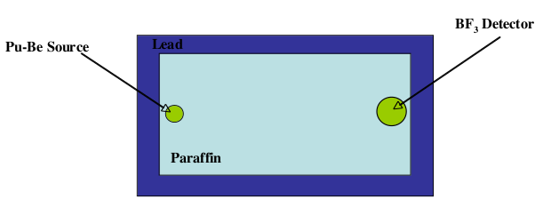

Figure 1: Neutron Moderating Cell

The particular experimental set up for this work is presented in the figure below.

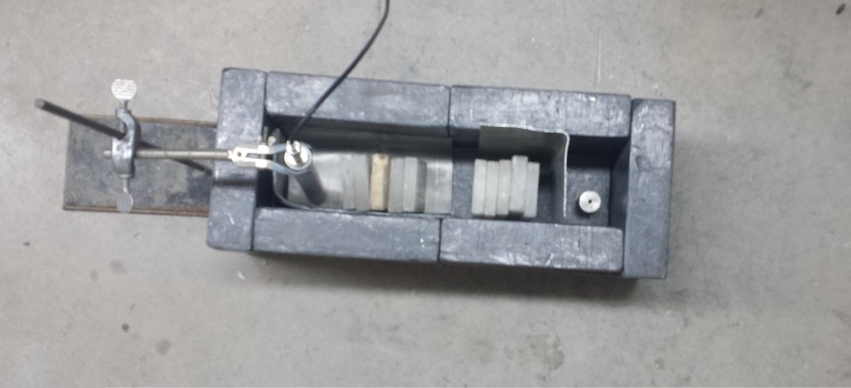

Figure 2: Neutron Moderating Cell experiment

A general nuclear-electronics configuration is presented in the figure below. A BF3 counter is connected to a per-amplifier and amplifier to examine the amplifier output on an oscilloscope. Connected the High Voltage bias supply to counter by amplifier. As the voltage increases the gas multiplication in the counter increases.

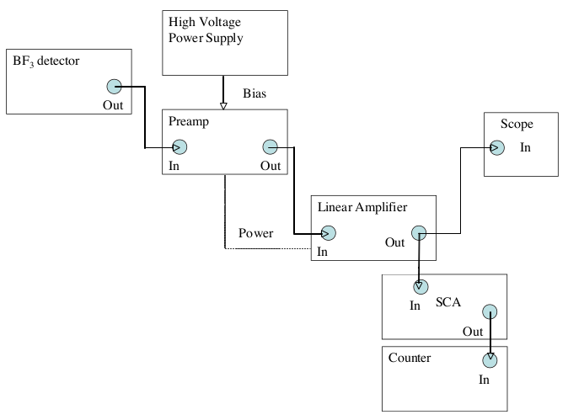

Figure 3: Nuclear Electronic setup

**Governing Mechanism**

**1. Neutron generation**

A plutonium-beryllium (Pu-Be) is a neutron source used for a variety of applications. It produces neutrons through an alpha particle emission reaction where the alpha particle from decaying plutonium interact with beryllium nucleus, causing a nuclear reaction that releases neutrons.

Pu + Be → He + Be → C + n (1)

Kinetic energy of the neutron flux ranges up to 11 MeV with an average energy between 4 and 5 MeV.. Figure below presents the released neutron’s energy distribution.

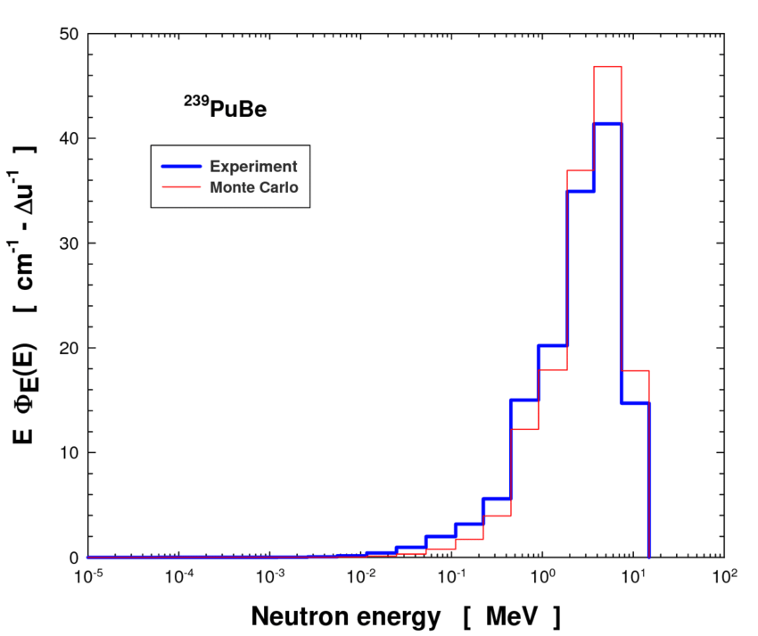

Figure 4: Neutron Energy Distribution

**2. Neutron Moderation**

Neutron moderation is the process of slowing down fast neutrons produced by a fission reaction to thermal energies. Moderators are material that slow down neutrons without capturing them. These materials have specific properties. (1) Low neutron absorption cross-section. The moderator has a low probability of absorbing the incoming neutrons. (2) High neutron scattering cross section: The moderator should slow down the incoming neutrons to a low speed. Paraffin is used as moderator in this particular experiment as it is demonstrated in figure above.

**3. Proportional Counters**

Typical proportional counters are constructed with the cylindrical geometry. The basic element of a proportional counter. The outer cathode must also provide a vacuum-tight enclosure for the fill gas. The output is developed across the load resistance RL. The Gas multiplication requires large values of the electrical field. In this geometry, the electric filed at radius r is given by

g(r) = V / r ln(b/a)

where

V = voltage applied between the anode and cathode

a = anode wire radius

b = cathode inner radius

**4. The 10B(n,alpha) reaction**

Material BF3 is the most popular material used for the conversion of the neutrons into directly detectable particles. The reaction may be written.

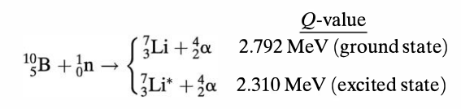

7Li is left either in the ground state or excited state. 94% of all reactions lead to the excited state and only 6% directly to the ground state. In this experiment, the Multi-Channel Analyzer captured the energy deposit in the outer wall of the proportional counter as produced in the figure below.

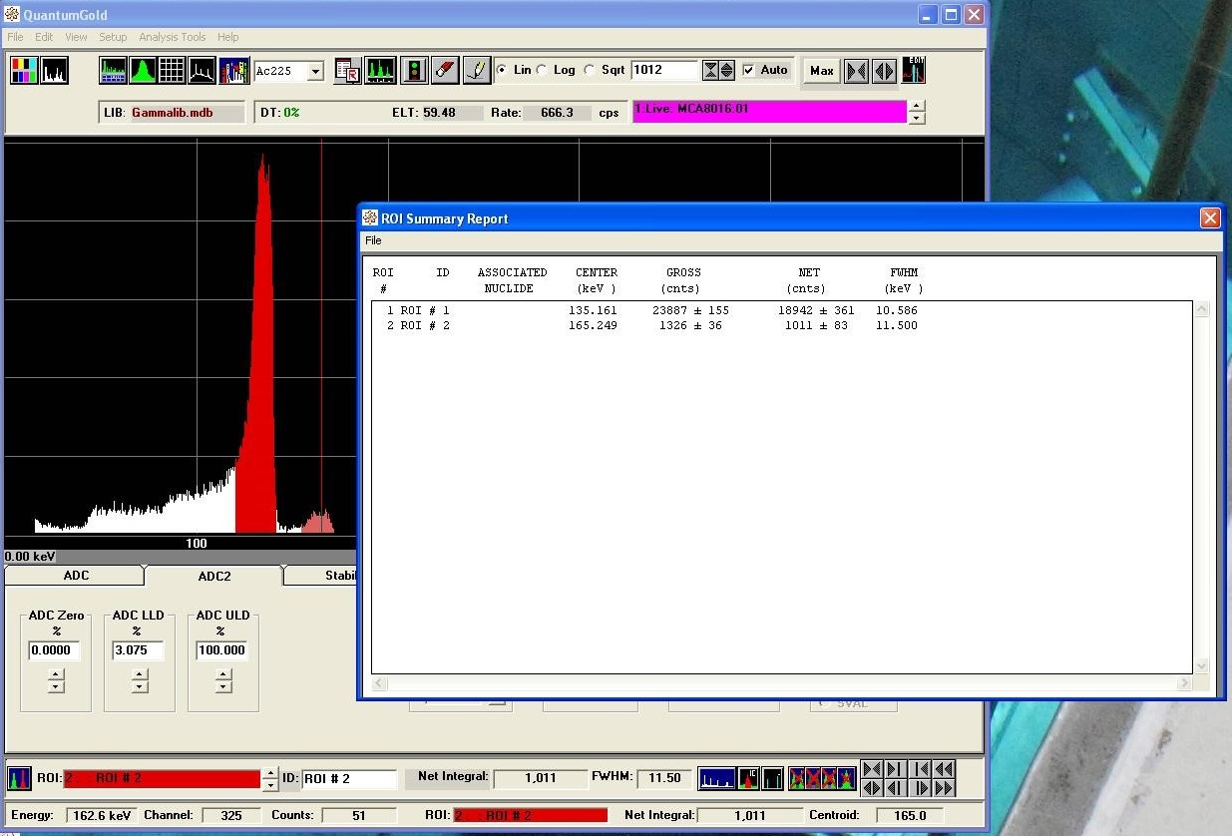

Figure 5: MCA captured BF3’s energy distribution

**5. Monte-Carlo simulation**

In this effort Geant4 version 11.1 toolkit was constructed to develop a simulation applications. This application will follow the ‘run’ methodology delineated in Geant4 architecture. In every run an object of G4Run is created which is the collection of G4Event(s). A single G4Event object is a collection of G4Track(s). A single G4Track is a collection of many G4Stepping(s). Figure below present the geometry of this application where the box in solid blue is the moderator and rectangle in solid red is BF3.

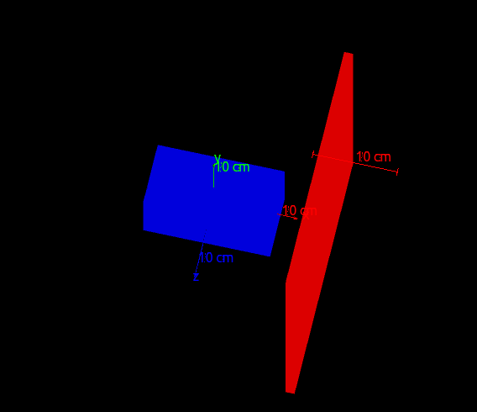

Figure 6: Geant4 Neutron moderation simulation

**6. Simulation Results**

Figure below shows the two peaks for the ground state and excited state of 7Li. The frequency (thermal neutron count) and the Q values (Deposit energy) are within 0.1 percent of the experimental results.

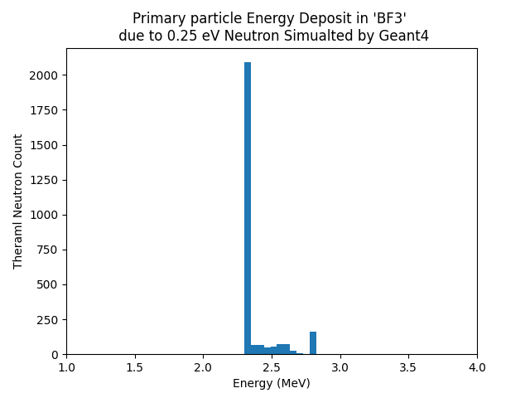

Figure 7: Geant4 BF3’s energy distribution simulation

As the figure below presented the neutron beam starts from the left hand side. It is simulated with G4Gun object and kinetic energy of the neutron beam is simulated to be a normal distribution. The blue box is the moderator where the neutron beam is scattered. Because of the moderation process fast neutrons lose their kinetic energy and eventually enters the thermal neutron energy domain. Some of these neutron find their way to the target BF3 and deposit their energy.

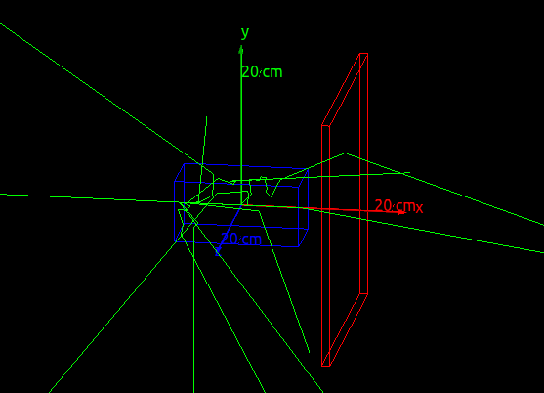

Figure 8: Geant4 Neutron Moderation Simulation

**Conclusion**

Geant4 platform is an exceptionally powerful toolkit to simulate shielding and radiation

experiments in the field of Nuclear Engineering. It provided libraries to generate fast neutron flux, it provides physic list libraries to simulate subatomic particles and relevant processes, it provides libraries to score the energy deposit as sub-atomic particles interact with mater. A thermal neutron detector was was constructed in this scenario. The experimental collected data and the Monte-carol simulated data are in agreement with 0.1 percent margin of error.

Reference:

https://www.researchgate.net/publication/232846058_Spectrometry_and_dosimetry_of_a_neutron_source

Links

[https://geant4.org](https://geant4.org/)