**Simulation of Cherenkov Radiation and**

**Frank and Tamm Equations**

**Utilizing Geant4 Monte Carlo**

**Submitted to**

**TBD**

**By**

**Faramarz Arad**

**Department of TBD Engineering,**

**University of TBD, TBD**

**March 29th, 2023**

**Abstract**

When high-speed charged particles travel in transparent dielectric faster than the speed of light in that medium, Cherenkov radiation phenomena is observed. This effort is intended to simulate the Cherenkov Radiation Phenomena and compare Monte Carlo result against the theoretical explanation given by Frank and Tamm [1]. Monte Carlo simulation is implemented using Geant4 [2] on UNIX/Ubuntu platform. The Cherenkov Radiation Angle and the Photon’s wavelength are simulated and plotted with ROOT tool [3]. The comparison of the simulation results and the theoretical model showed that Geant4 application provides a very accurate approximation for this phenomenon. The margin of error for the Cherenkov radiation approximation is less than 0.3 percent. The photon’s wavelength spectrum simulated and theoretically predicted follow the inverse of the wavelength squared shape. In conclusion, this effort to simulate the phenomena with Geant4 Monte Carlo tool provided a deep understanding on the topic of interaction of ionic radiation with matter (an atom) in dielectric medium.

**Introduction**

The blue colored radiation in an open pool fission reactor is caused by high energy electrons released as the byproduct of a fission nuclear reaction decay. The glow continues after the chain reaction stops and it dims as the shorter-lived product decay. This phenomenon is analogous to the sonic boom which is a sharp sound heard when an object moves faster than speed of sound in air. This phenomenon is named after Soviet physicist Pavel Cherenkov.

**Cherenkov Radiation**

The equations governing the physics of the Cherenkov radiation and Frank and Tamm theoretical model are documented [1]. The photon radiation is emitted in a conical surface with a half angle of $θ$ with equation (1.1) as shown in the figure 2 and figure 3. The angle $θ$ is between the path of the charged particle and the conical surface produced by radiation. The value $β$ is the ratio of particle velocity over the speed of light (v/c) and $n$ is the refractive index of the dielectric medium.

$cos⁡\left(θ\right)=1/{\left(βn\right)}$ (1.1)

The original form of the Frank and Tamm formula can be equivalently written as equation (1.2). The number of photons produced per unit path length and per unit of energy of a charged particle (charge equal to Zq) is given by (1.2). The wavelength of radiated photon is represented by Greek letter $λ$.

$\frac{d^{2}N}{dEdX}≈\frac{2παz^{2}}{λ^{2}}\left(1-\frac{1}{β^{2}n^{2}\left(λ\right)}\right)$ (1.2)

In this effort, equation (1.1) was used to calculate the Cherenkov radiation angle to be 40.42 degrees for a proton traveling with a kinetic energy of 5000 MeV in a dielectric medium with refractive index of 1.3. It is also observed that equation (1.2) has $\frac{1}{λ^{2}}$ characteristics.

**Monte Carlo (Geant4 Simulation)**

Geant4 version 11.1 toolkit was used to simulate the passage of proton through matter [2]. This simulation was based on Mono-energetic Proton Pencil Beam example. The code runs with a single proton of 1.0 GeV, 5.0 GeV, and 10 GeV to produce Cherenkov radiation. The world mater is produced from an air cube. A Cherenkov radiator is constructed by using Aero with refrative index of 1.1, 1.2, and 1.3. The energy and dose are scored using the classes G4userSteppingAction and G4userRunActoin. The proton beams are simulated using G4ParticleGun class. G4EmStandardPhysics and G4OpticalPhysics were selected for the Physics List.

Object of G4Track type and G4StepPoint type provided GetTrack and GetPreStepPoint methods to collect photon positions in the detector grid inside CCherenkSensitiveDetector class. Objects G4UserSteppingAction provided virtual method UserSteppingAction to calculate the photon energy deposit in the radiator grid.

The Cherenkov radiation angle measured to be 41.88 degrees from figure 2 for a proton traveling with the kinetic energy of 5.0 GeV in a dielectric medium with refraction index of 1.3. In addition, the Cherenkov Ring image plotted using ROOT from the data simulated by this effort figure 1. The Frank-Tamm equation is plotted for the data produced by Geant4 simulation run (figure 4).

The Cherenkov radiation simulator application was constructed upon Geant4 version 11.1. The Physics Lists selected are G4EmStandardPhysics, G4OpticalPhysics, radioactiveDecay, since they manage electromagnetic physics, standard electromagnetic process and sentilation optical photons. The primary generators and initial conditions are defined using the G4ParticleGun object. The proton’s kinematics is 5000 MeV with no randomized energy or distribution. The virtual method of ‘construct’ from the G4VUserDetectorConstruction is implemented to define the world material, radiator material, detector material, world logical volume, radiator logical volume and detector logical volume. Figure 5. The virtual method “ProcessHits’ from the G4SensitiveDetecor class is implemented to extract information from the G4Track object. Information like the photon’s position, momentum and wavelength in the sensitive volume figure 6. The G4UserEventAction has a virtual method EndOfEventAction that is implemented. This method is invoked by G4EventManager at the end of event for each event as presented by figure 7. It adds the energy deposit evaluated in the UserSteppingAction method. The G4UserSteppingAction has a virtual method UserSteppingAction that is implemented. This method is invoked at the end of each stepping so the method G4Step’s method named GetTotalEnergyDeposit is invoked to return the energy deposited property of the G4Step object and the EventAction’s add_energy_deposit method is invoked. The UML for this class is presented in figure 8.

**Conclusion**

Comparing the results evaluated using the Geant4 based simulation of Cherenkov radiation vs the theoretical equation reveals that Monte Carlo based approximation provides a very accurate model for this phenomena. This is based a few predictions like the Cherenkov Ring as it is presented in figure 1. The Cherenkov radiation angle simulated is within 0.3 percent of value predicted using the theoretical equation (figure 3). The Frank-Tamm equation predicts the amount of Cherenkov Radiation emitted on a given charged particle moving through a medium predicted is inversely proportional with the of emitted photon’s wavelength squared (figure 4 ).

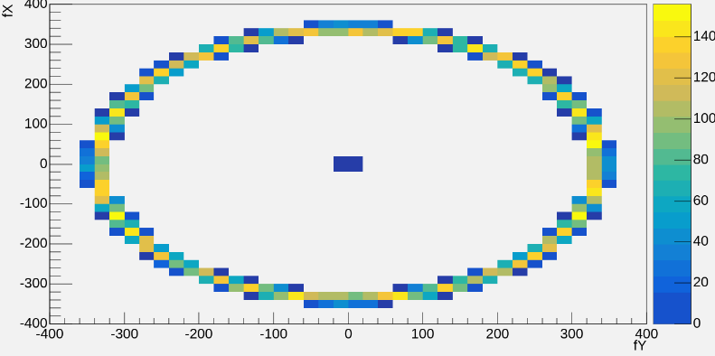

Figure 1: Cherenkov Ring Image Simulated by Geant4

Figure 2: Cherenkov radiation simulated for Dielectric Medium of 1.3 Refraction index.

Figure 3: Cherenkov radiation simulated for a dielectric with refractive index of 1.2

Figure 4: Frank-Tamm equation simulated by Geant4.

Figure 5: UML Class Diagram of Detector Construction

Figure 6: UML Class Diagram of Sensitive Detector

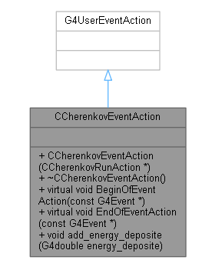

Figure 7: UML Class Diagram of EventAction()

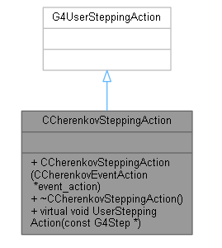

Figure 8: UML Class SteppingAction().

**Reference**

[1] Evans, R. D. (1955). The Atomic Nucleus. TATA McGRAW-Hill Publication. pp. 589.

[2] https://www.geant4.org/

[3] https://root.cern/