**Abstract:**

This effort is intended to simulate a cloud chamber using Geant4 Monte-Carlo Application. These tools are used in experimental particle physics to calculate sub-atomic particle’s properties. To start with, Geant4 basic example (2) is modified to simulate a pencil beam of electrons, negative muons and positive muons at kinetic energy from 1.02 MeV to 25 MeV. A magnetic field of 0.007, 0.035 and 0.2 Tesla is applied causing the charged particle to move in a spiral or circular path. This study demonstrated the charge property along with the charge to mass ration of the three particles. The particle properties are calculated with margin of error 6.0-E7. In conclusion, the electromagnetic field library of Geant4 is an accurate Monte Carlo tool simulating the subatomic particles and their properties with a high degree of accuracy allowing for a deeper understanding of the experimental physics particles.

**Introduction:**

A cloud chamber is a particle detector used for visualizing the passage of ionizing radiation. This sealed environment contains a super-heated vapor of water or alcohol. An energetic charged particle interacts with gaseous mixture by knocking electrons off gas molecules resulting a trial of ionized gas particle.

**Governing Equations:**

The laws of electromagnetism are applied to this Monte-Carlo experiment. The right/left hand magnetic rule helps understand the charge of the particle. The spiral downward represents the negative charge. The spiral upward represents the positive charge. The subatomic particles are very tiny, so the charge to mass ratio is calculated instead of their mass. The magnetic force is equal to centrifugal force (Newtonian physics).

Fm = Bqv = Fc = m v^2 /r (1)

q/m = v / (B r) (2)

where B is magnetic force, q is the electrical charge property, v is the kinetic velocity, m is the mass of the particle and r is the radius of the spiral, c = 3.00*10^8 m/s and 1eV = 1.6*10^-19 J.

**Electron with K.E. = 100 eV**

m = 9.11*10^-31 kg

Change units of KE from eV to Joules = 100 eV * (1.6*10^-19 J/eV) = 1.6*10^-17 J

Substitute values in relativistic equation for v:

v = c*{((1) - 1/( KEm*c^2) +1)^2}^1/2 =

= c{ 1- 1/(1.6*10^-17J)/(9.11*10^-31(3.00*10^8)^2 ) + 1}^1/2

= .0198*c =.0594 * 10^8 m/s

**Electron with K.E. = 1.02 MeV**

Change units of KE from eV to Joules = 1.02 * (1.6*10^-13 J/MeV) = 1.632*10^-13 J

Substitute values in relativistic equation for v:

v = c*{((1) - 1/( KEm*c^2) +1)^2}^1/2 =

= c{ 1- 1/(1.632*10^-13J)/(9.11*10^-31(3.00*10^8)^2 ) + 1}^1/2

= 0.258C m/s = 0.258*10^8 m/s

Geant4 Sim (q/m) = (**0.258*10^8** m/s)/(**0.007** (Tesla)*(**0.0209** m)) = 1.7576E+11 (Coulomb/kg)Theoretical (q/m) = (1.6E-19 Coulomb) / (9.1 E-31 Kg) = 1.7582E+11 (Coulomb/kg)

**Muon with K.E. = 1.02 MeV**

m = 1.8835327E-28 kg

Change units of KE from eV to Joules = 1.02 * (1.6*10^-13 J/MeV) = 1.632*10^-13 J

Substitute values in relativistic equation for v:

v = c*{((1) - 1/( KEm*c^2) +1)^2}^1/2 =

= c{ 1- 1/(1.632*10^-13J)/(1.8835*10^-28(3.00*10^8)^2 ) + 1}^1/2

= 0.00482 m/s = 0.00482*10^8 m/s

Geant4 Sim (q/m) = (**0.00482*10^8** m/s)/(**0.035** (Tesla)*(**0.016** m)) = 8.6714E+8 (Coulomb/kg)

Theoretical (q/m) = (1.6E-19 Coulomb) / (1.8835 E-28 Kg) = 8.4948E+8 (Coulomb/kg)

**Monte Carlo (Geant4):**

This example is a modification of example B2A. It simulates a simplified fixed target experiment.

1- GEOMETRY DEFINITION

The setup consists of a target followed by six chambers (sensitive detectors) at per-determined distances from the target. Their shape are cylinders, constructed as simple cylinders (in B2a::DetectorConstruction) and as parameterized volumes (in B2b::DetectorConstruction). In addition, a uniform magnetic field is applied using G4GlobalMagFieldMessenger, instantiated in B2a::ConstructSDandField.

2- PHYSICS LIST

The particle's type and the physic processes which will be available in this example are set in the FTFP_BERT physics list. This physics list requires data files for electromagnetic and hadronic processes.

3- ACTION INITALIZATION

This class is implemented in B2a::ActionInitialization, instantiates and registers to Geant4 kernel all user action classes.

4- PRIMARY GENERATOR

The primary generator action class employs the G4ParticleGun. The primary kinematics consists of a single particle which starts at the world boundary and hits the target perpendicular to the entrance face.

5- RUNS and EVENTS

A run is a set of events. The user has control: - at Begin and End of each run (class B2::RunAction) - at Begin and End of each event (class B2::EventAction) - at Begin and End of each track (class TrackingAction, not used here) - at End of each step (class SteppingAction, not used here) The event number is written to the log file every requested number of events in B2::EventAction::BeginOfEventAction() and B2::EventAction::EndOfEventAction(). The run number is printed at B2::RunAction::BeginOfRunAction(), where the G4RunManager is also informed how to SetRandomNumberStore for storing initial random number seeds per run or per event.

**Results:**

The Geant4 Monte-Carlo Simulation tool has predicted the ratio of q/m for an electron to be 1.7576E+11 (Coulomb/kg) with margin of error 6.0-E7 vs the theoretical value. Furthermore, it has predicted the ratio of q/m for a muon to be 8.6714E+8 (Coulomb/kg) with margin of error 0.1766E-4 vs the theoretical value. In addition, it has predicted the electrical charge of the electron, negative muon and positive muon to follow the right hand elector-magnetic rule. The electrical charges are presented in the following figures:

**Conclusion:**

In conclusion, the Geant4 Monte-carlo application provides a library to simulate magnetic field. This allows the tool to make accurate prediction when magnetic fields are applied. In this particular simulation of the clouds chamber, the direction of the electrical charge and the ratio of charge to mass were predicted with high degree of accuracy.

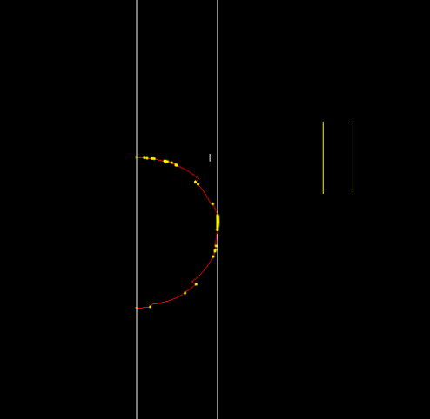

Figure 1: 1.02 MeV Electron exposed to 0.007 Tesla EMF (Geant4 Sim)

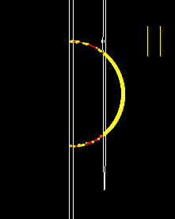

Figure 2: 50 MeV electron exposed to 0.2 Tesla EMF (Geant4 Sim)

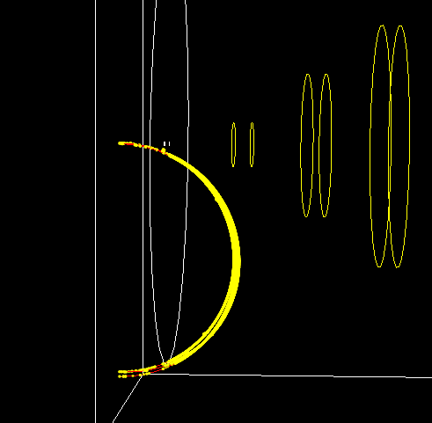

Figure 3: 25 MeV Negative Muon exposed to 0.2 Tesla EMF (Geant4 Sim)

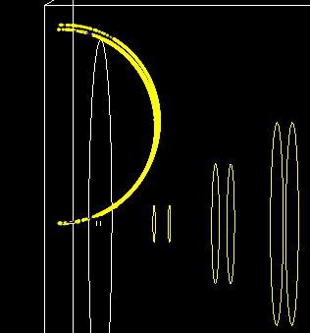

Figure 4: 25 MeV positive Muon exposed to 0.2 Tesla EMF (Geant4 Sim)

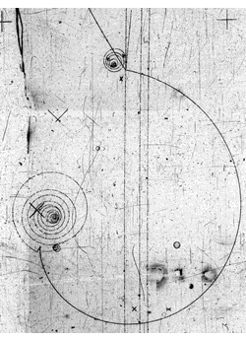

Figure 5: Muon Spiral (Cloud Chamber)