**Title**

Simulation of Positron Emission Tomography system utilizing Geant4 toolkit.

**Abstract**

This effort is intended to simulate the decay of Fluorine 18 isotope as an avenue to understand Positron Emission Tomography (PET) and become acquainted with Geant4 MonteCarlo Libraires [3]. Firstly, a Monte Carlo experiment is constructed using Geant4 tool kit (exampleB3) [1]. The radioactive trace is constructed from Fluorine 18 inside a brain tissue. An array of crystals is constructed simulating Lu2SiO5 as sensitive detector. The crystals are circularly arranged to from a PET ring. The head of a patient is schematized as a cylinder of brain tissue and placed at the center of detector. The gammas produced from positron and electron annihilation are captured in crystals and their dose is measured. The location and energy of the gammas can be used to reveres engineer the position of the radioactive tracer. In conclusion, this study increases the understanding of the nuclear physics behind the PET scans, deepens the understanding of the Geant4 Monte Carlo application and characterizes the impact of ionic radiations as it applies to the medical field of cancer diagnosis.

**Introduction**

A positron emission tomography (PET) scan creates a three-dimension image of a body [3]. A radioactive tracer is administered to a patient through injection. The tracers are consistent of carrier molecules that are tightly bonded to a radioactive isotope. The particular carrier molecule that is used depends on the type of the cancer diagnostics. It could be a modified form of glucose which gets absorbed by tissues. When tissues absorb a lot of glucose, it indicates a cancerous tumor. The radiation from tracers poses little danger to the patient since they quickly pass through the body. The isotope radiates positrons which interact with a nearby electron and results in a complete annihilation of both particles. The nuclear interaction produces a pair of gammas (511 keV) that speed up in opposite directions. The sensitive detectors in the PET scanner measure the gammas and reverse engineer an image of the tracer’s distribution in the body.

**Geant4**

In this effort the Geant4 example B3 is used as the starting point [1] [2].

1. GEOMETRY DEFINITION. Defines the gamma detection which are scintillating crystals. A small number of such crystals are optically grouped in a matrix of crystals. Crystals are circularly arranged to form a ring. Few rings make up the full detector.
2. PhysicsList. Defines the Geant4 modular physics list with registered physics builders. The classes are G4DecayPhysics which defines all particles and their decay processes, G4RadioactiveDecayPhysics which defines the radioactiveDecay for GenericIon, G4EmStandardPhysics which defines all EM standard processes.
3. ACTION INITALIZATION. Defines, instantiates and registers to Geant4 kernel all user action classes.
4. PrimaryGeneratorAction::GeneratePrimaries() implements the primaries generations like the type of a primary particle.
5. DETECTOR RESPONSE scorers A 'good' event which is an event where an identical energy of 511 keV is deposited in two separate Crystals. A count of the number of such events corresponds to a measure of the efficiency of the PET system. The total dose deposited in a patient during a run is also computed. Scorers are defined in DetectorConstruction::ConstructSDandField() method. There are two G4MultiFunctionalDetector objects: one for the Crystal (EnergyDeposit), and one for the Patient (DoseDeposit). At the end of event, the values accumulated in EventAction process are passed in RunAction and summed over the whole run and in the class RunAction::EndOfRunAction() method.
6. 6- STACKING ACTION Beta decay of Fluor generates a neutrino. One wishes not to track this neutrino; therefore, one kills it immediately, before created particles are put in a stack.

**Result**

This example provided in B3 is compiled, built, and linked on an ubuntu 20.04 operating system. The following graph presents the visualization of the PET. Additional data in terms of the pair of gammas and their efficiency are also gathered, however, they are not presented here.

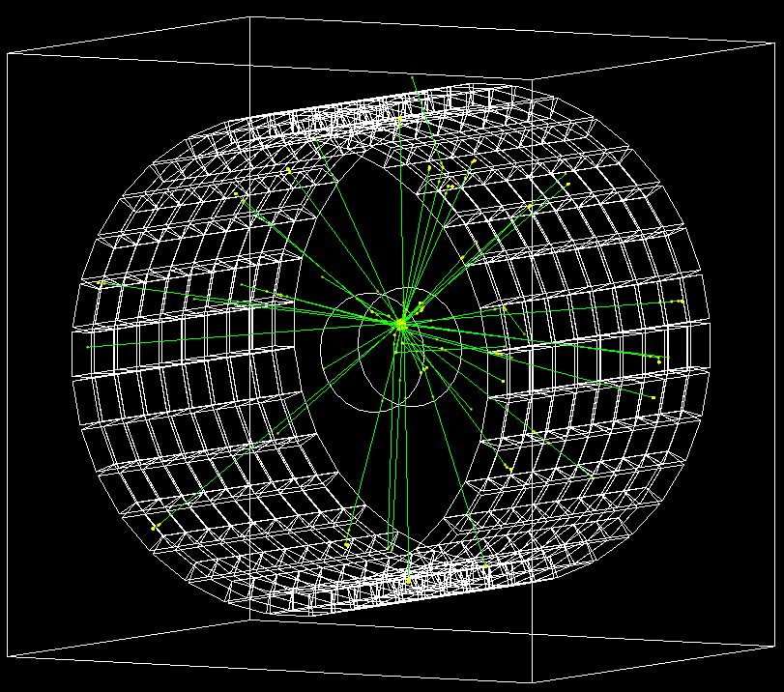

As the graph presents, the pairs of gammas produced by the positron and electron annulation are detected and scored in the gamma detector. The isotope of fluorine 18 is identified to be located near the center of the scanner.

**Conclusion**

Observing the results of this Geant4 simulation, provided a very detailed understanding of nuclear physics utilized in the PET scan and deepens the understanding of the algorithm required to reverse engineer the position of the caner tissue. One can gather the pair of gammas location, timing and efficiency in an ascii file. For a future study, this data can be utilized to develop an algorithm to reverse engineer the position of the cancer tissue.

Reference

[1] <https://www.geant4.org>

[2] <https://root.cern/>

[3] <https://en.wikipedia.org/wiki/Positron_emission_tomography>