**Simulation of Cobalt 60 Beta Decay**

**Utilizing Geant4 Monte Carlo**

**Submitted to**

**TBD**

**By**

**Faramarz Arad**

**Department of TBD Engineering,**

**University of TBD, TBD**

**June 29th, 2023**

**Abstract**

Cobalt-60 (60Co) is radioactive isotope of Cobalt with a half time of 5.2713 years. It is artificially produced in fission reactor. The main advantage of this isotope is that it has low energy β-decay which is easily shielded; however, the gamma-ray emission lines have energies around 1.3 [MeV] and are highly penetrating. This effort is intended to simulate the β-decay of Cobalt 60 and compare the Monte Carlo result against the Fermi Theory of Beta Decay [1]. Monte Carlo simulation is implemented using Geant4 [2] on UNIX/Ubuntu platform. The Cobalt-60 decays to Nickel-60 plus an electron and an electron anti-neutrino is simulated and the energy spectrum of the two gamma ray photons (from the nuclear excited state of Nickel-60), Beta decay and electron anti-neutrino are plotted using ROOT tool [3]. The comparison of the simulation results and the theoretical model showed that Geant4 Application provides a very accurate approximation of this phenomenon. The margin of error between the gamma ray is less than 0.5 percent, the maximum of Beta’s energy spectrum is less than 0.01 percent, the energy spectrum (curvature) of Beta resembles the impact of the Coulomb law of attraction. In conclusion, this effort to simulate the beta decay phenomena with Geant4 Monte Carlo tool provided a deep understanding on the topic of decays along with understanding of Geant4 Montecarlo simulation application.

**Introduction**

Cobalt-60 is used in a myriad of industries. It is used as implants and external source of radiation exposure in the medical industries. It is used for medical devices sterilization process to kill microorganisms. It is used to detect flaws, to inspect metal parts and to inspect welds in industrial radiography. It is used for food irradiation as a safety process that uses radiation to kill germs causing food poisoning. Cobalt-60 is very advantages because it is a high intensity gamma-ray emitter with a relatively long half-life. The released beta is low energy and it easily shielded while the gamma-ray emission lines have energies around 1.3 [MeV] so they are highly penetrating. Furthermore, the chemical properties of cobalt, like resistance to oxidization and low solubility in water, are favorable in comparison to other sources of gamma sources such as ceasium-137.

Cobalt-60 is radioactive isotope of cobalt which is produced artificially in nuclear reactor. It is produced by the neutron activation of Cobalt-59. It undergoes beta decay to the stable isotope of Nickel-60. The excited nickel nucleus emits two gammas’ rays with energies of 1.17 and 1.33 [MeV], hence the nuclear reaction is:

59Co + n -> 60Ni + e- + νe + gamma rays. (1)

The decay scheme of 60Co in figure (1). The main Beta-decay, gammas released because of 60Ni excited nucleus along with the transitional probability [4].

Figure 1: Decay Diagram of Cobalt 60.

**Fermi Theory of β decay**

Enrico Fermi proposed a low-energy effective field theory deciphering the interaction of four fermions with one another. His theory explained the beta decay of a neutron by direct coupling of a neutron with an electron, an anti-neutrino, and a proton. The calculation of transition probability of the Beta decay resulted by the theory treated the decay-causing interaction as a weak perturbation.

λ = (2π/h) |*vfi*|2 ρ(Ef) (2)

The matrix element |*vfi*|2 is the integral of the interaction between the final wave form and the initial wave form of the system. This element is evaluated to be a constant after detailed calculation out of scope for this report.

*vfi* = (3)

The factor ρ(Ef) is the density of final states is what causes the continuous distribution of the beta-electron energy presented in figure (2), since the (2π/h) |*vfi*|2 portion of the transitional probability is a constant.

Figure 2: Energy spectrum of released Beta simulated with Geant-4

**Q-Value Calculation**

The nuclear reaction presented in equation (1) is used to calculate the Q-value of this beta-decay to be equal to 0.31739704999 [MeV]. This is calculated assuming the atomic mass unit of 60Co is 59.9338171 [a.m.u], 60Ni is 59.9307864 [a.m.u], first gamma γ is 1.1732 [MeV], and second gamma γ is 1.3325 [MeV]. Please note that Geant4’s evaluation of the maximum energy spectrum is within 0.01 percent of this value assuming the anti-neutrino does carry any kinetic energy due to its negligible stationary mass comparing to an electron’s stationary mass.

**The Gamma’s density function**

The nuclear reaction presented in equation (1) produces two lines of gamma rays. The first line of gamma ray has the mean of 1.1792 [MeV] with standard deviation of 1.2499 on a sample size of 1000 gammas presented in figure (3). Geant4 simulation has less than 0.5 percent margin of error vs the observed value in a lab [4]. The second line of gamma ray has the mean of 1.3289 [MeV] with standard deviation of 1.5612 on a sample size of 1000 gammas presented in figure (4). Geant4 simulation has less the 0.5 percent margin of error vs the observed value in a lab for both gamma ray lines [4].

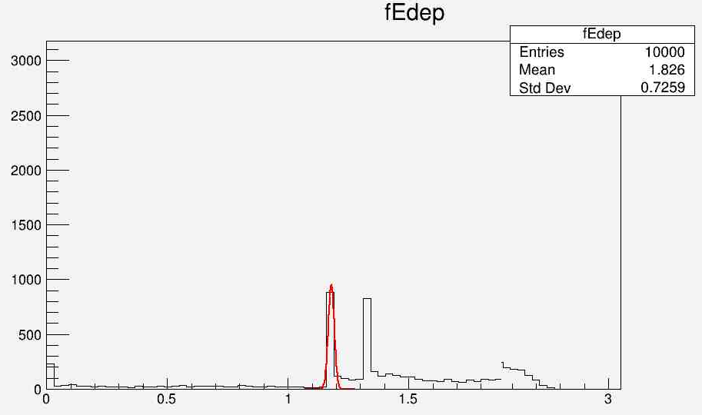

Figure 3: Geant4 simulation for gamma ray with average of 1.1792 [MeV]

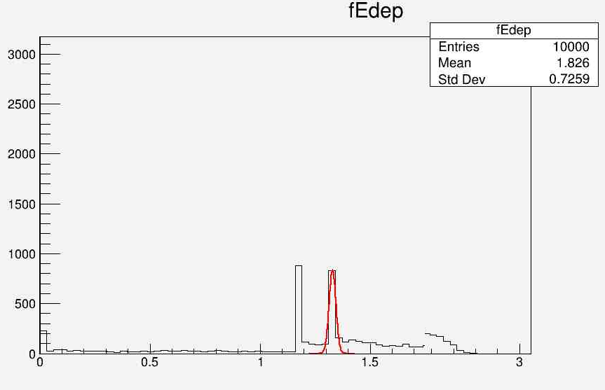

Figure 4 Geant4 simulation for gamma ray with average of 1.3289 [MeV]

**Monte Carlo (Geant4 Simulation)**

Gean4 version 11.1 toolkit was used to simulate the decay of Cobalt-60. This simulation was based on two set of codes. One was to simulate the gamma ray lines and the second to simulate the energy spectrum of the beta decay. The radioactive decay world object was constructed based on G4Box of size 1.0 by 1.0 by 1.0 [m^3]. The Physics list is consisting of G4EmStandardphysics object, G4OpticalPhysics object, G4DecayPhysics object and G4RadioactiveDecayPhysics object. The particle generator is based on G4Geantino object with proton number of 27 and atomic number of 60. The photon positions and momentums were calculated using the Tracking information provided by the G4Step object [2]. Nuclear beta decay (1) is visualized using Geant4 tool and are presented in figure (5), figure (6) and figure (7).

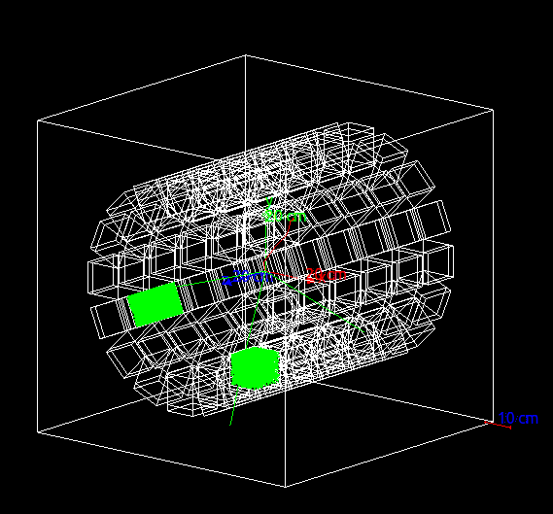

Figure 5: Presenting the Beta decay in blue and two photons decay in green.

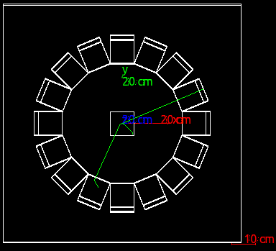

Figure 6: Presenting the Beta in blue and two photons in green.

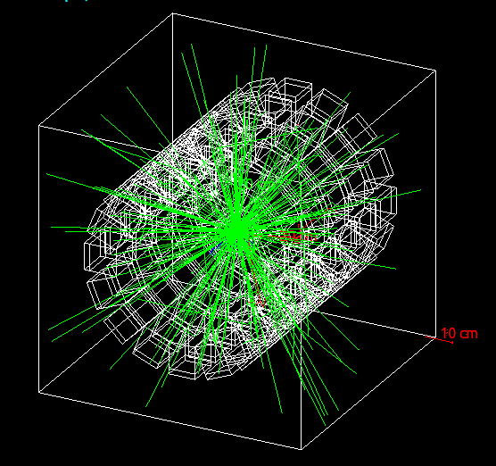

Figure 7: Presenting 100 Beta Decay of Cobalt-60

**Conclusion**

Comparing the results evaluated using the Geant4 based simulation of Beta decay of Cobalt-60 vs the Enrico Fermi’s rule along with the experimental measurements reveals that Monte Carlo based approximation provides a very accurate model for this phenomenon. This is based on small margin of 0.1 percent for maximum beta energy calculated using Q-value vs Geant4 approximation. It is based on the experimental energy values of the two gamma ray lines are less than 0.5 percent different from the value approximated by Geant4. Finally, the energy spectrum (curvature) of Beta resembles the impact of the Coulomb law of attraction predicted by Enrico Fermi’s Beta decay.

Reference:

[1] Krane, Kenneth. “Fermi Theory of Beta Decay” Introductory Nuclear Physics, John Wiley and Sons, 1987, pp. 277

[2] <https://www.geant4.org/>

[3] <https://root.cern/>

[4] <https://en.wikipedia.org/wiki/Cobalt-60>